A ofComputer Science 12



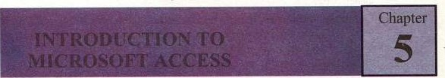

5.1 OVERVIEW



Microsoft Access is one of the most popular and powerful DBMS. It has many built in features to assist you in constructing database and viewing information. MSAccess is much more involved and is a more genuine DBMS than other programs such as Microsoft Works. Microsoft Access is a Relational Database Management System (RDBMS) that you can use to store and manipulate large amount of information. It is easy to understand and its graphical interface helps to create queries, forms, and reports. In other words, even inexperienced programmers can use Access to turn a stack of invoices, a card file of customer names, a ledger, and an inventory list into a relational database that makes entering, updating, and reporting information as easy as clicking a button.

MS-Access offers more than just pretty interface for learning how to manage data. You' Il find following benefits and more from using Access: 

* + - Sample databases: It includes sample database applications to assist you learn about real-world tables, forms, queries, and reports, and how they are interconnected to form a database management system.
    - Wizard: It makes very easy to create a database. You can choose from several examples of databases in the Database Wizard for such storage uses as contact information, inventory control, a ledger, and so on. You can create and then modify these databases to meet your own needs.
    - Keys to understand the structure: After you have decided how to create and relate tables, you can easily view all the relationships in the database with the graphical interface in the Relationship Window. This makes one of the toughest parts of relational database design much easier and more manageable.

Microsoft Office integration: You can use access with Word, Excel, and other offce application to create mail merges, charts, and other helpful uses for your data.

* + - Easier programming: You can use relatively simple code with macros to automate repeated tasks, or you can try more complex and flexible code

with VBA. Access provides graphical shortcuts and hints to help writing easier code.

* + - Common Standards: It uses standards that help applications scale up to work within larger environments. Access uses objects and SQL (Structure Query Language) to make its code from the adaptable to other applications.
    - Redundancy: MS-Access allows you to store, retrieve, sort, analyze, and print information contained in • the database. Data may be manipulated Without data redundancy by defining relationships between sets of data. Databases are often used for product data. Redundancy means duplication of data in multiple files. It wastes the storage media of computer.

5.1.1 Creating New Database

Once Access has been accessed, choose the File New Database command from the menu at the top of the screen in order to create a new database. The database window is displayed. Choose the appropriate directory and drive.

Then enter an eight-character name for the new database file and click "OK"



|  |  |  |  |  |  |  |  |  |  |  |  |  |  |  |  |  |
| --- | --- | --- | --- | --- | --- | --- | --- | --- | --- | --- | --- | --- | --- | --- | --- | --- |
|  |  |  |  |  |  | | |  |  |  |  |  |  |  |  |  |
| deegases | | |
|  |  | | |  |  | | |  | | | | | | | | |
|  | | |
|  |  | |  |
|  |  |  |  |
|  |  | | |
|  |  |  |  | | | | |  |  | | |
|  |  | |  |  | Access | | .rrdb) | | | | |  | |  |  |

Fig.'. I Defining F a

When you start up Ms-Access, you get a dialog box asking if you want to open an existing database or create a new one.

|  |
| --- |
| previously created a database, and then create it egain using the same name, u will overwrite any work |

* Create a New Database.
* Create a File New Database using wizard  Open an existing database

5.1.2 Create a database using the Database Wizard

The Database Wizard guides you through process Of the creation a database; it includes choosing a database template; selecting fields, making customizations, adding pictures, and the database.

|  |  |  |
| --- | --- | --- |
| A Textbook o Co | uter Science | Class 12 |

* When Microsoft Access first starts up, a dialog box is displayed with options to create a new database or to open an existing one. When this dialog box appears, select Access Database Wizards, pages. and projects and then click OK. Microsoft Access starts up, when you click the New Database on the toolbar.

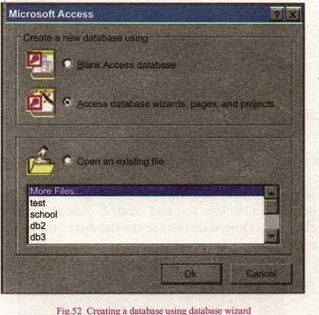

ig.S2

Crwting

database

using

On the Databases tab, double-click the icon for the kind of database you want to create.

1. Speci$' a name and location for the database.
2. Click Create to start defining the new database

5.13 Create a database without using the Database Wizard

If you don't want to use the database wizard, you can create a database, you first start the Microsoft Access, a dialog box is displayed with options to create a new database or open an existing one. when this dialog box is displayed.

Click on the Blank Access Database, and •then click OK.

(iii) Speci$' a name and location for the database and click Create.

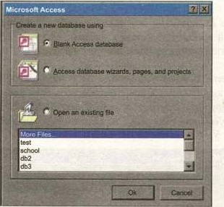

"Sing

Wizard

5.1.4 Opening Existing Databases

The white box gives you the most existing databases you have used. If you do not see the one you had created, choose the More Files option and click OK. Otherwise choose the database you had previously used and click OK.

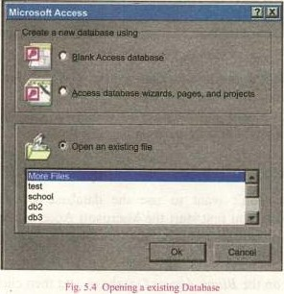

A of



5.1.5 Exiting Microsoft Access

When you finish working in Access, be sure to exit the program properly to avoid damaging your database.

 Click on File. The File menu will appear.

 Click on Exit. Access will close and you will return to the Widows desktop.

OR

Click on the Close button as an alternate way to exit Access in only one step.

5.2 MS-ACCESS APPLICATION WINDOW

The Access Application Window follows the standard layout of all Microsoft Application

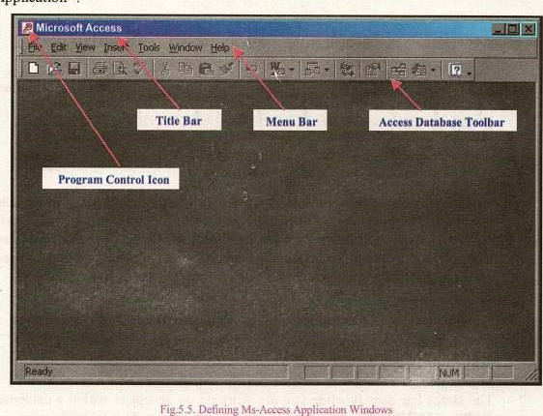

$

Title Bar

The Title bar identifies the database application you are running in Microsoft

Access. On the len side Of the title bar is program Control Icon If you

click this, a menu of the commands tp control the Access window is displayed. You can also use the minimize Maximize Restore close buttons on the right side of the Title bar to control the MS-Access Window.



Menu Bar

Each word on the menu bar represents a different menu. Each menu contains the commands you use to activate features of Access. If a command is also found on a toolbar then the icon representing the command is displayed in the menu too. This make recognizing commands easier.



Toolbars

Toolbars contain icon button that are shortcuts to the commands in the menu.

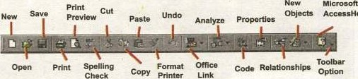

AccessHeIp

Toolbars make it easy to use the program's most common features and functions. The buttons on the toolbar can change depending on the objects selected. wrhen you click on a button on the toolbar, as you open individual tables, queries, forms, and reports within that database, the toolbars change.

For example, when you open a table, the table datasheet toolbar appears.

Scroll Bar

Scroll bars are used to move around the window if its contents do not fit on screen. You can scroll around the sheet by clicking the scroll arrows at either end of the scroll bar or by dragging the scroll button in the scroll bar.

Status Bar

The status bar display while you are working on an object within a database.

CAPS and NUM buttons on keyboard show whether and respectively are on.





5.3 DATABASE WINDOW

•The Database Window organizes all of the objects in the database. The default table Listing provides Ways to create tables and lists all ofthe tables in the database. The left side of the MS-Access database window includes seven buttons, each corresponding to one of the seven objects that make up an Access database. A database is essentially an organized collection of data. In an Access database, you collect data into the tables by using forms, query tables to analyze their content, Create report based on the tables and queries, and design data access page to view your Access data from the web. As an advanced user, you may create macros (A macro is used to perform the same sequence ofsteps or automating tasks repeatedly.) to automate takes or modules (A module contains an object that stores VBA code.) to create database applications using Access.

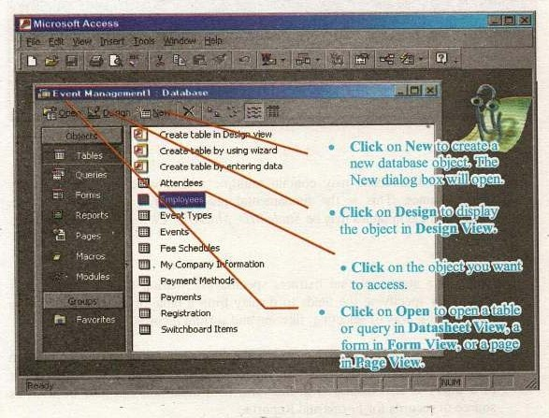

Fig.5.6 netining the Database window

54



5.4 DATABASE OBJECTS

A Ms-Access database consists of various components called the objects. The database objects are used to store data and to retrieve data from database. The major

|  |  |  |  |
| --- | --- | --- | --- |
| database objects are: |  |  |  |
|  | Tables | (ii) | Queries |
| (iii) | Forms | (iv) | Reports |

Tables

The most important Object of a database is a Table. The data is stored in tables of database. A table is a collection of related data organized in rows and columns. Each row consist a record, and each record consists of columns. The row is divided into columns called field containing different data values of a particular record. A table having recodes of students is given blow. Each record contains fields; StudentID, First Name, Parents Name, Address, City, MajorID, and ClasslD.

|  |  |  |  |  |  |  |  |  |  |  |  |  |  |  |  |  |  |  |  |  |  |
| --- | --- | --- | --- | --- | --- | --- | --- | --- | --- | --- | --- | --- | --- | --- | --- | --- | --- | --- | --- | --- | --- |
| l*Students | |  | | | |  | | |  | | |  | | | | | | | | |  |
|  |  |  |  |  |  |  |  |  |  |  |  |  |  |  |  |  |  |  |  |  |  |
|  | | | | | | A,'mat | | |  | Åzrrx | | 345, Islamabad | | | | | | |  | | |
| 2 Rashid | | | | | | Ahmed | | |  | Ahmed &Jtt | | 78 Cali 50 Lahore | | | | | | |  | | |
| 3'ZairrubAbid | | | | | | Khan | | | MR. khan | | | 567 | | | 52 | | | |  | | |
| ONumie | | |  | | |  | | |  | | |  | |  | | | | | | | |

Figs.7 Creating u Database without using Database N&izard

A relational database may contain multiple tables, which are identified by unique names. This is the fundamental property of a relational database. Common field in tables may be StudentID, MajorID, ClasslD etc.

Queries

Query is a statement that extracts specific information from database. It is created by specimng the fields to display from a table or another query. It is more flexible way of selecting, filtering and sorting records.

The user can also change data in the database that fulfils certain criteria. In addition, queries allow to perform calculations of different fields. The output of a query is also displayed in the form of a table and can also be used as source of records for Forms and Reports.



The query allows you to view and analyse data in many different ways. Technically, a query is a stored question or request. You design a query in design view to extract certain information from the database.

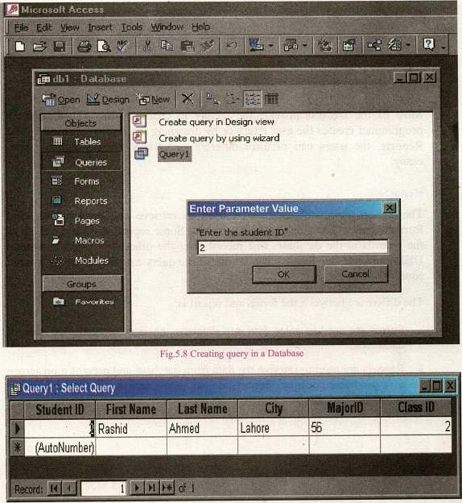

Fig.5.9 Select Query

The information appears in Datasheet view, which looks exactly like Datasheet view for a table. The difference between a datasheet for a table and  a datasheet for a query is that the query's datasheet can combine information from multiple tables.



S

Forms

The Form object of database is used to enter data into databases, edit data and view data from database. You can add, update, and delete records in your table by using a form. Form provide:

* an easy method for entering and editing data in tables. Thus the user does not have to work directly with tables.
* mcüities to display data retrieved from database tables.

Most of the DBMSs provide the Ricility to create Forms. The application programmer creates the user interface by designing the Forms. In this way and Reports, the users can perform different operations on the database very easily.

Reports

The Report object of database is used to retrieve and present data in a formatted way. The Repon can be printed. Some reports are simply a list of the records in the database, one record after the other. Most of the popular DBMS provide this mcility. The output of the query can also be given as input source to Reports.

The difference between the forms and report is:

* Forms are used to enter data into database, change data and view data of databases.
* Reports are used to retrieve the data from database and present it on screen in a predefined format. Reports do not allow user to change data or to enter data into database.

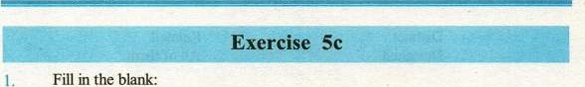

in

the

A

of

IDE stands for is basically a cornputerized record keeping system.

* 1. RDBMS stands for
  2. The Object is used to store data in a database.

object is used to retrieve data from a database.

* 1. A field with data type is automatically incremented by Access each time a new record is entered.
  2. Each row ofa table is divided into columns called
  3. Each row ofa table representing a set of information is called
  4. The window that is used to display, enter and edit data on the screen is called

A database consists ofmajor database objects, which are used to store and retrieve data to and from the database.

2. Multiple Choice questions:

A database consists ofvarious components Called the:

a) Tool. b) Properties.

c) d) Object

1. Which ofthe following object ofdatabase is used to retrieve data from database?
   1. b) Forms

c) d) Tables

1. The output ofa query is in the form of a: 
   1. Table b) Form

c) Report d) 

Which ofthe following object is used to retrieve data from database and present in a formatted way?

a) Report b) Form

c) Table . d) Query

Microsoft Access saves the database with the extension: a) 

c)  d) None ofthem

A record is a complete Set offield.

5



a) Distinct b) Related

c) d) All ofthem

(vii) In Access, the structure ofa table is created in 

a) Design View b) Datasheet View

c) a and b both d) None ofthem

 Write T for true and F for false statement.

An IDE simplifies the tasks of creating and using a database. The major objects of database are five.

1. Forms are provided by database management system to generate reports.
2. An integrated development environment is an interfice that is used by  database designers and application programmers to create database applications.

To view data in an Access table, the table is displayed in design view. RDBMS stands for Relational Database Management System.

1. A request to extract data from a database is called report.
2. Database design plays an important role in achieving the goals of emciency, speed and consistency.

The table can be displayed in two views in Access. There are Design view and Datasheet view.

The Window in a database IDE that is used to display, enter and edit data on the screen is called form.

1. Define the database objects are used to store and retrieve data.
2. Explain the procedure for creating a new database in Access.
3. Differentiate between Toolbar and Menu bar. What is meant by RDBMS?
4. What is an IDE?
5. Define the use ofToolbar in Microsoft Access.
6. What are the advantages ofusing a Microsoft Access IDE?
7. Write a procedure to open an existing database file.
8. How is Microsoft Access started or loaded?
9. Differentiate between Form and Report.

14• Define the use of status bar and title bar in Microsoft Access.

15. Describe the Database Window in Microsoft Access

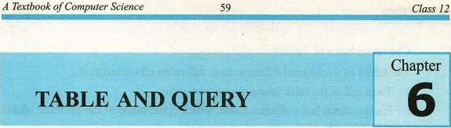

6.1 OVERVIEW

In a relational database the data is stored in tables. The table is the fundarnental concept of relational databases. It is also called relation. It is the foundation of every Relational Database Management System is a database object called table.

Tables are grids that Store information in a database similar to the way an Excel worksheet stores information in a workbook. Access provides three ways to create a table for which there are icons in the Database Window. Double-click on any of the icons to create a table.

Every database consists of one or more tables which store data. Each table has its own unique name and consists of columns and rows. It is a very convenient way to Store information.

The columns in a table (also called table fields) have their own unique names and have a pre-defined data type. The field can be a primary key, an index defined on it and it can have certain default value.

The table columns describe the data types, whereas the table rows contain the actual data. Here is an example of a simple database table, containing students' data. The first row, listed in bold, contains the names of the table columns:

Table: Students

|  |  |  |  |  |  |  |  |  |  |  |  |  |  |  |  |  |  |  |  |  |  |  |  |  |  |  |
| --- | --- | --- | --- | --- | --- | --- | --- | --- | --- | --- | --- | --- | --- | --- | --- | --- | --- | --- | --- | --- | --- | --- | --- | --- | --- | --- |
| Students : lable | | | | | | |  | | |  | | | | |  | | | | |  | | | | | | |
|  |  |  |  |  |  |  |  |  |  |  |  |  |  |  |  |  |  |  |  |  |  |  |  |  |  |  |
|  | | | | | | |  | Azna! | |  | | kamal Hasan | | | 345. street #E61sIamabad | | | | | 86 | | | |  | | |
| Rashid | | | | | | |  | Ahmed | |  | | Ahmed Butt | | | 78 Ga15•0 Lahore | | | | | 56 | | | |  | | |
|  | | | | ZairFulAhid | | |  |  | |  | | MRKhan | | |  | | | | ndi |  | 52 | | |  | | |
| umbe | | | | | | |  |  | |  | |  | | |  | | | | |  |  | | |  | | |



and

Query

6

Characteristics of Tables

The tables of a relational database have following characteristics:

* Each cell of the table contains only one value.

Each column has a distinct name, which is the name of the attribute (field) it represents.

* The order of the columns is immaterial.
* Each row represents a record.
* Each row is distinct; there are no duplicate rows.  The order of rows is immaterial.

Using a separate table for each entity means that you store that data only once, which makes your database more efficient, and reduces data entry errors. Tables form the foundation of an Access database structure.

Degree of a Relation

The number of fields in a relation is called the degree of a table. Once the table has been created, its degree usually dose not changes, e.g. a table with five fields has a degree of 5.

Cardinality of a Relation

The number of record in a relation is called the cardinality of the relation. The cardinality Of a relation changes as new records are added or existing records are deleted, e.g. a table with 50 records has a cardinality of 50.

A Basic Termin010kv

These words are used often in Assess so you will want to become familiar with them before using the program and this book. 

* + - A database is a collection of related data (or record).
    - An object is a component in the database such as a table, query, form, or
    - A table is a group of related data organized in fields (columns) and records (rows). By using a common field in two tables, the data can linked. Many tables can be stored in a single database. 
    - A field is a column in a table and defines a data type for a set of values in the table. For exarnple a mailing list table might include fields for first nanw, last name, address, city, state, zip code, and telephone number.
    - A record is a row in a table and is a set of values defined by fields. In a mailing list table, each record would contain the data for one person as specified by the intersecting fields.

Design View provides the tools for creating field in a table.

|  |  |
| --- | --- |
| A Textbook Com uter science |  |

* + - Datasheet View allows you to update, edit, and delete information from a table.

6.1.1 Access IDE

IDE stand for Integrated Development Environment. It is an interface that is used to create a database. An IDE makes the using of database simple, manageable for end users who may not have a complicate programming knowledge of the database system.

Microsoft Access is an example of a database management system. The access IDE simplifies the task of creating, designing good-looking screens with features (i.e. text boxes, list boxes, button, dialog boxes etc.). It provides the facilities for searching, sorting, and retrieving the data,

6.1.2 Starting Microsoft Access

 You can build a database in two ways by using the Database Wizard,



or by opening an empty database and building all your objects with wizards or from scratch. 

Double click on the Microsoft Access icon on the desktop if its icon in the desktop,

Microsoft

Access

OR



Click on Start

6.2 TABLE DESIGN VIEW

Design View allows you to define fields in the table before adding any data to



Table and Query 62 6

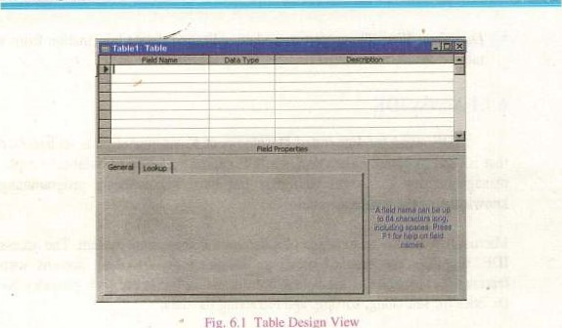

Table

Design

View

Fig.

6.2.1 Datasheet View

When you open a table or query using the database window, it will be displayed in datasheet view. A table Or query is opened in Datasheet View to perform different operations on the data in the table such as displaying data, adding new data, searching data etc.

The Datasheet view is Ilke worksheet. When table is opened in Datasheet view, the field names are displayed as header of columns and each row contains a complete record.

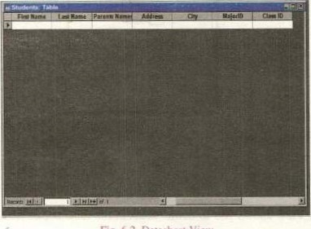

fig. 6.2 Datasheet View



Of

Computer

63

Class

12

Switching Views

 To switch views form the datasheet (spreadsheet view) to the design view, simply click the button in the top-left corner of the Access program.

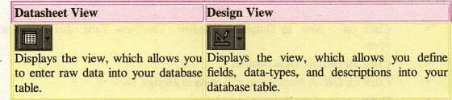

Table

6.

I

6.3 TABLE CREATION

You can open or create a table in several ways in Microsoft Access i.e.,

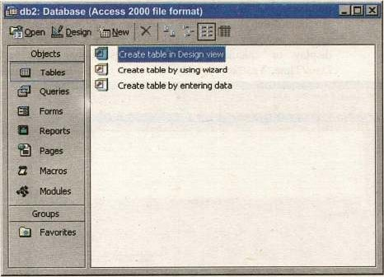

Fig. 6.3 Creating Database Different Way.

Creating database in Design view.

Creating database by wizard.

(iii) Creating database by entering data.

Table and

Creating database in Design View

* + - * Click on the Table object from the list of database object.
      * In Database Window, Double-Click on "Create table in Design view"; a table window in Design View is appeared to design the structure of table.

OR

* + - * Click on New, in Database Window. The New Table dialog box will open.
      * Click on Design View Oplion.
      * Click on OK. A blank table will open in Design View.
      * Define each of the fields in your table.
      * Under the Field Name column, enter the categories of your table.
      * Under Data Type column, enter the type you want for you categories,

 The attribute of a variable or field determines what kind of data it can hold. For example, in a Microsoft Access database. the Text and Memo field data types allow the field to store either text or numbers, but the Number data type allow the field to store numbers only. Number data type fields store numerical data that is used in mathematical calculations. Use the Currency data type to display or calculate currency values. Other data types are DaterTime, Yes/No, Auto Number, and OLE object (Picture).

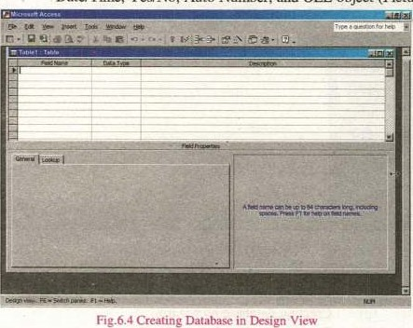



* + - * Under the Description column, enter the text that describes the field. (This field is optional).

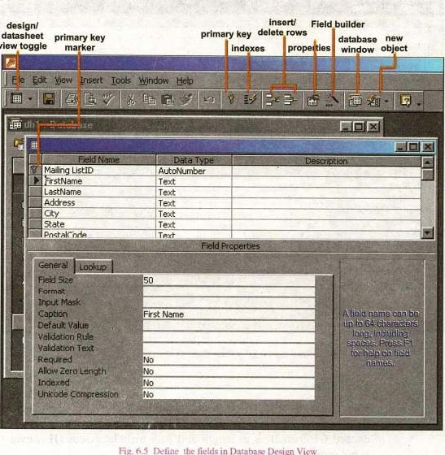

view

g.

the

in

Data

base

Design

Vies'

Defining Field Properties in Design View

The properties of each field can be set in design View. The window is divided into two parts: a top pane for entering the field name, data type, and an optional description of the field, and a bottom pane for specifying field properties.

To assign the Primary Key, select the field and click the Primary Key button in the toolbar. You can set the remaining properties in the Table Window's lower pane. The following properties are defined briefly.

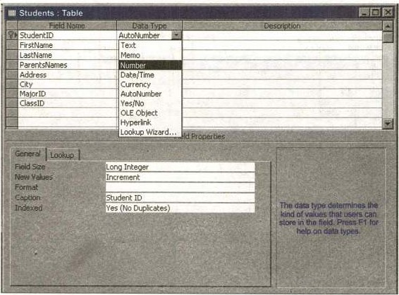

fig. 6.6 Define the Field' s Data Type in Database Design View

1. meld Name

This is the name of the field and should represent the contents of the field such as 'Name", "Address", "Final Grade", etc. The name cannot exceed 64 characters in length and may include spaces (However, this is not considered a good practice).

1. Data Type

Before you start creating a new table in Access, you first consider how you want to break down the information you are organizing into smaller units of data in the table. Dividing the data into units of information is the process of determining the fields. Each field will be assigned a unique field name. Each field is also assigned a data type. Following are the data types available in Ms. Access:

Text - The default type, text type allows any combination of letters and numbers up to a maximum of 255 characters per field record.

* Memo - A text type that Can store more than 64,000 characters and is used for detailed descriptive feilds().
* Number — This data type is used to store numbers that are used in mathematical calculations. Several number field sizes are available. The most useful are summarized in table 6.3.
* Date/Time - A Date, Time, or combination Of can be specified in this field.
* Currency Monetary values that can be set up to automatically include a dollar sign ($) and correct decimal and comma positions.
* Auto Number - When a new record is created, Access will automatically assign a unique integer to the record in this field. From the General options, select Increment if the numbers should be assigned in order or random if any random number should be chosen. Since every record in a datasheet must include at least one field that distinguishes it *from all others, this is a useful data type to use if the existing data will not produce such values.
* Yes/No - Use this option for True/False, Yes/No, On/Off, or other values that must be only one of two.
* OLE Object - An OLE (Object Linking and Embedding) object is a sound, picture, or other object such as a Word document or Excel spreadsheet that is created in another program. Use this data type to embed an OLE object or link to the Object in the database.
* Hyper link - A hyperlink will link to a website, or another location in the database. A hyperlink address have up to four parts: the text that is displayed in the field; the path to a file or URL; a subaddress which is a location in the file or page in the web site; and the text that is displayed as the tooltip. The data

consists of up to four parts each separated by the pound sign  The Address is the only required part of the string. Examples:

Internet hyperlink example: Google Home Page#http://www.google.com# Database link example:

Documents\database.mdb#MyTable

Description (optional)

Enter a brief description of what the contents of the field are.

Field Properties

Select any pertinent properties for the field from the bottom pane. Properties for each field are set from the bottom pane of the Design View window.

* Field Size is used to set the number of characters needed in a text or number field. The default field size for thc text type is 50 characters. If the records in the field will only have two or three characters, you can change the size of the field to save disk space  or prevent entry errors by limiting the number of characters allowed. Likewise, if the field will require more than 50 characters, enter a numlEr up to 255. The field size is set in exact characters for Text type, but options are give for numbers:
* Byte - Positive integers between I and 255
* Integer - Positive and negative integers between -32,768 and 32,767
* Long Integer (default) - Larger positive and negative integers between-2 

 Single - Single-precision floating-point number

* Double - Double-precision floating-point number

 Decimal - Allows for Precision and Scale property control

* Format conforrns the data in the field to the format specified in the format property. For text and memo fields, this property has two

of Class 12

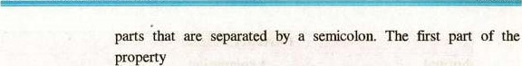

is used to apply to the field and the second applies to empty fields.

Text and memo format.

|  |  |  |  |
| --- | --- | --- | --- |
| Text Format | | |  |
| ormat Datasheet | | Display | Explanation |
|  | 1234567 | 1234567 | @ indicates a required acter space |
|  | 123456 | 123-456 | & indicates an optional acter or Space |
|  |  |  | converts characters to |
|  |  |  | converts characters to |
|  |  |  | adds characters to the end |
| Data Entered"jyello | |  |  |
| Data Entered | | 0 Data En |  |

Table 6.2

* Number format. Select one of the preset options from the drop down rrrnu or construct a custom format using symbols explained below:

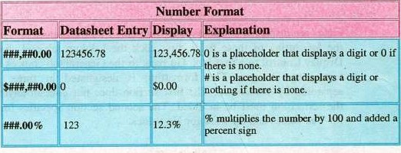

Table €3

* Currency format. This formatting consists of four parts separated by semicolons:format for positive numbers; format for negative numbers: format for zero values; format for Null values.



|  |
| --- |
| CurrenCY Format |
| Explanation  ormat |
| values will normal currency negative numtrrs will be red in parentheses, zero entered for zero values. and "none" will be writt for Null values. |
|

Table 6.4

* Date format.

In the table below, the value " 1/1/01 " is entered into the datasheet. and the following values are displayed as a result of the different assigned for-nuts.

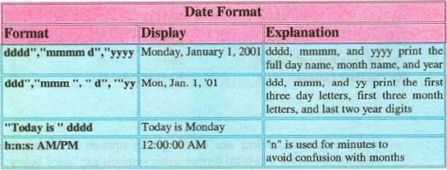

Table 6.5

* Yes/No

Fields are displayed as check boxes by default on the datasheet. TO change the formatting of these fields, first click the Lookup tab and change the Display Control to a text box. Go back to the General tab choices to make • formatting changes. The formatting is designated in three sections separated by semicolons. The first section does not contain anything but the semicolon must be included. The second section specifies formatting for Yes values and the third for No values.

|  |  |
| --- | --- |
| Format | |
| Ékplanåiiön | |
|  | Prints 'Yes" in green or "No" in red |

Table 6.6

of Class 12



* Default Value

There may be cases where the value of a field might usually be the same for all records. In this case, a changeable default value can be set to prevent typing the same value numerous times. 

* Indexes

Creating indexes allow Access to query and sort records faster. To set an indexed field, select a field that is commonly searched and change the Indexed property to Yes (Duplicates OK) if multiple entries of the same data value are allowed or Yes (No Duplicates) to prevent duplicates. 

* Field Validation Rules

Validation Rules specify criteria for the data entered in the worksheet. A customized message can be displayed to the user when data that violates the rule is entered. Click the expression builder button at the end of the Validation Rule box to write the validation rule. Examples Of field validation rules include <> O (not allow zero values in the record), and??? (only data strings with three characters in length).

* Input Masks

An input mask controls the value of a record and sets it in a specific format. They are Similar to the Format property, but instead display the format on the datasheet before the data is entered. For example, a telephone number field can be formatted with an input mask to accept ten digits in the form "(555) 123-4567". The blank field would 100k like (—) . An an input mask can be applied to a field by  following these steps: 

* In design view, place the cursor in the field that the input mask will be  applied to.
* Click in the white space following Input Mask under the General tab.
* Click the button to use the wizard or enter the mask such as, (@@@) @@@-@@@@, into the field provided. The following symbols can be used to create an input mask from scratch:



|  |  |  |
| --- | --- | --- |
| In Mask Symbols | | |
| Symbol |  | lanation |
| Letter or digit | | |
| A digit 0 through 9 without a + or - sign and with blanks displayed as zeros | | |
| Same as 0 with blanks displayed as spaces | | |
| Same as 9 with +1- signs | | |
|  | | |
| L Letter A through Z | | |
| Cor&_ygyyacter or space | | |
| Convert letters to lower case | | |
| Convert letters to u | | |

Table 6.7

Primary Key

Every record in a table must have a primary key' that differentiates it from all other record in the table. In some cases, it is only necessary to designate an existing field as the primary key if you are certain that every record in the table will have a different value for that particular field. A social security number is an example of a field whose values will only appear once in a database table.

Designate the primary key field by right-clicking on the record and selecting Primary Key from the shortcut menu or select EditlPrimary Key from the menu bar. The primary key field will be marked with a key image to the left. To remove a primary key, repeat one of these steps.

If none of the existing fields in the table produces unique values for every record, a separate field must be added. Ms.- Access will prompts you to create this type of field the first time you save the table if a primary key field has not been assigned. The field is named "11)" and the data type is "autonumber". Since this extra field sen;es no purpose to you as the user, the autonumber type automatically updates whenever a record is added so there is no extra work On your part. You may also choose to hide this column in the datasheet as explained at later Stage in this 

Creating database through using Wimrd

The Access Table Wizard offers an easy way to create tables. Access includes numerous table templates that you can use to create both business and personal database tables. The Wizard can help you create common types of



tables, including those that store mailing lists, recipes, investments, video collection etc.

* Click on the Table button in the main database window.
* Double-click on the "Create table by using wizard' option. The table Wizard will appear.
* Next, choose the specific field for the table. Click on the Business or Personal option button. Sample business or personal table will appear in the Sample Tables scroll box.
* Scroll down the Sample Tables scroll box until you see the table you want to use. Click On this Sample Table. Sample field, based on the table you choose, Will appear in the Sample Fields scroll box.
* Click on the Sample field from the Sample Fields scroll box that you want to include in your table. The field will be selected.

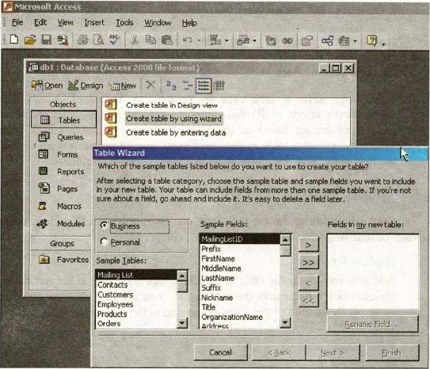

Fig. 6.7 Creating Database by using Wizarc_!

* The sample field will move to the field, click on right arrow button or click on the right double-arrow button for all fields. You can easily to remove a single field by clicking on left arrow button click on double arrow button for removing all fields. You can also rename a field after you move it to the Field in my new table scroll box.
* Enter a name for your table in text box. Set the Primary Key, it is an important concept in relational database.



|  |  |
| --- | --- |
| Click on Next if your new table isn't | Note: A table name can |
| related to any existing tables. If you | have up to 64 characters |
| want to relate your new table to an | including letters, numtrrs, |
| existing One, Access can create the relationship for you. | and spaces. |

Create Table by entering data

If you want to create your own table without using the Table Wizard, you can create one in Datasheet View, then let Access analyse it and automatically sea data types and a primary key.

When you save a table you've created in Datasheet View, Access automatically inserts an ID AutoNumber field and sets it as the primary key. Data types are set based on the type of entries you make in each column. When you create a table in datasheet view, you 'Il probably want to rmdify the field names. By default the fields are labelled Fieldl, Field2, etc.

6.4 MODIFYING A TABLE

Once you create an Access table, you can easily rmdify it by adding, deleting, moving, or renaming table fields.

Adding Records

Add new records to the table in datasheet view by typing in the record beside the asterisk (*) that marks the new record. You can also click the new record button at the bottom of the datasheet to skip to the last empty record.

Editing Records

To edit records, place the cursor in the record that is to be edited and make the necessary changes. Use the arrow keys to move through the record grid. The

Of



previous, next, first, and last record buttons at the bottom of the datasheet are helpful in manoeuvring through the datasheet.

Deleting Records

Delete a record on a datasheet by placing the cursor in any field of the record  row and select EditlDelete Record from the menu bar or click the Delete Record button on the datasheet toolbar.

Inserting and Deleting Fields

Although it is best to add new fields (displayed as columns in the datasheet) in design view because more options are available, they can also be quickly added in datasheet view. Highlight a column by clicking its label at the top of the datasheet and select InserrlColumn from the menu bar. The new column will be added to the left of the selected column.

Entire columns can be deleted by placing the cursor in the column and selecting Edi11Delete Column from the menu bar.

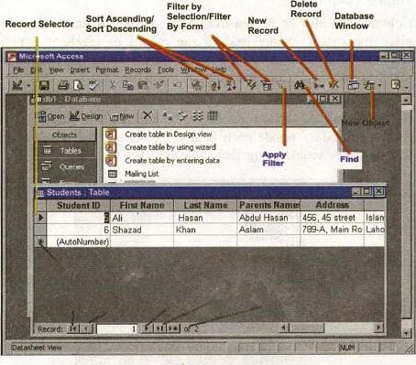

fig.6.8 Defining the Datasheet View

76



Resizing Rows and Columns

The height of rows on a datasheet can be changed by dragging the grey sizing line between row labels up and down with the mouse. By changing the height of one row, the height Of all rows in the datasheet will be changed to the new

Column width can be changed in a similar Way by dragging the sizing line between columns. Double click on the line to have the column automatically fit to the longest value of the column. Unlike rows, columns on a datasheet can be of different widths. More exact values can be assigned by selecting FormatlRow Height or FormatlColumn Width from the menu bar.

Freezing Columns

Similar to freezing panes in Excel, columns on an Access table can be frozen. This is helpful if the datasheet has many columns and relevant data would otherwise not appear on the screen at the same time. Freeze a column by placing the cursor in any record in the column and select FonnatlFreeze Columns from the menu bar. Select the same option to unfreeze a single column or select FormatlUnfreeze All Columns.

Hiding Columns

Columns can also be hidden from view on the datasheet. To hide a Column, place the cursor in any field of the record or highlight multiple adjacent columns by clicking and dragging the mouse along the column headers, and select FonnatlHide Columns from the menu bar.

TO show columns that have been hidden, select FormatlUnhide Columns from the menu bar. A window displaying all the fields in the table will be listed with check boxes beside each field name. Check the boxes beside all fields that should be visible on the data table and click the Close button.

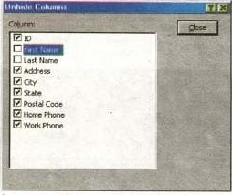

Fg.6.9 Shows the Hiding and Unhidden Columns



Finding Data in a Table

Data in a datasheet can be quickly located by using the Find command.

* Open the table in datasheet view.
* Place the cursor in any record in the field that you want to search and select EditlFind... from the menu bar. 

Enter the value criteria in the Find What: box.

* From the Look In: drop-down menu, define the area of the search by selecting the entire table or just the field in the table you placed your cursor in during step 2.

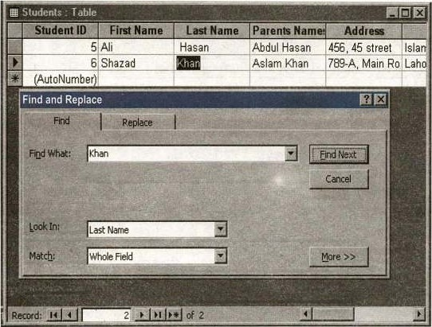

fig.6.10 finding Dat&in a Table

* Select the matching criteria from Match: and click the More button for additional search parameters.
* When all of the search criteria are set, click the Find Next button. If nwre than one records meet the criteria, keep clicking Find Next until you reach the desired record.

78



Replace

The replace function allows you to quickly replace a single occurrence of data with a new value or to replace all occurrences in the entire table.

* Select EditlReplace... from the menu bar (or click the Replace tab if the Find window is already open).
* Follow the steps described in the Find procedure to search the data that should be replaced and type the new value Of the data in the Replace With:

Click the Find Next button to step through occurrences of the data in the table and click the Replace button to make single replacements. Click Replace All to change all occurrences of the data in one step.

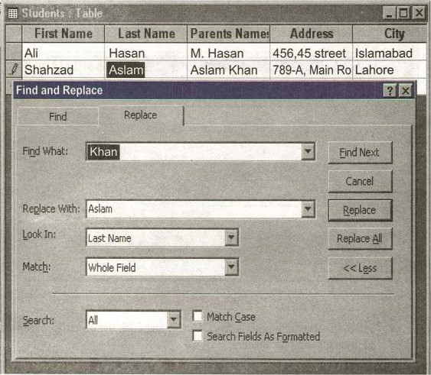

Figs

_

I

I

Replacing

Data

in

a

Table



Check Spelling and AutoCorrect

The spell checker can be used to locate spelling errors in text and menu fields in a datasheet. Select ToolslSpelling from the menu bar to activate the spell checker and make corrections just as you would use Word or Excel. The AutoCorrect feature can autornatically correct common spelling errors such as two 'initial capitals", capitalizing the first letter of the first word, and anything you define. Select ToolslAufoCorrecttO set these features.

* 1. PRINT A DATASHEET

Datasheets can printed by clicking the Print button on the toolbar or select

FilelPrint to set more printing options.

* 1. TABLE RELATIONSHIPS

Relationships can be established among tables by repeating field in more than one table in this way duplication of information can be prevented in database. Follow the steps below to set up a relational database:

* Click the Relationships button on the toolbar.
* From the Show Table window (click the Show Table button on the toolbar to make it appear), double click in the names of the tables you would like to include in the relationships. When you have finished adding tables, click Close

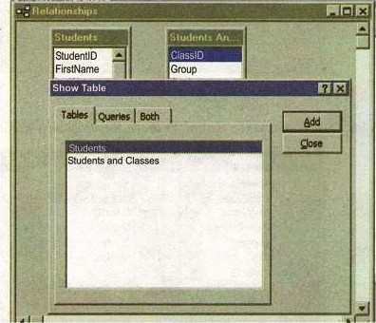

Ftg.6.12 Relationship in Show Table

80



* To link fields in two different tables, click and drag a field from one table to the corresponding field in the other table and release the mouse button. The Edit Relationships window will appear. From this window, select different fields if necessary and select an option from "Enforce Referential Integrity" if necessary. These options give Access permission to automatically make changes to referencing tables if key records in one of the tables is deleted. Check the Enforce Referential Integrity box to ensure that the relationships are valid and that the data is not accidentally lost when a record is added, edited, or deleted. Click Create to create the link.

Hg.6.13 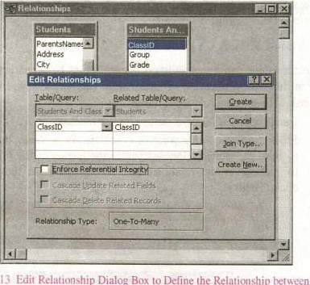Edit Relationship Dialog Box to Define the Relati€mship Student Table and Student and Classes.

* A line now connects the two fields in the Relationships window.

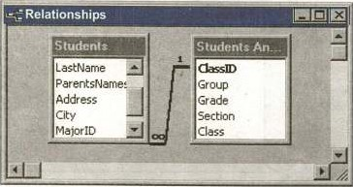

Flg_6.14 Showing the database-s Relationship windows



The datasheet of a relational table will provide expand and collapse indicators to view subdatasheets containing matching information from the Other table. In the example below, the student and student and classes table were related and the two can be shown simultaneously using the expand feature. TO expand or collapse all subdatasheets at once, select FormatlSubdatasheetlExpand All or Collapse All from the toolbar.

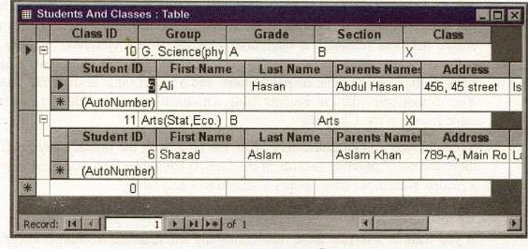

Fig.6.15 Showing the relationship between Student table and Student and Classes table. Relationship and Join

Relationships are really at the center of Relational Database Design for obvious reasons. While there are many benefits to have a relational database, there's also a requirement that you have an understanding Of how database design — and relationships in particular — work.

Without a relational database structure, you've got a flat-file. A big block of data — similar to an Excel sheet. While in some cases this frelationship-less" database may be exactly what the Doctor ordered, as soon as you get a substantial amount of data, or throw even a slightly complicated piece of data into the equation, you're destined for a hard time. You simply cannot access. the kinds of statistics in a flat-file that you normally would with relational database design, at least not with such ease as you normally would.

Joins are what make relationships work (don't use that line in a bar, you'll get slapped — nobody likes database humor). With something like a flat-file, none Of this is a concern to you. Of course, that's not necessarily good because you're probably more concerned with having hundreds or thousands more



records than you actually need or can manage. When two tables start to make goo-goo eyes and you think they're ready for a relationship, it's time to make ajoin!

Referential Integrity

A referential Integrity constraint is a rule that maintains consistency among the rows of two tables. The rule States that if there is a foreign key in one relation, either each foreign key value must match a primary key value in the other relation or the foreign key value must be null. It is absolutely crucial that the data contained in a database file is reliable. One method Access uses to ensure database reliability is referential integrity. When referential integrity is enforced, you cannot delete or change related records. In the above Class table is the primary table or parent table and Student table is the child table. You cannot enter data in Student table without first entering the data of the same record in the Class table.

Similarly, you cannot delete records in the table with the prirnary key field, if there are corresponding records in the foreign key table. First you must delete a record in Students table, which is related to Class table.

Cascade Update Related Fields and Cascade Delete Related Fields

If you Want to override these restrictions and still maintain referential integrity you can select the Cascade Update Related Fields and the Cascade Delete Related Records check boxes in Edit Relationship dialog box. If the Cascade Update Related Fields check is selected, whenever you change the primary key of a record in the primary table, Access automatically updates the primary key to the new value in all related records. If the Cascade Delete Related Records check box is selected, whenever you delete records in the primary table, Access automatically delete related records in the related table.

6.7 SORTING AND FILTERING

Sorting and filtering allow you to view records in a table in a different way either by reordering all of the records in the table or view only those records in a table that meet certain criteria that you specify.

Sorting

You may want to view records in a table in a different order than they appear such as sorting by date or in alphabetical order. Follow these steps to sort records in a table based on the values of one field:

* In table view, place the cursor in the column that you want to sort by,

of



* Select RecordslSortlSort Ascending or RecordslSortlSort Descending from the menu bar or click the Sort Ascending or Sort Descending buttons on the toolbar.

To sort by more than one column (such as sorting by date and then sorting records with the same date alphabetically), highlight the columns and select one of the sort methods stated above.

Filter by Selection

This feature will filter records that contain identical data values in a given field such as filtering out all of the records that have the value "Smith" in a name field. To Filter by Selection, place the cursor in the field that you want to filter the other records by and click the Filter by Selection button on the toolbar or select RecordslFilterlFilter By Selection from the menu bar. In the figure, the cursor is placed in the City field of the second record that displays the value "Lahore" so the filtered table will show only the records where the city is Lahore.

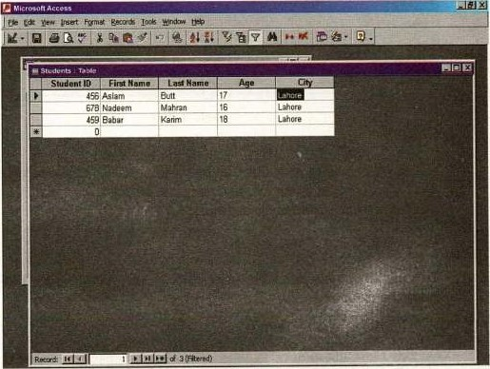

Flg.6.16 Filtering Data in table

|  |  |  |  |
| --- | --- | --- | --- |
| Table and Query | 84 | Ch | 6 |

Filter by Form

If the table is large, it may be difficult to find the record that contains the value you would like to filter by so using Filter by Form may be advantageous instead. This method Creates a blank version of the table with drop-down menus for each field each menu contains the values found in the records Of that field. Under the default Look for tab of the filter by Form window, click in the field to enter the filter criteria. To specify an alternate criteria if records Contain one of two specified values, click the Or tab at the bottom of the window and select another criteria from the drop-down menu. More Or tabs will appear after one criteria is set to allow you to add more alternate criteria for the filter. After you have selected all of the criteria you want to filter, click the Apply Filter button •on the toolbar.

Following methods can be used to select records based on the record selected by that do not have exactly the same value. Type these formats into the field where the drop-down menu appears instead of selecting an absolute value.

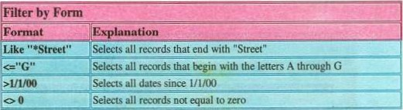

Table 6.7

Saving A Filter

The filtered contents of a table can be saved as a query by selecting FilelSave As Query from the menu bar. Enter a name for the query and click OK. The query is now saved within the database.

Remove a Filter

TO view all records in a table again, click the depressed Apply Filter toggle button on the toolbar.

6.8 INTRODUCTION TO QUERIES

Queries mean question or inquires. The questions like statements that are to retrieve data form one or more database tables are called queries. It is a powerful and flexible way of selecting, filtering and sorting records.



Queries select records from one or more tables in a database: these selected records can be viewed, analyzed, and sorted on a common datasheet. The resulting collection of records, called a dynaset (short for dynamic subset), is saved as a database object and can therefore be easily used in future.

The query will be updated whenever the original tables are updated. Types of queries are select queries that extract data from tables based on specified values, find duplicate queries that display records with duplicate values for one or more Of the specified fields, and find gnmatched queries display records from one table that do not have corresponding values in a second table.

Types of Queries

In general, there are five types of query. Select queries, Action queries, Crosstab queries, Parameter queries and SQL queries.

Select Queries

A Select query gathers, collates and presents information in usable forms. It retrieves data from one or more tables and displays the results in a datasheet where you can update the records. You can also use a select query to group records and calculate sums, counts, averages, and other types of totals,

Action Queries

An action query makes changes in specified records of an existing table, or creates a new table. There are four types of action queries:

Delete Queries:

A delete query deletes a group Of records from one or rmre tables.

* Update Queries:

An update query makes changes to a group of records in one or more tables.

* Append Queries:

An append query adds a group of records from one or more tables to the end of one or rmre tables.

86 



Crosstabe Queries

There are crosstab queries to calculate and restructure data for easier analysis of your data. Crosstab queries calculate a sum, average, count, or other type of computation for data. These queries are grouped by two types of information one down the left side of the datasheet and another across the top.

Parametic Queries

A parameter query is a query that when run displays its own dialog box prompting you for information. Parameter queries are also used as the basis for forms and reports,

Create a Query in Design View

Follow these steps to Create a query in Design View:

* From the Queries page on the Database Window, click the New button.

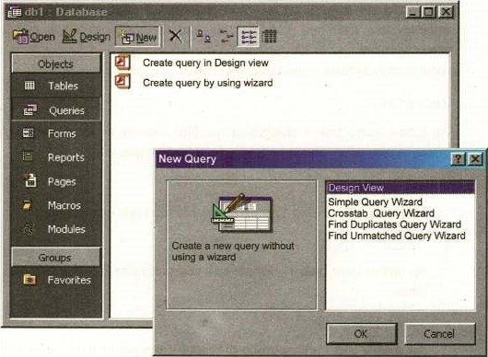

fig.6.17 Creating a Query in Design View



Of

* Select Design View and click OK.
* Select tables and existing queries from the Tables and Queries tabs and click the Add button to add each one to the new query.

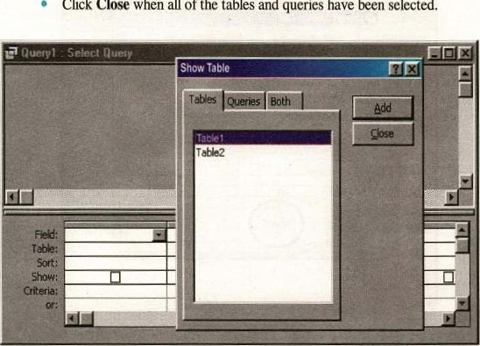Click Close when all of the tables and queries have been selected.

fig.6.18. Add a Table to the Queryin Design View

* Add fields from the tables to the new query by double-clicking the field name in the table boxes or selecting the field from the Field: and Table: drop-down menus on the query form. Specify sort orders if necessary.
* Enter the criteria for the query in the Criteria: field. The following table provides examples for some of the wildcard symbols and arithlnetic operators that may be used. The Expression Builder —can also used to assist in writing the expressions.
* After you have selected all Of the fields and tables, click the Run button on the toolbar.
* Save the query by clicking the Save button.

88



query Show shcnv tog type run table totals values

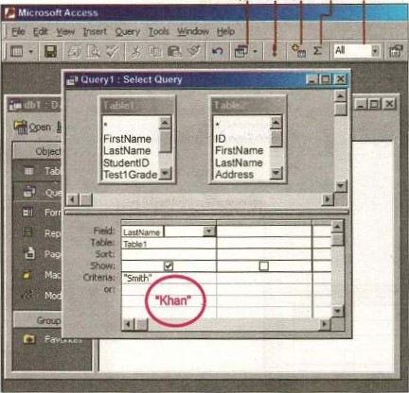

Fig.6.19 Specifying Criteria

Specifying Criteria

Once you've Selected all your query fields, you can narrow your query to include only data that matches specific criteria. You may want to display only records with certain field values, for example, A query that display only employees in a certain state is an example Of the use of criteria or indicate what values not to include.

 Wildcards

Wildcards offer a way of setting criteria based on patterns or partial words rather than exact matches. For example, the criterion A* in a First Name field specify' name beginning with the letter such as Ahmed Ali. The following are the most common wildcard operators:

of



|  |  |
| --- | --- |
| Query Wildcards and Expression Operators | |
| Wildcard I Operator | Explanation |
| ? Street | e question mark is a wildcard that takes the place of a single letter. |
|  | The asterisk is the wildcard that resents a of Characters |
|  | Value less than 100 |
| 1 | Value greater than or equal to I |
|  | Not equal to (all classes besides Xl) |
| etween 1 and 10 | umbers between I and 10 |
| s Null  Not Null | mds records with no value. or all records that have a value |
|  | words beginning with "a" |
| And | numbers greater than 0 and less than 10 |
| "Khan" Or | alues are Khan or Ahmed |

Table 6.8

Query Wizard

Ms-Access' Query Wizard will easily assist you to begin creating a select

* Click the Create query by using wizard icon in the database window to have Access step you through the process of creating a query.

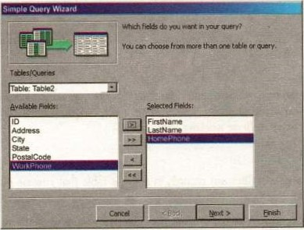

Fig.6.20 Creating query by using wizard

From the first window, select fields that included in the query by first selecting the table from the drop-down Tables/Queries menu. Select the fields by clicking the > button to rmve the field from the Available Fields list to Selected Fields or Click the double arrow button to move all of the fields to Selected Fields. Select another table or query to choose from more fields and repeat the process Of moving them to the Selected Fields box. Click Next > when all required fields have been selected.



will

•

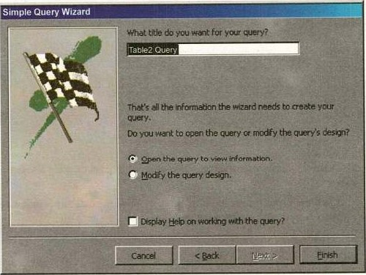

Fig.6.21 Finishing query wizard

* On the next window, enter the name for the query and click Finish.
* If you want to automatically open a help window click on check box of "Display Help on working with query?'

Find Duplicates Query

This query will filter out records in a single table that contain duplicate values in a field.

* Click the New button on the Queries database window, select Find Duplicates Query Wizard from the New Query window and click OK.

Of

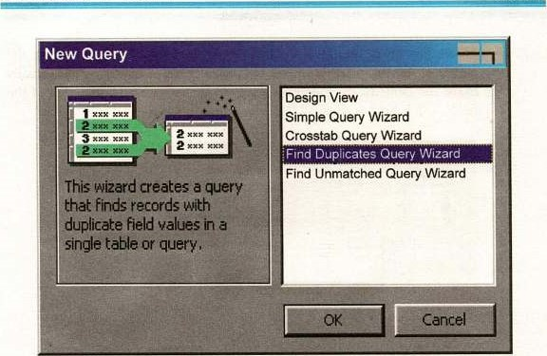

fig. 6.22 Creating a Query that finds records with Duplicate Field

* Select the table or query that the find duplicates query will be applied to from the list provided and click Next

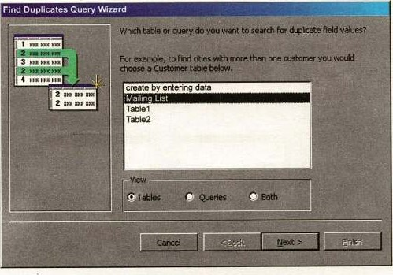

Fig623 Defining Table or Query to find Duplicate Field Value.



* Select the fields that may contain duplicate values by highlighting the names in the Available fields list and clicking the > button to individually move the fields to the Duplicate-value fields list or to move all of the fields. Click Next > when all fields have been selected.

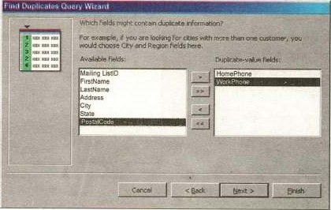

fig.6.24 Definging Fields that have more than one Duplicate Information

* Select the fields that should appear in the new query along with the fields selected on the previous screen and click Next

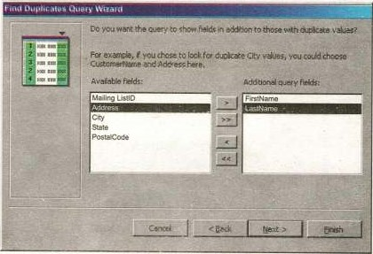

Fig.625 A Query to Show Fields for Duplicate Information.



* Name the new query and click Finish.

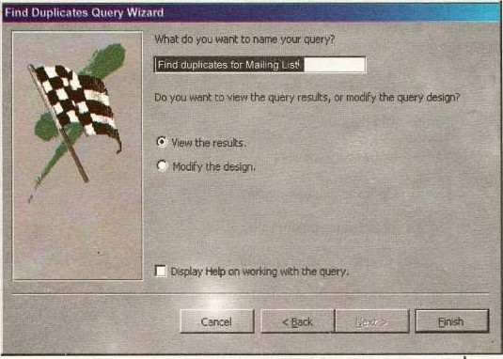

fig.6.25 Finishing the Find Duplicate Query

Delete a table from the Query

* To delete a table from the query, click the table's title bar and press the Delete key on the keyboard.

Sorting Query Field

By default, query fields are not sorted. You can, however, sort any field in either ascending or descending order.

* Click on the Sort row in the field column you want to sort. A down arrow will appear to the right of the field.
* Click on the down arrow. A menu will appear.

Click on Ascending / Descending or not sorted to Sort in ascending/descending order or not sort the field.

6.9 PERFORMING CALCULATION IN A QUERY

Using a query is a convenient way to perform a calculation on a group of records. You can perform calculation in a query either by using the predefined calculations that come with Access or by creating a custom calculation. In Access, you can specify the following calculation types:

* Group By: Identified the group to calculate.
* Sum: Add the values.
* Avg: Average the values.
* Min: Finds the minimum value.
* Max: Finds the maximum value.
* Count: Counts the number of values.
* StDev: Calculates the standard deviation of the value.
* Var: Calculate the variance of the value.
* Fir-st: Finds the first field value.
* Last: Finds the last field value.
* Expression: Creates a calculate field through an expression.
* Where: Indicates criteria for a field not included in the query.

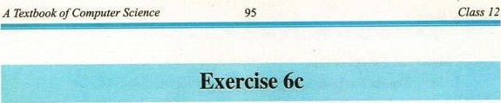

Fill in the blank

is specified in table to avoid duplicate entries of

records.

In Microsoft Access, the data of the table is displayed in

1. In the relational model,is the basic structure in which data is stored.
2. is a graphical representation of the structure Of a database.

button shows the current record in the table.

1. If the primary key is made up of a group of two or more fields, it is
2. are special characters that are used in queries to specify the criteria.



1. In Microsoft Access, the output of a query is in the form of a
2. A query that involves two tables is called

The wildcard character is used to specify any number Of



(xi)

data type is used when the field is to contain text

consisting of about 300 characters.

1. The number of rows in a table of a relational database is called the

of the table.

1. The number of columns in a table is called the of the table.
2. A query that only retrieve and displays data is called
3. The wildcard character is used to specify a single digit.

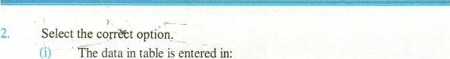The data in table is entered in:

* 1. Design View
  2. Normal View
  3. Datasheet View

d)Layout View

 How many types Of relationship?.

(iii) In a relational database, a single piece of information is called:

1. Field b) Record

c) Entity d) Attribute

 The rule that a record from a table cannot be deleted if its associated record exits in a related table is called

Referential integrity

1. Entity — relationship
2. Normalization
3. All of them

• How many table views are available in Microsoft Access.

1. To find a four-character name that starts with H, the criteria is specified as.
   1. 1-1*4
2. Which of the following buttons of Find and Replace dialog box is clicked to start the search process?
   1. Find b) Find Next c) Search d) Next
3. As in Design view, you can move from field to field in the Table window in Datasheet view using button:
   1. Tab b) Esc c) Enter d) Spacebar
4. The relationship between countries and their capitals is an example of relationships.

a) one-to-oneb) one-to-many

c) many-to-many d) None of them

The wildcardSal[eilma.

a) Saleemå b) Salma

c) both a and b d) None of them

1. Write T for true and F for false statement.

If for each entity in B, and for each entity in B, there is only one related entity in A, then the relationship between the entities is one-to-

* 1. Daterrirne data type is used when data such as data of birth or time of day is to Ix stored.
  2. The primary key is assigned in a table to avoid duplicate entries of records.
  3. An append query adds a group Of records from one or more tables to the end Of one or more tables.

The currency data type Cannot used in calculations.

* 1. The most commonly used type of query is Scratch Query.
  2. A query is used to extract specific information from a database. (viii) The wildcard character 'T" is used to specify any numtEr of



(ix) Fields are displayed as Check boxes by default on the datasheet. An action query makes changes in specified records of an existing table, Or creates a new table.

1. Define the different data types available in Microsoft Access.

6. Define the primary key.

What is Referential Integrity?

1. What are relationships?
2. How are relationship defined in Microsoft Access?
3. Explain the options in Find and Replace dialog box.

Differentiate between Relationship and Join.

1. Define different types calculation in a query and also specifies the some Functions.
2. What is query? Discuss its uses and advantages.

Explain the criteria in a query. How is it specified?

1. What is a join? Explain its purpose.
2. Differentiate between Sorting and Filtering
3. What are Wildcards?
4. Define the various types of queries,
5. How can you create a query in Design View?
6. Create a Query in Design View Create a Query in Design View.