**Example 9:** The power-set *P*(*S*) of a set *S* is a **monoid** w.r.t. the operation ~,because, as seen above, it is a semi-group and its identity is the empty-set Φ because if *A* is any subset of *S*, Φ~*A* = *A*~ = *A*

**Example 10:** The set of all non negative integers i.e., *Z*+ ~{0} i) is clearly closed w.r.t. addition, ii) addition is also associative, and iii) 0 is the identity of the set.

(*a* + 0 = 0 + *a* = *a* " *adZ*+~{0}) ∴the given set is a monoid w.r.t. addition.

**Note:** It is easy to verify that the given set is a monoid w.r.t. multiplication as well but not w.r.t. subtraction

**Example 11:** The set of natural numbers, *N*. w.r.t. -

i) the product of any two natural numbers is a natural number; ii) Product of natural numbers is also associative i.e.,

" *a,* b*,* c*dN* *a.*(*b.c*) = (*a.b)*.*c*  iii) 1*dN* is the identity of the set.

∴*N* is a monoid w.r.t. multiplication

**Note:** *N* is not a monoid w.r.t. addition because it has no identity w.r.t. addition. **Deinition of Group:** A *monoid* having inverse of each of its elements under%.... is called a group under%.... . That is a group under%.... is a set *G* (say) if i) *G* is closed w.r.t. some operation%....  ii) The operation of%.... is associative; iii) *G* has an identity element w.r.t.%.... and iv) Every element of *G* has an inverse in *G* w.r.t.%.... . If *G* satisies the additional condition: v) For every *a,bdG*

*a* %.... *b= b* %.... *a* then G is said to be an Abelian* or commutative group under%....

**Example 12:** The set *N* w.r.t. +

Condition (i) colsure: satisied i.e., " *a, bd* *N*, *a + b d* *N*

* 1. Associativity: satisied i.e.,

" *a,b*,c *d* *N*, *a* + (*b + c*) = (*a + b*) + *c*

* 1. and (iv) not satisied i.e., neither identity nor inverse of any element exists. ∴*N* is only a semi-group. Neither *monoid* nor a *group w.r.t.* +.

**Example 13:** *N* w.r.t Condition: (i) Closure: satisied

" *a, bd* *N*, *a, bd* *N*

* 1. Associativity: satisied

" *a,b*,c*d* *N*, *a*.(*b.c*) = (*a.b*).*c*

* 1. Identity element, yes, 1 is the identity element
  2. Inverse of any element of *N* does not exist in *N*, so *N* is a *monoid* but not a group under multiplication.

**Example 14:** Consider *S* = {0,1,2} upon which operation +has been performed as shown in the following table. Show that *S* is an abelian group under +.

**Solution :**

i) Clearly *S* as shown under the operation is closed. + 0 1 2 ii) The operation is associative e.g 0 0 1 2 0 + (1 + 2) = 0 + 0 = 0 1 1 2 0 (0 + 1) + 2 = 1 + 2 = 0 etc. 2 2 0 1

iii) Identity element 0 exists. iv) Inverses of all elements exist, for example

0 + 0 = 0, 1 + 2 = 0, 2 + 1 = 0

⇒ 0-1= 0 1-1 = 2, 2-1 = 1

v) Also + is clearly commutative e.g., 1 + 2 = 0 = 2 + 1

Hence the result,

**Example 15:** Consider the set *S* = {1,-1,*i* -*i*). Set up its multiplication table and show that the set is an abelian group under multiplication

46 47

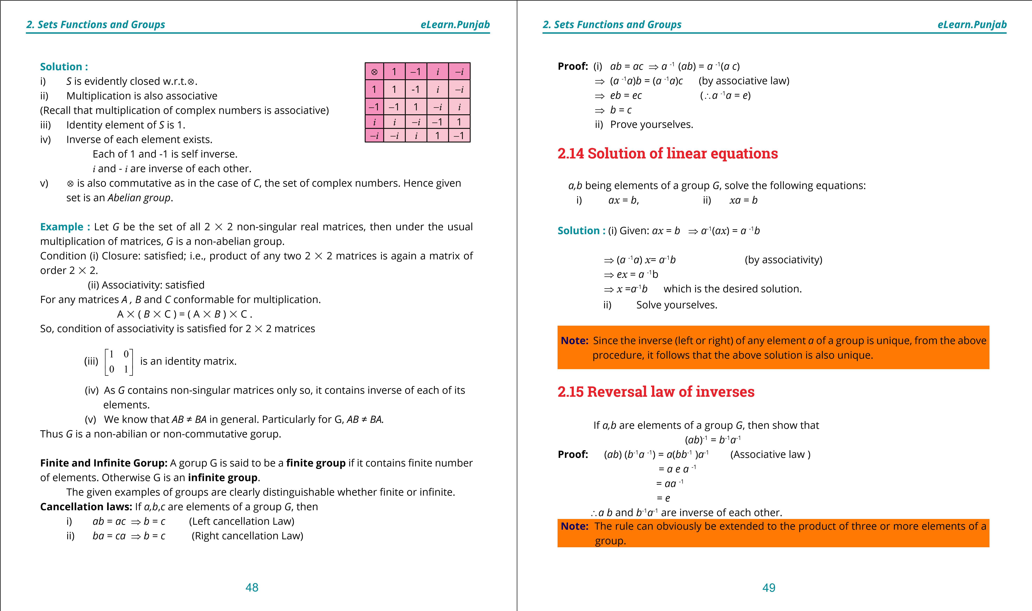

**1. Quadratic Equations eLearn.Punjab 1. Quadratic Equations eLearn.Punjab *2. Sets Functions and Groups eLearn.Punjab 2. Sets Functions and Groups eLearn.Punjab***

**Theorem:** If (G,%.... ) is a group with *e* its identity, then *e* is unique.

**Proof:** Suppose the contrary that identity is not unique. And let *e*’ be another identity.

*e*, *e’* being identities, we have

*e’* %.... *e* = *e* %.... *e’*= *e’* (*e* is an identity) (i)

*e’* %.... *e* = *e* %.... *e’* = *e* ( *e’* i s an identity) (ii)

Comparing (i) and (ii)  *e’* = *e*.

Thus the identity of a group is always unique.

**Examples:**

i) (*Z*, +) has no identity other then 0 (zero). ii) ( - {0}, % ) has no identity other than 1. iii) (*C*,+) has no identity other than 0 + 0*i*. iv) (*C*,**.**) has no identity other than 1 + 0*i*.

1 0

v) ( *M*2,**.**) has no identity other than 0 1 .

where *M*2 is a set of 2 % 2 matrices.

**Theoram:** If (*G*,%.... ) is a group and *adG*, there is a unique inverse of *a* in *G*.

**Proof:** Let (*G*,%.... ) be a group and *adG*.

Suppose that *a*’ and *a*’’ are two inverses of *a* in *G*. Then

*a’* = *a’* %.... *e* = *a*’%.... (*a* %.... *a*”) (*a*”is an inverse of *a* w.r.t. %.... ) = (*a*’%.... *a*)%.... *a*” (Associative law in *G*). = *e* %.... *a*’’ (*a*’ is an inverse of *a*).

= *a*’’ (*e* is an identity of *G*). Thus inverse of *a* is unique in *G*.

**Examples 16:**

1. in group ( *Z*, + ), inverse of 1 is -1 and inverse of 2 is -2 and so on.
2. in group ( - {0}, % ) inverse of 3 is etc.

**Exercise 2.8**

1. Operation + performed on the two-member set *G* = {0,1}is shown in the adjoining table. Answer the questions: -

+ 0 1 i) Name the identity element if it exists? 0 0 1 ii) What is the inverse of 1 ?

1 1 0 iii) Is the set *G*, under the given operation a group?

Abelian or non-Abelian?

1. The operation + as performed on the set {0,1,2,3} is shown + 0 1 2 3

in the adjoining table, show that the set is an Abelian group? 0 0 1 2 3 **3.** For each of the following sets, determine whether or not the 1 1 2 3 0

set forms a group with respect to the indicated operation.

* 1. 2 3 0 1
  2. 3 0 1 2

**Set Operation** i) The set of rational numbers % ii) The set of rational numbers + iii) The set of positive rational numbers % iv) The set of integers +

v) The set of integers % + *E O* **4.** Show that the adjoining table represents the sums of the elements of the set {*E, O*}. What is the identity element of this set? Show that this *OE OE OE*  set is an *abelian group*.



1

3

1. Show that the set {1 ,w,w2}, when w3=1, is an Abelian group w.r.t. ordinary multiplication.
2. If *G* is a group under the operation and *a, b d* *G*, ind the solutions of the equations: *a*%.... *x* = *b*, *x*%.... *a* = *b*
3. Show that the set consisting of elements of the form *a* + 3 *b* (*a, b* being rational), is an abelian group w.r.t. addition.
4. Determine whether,(*P*(*S*),%.... ), where %.... stands for intersection is a semi-group, a monoid

50 51

**1**

**. Quadratic Equations**

**eLearn.Punjab**

***2***

***. Sets Functions and Groups***

***eLearn.Punjab***

52

or neither. If it is a monoid, specify its identity.

**9.**

Complete the following table to obtain a semi-group under

%

.

.

.

.

%

.

.

.

.

*a*

*b*

*c*

*a*

*c*

*a*

*b*

*a*

*b*

*b*

*c*

*-*

*a*

*c*

*-*

**10**

**.**

Prove that all 2

%

2 non-singular matrices over the real ield form a non-abelian group

under multiplication.