Project Sprint #1

The SOS game is described in CS449HomeworkOverview.docx. You should read the description very carefully.

GithubRepository: https://github.com/ImanolRamirez1/SOS_GAME

In this assignment, you aim to specify the requirements (i.e., user stories and acceptance criteria) of the target software that allows a human player to play a simple or general SOS game against a human opponent. These requirements will be fully implemented by the end of sprint 3. The minimum features include choosing the board size, choosing the game mode (simple or general), starting a new game, making a move (in a simple or general game), determining if a simple or general game is over. The following is a sample GUI layout.

SOS Simple game General game Board size
8
Blue player  S  O | 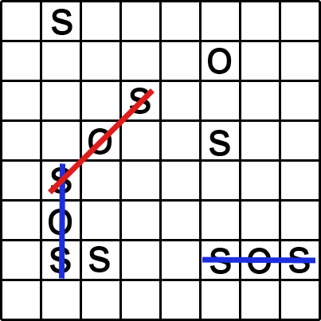 | Red player  S  O
 | Current turn: blue (or red) | New Game
Figure 1. Sample GUI layout of the first working program by the end of Sprint 3

Use the following tables to document your user stories and acceptance criteria.
You are required to use the free ChatGPT or another LLM to complete 2 user stories and 2 of their respective acceptance criteria. You must ensure that the generated user stories are correct and fix them if not. At the end of the submission, provide screenshots of your LLM prompts and answers, along with the description of errors the LLM made that you had to correct. Points will be deducted if no screenshots/description are provided.

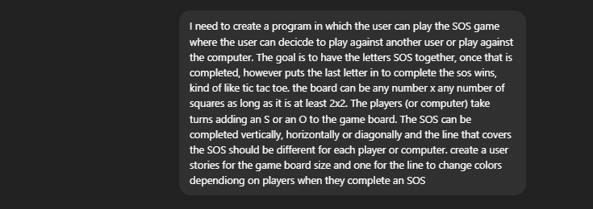
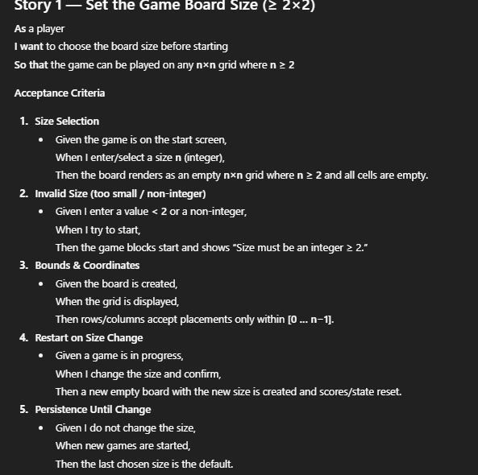
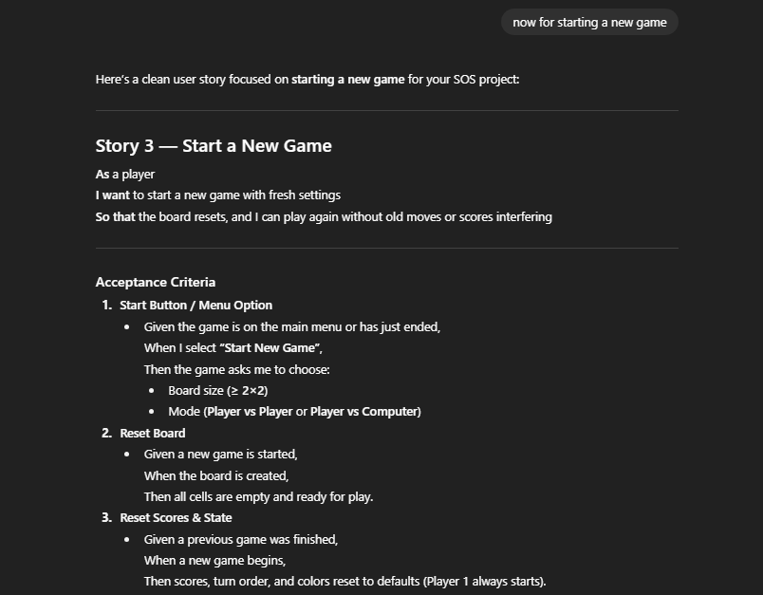
- User Stories (3 points)

- User Story Template: As a <role>, I want <goal> [so that <benefit>]

ID | User Story Name | User Story Description | Priority | Estimated effort (hours)
1 | Choose a board size | As a player I want to pick the grid area of the board before the game begins (so that I can adjust the difficulty and playstyle to me liking). | High | 3 hours
2 | Choose the game mode of a chosen board | As a player I want to choose a specific game mode before beginning the game (So that I can play the game and strategize to the way I want) | Medium | 4 hours
3 | Start a new game of the chosen board size and game mode | As a player  I want to start a new game with the board size and mode I picked  (So that I can play the way I like) | Low | 3 hours
4 | Make a move in a simple game | As a player  I want to place an s or o in an empty cell  (So that I can try to form SOS and win the game) | Hugh | 3 hours
5 | A simple game is over | As a player  I want to end the game with a message  (So that I Know when the game is over and begin a new one) | Medium | >1hour
6 | Make a move in a general game | As a player  I want to place an s or o in an empty cell  (So that I can keep playing and try to make SOS ) | High | 3 hour
7 | A general game is over | As a player  I want to know when the general game is over  (so that I can start a new game) | Medium | >1 hour

- Acceptance Criteria (AC) (12 points): Add/delete rows as needed.

User Story ID and Name | AC  ID | Description of Acceptance Criterion | Status (completed, toDo, inPprogress)
1. Choose a board size | 1.1 | AC 1.1 <Valid Board Size>  Given player is initializing a new game,  When the player chooses a board size with a grid area greater than 2x2,  Then the game should create a game board of the given size. | inProgress
1. Choose a board size | 1.2 | AC 1.2 < invalid Board Size>  Given player is beginning an new game,  When the player chooses a board size with a grid area LESS than 2x2,  Then the game should NOT create a game board of the given size  And should provide an error message. | inProgress
1. Choose a board size | 1.3 | AC 1.3 <Invalid Input (when Choosing board size)>  Given the user is beginning a new game,  When the user inputs a symbol or letter instead of a number,  Then game should throw an error message. | inProgress
 | 1.4 | AC 1.4 <Game Memory?>  Given the user has previously played a game  When the player decides to begin a new game without specifying the game board size  Then the game should use the same game board size as the previous game. | inProgress
2. Choose the game mode of a chosen board | 2.1 | AC 2.1 <Select Simple Game Mode >  Given the user has chosen a valid game board size,  When the user selects “simple mode”  Then the game should ask to confirm selected game mode | inProgress
2. Choose the game mode of a chosen board | 2.2 | AC 2.2 <Select General Game Mode>  Given the user has chosen a valid board size  When user selects “general mode”  Then the game should ask to confirm selected game mode | inProgress
… | 2.3 | AC 2.3 <No selected mode>  Given the user fails to choose a valid game mode  When then user attempts to begin a new game  Then the game will fail to start  And will throw an error message, prompting user to choose game mode. | inProgress
3.Start new game with chosen board size and mode; | 3.1 | AC 3.1 < Start New Game>  Given player has chosen board size as well as game mode  When plaer selects start game  Then game board cells reset  And new game begins | Todo
3.Start new game with chosen board size and mode; | 3.2 | AC 3.2 <Show Current Settings >  Given player begins new game  When game begins  Then the game should display chosen game configurations (Board size, game mode, player vs player or computer) | Todo
3.Start new game with chosen board size and mode; | 3.3 | AC 3.3 <reset score and turn>  Given a game has already been played  When the user starts a new game  Then the score and turn should reset  And the new game begins with player 1 | Todo
4.Make move in simple game mode | 4.1 | AC 4.1 <Place letter in empty cell.  Given it is a player’s turn  When the player selects an empty cell  And places an S or O  Then the letter should appear in that cell | Todo
4.Make move in simple game mode | 4.2 | AC 4.2 <Invalid move in taken cell>  Given a cell is already filled  When the player tries to place a letter there  Then the game should not change the cell  And should show an error message | Todo
4.Make move in simple game mode | 4.3 | AC 4.3 <Winning move>  Given a player places a letter in a cell  When that move completes an SOS  Then the game should end immediately  And should declare that player the winner | Todo
 | 4.4 | AC 4.4 <Turn Switch>  Given a player makes a move  When the move does not form SOS  Then the game should switch player and state whose turn it is. | TODO
5.Simple game is over | 5.1 | AC 5.1 <Game ends >  Given a player completes an SOS sequence  When last the letter is placed  Then the game should end  And produce the user with a message stating who the winner is. | Todo
5.Simple game is over | 5.2 | AC 5.2 < No moves after game is finished>  Given the game is over  And there is a declared winner  When a user tries to continue placing letters  Then the move is invalid  And should prompt an error message. | Todo
5.Simple game is over | 5.3 | AC 5.3 <Restart?>  Given the game has finished  When the user chooses the “restart” option  Then the game should empty cells | Todo
6.Make a move in general game mode | 6.1 | AC 6.1 <Place letter in empty cell >  Given it is one of the user’s, or computer’s, turn  When the user selects an empty cell to place their corresponding letter  Then the letter should appear in chosen cell | Todo
6.Make a move in general game mode | 6.2 | AC 6.2 < Place letter in Occupied cell>  Given a cell is already filled  When user attempts to place their corresponding letter in said cell  Then the move should be marked as invalid  And an error message should appear to notify | Todo
6.Make a move in general game mode | 6.3 | AC 6.3 <score points>  Given a player places a letter  When that letter placement create an SOS (can create more than one)  Then the player should earn one point for every SOS created with that letter placement. | Todo
 | 6.4 | AC 6.4 <switch turns>  Given a player makes a valid move  When move has been completed  Then the game should update scores  And the game should switch to other players turn with notification | Todo
7.A general game ends | 7.1 | AC 7.1 <Game ends >  Given a game is in progress  When all cells have been filled with an S or an O  Then the game should end | Todo
7.A general game ends | 7.2 | AC 7.2 < counting score>  Given the game has ended  When on player has created more SOS sequences than the other  Then that player should be declared the winner | Todo
7.A general game ends | 7.3 | AC 7.3 <draw>  Given the game ends  When both players have the same amount of created SOS sequences  Then the game ends in a draw  And the game should notify the users of the result (draw) | Todo
 | 7.4 | AC 7.4 < No moves after game is finished>  Given the game is over  And there is a declared winner  When a user tries to continue placing letters  Then the move is invalid  And should prompt an error message. | Todo
 | 7.5 | AC 7.5 <Restart?>  Given the game has finished  When the user chooses the “restart” option  Then the game should empty cells | Todo

