A

Mini Project Report on

**Student Productivity Management System**

Submitted in partial fulfilment of the requirements

for the degree of

BACHELOR OF ENGINEERING

IN

**Computer Science & Engineering**

Artificial Intelligence & Machine Learning

by

Sami Ansari (23106093)

Jeet Jain (23106029)

Tanishq Birje (23106106)

Shashank Iyer (23106056)

**Prof. Poonam Tiware**



Department of Computer Science & Engineering

(Artificial Intelligence & Machine Learning)

A. P. Shah Institute of Technology

G. B. Road, Kasarvadavali, Thane (W)-400615

University Of Mumbai

2024-2025



CERTIFICATE

This is to certify that the project entitled “Student Productive Management System” is a bona fide work of Sami Ansari (23106093), Jeet Jain (23106029), Tanishq Birje (23106106), Shashank Iyer (23106056) submitted to the University of Mumbai in partial fulfillment of the requirement for the award of Bachelor of Engineering in Computer Science & Engineering (Artificial Intelligence & Machine Learning).

|  |  |  |
| --- | --- | --- |
| ________________ |  | _______________ |
| Prof. Poonam Tiware |  | Dr. Jaya Gupta |
| Mini Project Guide |  | Head of Department |



Project Report Approval

This Mini project report entitled “**Student Productive Management System*”*** by **Sami Ansari, Jeet Jain, Tanishq Birje and Shashank Iyer**is approved for the degree of ***Bachelor of Engineering*** in ***Computer Science &Engineering***, (AIML) ***2024-25***.

External Examiner:

Internal Examiner:

Place: APSIT, Thane

Date:

**Declaration**

We declare that this written submission represents my ideas in my own words and where others' ideas or words have been included, I have adequately cited and referenced the original sources. I also declare that I have adhered to all principles of academic honesty and integrity and have not misrepresented or fabricated or falsified any idea/data/fact/source in my submission. I understand that any violation of the above will be cause for disciplinary action by the Institute and can also evoke penal action from the sources which have thus not been properly cited or from whom proper permission has not been taken when needed.

|  |  |  |  |
| --- | --- | --- | --- |
| Sami Ansari | Jeet Jain | Tanshiq Birje | Shashank Iyer |
| (23106093) | (23106029) | (23106106) | (23106056) |

**ABSTRACT**

This project is a year-long that introduces a comprehensive web platform designed to enhance communication, collaboration, and academic management for students and teachers in an educational environment. The platform integrates several key features aimed at streamlining day-to-day academic tasks and improving the efficiency of information sharing between users. One of the central components of the platform is a real-time chat system that supports group chats, allowing students to communicate effectively with their peers. This system also includes file-sharing capabilities to facilitate collaboration on assignments and projects.

A core feature of the platform is the notes database, which allows both teachers and students to upload, categorize, and search for academic resources. Notes can be organized based on categories such as subject, year, or course, and can be easily filtered to ensure quick access to the necessary material. This feature ensures that all users have access to a centralized repository of information, reducing the reliance on scattered resources and improving overall academic efficiency.

The tasks management feature enables teachers to assign tasks such as homework, projects, and exams, while providing students with a system to track their workload. The task page allows students to monitor their progress, set personal deadlines, and prioritize their work according to urgency or importance. This feature ensures that students can manage their academic responsibilities more effectively, leading to better organization and time management.

In conclusion, this platform offers a comprehensive solution to the challenges of academic communication and management. By providing features such as real-time communication, a centralized notes database, task tracking, schedule management, and event coordination, the website aims to enhance productivity, organization, and collaboration for both students and teachers within an academic setting.

**Keywords**: Student Management, Communication, Platform, Task

|  |  |  |  |
| --- | --- | --- | --- |
| Index | | | Page no. |
| Chapter-1 | | | 1 |
|  | Introduction | | 2 |
|  |  |  |  |
| Chapter-2 | | | 3 |
|  | Literature Survey | | 4 |
|  | 2.1 | History | 6 |
|  | 2.1 | Review |  |
|  |  |  |  |
| Chapter-3 | | | 9 |
|  | Problem Statement | | 10 |
|  |  |  |  |
| Chapter-4 | | | 11 |
|  | Experimental Setup | | 12 |
|  | 4.1 | Database | 12 |
|  | 4.2 | Development Tools | 12 |
|  | 4.3 | Frontend Development |  |
|  |  |  |  |
| Chapter-5 | | | 13 |
|  | Proposed system and Implementation | | 14 |
|  | 5.1 | Diagrams of proposed system | 14 |
|  | 5.2 | Description of diagrams | 17 |
|  | 5.3 | Implementation | 19 |
|  |  |  |  |
| Chapter-6 | | | 24 |
|  | Conclusion | | 25 |
|  |  |  |  |
| References | | | 26 |
|  |  |  |  |

**INDEX**

**CHAPTER 1**

**INTRODUCTION**

1. INTRODUCTION

This is a one-year (two semester) project that introduces a web-based platform aimed at improving communication and academic management within educational institutions. Recognizing the challenges posed by fragmented tools—such as email, standalone task management apps, and file-sharing services—this platform offers a centralized solution to enhance collaboration among students and teachers. Key features include a chat system that supports group discussions, allowing for seamless communication and file sharing. Additionally, the notes database serves as a searchable repository for academic materials, making it easier for students to access essential resources organized by subject and course.

The platform also includes robust task management capabilities, enabling teachers to assign tasks and students to track their workload effectively. A schedule page presents important updates in a user-friendly format, ensuring that students remain informed about class schedules, exams, and deadlines. Developed using a modern technology stack, the platform prioritizes secure user authentication and offers a responsive experience across devices. Ultimately, this integrated solution not only simplifies academic workflows but also fosters a collaborative and engaging learning environment, empowering students to manage their responsibilities more effectively while enhancing student-student communication.

Moreover, the platform includes an events page that keeps students updated on extracurricular and college-related events, such as seminars, workshops, and social gatherings. Teachers and student admins can create events, manage RSVPs, and send reminders, ensuring that students remain engaged with the broader college community. The integration of the events page with the schedule ensures that students have a holistic view of both their academic & extracurriculars.

From a technical perspective, the platform was developed using a modern web technology stack that ensures a smooth, responsive, and user-friendly experience across devices. The platform employs secure authentication mechanisms to safeguard user data and prevent unauthorized access, ensuring that all communication and resource sharing occurs within a protected environment.

In summary, this project seeks to address the common challenges of academic communication and resource management by providing an integrated platform that combines chat functionality, resource sharing, task tracking, schedule management, and event coordination. The website not only simplifies academic workflows for both students and teachers but also fosters a more collaborative and engaging learning environment. The platform represents a significant step forward in leveraging technology to improve the academic experience, making it easier for students to manage their responsibilities and for teachers to effectively communicate with and support their student.

**CHAPTER 2**

**LITERATURE SURVEY**

**2. LITERATURE SURVEY**

**2.1-HISTORY**

**The Evolution of Web Development: A Journey of Innovation**

Web development has undergone a remarkable transformation since the inception of the World Wide Web, reflecting human ingenuity and the relentless pursuit of technological advancement. From simple static pages to complex, interactive applications, web development has continuously evolved to meet the growing demands of users and businesses. As technology progresses, developers play a crucial role in shaping the digital landscape, offering new possibilities and addressing emerging challenges.

### ****The Early Days: Birth of the Web****

The history of web development began with **Tim Berners-Lee**, who created the World Wide Web in the late 1980s. In 1991, **HTML (HyperText Markup Language)** was introduced as the foundational language for creating web pages, allowing users to share and access information over the internet. Early websites were static, consisting of simple text and hyperlinks without interactive elements.

### ****The Mid-1990s: The Rise of Dynamic Content****

The mid-1990s marked a period of significant change with the emergence of **dynamic web content**. This era saw the advent of **JavaScript (1995)**, a scripting language that enabled interactivity on web pages. Around the same time, **CSS (Cascading Style Sheets) was introduced in 1996**, allowing developers to separate content from design, enhancing both aesthetics and maintainability.

The **"Browser Wars"** between Netscape Navigator and Microsoft Internet Explorer led to rapid innovations in web technologies, pushing the development of more sophisticated web applications.

### ****Late 1990s to Early 2000s: Web 2.0 and the Dot-Com Boom****

The late 1990s witnessed the rise of the **dot-com boom**, which fueled widespread internet adoption. Businesses started to embrace e-commerce, leading to the development of online marketplaces and digital storefronts.

By the early 2000s, the concept of **Web 2.0** emerged, emphasizing **user-generated content, interactivity, and social networking**. Websites evolved from static information repositories to dynamic, engaging platforms, giving rise to social media, blogging, and content-sharing websites. Technologies like **AJAX (Asynchronous JavaScript and XML)** enabled smoother user experiences by allowing web pages to update dynamically without requiring full reloads.

### ****The Mobile Revolution and Responsive Web Design****

With the advent of smartphones in the late 2000s, **mobile-first development** became a necessity. The introduction of **responsive web design (RWD)** allowed websites to adapt to different screen sizes, improving usability across devices. Frameworks such as **Bootstrap (2011)** provided pre-designed components that facilitated mobile-friendly development.

The emergence of mobile applications and Progressive Web Apps (PWAs) further expanded web development possibilities, allowing developers to create web-based experiences with native-like functionality.

### ****Modern Web Development: Cloud Computing, AI, and Beyond:****

Today, web development is driven by powerful frameworks, cloud computing, and artificial intelligence. **Cloud-based services** like AWS, Azure, and Google Cloud have enabled scalable web applications. **JavaScript frameworks** such as React, Angular, and Vue.js dominate front-end development, while **Node.js** and serverless architectures enhance back-end efficiency.

The integration of **AI-driven chatbots, machine learning algorithms, and automation tools** has further enriched web applications, making them more intelligent and personalized. Cybersecurity has also become a priority, with the widespread adoption of **HTTPS, multi-factor authentication, and blockchain-based security measures**.

### ****The Evolution of Student Portals:****

Student portals have been a significant part of web development, evolving alongside technological advancements. Initially introduced in the **late 1990s**, these portals provided basic access to course schedules, grades, and institutional announcements.

With the rise of **Learning Management Systems (LMS)** in the 2000s, student portals expanded to include features like:

* Online course registration
* Digital libraries
* Submission of assignments
* Communication tools such as forums and messaging systems

The **mobile revolution** of the late 2000s made student portals more accessible via smartphones and tablets, offering personalized dashboards and real-time updates.

### ****Student Portals Today and Beyond****

Modern student portals have become central to academic and administrative management, offering:

* **AI-driven support systems** for personalized learning recommendations
* **Integration with social media and collaboration tools**
* **Cloud-based access to academic resources**
* **Enhanced security measures** to protect student data

As **technology continues to advance**, student portals are expected to integrate **virtual reality (VR), augmented reality (AR), and blockchain-based credential verification**, further transforming the education landscape.

The history and evolution of web development showcase how technological innovations have shaped the way we interact with the digital world. From the simple HTML pages of the 1990s to the AI-driven applications of today, web development has come a long way. As new challenges arise and technologies continue to evolve, developers will remain at the forefront, shaping the future of the web and unlocking new possibilities for users worldwide.

**2.2-LITERATURE REVIEW**

**Web Development Framework: Future Trends, 2022 4th International Conference on Advances in Computing, Communication Control and Networking (ICAC3N), [IEEE, 2022]**

The most basic and first step for development is to decide the right frontend framework. There is a wide variety of options emerging every year as solutions for the problems developers face every day with browser-based applications taking over the world. This paper initially discusses different trends in framework and libraries of JavaScript, which then summarizes the project we worked on using these libraries and its future scope. However, one issue we noticed was that the paper lacked emphasis on enhancing user experience, particularly in terms of ease of navigation and overall accessibility. To address this, we made the website more user-friendly by implementing a simplified and intuitive user interface. We improved the layout for better navigation, added responsive design elements to ensure accessibility across all devices, and streamlined the user flow to minimize the number of actions needed to complete tasks. These enhancements made the website much easier for users to interact with, significantly improving their overall experience. [1]

**Development of a web – based Student Portal System for University Students, IEEE (2022); International conference on intelligent Education and Intelligent Research (IEIR) [IEEE, 2022]**

This project aims to design and develop a web-based Student Portal System (SPS) for the University of Malakand to replace the current traditional system and provide needed services for students use. Right now, the current traditional system handles things like grading, attendance, and assignments, but it relies on manual paper- based processes, leading to many inefficiencies. Regrettably, it lacks a student-centric approach. That’s where our exciting Student Portal System comes in, ready to shake things up and make student life a whole lot easier. The proposed SPS provide a consolidated platform that brings multiple services together, making life easier for students. Within this system, students can effortlessly access a range of services, including attendance management, assignment tracking, result retrieval, and quizzes. The proposed system provides a simple and user-friendly interface. Teachers can log in to upload assignments, quizzes, and attendance records. Meanwhile, students can log in to check their attendance, view their results, and submit assignments. The Student Portal System (SPS) is developed by using strong tools like PHP, MySQL Database, HTML5, CSS3, JavaScript, and Bootstrap. [2]

**Students Community Portal using Machine Learning 2023 Second International Conference on Electronics and Renewable Systems (ICEARS), [IEEE, 2023]**

The research paper introduces an online discussion system aimed at improving communication between students and teachers by addressing the challenges of asking and answering questions. However, the paper overlooks the issue of low student engagement and the potential for information overload in a discussion system. While it effectively uses support vector machines and feed-forward neural networks to ensure the accuracy of information, it fails to account for the difficulty students may have in navigating large volumes of data and participating actively in discussions. To address these drawbacks, we not only implemented personalized content recommendations based on each student's learning patterns and interests, but also introduced separate admin interfaces for students and teachers. This distinction allows students and teachers to interact with the system based on their roles—students can focus on asking questions and engaging in discussions, while teachers can more easily manage, review, and respond to queries. This approach enhances the usability of the portal. [3]

**Implementation of Intelligent Chatbot in Student Portal: A Systematic Literature Review 2022 International Visualization, Informatics and Technology Conference (IVIT), [IEEE, 2022]**

The research paper discusses the benefits of implementing a chatbot in a student portal to provide 24/7 support, but it overlooks several key aspects that would enhance the user experience. One significant drawback is the lack of a collaborative communication feature, limiting students to interacting only with the chatbot rather than engaging with their peers. Additionally, the paper highlights implementation challenges such as limited user interaction capabilities and the complexity of integrating a user-friendly interface, which could hinder users with minimal technical knowledge. To address these drawbacks, we not only implemented a simple and efficient chatbot interface but also added a real-time chat system that allows students to interact with each other. This fosters peer-to-peer communication, creating a more collaborative environment. By integrating this feature alongside the AI chatbot, we improved both support availability and user engagement, making the system more comprehensive and interactive than the one proposed in the original research. [4]

**Notes Sharing and Student performance Analysis Web Application, [IEEE, 2023]**

The research paper titled "Notes Sharing and Student Performance Analysis Web Application" (2023, 7th International Conference on Intelligent Computing and Control System (ICICCS), IEEE, 17 May 2023) introduces a platform for students to share notes and engage in collaborative learning. However, it highlights several drawbacks in existing models, such as the restriction of access to notes only after payment, inability to upload handwritten notes, the requirement for regular uploads, and limitations on uploading notes only for specific streams.

To address these shortcomings, our proposed solution allows students from all streams to upload notes, whether handwritten or in digital formats like PPT, PDF, and DOC. These improvements address the issues identified in the original research, creating a more versatile and student-friendly platform. [5]

**Summary of literature review in tabular form:**

|  |  |  |  |  |
| --- | --- | --- | --- | --- |
| **Title** | **Conference Details** | **Key Points** | **Improvements** | **Citation** |
| Notes Sharing & Students Performance Web App | ICICCS, IEEE (2023) | - Platform for students to share notes in multiple formats.  - Allows free or paid access. | - Overcame payment-only access & stream limitations.  - Allowed handwritten & digital uploads. | (IEEE, 2023) |
| Students Community Portal using Machine Learning | ICEARS, IEEE (2023) | - Online discussion system for student-teacher communication.  - Focuses on engagement & accurate info | - Added personalized task management and separate student-teacher interfaces. | (IEEE, 2023) |
| Web Development Framework: Future Trends | ICAC3N, IEEE (2022) | - Discusses trends in Javascript frameworks.  - Focuses on project implementation | - Enhanced user experience by simplifying UI & improving navigation | (IEEE, 2022) |
| Web-Based Student Portal System | IEIR, IEEE (2022) | - Consolidates services like grading, attendance & assignments.  - User-friendly for students & staff | - Addressed inefficiencies & lack of student centric design by integrating multiple services. | (IEEE, 2022) |
| Intelligent Chatbot in Student Portal | IVIT, IEEE (2022) | - AI chatbot for 24/7 support in student portals.  - Addresses interaction limitations. | - Added real-time peer chat for better user engagement & collaboration | (IEEE, 2022) |

**CHAPTER 3**

**PROBLEM STATEMENT**

**3. PROBLEM STATEMENT**

Many students and teachers face challenges managing academic tasks, resources, and communication due to the lack of a centralized platform. This often results in fragmented communication, disorganized study materials, missed deadlines, and inefficiencies in task tracking and scheduling. Students rely on various tools like email, messaging apps, and file-sharing services that lack integration, leading to ineffective collaboration. Teachers also struggle with managing tasks, distributing notes, and keeping students updated on schedules or events, which can be time-consuming without a unified system.

This project aims to address these issues by developing a unified web platform that integrates communication, resource sharing, task management, scheduling, and event coordination. It will offer distinct user roles—Teacher, Student Admin and Regular Student—ensuring each user can efficiently access and manage the features relevant to them. By centralizing academic responsibilities, the platform will improve communication, organization, and productivity within the academic community. It will also enhance event management, making it easier for students to stay informed about academic and extracurricular activities, increasing participation and engagement.

The overall goal is to provide a seamless academic experience that fosters collaboration, improves resource accessibility, and simplifies workload management for both students and teachers.

CHAPTER 4

EXPERIMENTAL SETUP

**4. EXPERIMENTAL SETUP**

This project is a web-based application designed to manage and display information efficiently using modern web technologies. It integrates Firebase services for backend operations and provides a seamless user experience through an interactive frontend.

### ****4.1 Database: Firebase Firestore & Firebase Storage****

* **Firebase Firestore:** A cloud-based NoSQL database that provides real-time data synchronization and efficient querying. It allows for structured storage and easy access to user data, ensuring a dynamic and responsive application.
* **Firebase Storage:** A cloud-based file storage service used to store and manage various file types, including images and documents. This ensures secure and scalable storage with fast retrieval capabilities.

### ****4.2 Development Tools****

* **Visual Studio Code (IDE):**
  + A powerful, lightweight, and highly customizable code editor that supports various extensions, making development more efficient.
  + Used for writing, debugging, and testing code.
* **Live Server Extension:**
  + A VS Code extension that enables real-time preview of web applications in a browser.
  + Automatically refreshes the browser when changes are made to the code, facilitating rapid development and testing.
* **Google Chrome:**
  + The primary web browser used for testing and debugging.
  + Chrome Developer Tools were used to inspect elements, debug JavaScript code, and analyse network requests.

### ****4.3 Frontend Development****

* **HTML (HyperText Markup Language):**
  + Defines the structure of web pages and ensures proper layout of content.
  + Used to create elements such as tables, forms, and buttons for user interaction.
* **CSS (Cascading Style Sheets):**
  + Enhances the visual presentation of the web application.
  + Provides styling, layout management, and responsiveness to improve user experience.

### ****4.4 Backend Development****

* **Vanilla JavaScript:**
  + Used to implement the logic of the web application without relying on external frameworks.
  + Manages user interactions, dynamically updates the UI, and handles API calls to Firebase services.
  + Fetches and manipulates data from Firestore and Firebase Storage

**CHAPTER 5**

**PROPOSED SYSTEM**

**&**

**IMPLEMENTATION**

**5. PROPOSED SYSTEM & IMPLEMENTATION**

We are making a system that can be used by students and teachers to connect with each other for academic resources, updates, schedules, managing tasks & for such other purposes. We basically are creating a better form of our college resources website by adding features that we desire that should have been there like notifications.

**5.1 DIAGRAMS OF PROPOSED SYSTEM**

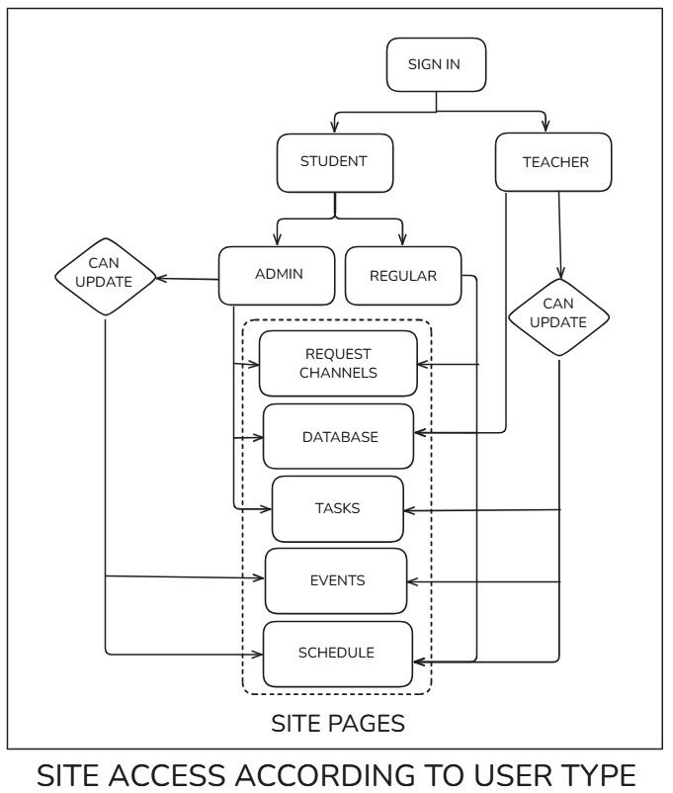

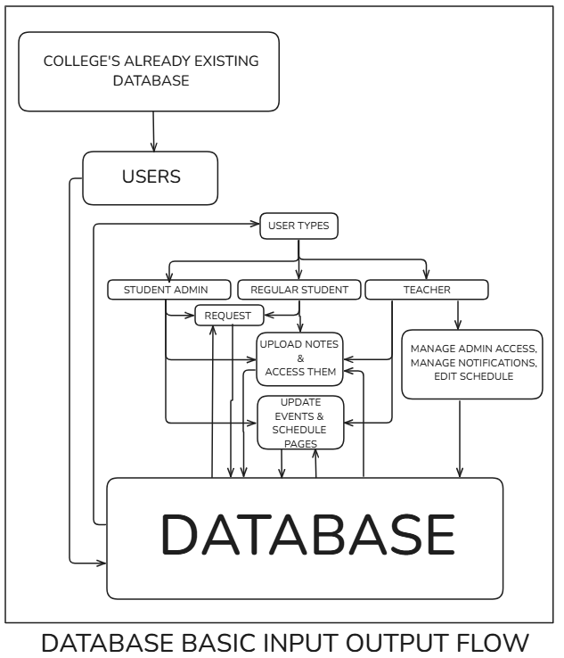

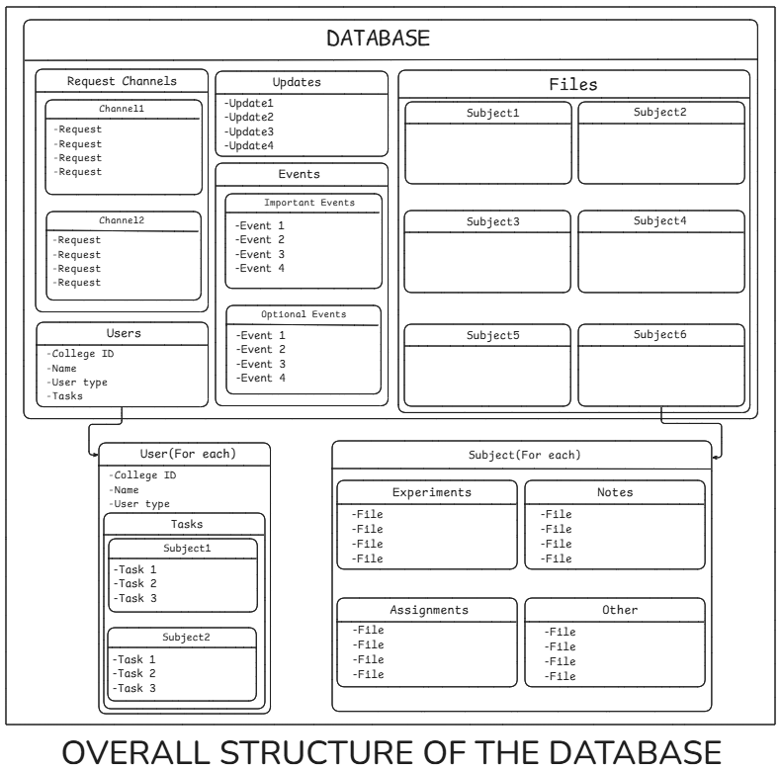

#### **5.2 DESCRIPTION OF DIAGRAMS**

**Diagram 1:** Site Access According to User Type

* **Sign In:** The starting point for accessing the system.
* **User Types:** The diagram outlines three primary user types: Student, Teacher, and Admin.
* **Student:** Students can access and update chats/channels, database, tasks, updates, schedule, and site pages**.**
* **Teacher:** Teachers have the highest level of access, allowing them to manage admin access, notifications, and access to the database.
* **Admin:** Admins have similar access rights as students, but they can also update events and schedule pages.

**Diagram 2:** Database Basic Input Output Flow

This section emphasizes the core functionality of the system, which involves inputting and outputting data from the database.

* **College's Already Existing Moodle Database:** The system uses data from the existing college database.
* **Users:** This section connects to the user types defined in Diagram 1.
* **User Types (Detailed):** The user types are specified as Student Admin, Regular Student, and Teacher.
* **Request Channels:** Regular Students & student admin user types can request notes in channels.
* **Database:** Students and Admins can upload notes and access them.
* **Tasks:** Students and Admins can manage tasks.
* **Updates:** Students can view & Admins can give schedule updates.
* **Schedule:** Teachers can update events and schedule pages, while other users can view the schedule.

**Diagram 3:** Overall Structure of the Database

This diagram represents the overall structure of the database for our project. Since our project involves task management, notes, files, and events this database schema is designed to organize all these functionalities.

* **Request Channels**
  + Contains multiple **channels** (Channel1, Channel2, etc.).
  + Each channel stores **requests** from users asking for notes, doubts or collaborations.
* **Updates**
  + A collection of **updates** (Update1, Update2, etc.).
  + This stores any temporary update in the daily schedule that will be updated by student admins.
* **Events**
  + Divided into **Important Events** and **Optional Events**.
  + Each section stores a list of events.
  + Could be used for scheduling or notifying users about upcoming academic events, deadlines, or meetings.
* **Files**
  + Organized by **subjects** (Subject1 to Subject6).
  + Each subject store’s related materials such as **lecture notes, assignments, or other resources**.
* **Users**
  + Stores user-specific data:
* College ID: Unique identifier for each user.
* Name: User’s name.
* User type: Defines roles (e.g., Student, Teacher, Admin).
* Tasks: List of assigned tasks.
* **User (For Each)**
  + Represents individual user data.
  + Tasks are categorized by subjects (Subject1, Subject2, etc.).
  + Each subject contains multiple tasks.
* **Subject (For Each)**
* Each **subject** contains different types of resources:
  + - **Experiments**: Stores multiple files.
    - **Notes**: Stores multiple files.
    - **Assignments**: Stores multiple files.
    - **Other**: Additional files that don’t fall under the above categories.

Overall, the diagrams illustrate the hierarchical structure of user access, the basic data flow within the system & the overall structure of the database.

**5.3 IMPLEMENTATION**

Implementation of proposed system is included here as screenshots:

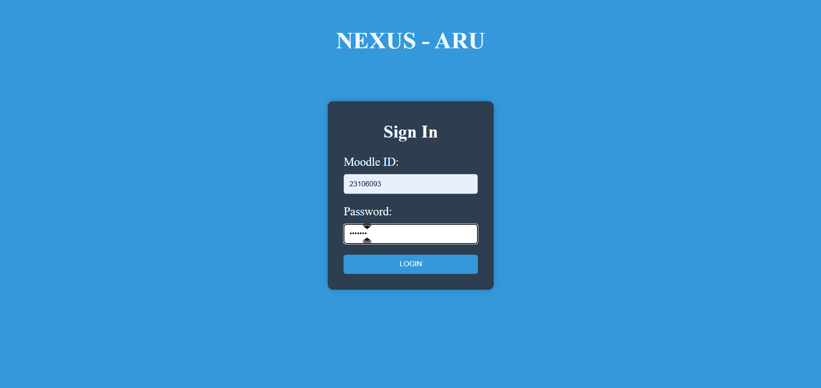

*Figure 1: Login page*

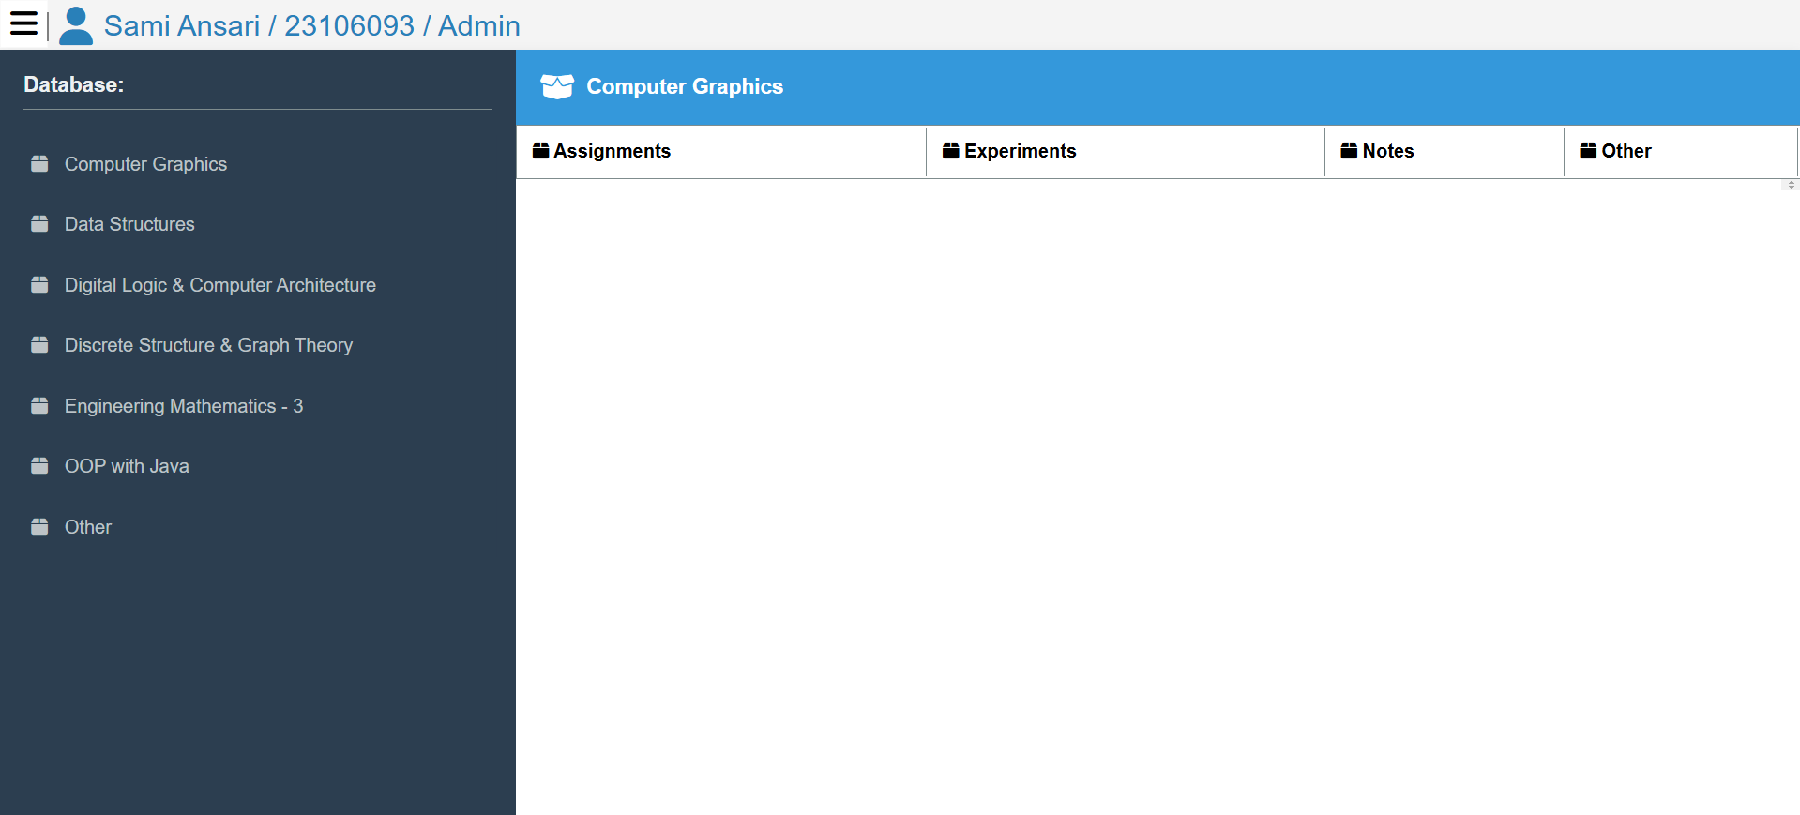

*Figure 2: Database page after successful login*

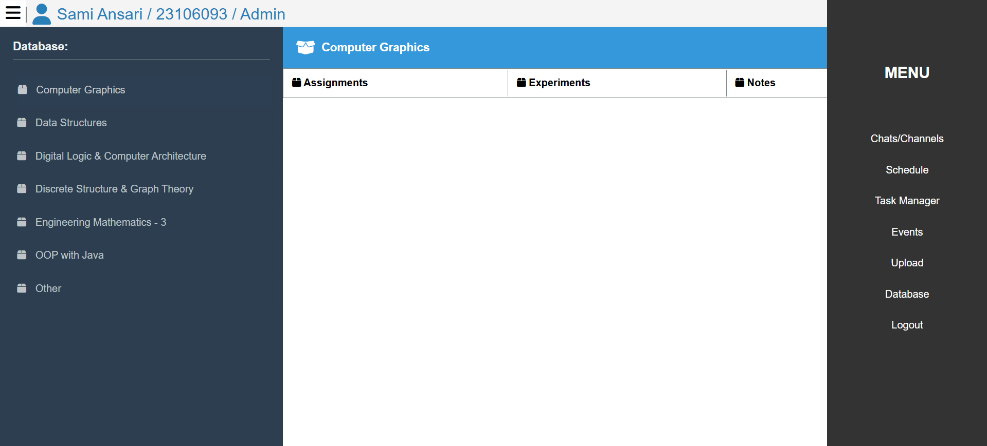

*Figure 3: Website menu to navigate different pages*

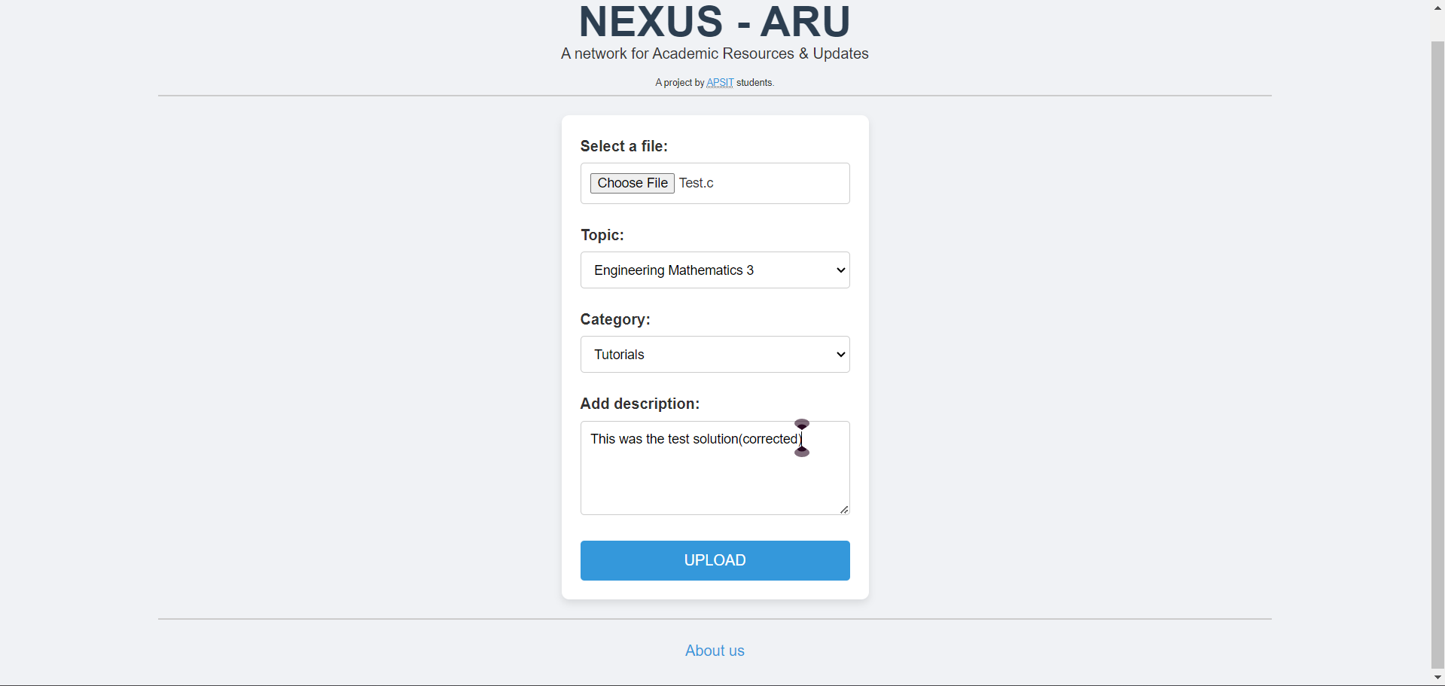

*Figure 4: Upload Page (Uploading a file to the database of the website)*

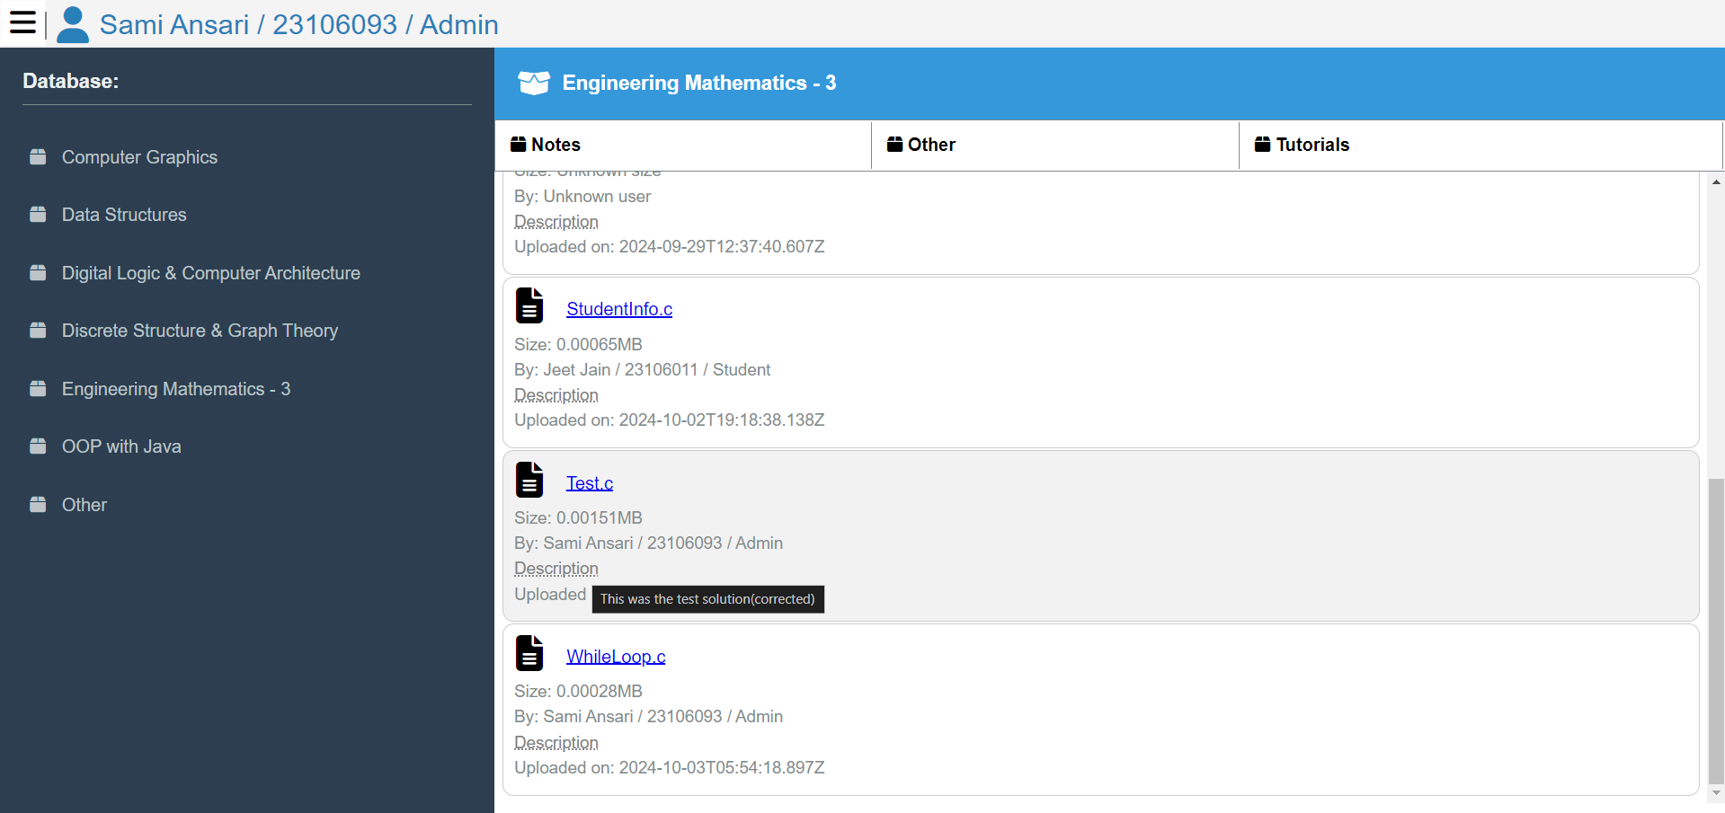

*Figure 5: Download link of the file on the database page of the website*

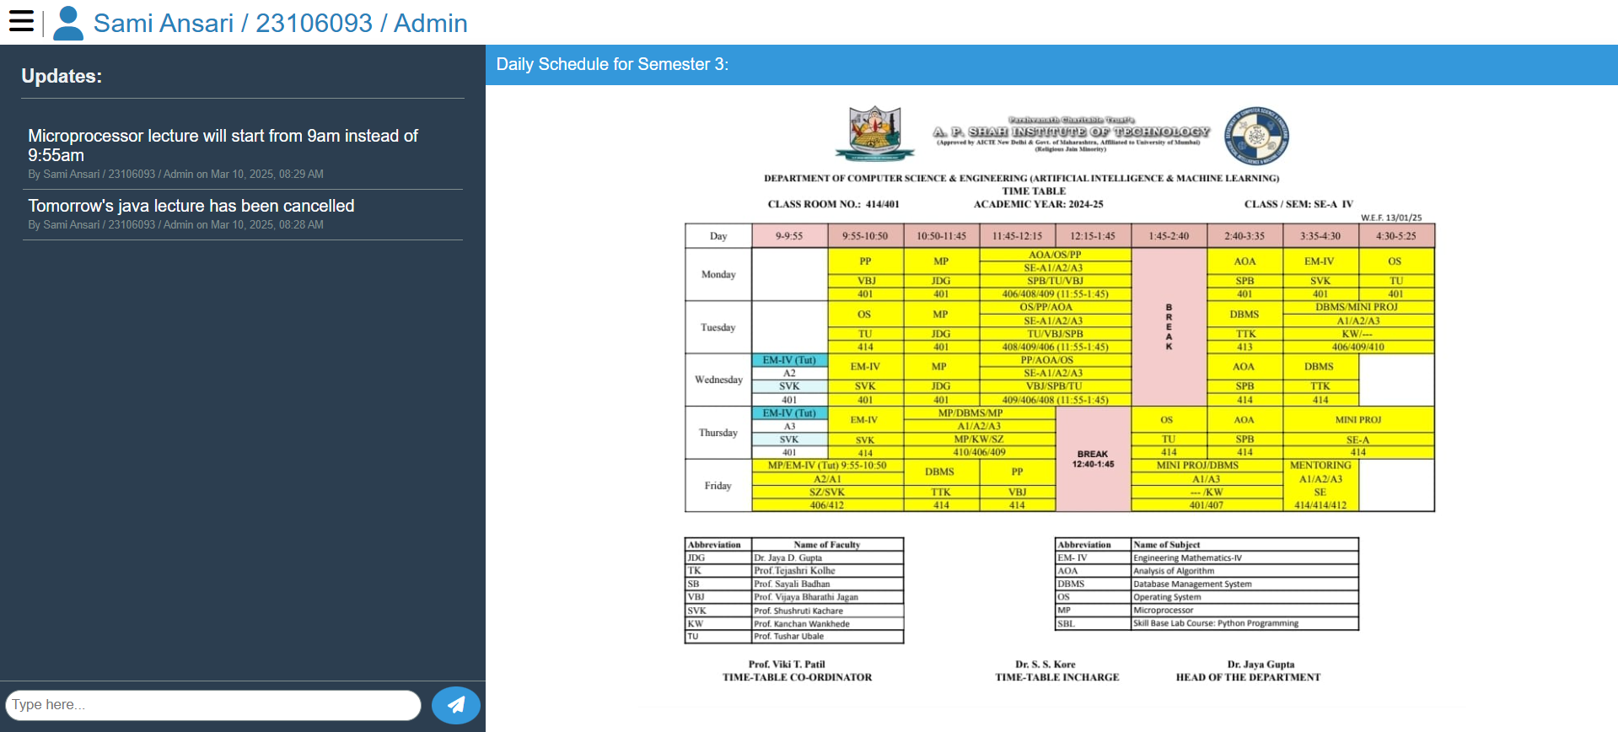

*Figure 6: Schedule page*

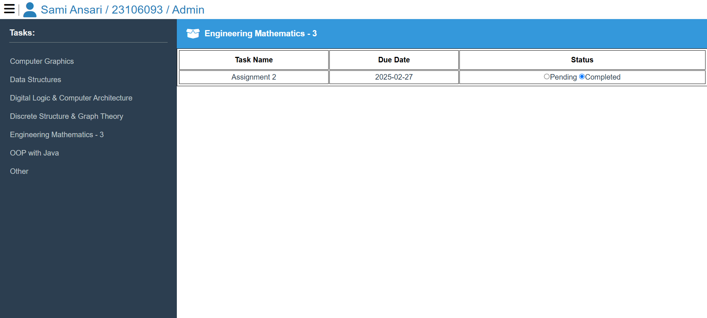

*Figure 7: Tasks page*

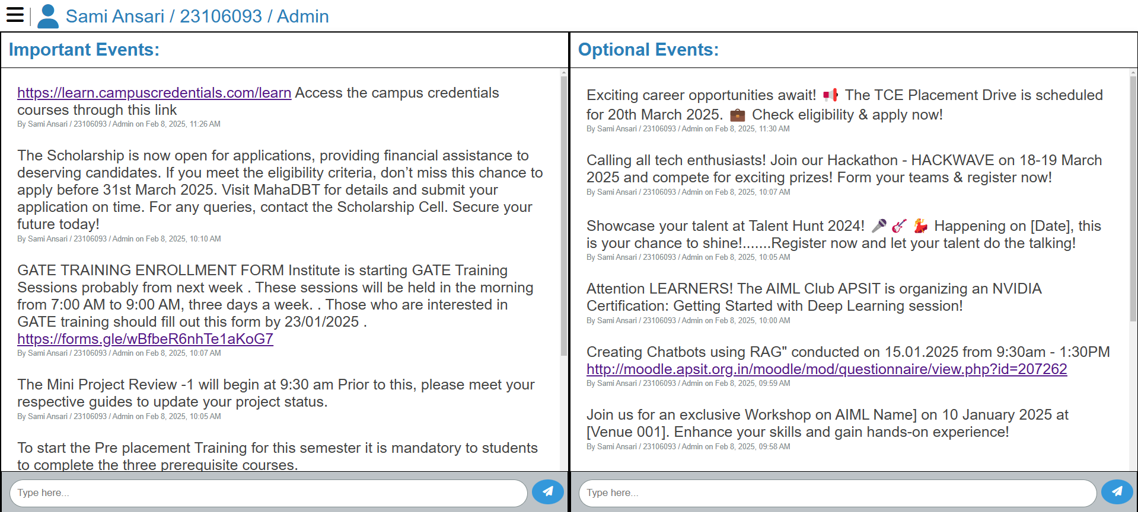

*Figure 8: Events page*

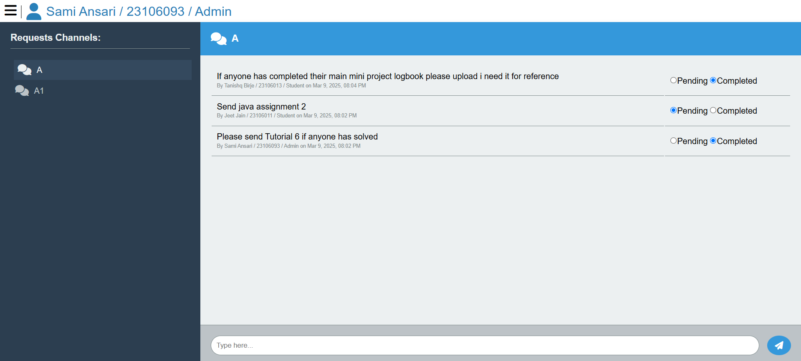

Figure 9: Request Channels Page

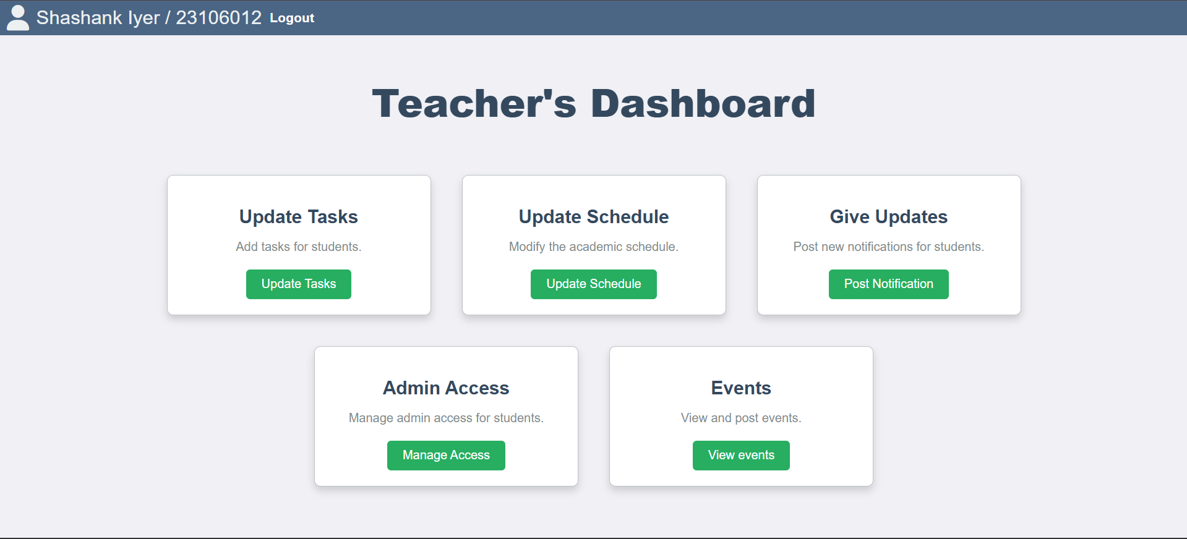

Figure 10: Teacher's Homepage after logging in as a teacher

**CHAPTER 6**

**CONCLUSION**

**6. CONCLUSION**

This project successfully demonstrates the development and implementation of a structured and efficient system aimed at improving user interaction, organization, and accessibility. Through the integration of modern technologies and a well-defined workflow, we have created a platform that effectively meets the needs of users while ensuring a seamless and intuitive experience. The project was carefully planned and executed, incorporating various functionalities that enhance usability, streamline processes, and optimize overall performance.

One of the key strengths of this project lies in its ability to facilitate efficient data management and real-time updates, ensuring that users can interact with the system in a dynamic and responsive manner. By leveraging cloud-based solutions and database management techniques, we were able to provide a scalable and reliable platform that can accommodate future enhancements. Additionally, the implementation of user-specific features ensures a personalized experience, fostering engagement and ease of use.

Throughout the development process, multiple challenges were encountered, including data synchronization, interface optimization, and performance efficiency. However, through rigorous testing, debugging, and iterative improvements, these challenges were effectively addressed, resulting in a robust and well-functioning system. The insights gained during this phase have been invaluable, offering a deeper understanding of system architecture, user experience design, and database integration.

Beyond its immediate functionality, this project also opens the door for future improvements and expansions. Potential enhancements could include the addition of more advanced automation, improved analytics, and further refinements to the user interface to enhance accessibility and responsiveness. With technological advancements, the system can continue to evolve, ensuring that it remains relevant and effective in meeting user requirements.

In conclusion, this project not only fulfils its initial objectives but also lays a strong foundation for future innovation and scalability. The successful implementation of its core features highlights the potential of well-structured digital solutions in addressing real-world challenges. The experience and knowledge gained from this project will be instrumental in future endeavours, providing a valuable framework for developing even more efficient and user-centric systems.

**REFERENCES**

**Research papers:**

[1] Tanya Uppal Saumitya Srivastava and Kavita Saini, “Web Development Framework: Future Trends”, 2022 4th International Conference on Advances in Computing, Communication Control and Networking (ICAC3N), IEEE (6 December 2016).

[2] Khalid Wahab, Anwar Ullah, Yulin Wang and Abdul Majid, “Development of a Web-Based Student Portal System for University Students”, IEEE (2022); International Conference on Intelligent Education and Intelligent Research (IEIR).

[3] Pavani V Lakshmi Sravya K Poorna Vyshnavi A and Sai Bhavani G, “Students Community Portal using Machine Learning”, 2023 Second International Conference on Electronics and Renewable Systems (ICEARS) , publish by IEEE(3 March 2023).

[4] Eka Wahyu Aditya Shahrinaz Ismail and Noormadinah Allias, “Implementation of Intelligent Chatbot in Student Portal: A Systematic Literature Review” ,2022 International Visualization, Informatics and Technology Conference (IVIT), IEEE (2 November 2022).

[5] Jianhua Zhao and Yinjian Jiang, “Categories of questions in an online discussion forum”, An

analysis 2020 5th International Conference on Computer Science & Education IEEE (5 June 2020)

[6] K. Swasha, S. Steffie Gracia and M. Maheswari, “Notes Sharing and Student performance

Analysis Web Application”, IEEE (17 May 2023), 2023 7th International Conference on Intelligent Computing and Control Systems (ICICCS)

**URL**

<https://ieeexplore.ieee.org/document/10391217/authors#authors>

<https://ieeexplore.ieee.org/document/7949591>

https://ieeexplore.ieee.org/abstract/document/9673464 https://ieeexplore.ieee.org/document/10142801/authors#authors