CLOONIX-V28-00(latest_version)
Installation and Running the cloonix server

Cloonix:

Cloonix is an open-source network emulator that enables users to create and simulate complex computer networks in a virtual environment. It provides a platform for testing and debugging network configurations and applications without requiring physical network hardware.
Cloonix allows users to create virtual networks with different types of nodes and connect them together, configure network protocols and routing, and run applications and services on the virtual nodes. It supports various networking technologies such as Ethernet, VLAN, IP, MPLS, and VPN, and provides a GUI and a command-line interface for configuration and management.

Installation:
The installation of cloonix is provided from source only with compilation on host and install in /usr/local/bin/cloonix of the host. For more info on the dependancy, look into install_depends file. The podman package is not necessary for cloonix use, if you which, you can suppress the line installing it before launching the script.
The 2 main steps to have a successfull installation are:
sudo ./install_depends
which will install all the necessary developement packages on your host. and:
./doitall
Here under is the complete list of commands for this installation:
cd ${HOME}
wget http://clownix.net/downloads/cloonix-28/cloonix-28-00.tar.gz
tar xvf cloonix-28-00.tar.gz
cd cloonix-28-00
wget http://clownix.net/downloads/cloonix-28/targz_store.tar.gz
tar xvf targz_store.tar.gz

sudo ./install_depends
./doitall
To erase all trace of cloonix from the host
rm -rf /usr/local/bin/cloonix*
The cloonix source to compile and install is also on github:
git clone --depth=1 https://github.com/clownix/cloonix.git
---------------------------------------------------------------------------------Running of cloonix_gui server:
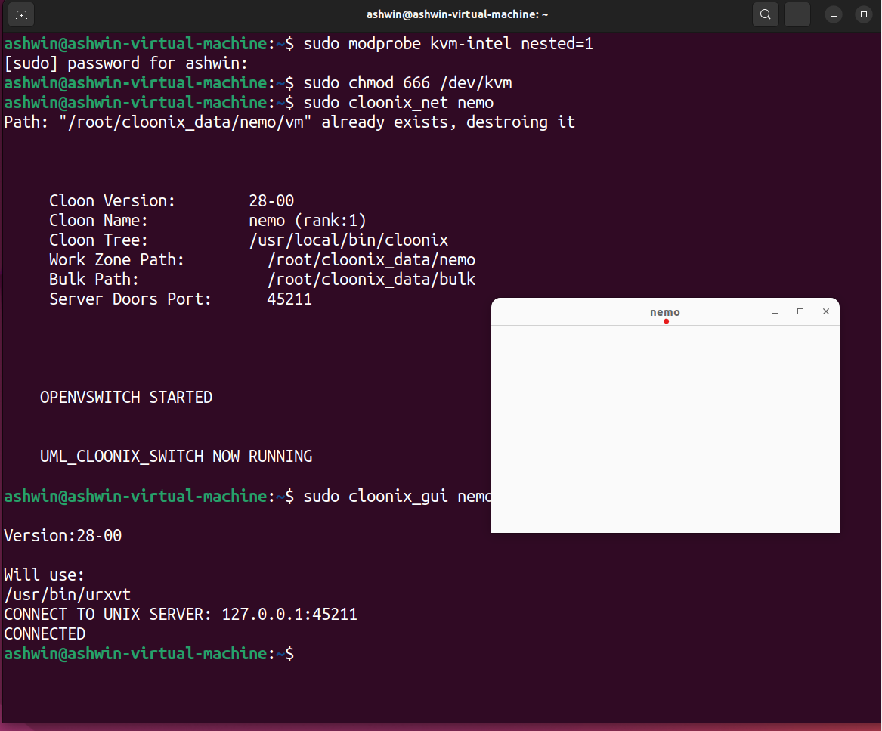
Thus on above I have configured and initialized the cloonix server without any errors..
Ipv6 Networksimulation:
On nemo server I initiated ipv6 network simulation
