Welcome to the User Manual for the Employee Management Software designed for Colombo Institute of Studies. This manual is intended to guide users through the functionalities and operations of the software, which has been meticulously developed to streamline the management of employee details within the institute.

With the increasing demand for efficiency and accuracy in administrative tasks, the institute has embarked on the journey of digital transformation by automating its employee management process. This software caters to the needs of HR Managers and Administrators, providing them with the tools necessary to add, update, and search for employee details seamlessly.

Employing Object-Oriented Programming (OOP) concepts, the software ensures modularity, flexibility, and scalability, allowing for easy adaptation to future requirements. Additionally, data persistence is achieved through file handling mechanisms, ensuring that employee details are securely stored and readily accessible.

This manual will walk you through the various user levels and functionalities, providing step-by-step instructions on how to perform tasks such as adding new departments and designations, creating employee accounts, and searching for employee details based on different criteria.

I trust that this software will enhance the efficiency of employee management processes at Colombo Institute of Studies, empowering HR personnel to focus on strategic initiatives and fostering a more productive work environment. Let’s embark on this journey together towards a more streamlined and efficient management system.

## Loading Screen

The Loading Screen is essential to inform users that the software is actively starting up and preparing to provide access to its features. This brief delay allows for necessary processes such as data initialization, file loading, and system setup to occur seamlessly in the background, ensuring a smooth user experience once the software is fully loaded.

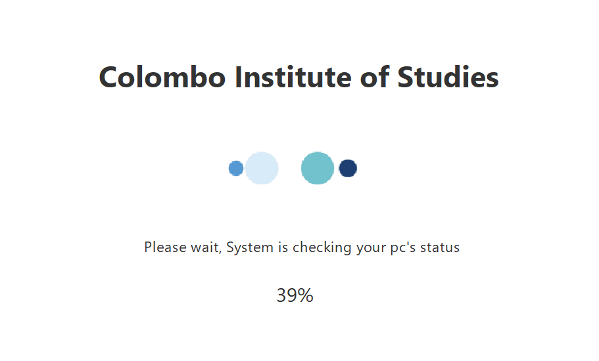

Figure 54 - Loading screen

By displaying a Loading Screen, users are reassured that the software is responsive and actively working to fulfill their needs. This brief moment of anticipation also sets the stage for engagement, building anticipation for the upcoming interaction with the software's functionalities.

## Home Page

The Home Screen serves as the primary interface upon successfully loading the Employee Management Software for Colombo Institute of Studies. This screen presents users with four distinct options:

1. Login: This option allows authorized users, such as Administrators, HR Managers and HR Assistants, to access the software by entering their credentials. By providing a secure login mechanism, sensitive employee data remains protected, ensuring compliance with privacy regulations and organizational policies.
2. Help: The "Help" option offers users access to comprehensive documentation and assistance resources. Whether users require guidance on performing specific tasks or troubleshooting issues, the Help section serves as a valuable resource to enhance user proficiency and resolve queries effectively.
3. About: The "About" option provides users with essential information about the Employee Management Software, including developer details, developer credits, and any pertinent acknowledgments.
4. Exit: The "Exit" option enables users to gracefully exit the software when their session is complete. By providing a convenient exit mechanism, users can easily close the application without any hassle, ensuring a seamless user experience and promoting user satisfaction.

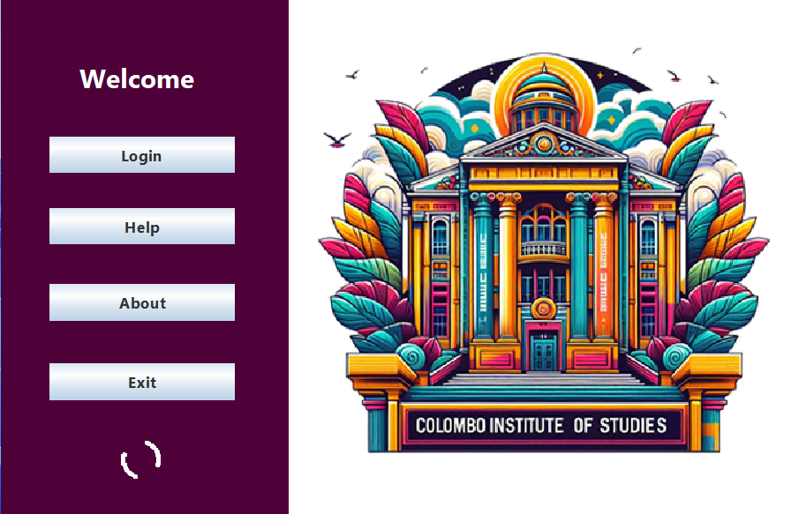

Figure 55 - Home page

## Main Login Page

The Main Login Screen serves as the gateway for authorized users to access the Employee Management Software for Colombo Institute of Studies. This screen presents users with three distinct login options:

1. Admin Login: This option is designated for administrators responsible for overseeing user accounts and system configurations. Administrators possess elevated privileges, enabling them to create new accounts, manage user permissions, and maintain the integrity of the software.
2. HR Manager Login: HR Managers, entrusted with the management of employee details and organizational hierarchies. HR Managers can add new departments, designations, and employees, as well as search and retrieve employee details based on various criteria.
3. HR Assistant Login: HR Assistants, tasked with providing support to HR Managers and assisting in day-to-day administrative tasks. HR Assistants can assist in searching employees.

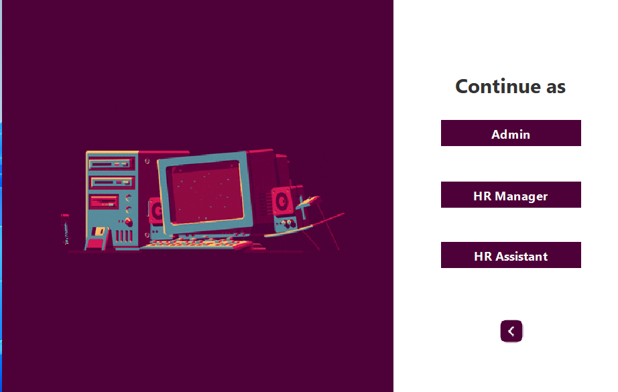

Figure 56 - Main login page

## About Page

The About Page provides users with essential information regarding the individuals involved in the development and instruction of the Employee Management Software for Colombo Institute of Studies. This page includes details about the instructor overseeing the software's implementation and the developer responsible for its creation.

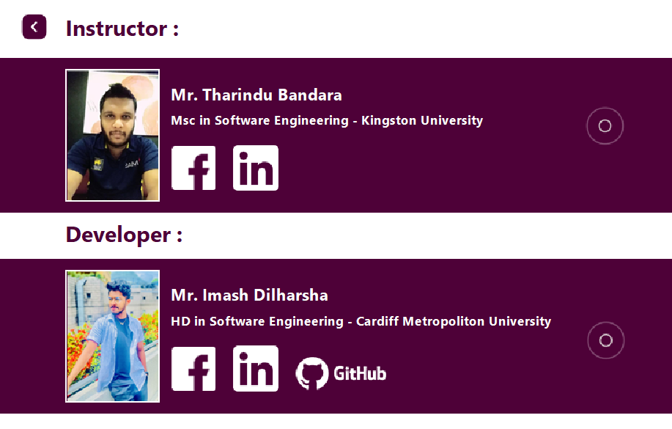

Figure 57 - About page

## Admin Dashboard – User account section

The Admin Dashboard - User Account Section provides administrators with the ability to manage user accounts within the Employee Management Software for Colombo Institute of Studies.

This section offers two distinct options: "Create New Manager Account" and "Create New Assistant Account," enabling administrators to facilitate the addition of HR Managers and HR Assistants to the system.

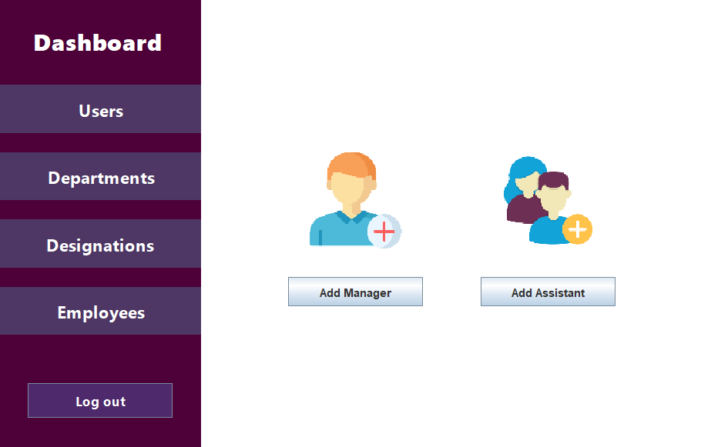

Figure 58 - Admin dashboard 1

## Admin Dashboard – Department section

This section empowers administrators to manage the organizational structure of Colombo Institute of Studies by creating new departments within the Employee Management Software.

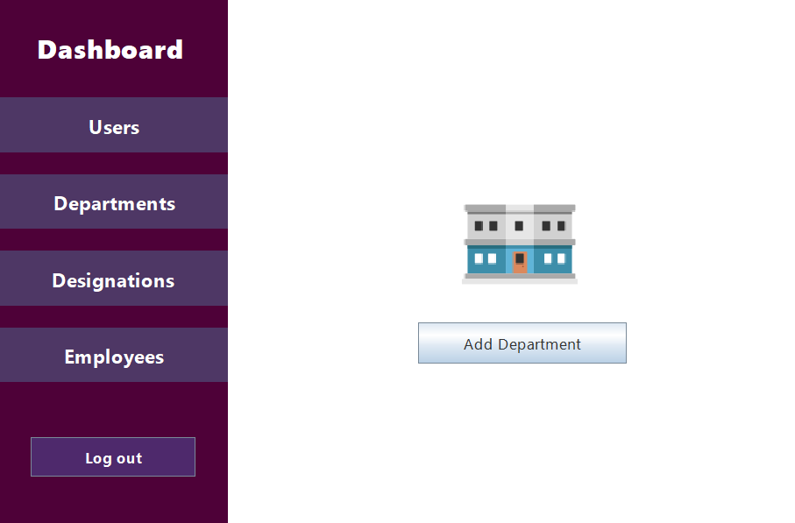

Figure 59 - Department section

## Admin Dashboard – Designation section

Designation Section provides administrators with the capability to define and manage employee designations within the Employee Management Software for Colombo Institute of Studies. This section offers administrators the option to "Create Designation," enabling the establishment of specific roles or positions within the institute's organizational structure.

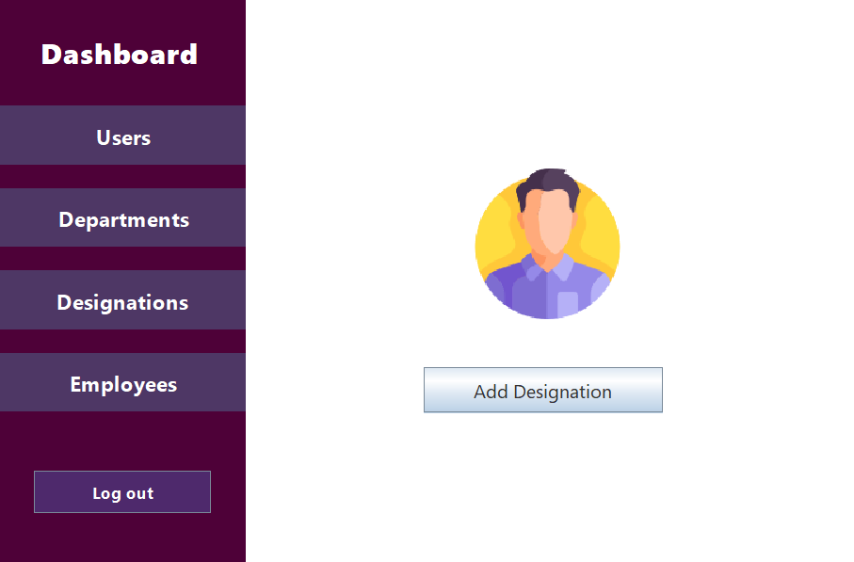

Figure 60 - Designation section

## Admin Dashboard – Employee section

This section equips administrators with comprehensive tools to manage employee details effectively within the Employee Management Software for Colombo Institute of Studies. This section offers four essential options: "Add Employee," "Delete Employee," "Search Employee," and "Update Employee," facilitating seamless management of employee records and information.

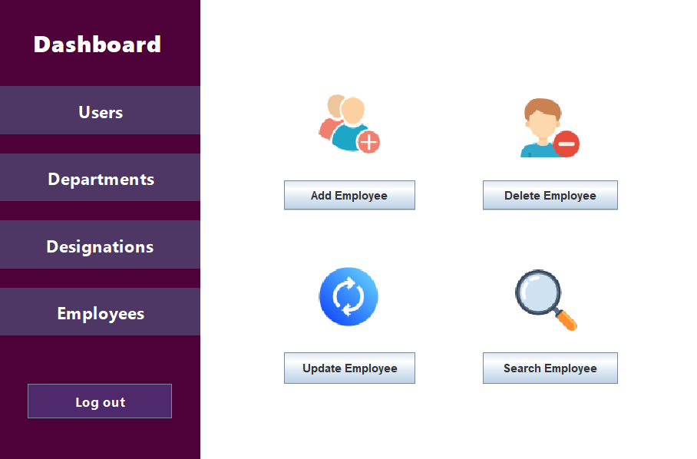

Figure 61 - Employee section

## Add Employee Page

This page serves as a crucial component of the software's functionality, facilitating the seamless integration of new hires into the institute's workforce management system. By providing managers with a structured form to input employee details, this page ensures consistency, accuracy, and completeness of employee records within the software.

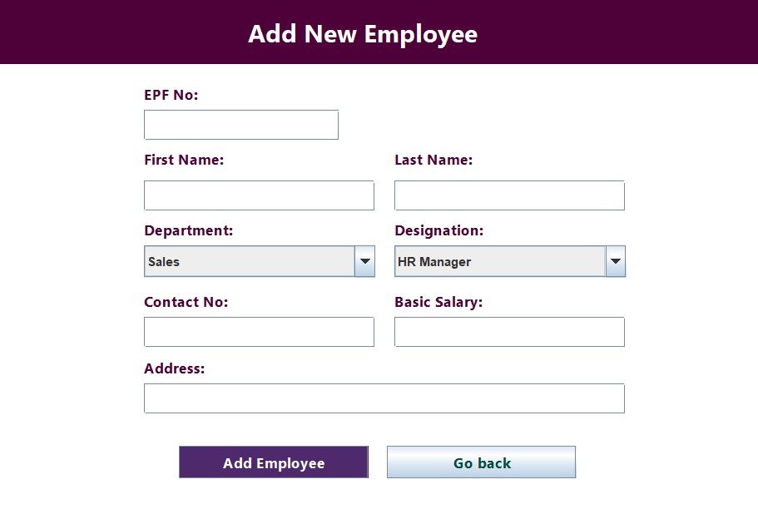

Figure 62 - Add employee page

## Update Employee Page

The Update Employee Page plays a crucial role in ensuring the accuracy, relevance, and completeness of employee records within the software. As employee information may change over time due to various factors such as promotions, transfers, or personal updates, managers require a user-friendly mechanism to update these details efficiently.

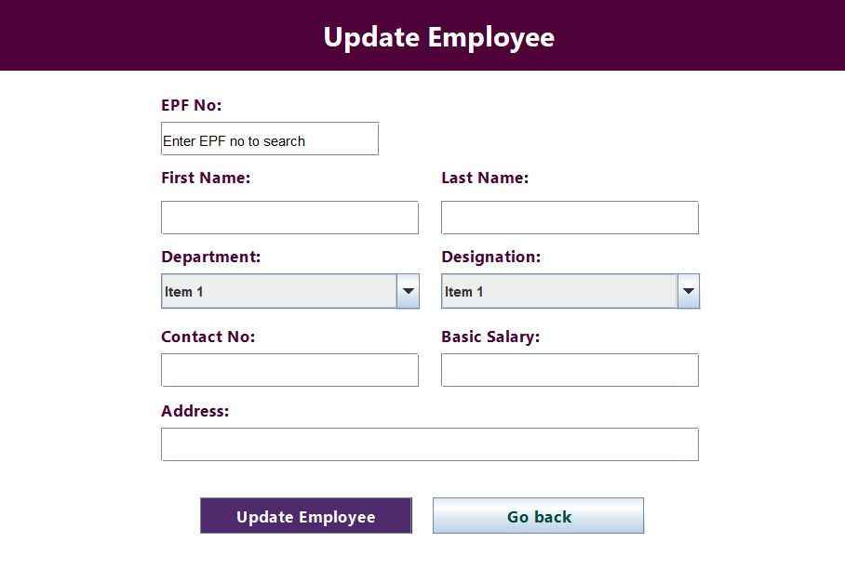

Figure 63 - Update employee

## Delete Employee Page

While employee departures are an inevitable aspect of organizational dynamics, it is essential for managers to have a structured and efficient process for removing employee records from the system. The Delete Employee Page serves as a dedicated platform for this purpose, ensuring that the deletion process is conducted securely, accurately, and in compliance with organizational protocols and privacy regulations.

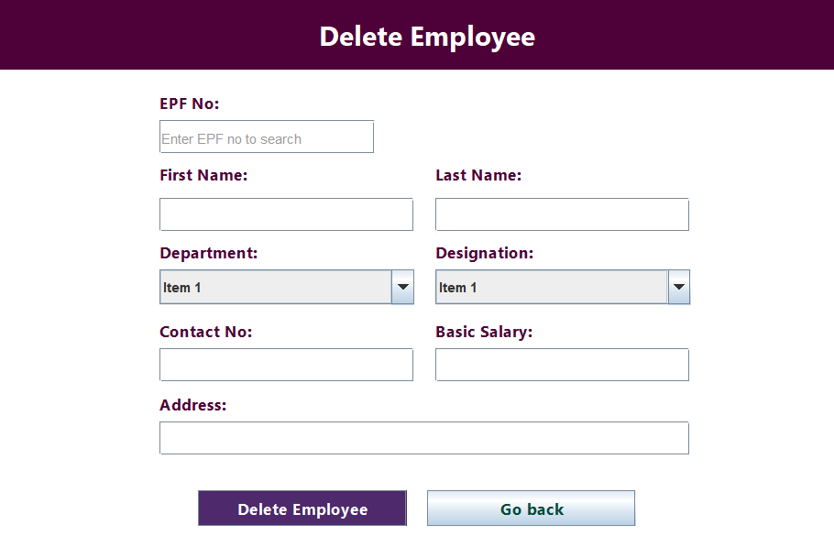

Figure 64 - Delete employee

## Search Employee Page

Efficient retrieval of employee records is essential for effective employee management and administrative decision-making within an organization. The Search Employee Page addresses this need by providing managers with a versatile and user-friendly interface to locate specific employee information quickly and accurately.

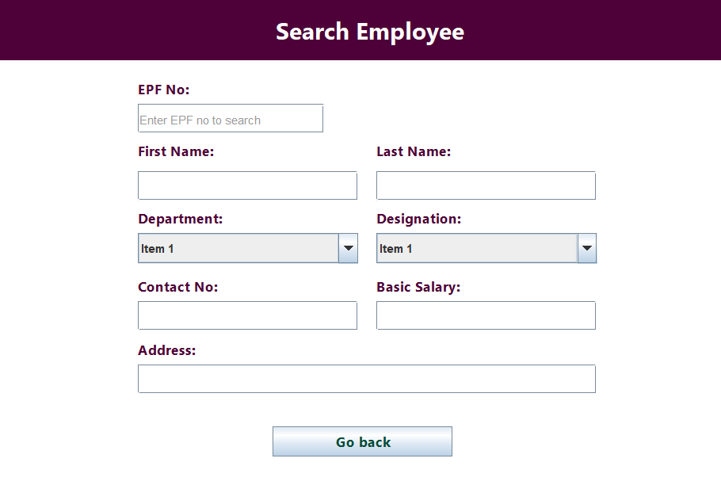

Figure 65 - Search employee