1.

(a) An IoT-based water tank monitoring system.

* An **ultrasonic sensor** mounted on the top of the tank to measure the distance to the water surface.

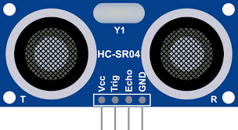

* An **Arduino microcontroller** to process the sensor data.
* An **LED indicator** to show the tank's status (e.g., Full, Empty).
* A **mobile app** to notify users about the current water level and send alerts when the tank needs refilling.

The ultrasonic sensor measures the distance (D) from the sensor to the water surface, and the water level (L) is calculated as-

**L = Tank Height (H) – D**

(Assume, tank height is 10m)  
For the tank to be considered "full," the water level should be greater than or equal to 9.5m (95% )of the tank height. For it to be "empty," the water level should be less than or equal to 0.5m ( 5% ) of the tank height.

(i) Draw a diagram representing the components of the system and how they interact(without mobile application connecting)  
(ii) Explain the importance of real-time monitoring and alerts in this system.

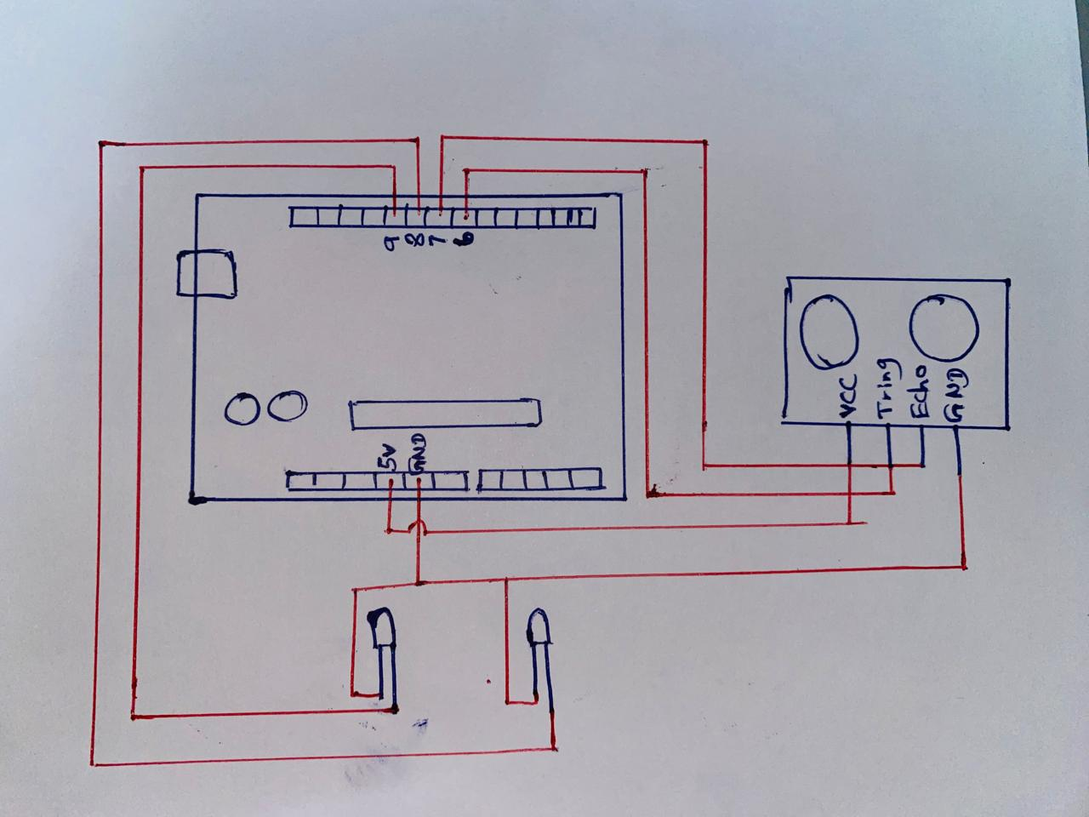

(b) The system uses the following logic to update the tank's status based on the water level. Assume the Arduino's void loop() function is equivalent to the **While (true)** loop in this pseudocode.

Complete the following pseudocode by filling in the missing logic (X, Y, and Z)

**While (true) {**

**Read Distance as D**

**Calculate Water Level as L = H - D**

**if L <= X { // Missing Logic X**

**Turn on Red LED**

**Update Tank Status as "Empty"**

**Notify Mobile App with “Tank Empty”**

**}**

**else if L >= Y { // Missing Logic Y**

**Turn on Green LED**

**Update Tank Status as "Full"**

**Notify Mobile App with Z // Missing Logic**

**}**

**}**

(c) Write the **void setup()** function for initializing the ultrasonic sensor, LEDs, and serial communication for the water tank monitoring system. Use the pin definitions below:

* **Trigger Pin**: Pin 7 (for the ultrasonic sensor)
* **Echo Pin**: Pin 6 (for the ultrasonic sensor)
* **Red LED**: Pin 8 (indicates the tank is "Empty")
* **Green LED**: Pin 9 (indicates the tank is "Full")

The setup should configure the pins appropriately and start the serial communication for monitoring sensor values.