

ADVANCE PROGRAMMING

ASSIGNMENT-01



**MY BULLETIN BOARD**

**(MYBB)**

The Open Source software that I chose is, My Bulletin board also known as MyBB. It is used for forum based sites. Written in PHP and MySQL, this software supports different databases and multiple languages. The reasons I chose this software are

1. Easier to use.
2. Less complex for user and for the admin.

Installation of the software was very easy. The instructions were clear and simple.

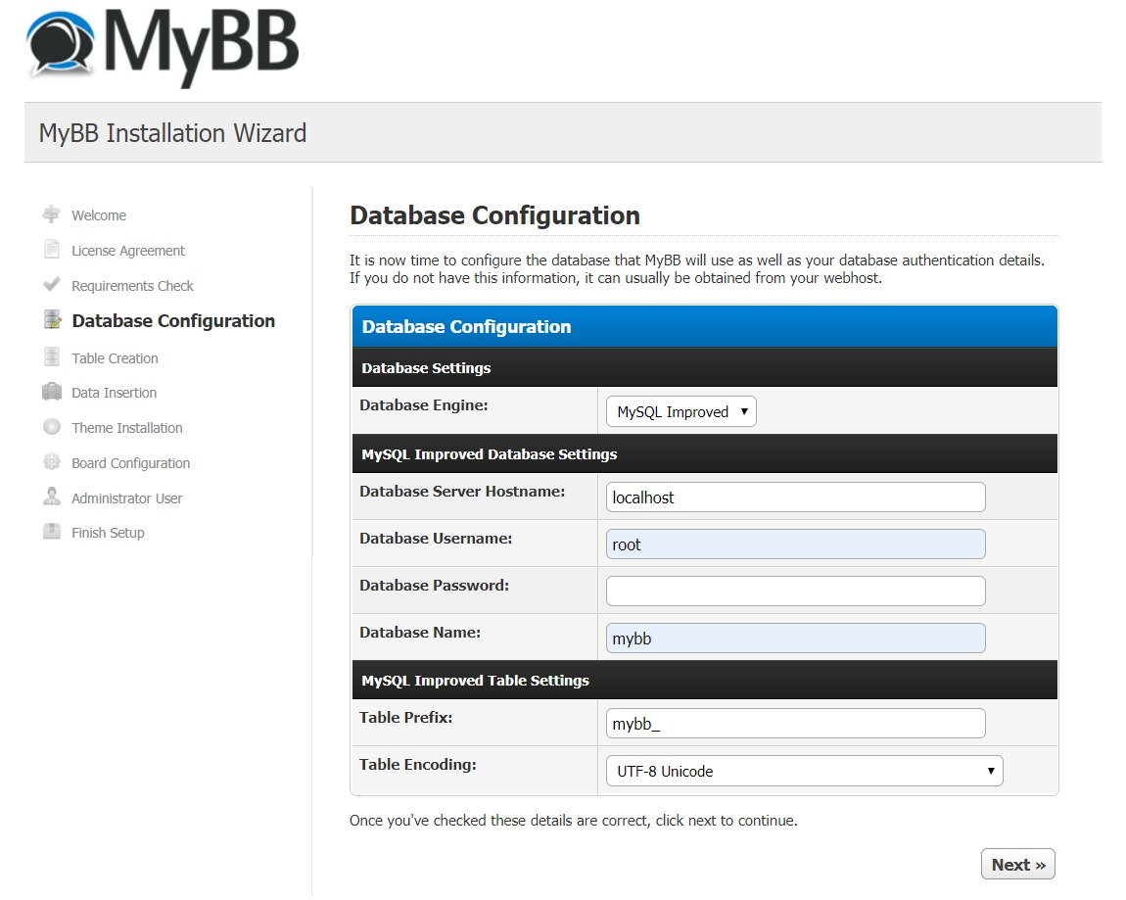

**From the User Perspective:**

1. **Admin Perspective:**

After logging in as an admin, It is very easier to access the user control panel, Moderator control panel, and the admin control panel. On the left side of the User control panel, a sidebar shows admin as a user i.e the inbox, settings etc. The moderator control panel or as the site says Mod CP, shows the threads that are in the waiting list. Moderators actions and the banning list is visible on the front page of the panel. On the left sidebar, admin can check different users or check the forum threads.Through out the Admin CP,You can configure the site, see the forums,users. The admin can also change the template and maintain the site through the dashboard.

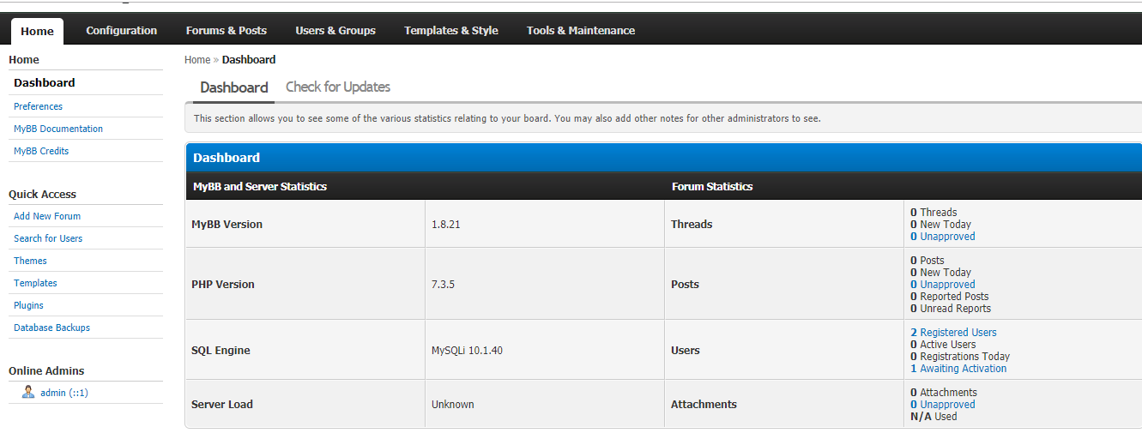

1. **User Perspective:**

After registering as a user, The front page shows the forums or threads. To access new posts or today's post , a clickable text is present on the top right. Similarly, a User CP is also present for user to access the settings of his account. It is very easy to search different post or forums through the search bar. Below are the screen-shots of the user main page.

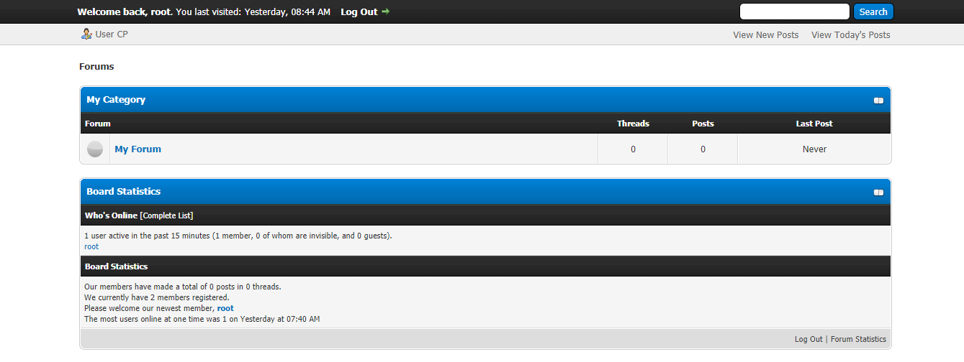

**Coders Perspective:**

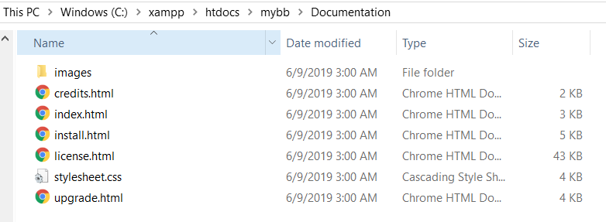As a coder, it is very easy to understand the software architecture of mybb. There are two folders named Documentation and Upload. The documentation folder contains the likes of install and the images used in installation.License and upgradation from last version of mybb is also present there.

The Upload folder contains different PHP and js files. It also contains different folders.The main PHP files are present here. And with there literal names.The jscripts includes the js files. While install contains the files used in installation.The admin folder contains admin back-end sites files. The inc folder contains the different plugins that can be added or available to add, the languages that are used by the sites, the captcha fonts, data-handlers, mail-handlers etc with different PHP files for using in front and back-end. Cache Folder contains themes that can be used and images contains the images used on the site.

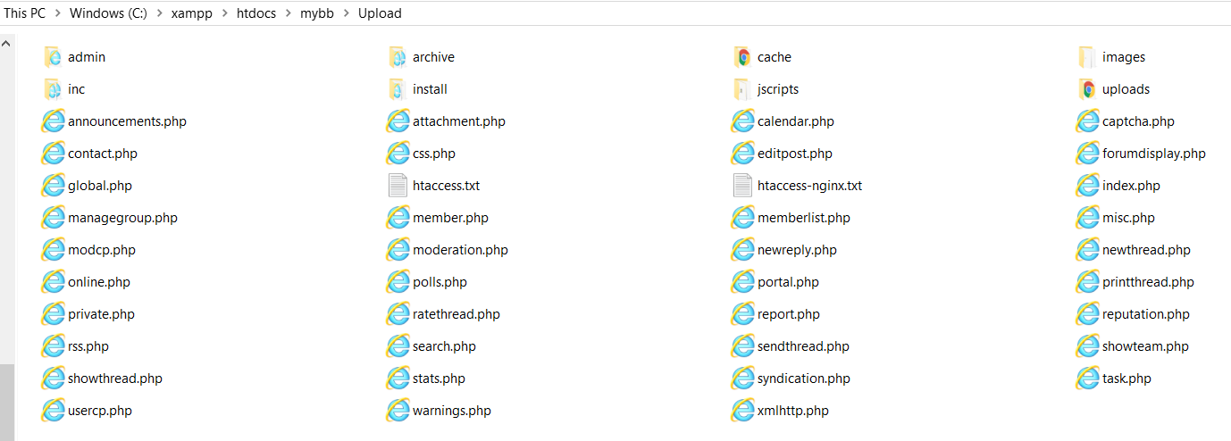

**Database Administrator perspective:**

The database contains 76 different tables. Some tables contain more data than the others.but as they follow the rules of database, it is not of our concern.The below picture shows a table of different users registered on the site.



This is the user _title table that contains the ranking of different users.

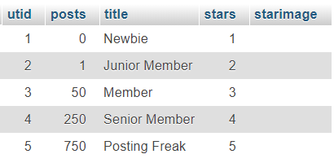

**Addition of plugin:**

There is an available online plugin named hello world. All the user can write a message that will be available to all. It is displayed at the main page of the page.

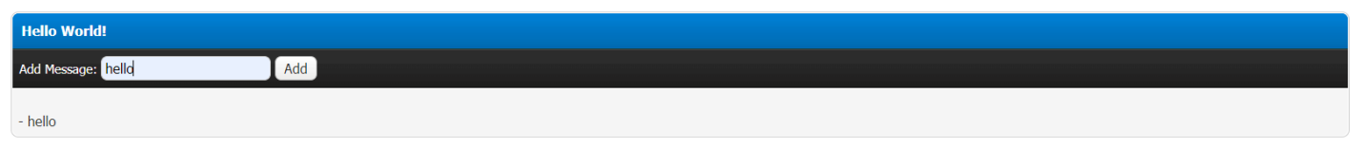

To activate the plugin, admin as to be logged in and choose the plugin from the left side. As given below.

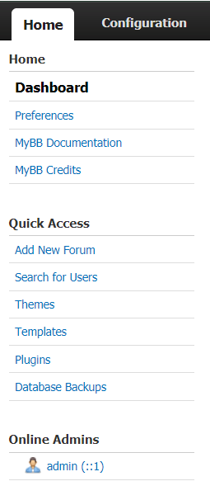

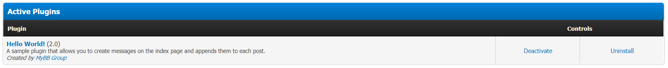From here you can activate or uninstall a plugin.