# Department of Computing

**CS-213: Advanced Programming**

**Class: BSCS 7AB**

# Lab 06: Node.js MongoDB

**Date: 3rd October, 2019**

**Time: 10:00-01:00pm & 02:00-05:00pm**

# Instructor: Dr. Sidra Sultana

**Lab Engineer: Ms. Ayesha Asif**

# 

# Lab 06: Node.js MongoDB

**Lab Tasks**

**Task 1:** Create a database named "mydb". Save the code in a file called "demo_create_mongo_db.js" and run the file.

var mongo = require('mongodb').MongoClient;

var url = "mongodb://127.0.0.1:27017/mydb";

mongo.connect(url, function(err, db) {

if (err) throw err;

console.log("Database created.");

db.close();

});



**Task 2:** Create a collection called "customers". Save the code in a file called "demo_mongodb_createcollection.js" and run the file.

var mongo = require('mongodb').MongoClient;

var url = "mongodb://127.0.0.1:27017/mydb";

mongo.connect(url, function(err, db) {

if (err) throw err;

var dbo = db.db("mydb");

dbo.createCollection("customers", function(err, res) {

if (err) throw err;

console.log("Collection created!");

db.close();

});

});



**Task 3:** Insert a document in the "customers" collection. Save the code in a file called "demo_mongodb_insert.js" and run the file.

var mongo = require('mongodb').MongoClient;

var url = "mongodb://127.0.0.1:27017/mydb";

mongo.connect(url, function(err, db) {

if (err) throw err;

var dbo = db.db("mydb");

var myobj = { name: "Suhaib", address: "attar2" };

dbo.collection("customers").insertOne(myobj, function(err, res) {

if (err) throw err;

console.log("1 object inserted");

db.close();

});

});



**Task 4:** Insert multiple documents in the "customers" collection. Save the code in a file called "demo_mongodb_insert_multiple.js" and run the file.

var mongo = require('mongodb').MongoClient;

var url = "mongodb://127.0.0.1:27017/mydb";

mongo.connect(url, function(err, db) {

if (err) throw err;

var dbo = db.db("mydb");

var myobj = [{ name: "farukh", address: "hostel" },

{ name: "ibrahim", address: "attar1" },

{ name: "Ali", address: "nowhere" },

{ name: "hafiz", address: "raazi" }];

dbo.collection("customers").insertMany(myobj, function(err, res) {

if (err) throw err;

console.log("Number of documents inserted: " + res.insertedCount);

db.close();

});

});



**Task 5:** Insert three records in a "products" table, with specified _id fields. Save the code in a file called "demo_mongodb_insert_id.js" and run the file.

var mongo = require('mongodb').MongoClient;

var url = "mongodb://127.0.0.1:27017/mydb";

mongo.connect(url, function(err, db) {

if (err) throw err;

var dbo = db.db("mydb");

var myobj = [

{ _id: 2, name: 'pepsi'},

{ _id: 1, name: 'Coke'},

{ _id: 3, name: 'fanta'}

];

dbo.collection("products").insertMany(myobj, function(err, res) {

if (err) throw err;

console.log(res);

db.close();

});

});

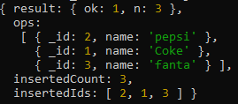

**Task 6:** Find the first document in the customer’s collection. Save the code in a file called "demo_mongodb_findone.js" and run the file.

var mongo = require('mongodb').MongoClient;

var url = "mongodb://127.0.0.1:27017/mydb";

mongo.connect(url, function(err, db) {

if (err) throw err;

var dbo = db.db("mydb");

dbo.collection("customers").findOne({}, function(err, result) {

if (err) throw err;

console.log(result.name);

db.close();

});

});



**Task 7:** Return the fields "name" and "address" of all documents in the customers collection.

var mongo = require('mongodb').MongoClient;

var url = "mongodb://127.0.0.1:27017/mydb";

mongo.connect(url, function(err, db) {

if (err) throw err;

var dbo = db.db("mydb");

dbo.collection("customers").find({},{projection:{ _id: 0, name: 1, address: 1 }}).toArray(function(err, result){

if(err) throw err;

console.log(result);

db.close();

});});

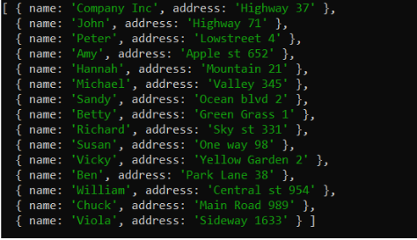

**Task 8:** Find documents with the address "Park Lane 38". Save the code in a file called "demo_mongodb_query.js" and run the file.

var mongo = require('mongodb').MongoClient;

var url = "mongodb://127.0.0.1:27017/mydb";

mongo.connect(url, function(err, db) {

if (err) throw err;

var dbo = db.db("mydb");

var query = { address: "raazi" };

dbo.collection("customers").find(query).toArray(function(err, result) {

if (err) throw err;

console.log(result);

db.close();

});

});

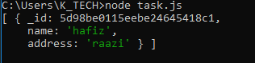

**Task 9:** Sort the result alphabetically by name. Save the code in a file called "demo_sort.js" and run the file.

**The program does this according to the ascii number thats why S came before h.**

var mongo = require('mongodb').MongoClient;

var url = "mongodb://127.0.0.1:27017/mydb";

mongo.connect(url, function(err, db) {

if (err) throw err;

var dbo = db.db("mydb");

var mysort = { name: 1 };

dbo.collection("customers").find().sort(mysort).toArray(function(err, result) {

if (err) throw err;

console.log(result);

db.close();

});

});

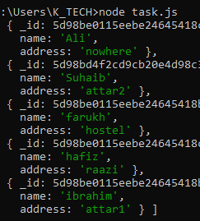

**Task 10:** Delete the document with the address "Mountain 21". Save the code in a file called "demo_delete.js" and run the file.

var mongo = require('mongodb').MongoClient;

var url = "mongodb://127.0.0.1:27017/mydb";

mongo.connect(url, function(err, db) {

if (err) throw err;

var dbo = db.db("mydb");

var myquery = { address: 'raazi' };

dbo.collection("customers").deleteOne(myquery, function(err, obj) {

if (err) throw err;

console.log("1 name deleted");

db.close();

});

});



**Task 11:** Delete all documents were the address starts with the letter "O". Save the code in a file called "demo_delete_many.js" and run the file

var mongo = require('mongodb').MongoClient;

var url = "mongodb://127.0.0.1:27017/mydb";

mongo.connect(url, function(err, db) {

if (err) throw err;

var dbo = db.db("mydb");

var myquery = { address: /^O/ };

dbo.collection("customers").deleteMany(myquery, function(err, obj) {

if (err) throw err;

console.log(obj.result.n + " document(s) deleted");

db.close();

});

});



**Task 12:** Delete the "customers" table. Save the code in a file called "demo_drop.js" and run the file.

var mongo = require('mongodb').MongoClient;

var url = "mongodb://127.0.0.1:27017/mydb";

mongo.connect(url, function(err, db) {

if (err) throw err;

var dbo = db.db("mydb");

dbo.collection("customers").drop(function(err, delOK) {

if (err) throw err;

if (delOK) console.log("Collection deleted");

db.close();

});

});



**Task 13:** Update the document with the address "Valley 345" to name="Mickey" and address="Canyon 123". Save the code in a file called "demo_update_one.js" and run the file .

var mongo = require('mongodb').MongoClient;

var url = "mongodb://127.0.0.1:27017/mydb";

mongo.connect(url, function(err, db) {

if (err) throw err;

var dbo = db.db("mydb");

var myquery = { address: "nowhere" };

var newvalues = { $set: {name: "ali", address: "attar1" } };

dbo.collection("customers").updateOne(myquery, newvalues, function(err, res) {

if (err) throw err;

console.log("1 document updated");

db.close();

});

});



**Task 14:** Consider you have a "customers" collection. Limit the result to only return 5 documents. Save the code above in a file called "demo_mongodb_limit.js" and run the file.

**P.S Don’t have enough data in the database. Used limit 3.**

var mongo = require('mongodb').MongoClient;

var url = "mongodb://127.0.0.1:27017/mydb";

mongo.connect(url, function(err, db) {

if (err) throw err;

var dbo = db.db("mydb");

dbo.collection("customers").find().limit(3).toArray(function(err, result) {

if (err) throw err;

console.log(result);

db.close();

});

});

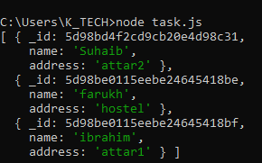

**Task 15:** Practice the Join operations on different tables.

var mongo = require('mongodb').MongoClient;

var url = "mongodb://127.0.0.1:27017/mydb";

mongo.connect(url, function(err, db) {

if (err) throw err;

if (err) throw err;

var dbo = db.db("mydb");

dbo.collection('customers').aggregate([

{ $lookup:

{

from: 'products',

localField: 'name',

foreignField: '_id',

as: 'orderdetails'

}

}

]).toArray(function(err, res) {

if (err) throw err;

console.log(JSON.stringify(res));

db.close();

});

});

