**Task 1**

**Code:**

**Counter.js**

import React, { Component } from 'react';

class Counter extends Component{

state={

count:0

}

Increment = ()=>{

this.setState({

count : this.state.count + 1

})

}

render(){

return(

<div>

<h1>Counter - {this.state.count}</h1>

<button onClick={()=>this.Increment()}>Increment</button>

</div>

)

}

}

export default Counter;

**OutPut:**

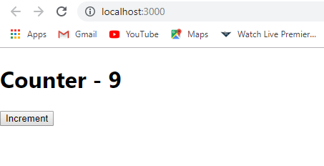

**Code:**

**Welcome.js**

import React, { Component } from 'react';

class welcome extends Component{

state= {

message: 'welcome visitor'

}

changeMessage = ()=>{

this.setState({

message:'thank you for subscribing'

})

}

render(){

return(

<div>

<h1>{this.state.message}</h1>

<button onClick={()=>this.changeMessage()}>Subscribe</button>

</div>

)

}

}

export default welcome;

**OutPut:**

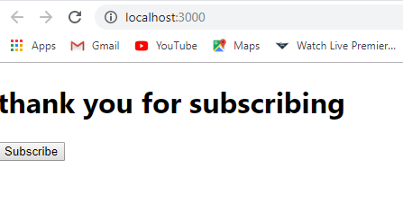

**Task 2**

**Code:**

import React, { Component } from 'react';

import AppN from './App.css';

export default class App extends Component {

    state = {

        minutes : 0,

        seconds: 0

    }

    minuteHandler = (event)=>{

        this.setState({

            minutes : event.target.value,

            seconds : event.target.value*60

        });

    }

    timer = ()=>{

        if(this.state.seconds > 0){

            this.setState((prevState) => ({

                seconds : prevState.seconds -1,

                minutes: Math.floor((prevState.seconds -1) / 60)

            }))

        }

    }

    Starttimer = () =>{

        setInterval(()=>{

            this.timer()

        },1000)

    }

    render(){

        return(

            <div className="AppN">

                <h3>Enter your Desired Countdown Time </h3>

                <input type="number" onChange={this.minuteHandler} placeholder="Enter in minutes."/>

                <br></br>

                <br></br>

                <button onClick={()=>this.Starttimer()}>START</button>

                <br/>

                <h1>{this.state.minutes}:{this.state.seconds % 60}</h1>

            </div>

        )

        }

}

**OutPut:**

