report

### 1. Use R build-in dataset Orange. Create the following figure for comparing the growth of tree 3 and tree 5

Load data set:

data("Orange") # load  
head(Orange) # print part of dataset

## Tree age circumference  
## 1 1 118 30  
## 2 1 484 58  
## 3 1 664 87  
## 4 1 1004 115  
## 5 1 1231 120  
## 6 1 1372 142

Take the sunset for ggplot:

s_df<-Orange[(Orange$Tree==3)|(Orange$Tree==5),] # take required data  
head(s_df)

## Tree age circumference  
## 15 3 118 30  
## 16 3 484 51  
## 17 3 664 75  
## 18 3 1004 108  
## 19 3 1231 115  
## 20 3 1372 139

Ok. Create the ggplot:

# transform each variable to required format  
s_df$circumference<-as.numeric(s_df$circumference)  
s_df$age<-factor(x = s_df$age,levels = unique(s_df$age))  
s_df$Tree<-factor(x = s_df$Tree,levels = unique(s_df$Tree))  
# create ggplot  
p<-ggplot(data=s_df, aes(x=age, y=circumference, fill=Tree)) +  
 geom_bar(stat="identity", position=position_dodge()) +  
 ylab("circumference (mm)")+  
 scale_fill_manual(values=c('red','blue'))  
p

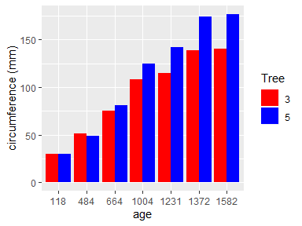

### 2. Use R build-in data mtcars

### 1) Create a graph to show the relations of weight, gross horspower, and the number of cylinders with mileage per gallon (mpg)

### 2) Add a line fit the data points with 98% confidence interval

Attach dataset:

data("mtcars") # attach dataset  
head(mtcars) # print part of dataset

## mpg cyl disp hp drat wt qsec vs am gear carb  
## Mazda RX4 21.0 6 160 110 3.90 2.620 16.46 0 1 4 4  
## Mazda RX4 Wag 21.0 6 160 110 3.90 2.875 17.02 0 1 4 4  
## Datsun 710 22.8 4 108 93 3.85 2.320 18.61 1 1 4 1  
## Hornet 4 Drive 21.4 6 258 110 3.08 3.215 19.44 1 0 3 1  
## Hornet Sportabout 18.7 8 360 175 3.15 3.440 17.02 0 0 3 2  
## Valiant 18.1 6 225 105 2.76 3.460 20.22 1 0 3 1

Here we need the next variables:

wt - Weight (1000 lbs);

hp - Gross horsepower;

cyl - Number of cylinders;

mpg - Miles/(US) gallon.

Select this variables:

s_df<-mtcars[,c("wt","hp","cyl","mpg")]  
head(s_df)

## wt hp cyl mpg  
## Mazda RX4 2.620 110 6 21.0  
## Mazda RX4 Wag 2.875 110 6 21.0  
## Datsun 710 2.320 93 4 22.8  
## Hornet 4 Drive 3.215 110 6 21.4  
## Hornet Sportabout 3.440 175 8 18.7  
## Valiant 3.460 105 6 18.1

Ok. Create the required ggplot:

p<-ggplot(s_df, aes(x = wt, y = mpg))+  
 geom_point(aes(size=hp, col=cyl))+  
 ylab("Miles Per Gallon")+  
 xlab("Gross Weight")+  
 geom_smooth(method = "lm", alpha = .4, level = 0.98)  
p

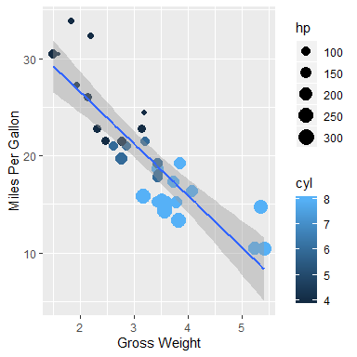

### 3. You need to provide your R codes for answering the following questions.

### 1) Plot a histogram and density graph of mpg

Create the histogram and density plot:

p<-ggplot(data = s_df, aes(x=mpg)) +   
 geom_histogram(aes(y=..density..),   
 alpha=0.5,position="identity",  
 bins = 9,fill = "#fff7d4", color = "black")+  
 geom_density(alpha=.2)   
p

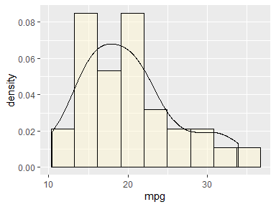

### 4. Use mtcars, generate the following figure

# Create required variable  
Transmission<-as.character(mtcars$am)  
Transmission[Transmission=='0']<-"Automatic"  
Transmission[Transmission=='1']<-"Manual"  
# create the ggplot  
p<-ggplot(s_df, aes(x = wt, y = mpg))+  
 geom_point(aes(col=Transmission))+  
 ggtitle("Mill per gallon vs weight of car")+  
 theme(legend.position = 'top',legend.direction = "horizontal",  
 plot.title = element_text(hjust = 0.5))  
   
p

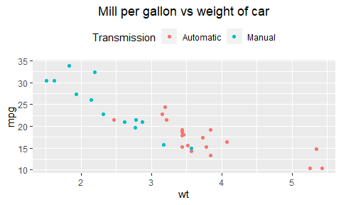

### 4. Iris is a R build-in dataset. Using Iris, generate the following figure (bonus)

Attach dataset:

data("iris")  
head(iris) # print part of dataset

## Sepal.Length Sepal.Width Petal.Length Petal.Width Species  
## 1 5.1 3.5 1.4 0.2 setosa  
## 2 4.9 3.0 1.4 0.2 setosa  
## 3 4.7 3.2 1.3 0.2 setosa  
## 4 4.6 3.1 1.5 0.2 setosa  
## 5 5.0 3.6 1.4 0.2 setosa  
## 6 5.4 3.9 1.7 0.4 setosa

Ok. Create the ggplot:

p<-ggplot(data = iris, aes(x = Petal.Length, y = Petal.Width, color = Species)) +  
 geom_point() +   
 facet_grid(.~Species,scales = "free")+  
 ggtitle("Petal Width VS Petal Length")+  
 theme_bw()+  
 theme(plot.title = element_text(hjust=0.5))+  
 xlab("Petal Length")+  
 ylab("Petal Width")+  
 geom_smooth(method = "lm", alpha = .4, level = 0.98)+  
 theme(strip.background =element_rect(fill="#8c00ec"))+  
 theme(strip.text = element_text(colour = 'white'))+  
 ggtitle(NULL)  
p

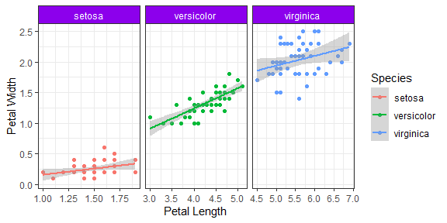

### Using iris, generate the following figure

# create the required shapes  
shapeV<-as.numeric(iris$Species) # set shapes  
shapeV[shapeV==1]<-16  
shapeV[shapeV==2]<-17  
shapeV[shapeV==3]<-15  
# create ggplot  
p<-ggplot(data = iris,  
 aes(x = Petal.Length, y = Petal.Width, color = Species)) +   
 geom_point(shape=shapeV) +   
 ggtitle("Petal Width VS Petal Length") +   
 theme_bw() +   
 # add title and axis labels  
 theme(plot.title = element_text(hjust=0.5))+   
 xlab("The Length of petal (cm)")+  
 ylab("The Width of petal (cm)")+  
 ggtitle("Iris Species")+  
 # add annotate (arrow)  
 annotate(  
 "segment",  
 x=5.6,  
 xend=5.2,  
 y=1.2,  
 yend=1.55,  
 color="black",  
 arrow=arrow(length=unit(0.08,"npc")),  
 size=1.2)+  
 guides(colour = guide_legend(override.aes = list(shape = c(16,17,15))))  
  
p

