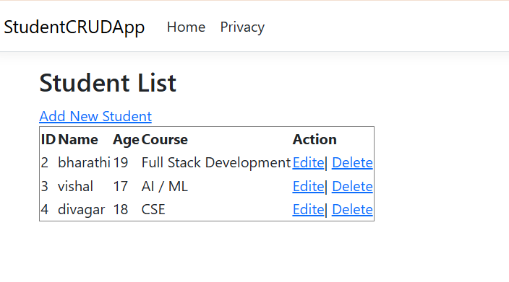Index.cshtml:  
@model List<StudentCRUDApp.Models.Student>

<h2>Student List</h2>

<**a** **asp-action**="Create">Add New Student</**a**>

<table border="1">

<tr><th>ID</th><th>Name</th><th>Age</th><th>Course</th><th>Action</th></tr>

@foreach(var s in Model)

{

<tr>

<td>@s.Id</td><td>@s.Name</td><td>@s.Age</td><td>@s.Course</td>

<td>

<**a** **asp-action**="Edit" **asp-route-id**="@s.Id">Edite</**a**>|

<**a** **asp-action**="Delete" **asp-route-id**="@s.Id">Delete</**a**>

</td>

</tr>

}

</table>

Initialcreate.cs:  
using Microsoft.EntityFrameworkCore.Migrations;

#nullable disable

namespace StudentCRUDApp.Migrations

{

/// <inheritdoc />

public partial class InitialCreate : Migration

{

/// <inheritdoc />

protected override void Up(MigrationBuilder migrationBuilder)

{

migrationBuilder.CreateTable(

name: "Students",

columns: table => new

{

Id = table.Column<int>(type: "INTEGER", nullable: false)

.Annotation("Sqlite:Autoincrement", true),

Name = table.Column<string>(type: "TEXT", nullable: false),

Age = table.Column<int>(type: "INTEGER", nullable: false),

Course = table.Column<string>(type: "TEXT", nullable: false)

},

constraints: table =>

{

table.PrimaryKey("PK_Students", x => x.Id);

});

}

/// <inheritdoc />

protected override void Down(MigrationBuilder migrationBuilder)

{

migrationBuilder.DropTable(

name: "Students");

}

}

}

Errorviewmodel.cs

namespace StudentCRUDApp.Models

{

public class ErrorViewModel

{

public string? RequestId { get; set; }

public bool ShowRequestId => !string.IsNullOrEmpty(RequestId);

}

}

Program.cs:

using Microsoft.EntityFrameworkCore;

using StudentCRUDApp.Data; // Ensure this points to your AppDbContext class

using System.Reflection;

var builder = WebApplication.CreateBuilder(args);

// Add services to the container.

builder.Services.AddControllersWithViews();

// Fix: Corrected typo from AddDbContext to AppDbContext.

// This is the main fix for your error.

builder.Services.AddDbContext<AppDbContext>(options =>

options.UseSqlite(builder.Configuration.GetConnectionString("DefaultConnection")));

var app = builder.Build();

// Configure the HTTP request pipeline.

if (!app.Environment.IsDevelopment())

{

app.UseExceptionHandler("/Students/Error");

// The default HSTS value is 30 days. You may want to change this for production scenarios, see https://aka.ms/aspnetcore-hsts.

app.UseHsts();

}

app.UseHttpsRedirection();

app.UseStaticFiles();

// Fix: Removed the second, redundant call to app.UseRouting().

app.UseRouting();

app.UseAuthorization();

// Fix: Corrected typo from 'Studets' to 'Students' in the default controller route.

// Also, 'MapStaticAssets()' and '.WithStaticAssets()' are not standard

// ASP.NET Core methods. Static file serving is already handled by app.UseStaticFiles().

app.MapControllerRoute(

name: "default",

pattern: "{controller=Students}/{action=Index}/{id?}");

app.Run();