IMAYAVARMAN M

727721EUCS043

DAY-7

Task1

package com.day7;

import org.openqa.selenium.WebDriver;

import org.openqa.selenium.chrome.ChromeDriver;

import org.openqa.selenium.chrome.ChromeOptions;

import org.testng.Assert;

import org.testng.annotations.Test;

import io.github.bonigarcia.wdm.WebDriverManager;

public class task1 {

@Test

public void f() {

WebDriverManager.chromedriver().setup();

ChromeOptions co=new ChromeOptions();

co.addArguments("--remote-allow-origin=\*");

WebDriver driver=new ChromeDriver(co);

driver.get("https://demo.wpeverest.com/user-registration/guest-registration-form/");

String pagetitle=driver.getTitle();

String expectedtitle="Guest Registration Form – User Registration";

Assert.assertEquals(pagetitle, expectedtitle);

}

}

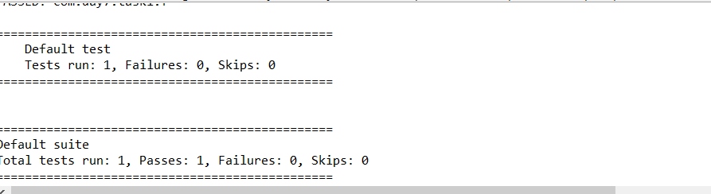

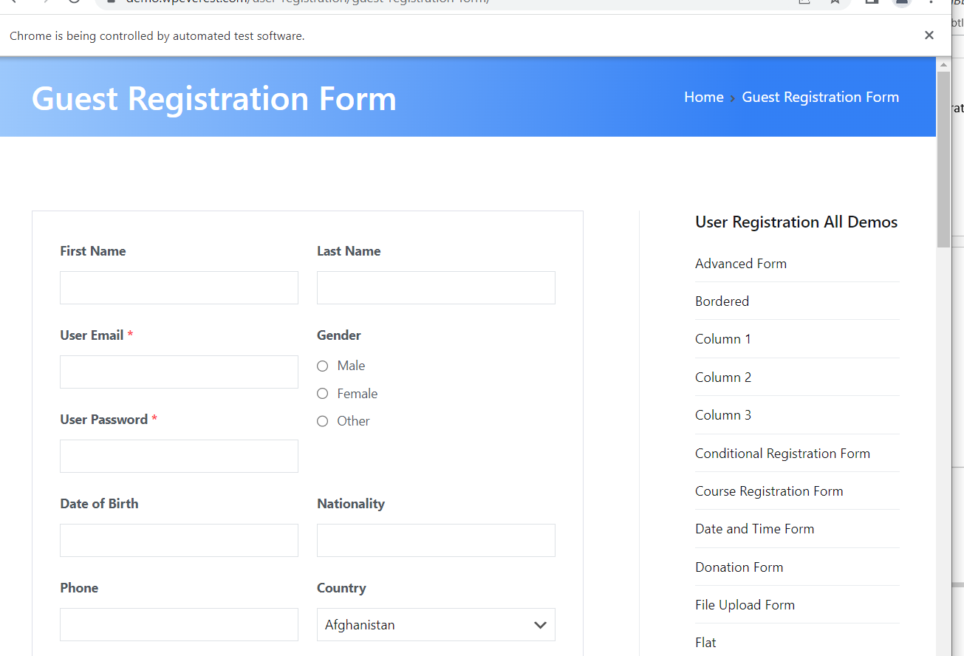

Task2

package com.day7;

import org.testng.Assert;

import org.testng.annotations.Test;

public class task2 {

int c;

int a=7;

int b=4;

@Test(priority=1)

public void add() {

c=a+b;

Assert.assertEquals(c,11);

}

@Test(priority=3)

public void sub() {

c=a-b;

Assert.assertEquals(c,3);

}

@Test(priority=2)

public void mul() {

c=a\*b;

Assert.assertEquals(c,28);

}

@Test(priority=4)

public void div() {

c=a/b;

Assert.assertEquals(c,1);

}

}

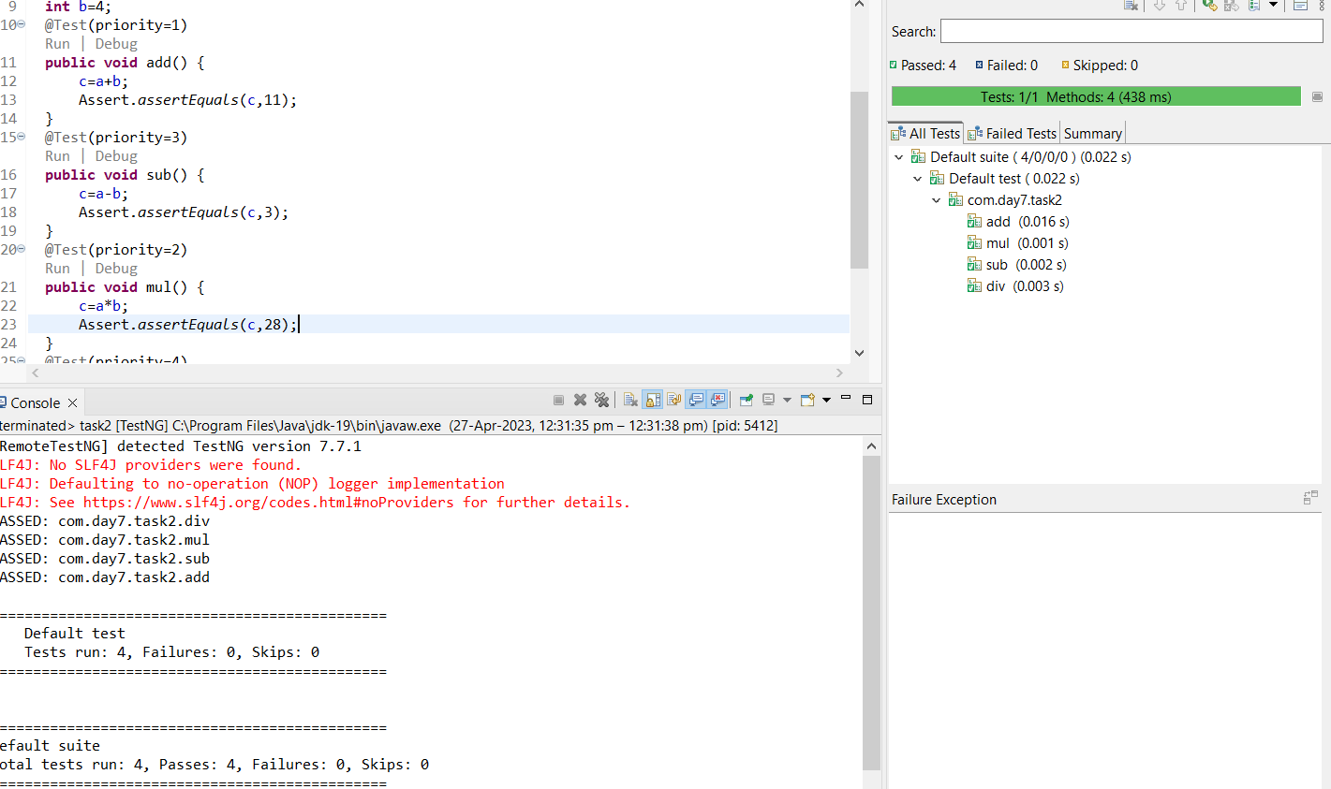

Task 3

package com.day7;

import org.testng.annotations.Test;

import io.github.bonigarcia.wdm.WebDriverManager;

import org.testng.annotations.BeforeMethod;

import org.openqa.selenium.By;

import org.openqa.selenium.WebDriver;

import org.openqa.selenium.WebElement;

import org.openqa.selenium.chrome.ChromeDriver;

import org.openqa.selenium.chrome.ChromeOptions;

import org.testng.annotations.AfterMethod;

public class task3 {

WebDriver driver;

@Test

public void f() throws InterruptedException {

Thread.sleep(4000);

WebElement user=driver.findElement(By.xpath("//\*[@id=\"app\"]/div[1]/div/div[1]/div/div[2]/div[2]/form/div[1]/div/div[2]/input"));

user.sendKeys("Admin");

WebElement pass=driver.findElement(By.xpath("//\*[@id=\"app\"]/div[1]/div/div[1]/div/div[2]/div[2]/form/div[2]/div/div[2]/input"));

pass.sendKeys("admin123");

WebElement sub=driver.findElement(By.xpath("//\*[@id=\"app\"]/div[1]/div/div[1]/div/div[2]/div[2]/form/div[3]/button"));

sub.click();

}

@BeforeMethod

public void beforeMethod() {

WebDriverManager.chromedriver().setup();

ChromeOptions co=new ChromeOptions();

co.addArguments("--remote-allow-origin=\*");

driver=new ChromeDriver(co);

driver.get("https://opensource-demo.orangehrmlive.com/web/index.php/auth/login");

driver.manage().window().maximize();

}

@AfterMethod

public void afterMethod() {

driver.close();

}

}

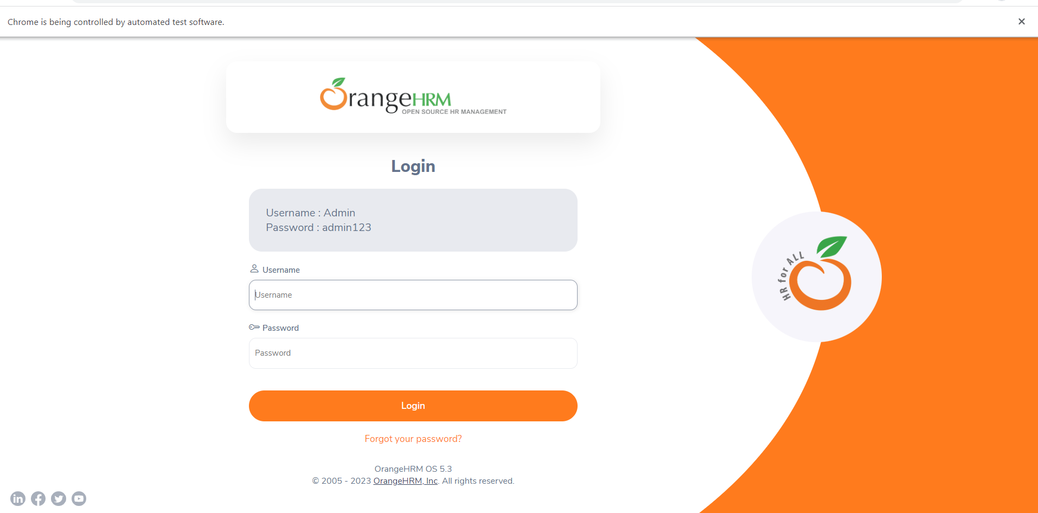

Task 4

package com.day7;

import org.openqa.selenium.By;

import org.openqa.selenium.WebDriver;

import org.openqa.selenium.WebElement;

import org.openqa.selenium.chrome.ChromeDriver;

import org.openqa.selenium.chrome.ChromeOptions;

import org.testng.annotations.BeforeSuite;

import org.testng.annotations.Test;

import io.github.bonigarcia.wdm.WebDriverManager;

public class task4 {

WebDriver driver;

@Test

public void f() throws InterruptedException {

driver.get("https://opensource-demo.orangehrmlive.com/web/index.php/auth/login");

driver.manage().window().maximize();

Thread.sleep(3000);

WebElement user=driver.findElement(By.xpath("//\*[@id=\"app\"]/div[1]/div/div[1]/div/div[2]/div[2]/form/div[1]/div/div[2]/input"));

user.sendKeys("Admin");

WebElement pass=driver.findElement(By.xpath("//\*[@id=\"app\"]/div[1]/div/div[1]/div/div[2]/div[2]/form/div[2]/div/div[2]/input"));

pass.sendKeys("admin123");

WebElement sub=driver.findElement(By.xpath("//\*[@id=\"app\"]/div[1]/div/div[1]/div/div[2]/div[2]/form/div[3]/button"));

sub.click();

}

@BeforeSuite

public void beforeMethod() {

WebDriverManager.chromedriver().setup();

ChromeOptions co=new ChromeOptions();

co.addArguments("--remote-allow-origin=\*");

driver=new ChromeDriver(co);

}

@Test(dependsOnMethods = "f")

public void logout() throws InterruptedException {

Thread.sleep(3000);

WebElement pro=driver.findElement(By.xpath("//\*[@id=\"app\"]/div[1]/div[1]/header/div[1]/div[2]/ul/li/span"));

pro.click();

WebElement log=driver.findElement(By.xpath("//\*[@id=\"app\"]/div[1]/div[1]/header/div[1]/div[2]/ul/li/ul/li[4]/a"));

log.click();

}

}

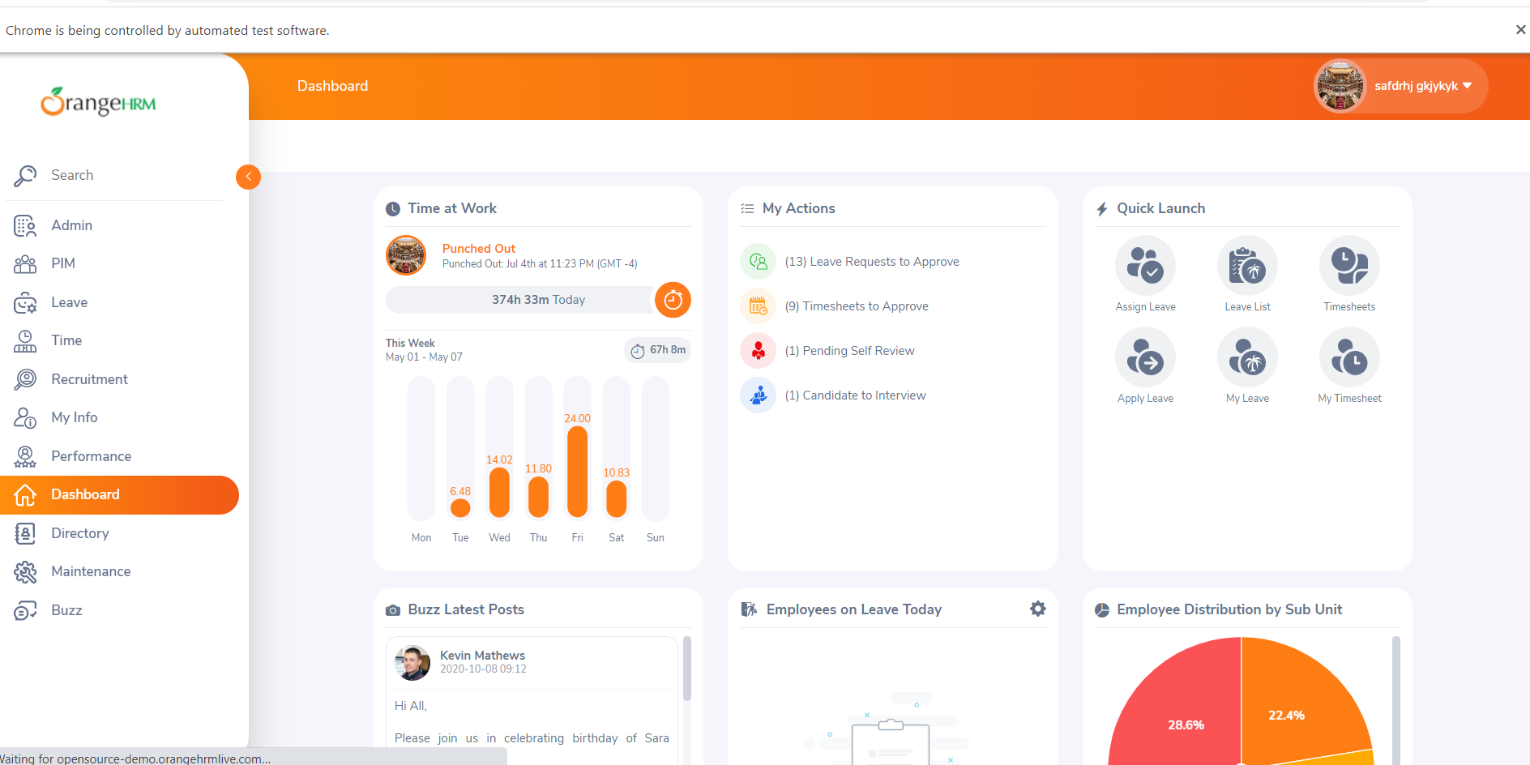

Task 5

package com.day7;

import java.util.concurrent.TimeUnit;

import org.openqa.selenium.By;

import org.openqa.selenium.WebDriver;

import org.openqa.selenium.WebElement;

import org.openqa.selenium.chrome.ChromeDriver;

import org.openqa.selenium.chrome.ChromeOptions;

import org.testng.Assert;

import org.testng.annotations.Test;

import io.github.bonigarcia.wdm.WebDriverManager;

public class task5 {

@Test(groups= {"a"})

public void test() {

WebDriverManager.chromedriver().setup();

ChromeOptions co=new ChromeOptions();

co.addArguments("--remote-allow-origin=\*");

WebDriver driver=new ChromeDriver(co);

driver.get("https://www.godaddy.com/");

driver.manage().window().maximize();

String pagetitle=driver.getTitle();

String expectedtitle="Domain Names, Websites, Hosting & Online Marketing Tools - GoDaddy IN";

Assert.assertEquals(pagetitle, expectedtitle);

String pageurl=driver.getCurrentUrl();

String expectedurl="https://www.godaddy.com/en-in";

Assert.assertEquals(pageurl, expectedurl);

}

@Test(groups= {"b"})

public void test2() throws InterruptedException {

WebDriverManager.chromedriver().setup();

ChromeOptions co=new ChromeOptions();

co.addArguments("--remote-allow-origin=\*");

WebDriver driver=new ChromeDriver(co);

driver.get("https://www.godaddy.com/");

driver.manage().window().maximize();

driver.manage().timeouts().implicitlyWait(2000,TimeUnit.MILLISECONDS);

WebElement dom=driver.findElement(By.xpath("//\*[@id=\"id-631b049a-e9c0-4d24-8710-c504745206dd\"]/div[2]/div[1]/ul/li[1]"));

dom.click();

Thread.sleep(1000);

WebElement dns=driver.findElement(By.xpath("//\*[@id=\"id-631b049a-e9c0-4d24-8710-c504745206dd\"]/div[2]/div[1]/ul/li[1]/div/div[2]/div[1]/ul/li[2]/a"));

dns.click();

}

@Test(groups= {"c"})

public void test3() throws InterruptedException {

WebDriverManager.chromedriver().setup();

ChromeOptions co=new ChromeOptions();

co.addArguments("--remote-allow-origin=\*");

WebDriver driver=new ChromeDriver(co);

driver.get("https://www.godaddy.com/");

driver.manage().window().maximize();

driver.manage().timeouts().implicitlyWait(2000,TimeUnit.MILLISECONDS);

WebElement dom=driver.findElement(By.xpath("//\*[@id=\"id-631b049a-e9c0-4d24-8710-c504745206dd\"]/div[2]/div[1]/ul/li[1]"));

dom.click();

Thread.sleep(1000);

WebElement dns=driver.findElement(By.xpath("//\*[@id=\"id-631b049a-e9c0-4d24-8710-c504745206dd\"]/div[2]/div[1]/ul/li[1]/div/div[2]/div[1]/ul/li[2]/a"));

dns.click();

String title=driver.getTitle();

System.out.print(title);

String exptitle="GoDaddy Domain Search - Buy and Register Available Domain Names";

Assert.assertEquals(title, exptitle);

}

}

