**AUTOMATION TESTING USING SELENIUM**

**727721EUIT055**

Day: 03 – Class Exercise Lab

Task 01: Create and Replay

Task 02: Selenese Commands

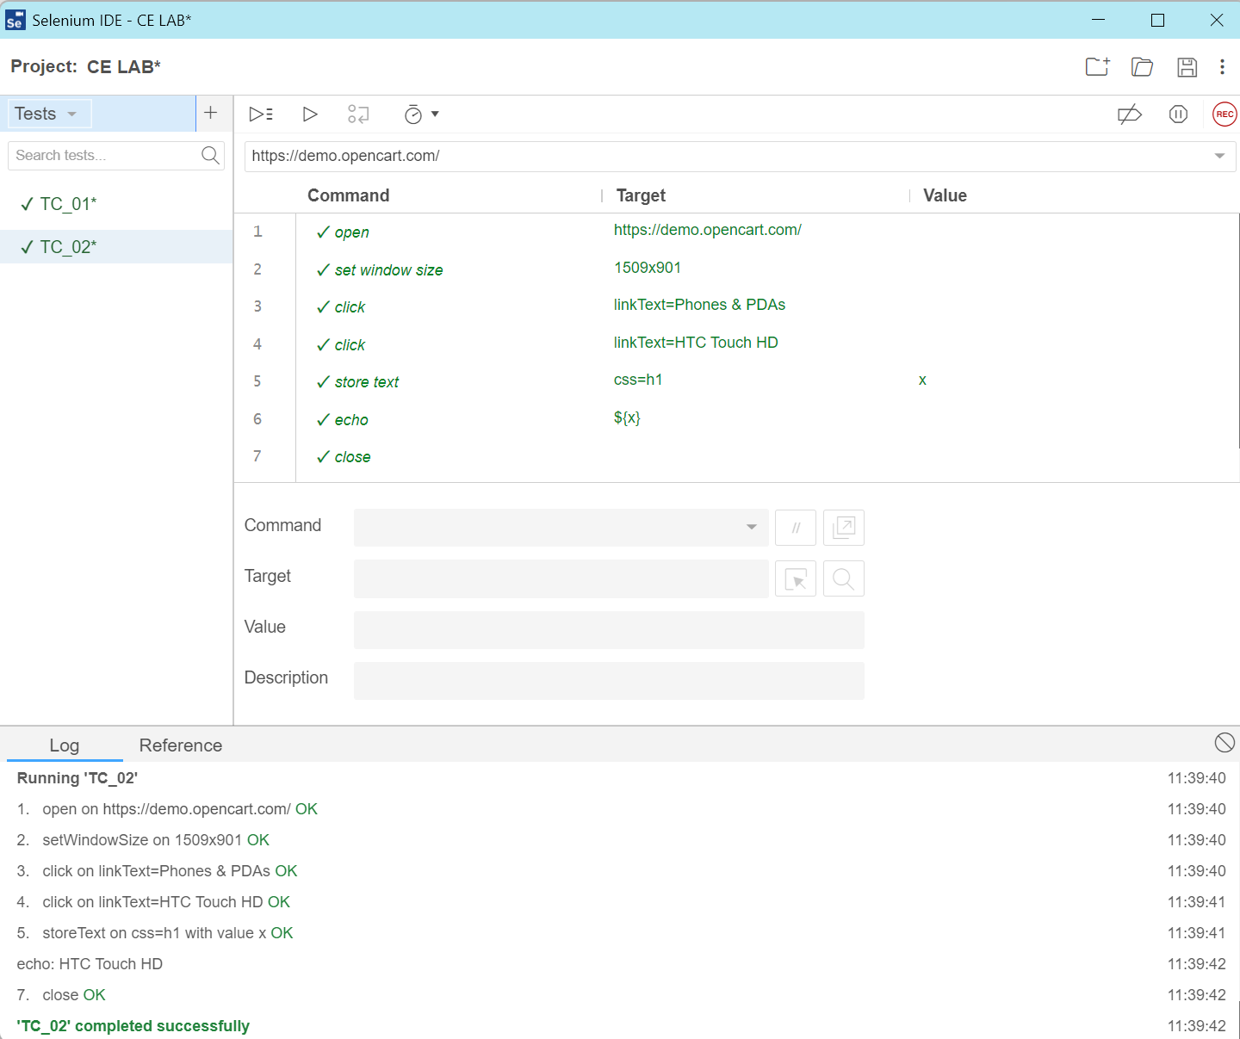

Task 03: Selenese Commands

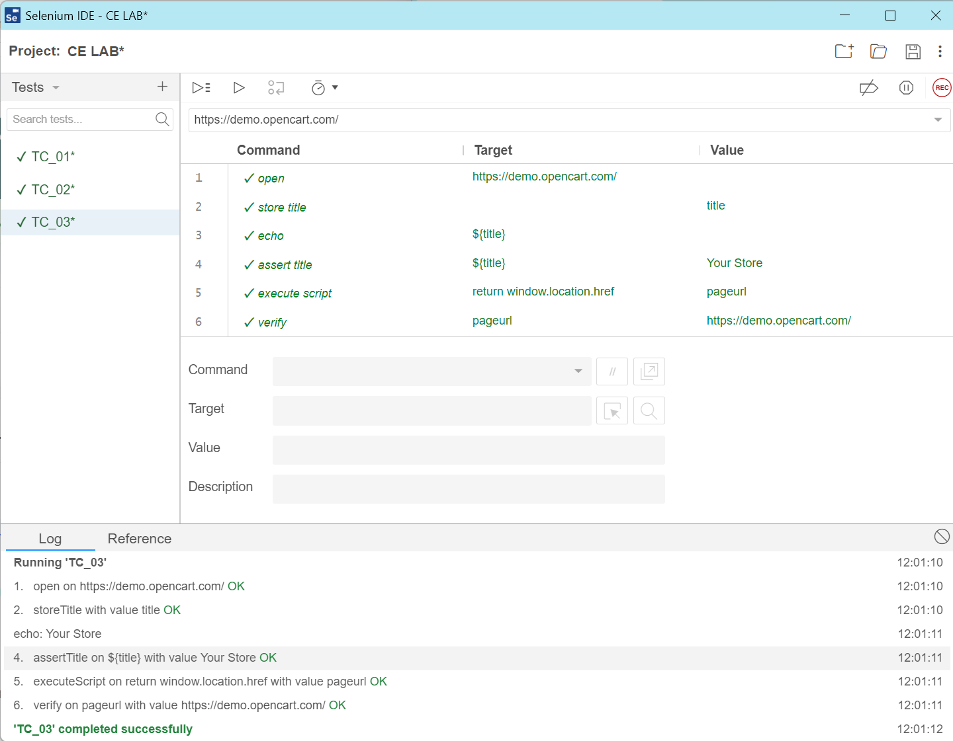

Task 04: Selenese Commands

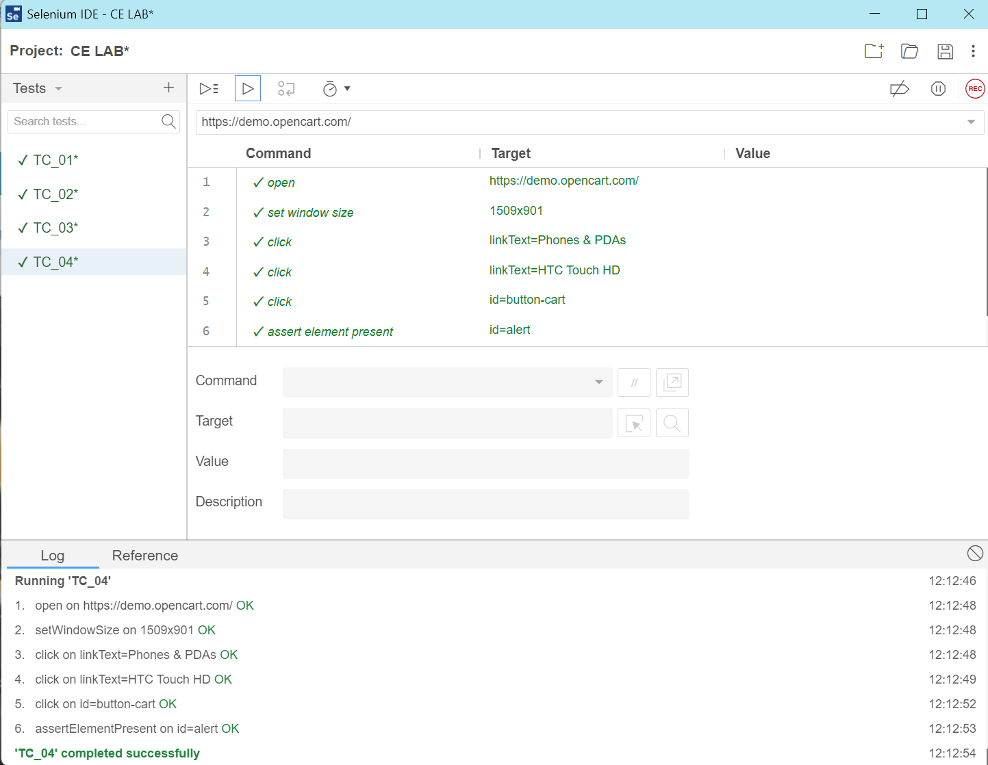

Task 05: Selenese Commands

