A PROJECT REPORT
https://github.com/Imdilshan/Easypass

Submitted by

24bcs10854 – Md Dilshan

24bcs10860 – Kajal

24bcs10861 - Rohit

in partial fulfillment for the award of the degree of

BACHELOR OF ENGINEERING

IN

COMPUTER SCIENCE & ENGINEERING


Chandigarh University

October, 2025

TABLE OF CONTENTS
List of Figures
CHAPTER 1. INTRODUCTION
  - Introduction to Project 5
  - Identification of Problem 6
CHAPTER 2. BACKGROUND STUDY 7
  - Existing solutions 7
  - Problem Definition 8
  - Goals/Objectives 8
CHAPTER 3. DESIGN FLOW/PROCESS 9
  - Evaluation & Selection of Specifications/Features 9
  - Analysis of Features and finalization subject to constraints 9
  - Design Flow 12
CHAPTER 4. RESULTS ANALYSIS AND VALIDATION 13
  - Implementation of solution 13
CHAPTER 5. CONCLUSION AND FUTURE WORK 15
  - Conclusion 15
  - Future work

CHAPTER 1: INTRODUCTION

Introduction to Project

In today’s digital era, online security has become one of the most crucial aspects of modern life. The rising incidents of cyberattacks, data breaches, and account thefts have underscored the importance of creating and using strong, unpredictable passwords. Despite this, many users continue to rely on weak or reused passwords across multiple platforms, significantly increasing their vulnerability to hacking attempts.

To address this issue, the project EasyPass: Strong Password Generator was developed — a Python-based desktop application built using the Tkinter GUI library. It provides users with a simple yet powerful tool to generate secure and customizable passwords efficiently.

Key features of EasyPass include:

Customizable Password Generation: Users can define the desired password length and select preferred character sets such as:

Lowercase letters

Uppercase letters

Numbers

Special characters

Input Validation – Ensures proper user inputs and prevents invalid operations.

Modern Dark-Mode Interface – Provides a clean, user-friendly visual design.

Clipboard Copy Functionality – Allows users to easily copy generated passwords for instant use.

By simplifying the process of generating secure passwords, EasyPass helps both individuals and organizations strengthen cybersecurity practices and improve password management. It makes the creation of strong, reliable passwords accessible, efficient, and visually appealing for all users.

Identification of Problem

With the increasing dependence on online platforms for banking, communication, shopping, and data storage, the need for secure and reliable authentication methods has become more critical than ever. Despite growing awareness, users continue to face several challenges related to password creation and management.

Common issues include:

Difficulty in remembering or manually creating complex passwords — Many users opt for simple or predictable passwords to avoid memorization hassles.

Reusing weak passwords across multiple accounts — This practice significantly increases the risk of credential leaks and unauthorized access.

Limited awareness of password security best practices — Users often overlook important security measures, such as using diverse character sets and sufficient password length.

Exposure to cyber threats like brute-force and dictionary attacks — Hackers exploit predictable patterns and weak passwords to compromise accounts.

Lack of user-friendly and reliable password generation tools — Most users do not have access to secure, offline applications for generating random passwords.

To overcome these challenges, EasyPass automates the process of secure password creation using randomized character combinations and multiple character types, ensuring high entropy and strong resistance against hacking attempts.

CHAPTER 2: BACKGROUND STUDY

2.1 Existing Solutions

In recent years, numerous password management and generation tools have been developed to enhance user security and simplify password handling. However, each of these solutions comes with its own limitations in terms of privacy, control, and accessibility.

Some of the commonly used solutions include:

LastPass and 1Password:

Premium password managers that offer advanced features such as cloud synchronization, password storage, and autofill capabilities.

However, these are often subscription-based and rely on internet connectivity, raising concerns about cost and potential data exposure.

Online Password Generators:

Free web-based tools that generate random passwords quickly.

Despite their convenience, they may pose significant security risks, as data transmitted online can be intercepted or logged by third parties.

Browser-Based Generators (e.g., Chrome, Edge):

Built-in password tools that automatically generate and save passwords within browsers.

These are easy to use but lack user control over the structure, complexity, and randomness of the generated passwords.

While these tools serve their intended purpose, they often compromise on one or more aspects such as security, cost-effectiveness, or customization.

In contrast, EasyPass offers a lightweight, open-source, and completely offline solution that emphasizes:

User privacy — No cloud storage or online data transmission.

Flexibility — Full control over password length and composition.

Accessibility — Free to use, minimal setup, and suitable for both technical and non-technical users.

2.2 Problem Definition

The project focuses on developing a desktop-based password generator application that enables users to create strong, secure, and customizable passwords with ease. The goal is to provide a safe, offline alternative to online password generators while maintaining simplicity and user convenience.

The system is designed to:

Allow users to define password length according to their security requirements.

Enable character-type selection, including lowercase letters, uppercase letters, digits, and special symbols.

Display the generated password clearly within the interface.

Provide a one-click copy-to-clipboard option for quick and easy use.

By generating passwords locally on the user’s device, the application ensures maximum privacy and data security, eliminating reliance on external websites or third-party servers.

This enhances both usability and trustworthiness, making password creation efficient, customizable, and secure.

2.3 Goals/Objectives

The primary goal of the EasyPass project is to develop a secure, efficient, and user-friendly password generation tool that empowers users to create strong and reliable passwords with minimal effort.

The main objectives of EasyPass are as follows:

Generate strong and random passwords with high complexity to resist brute-force and dictionary attacks.

Allow full customization by letting users define password length and choose from multiple character sets (uppercase, lowercase, digits, and special symbols).

Provide an intuitive graphical interface (GUI) built using Tkinter, ensuring simplicity and ease of use for all users.

Enhance user privacy and data security by operating entirely offline without storing or transmitting any sensitive information.

Promote cybersecurity awareness by encouraging better password hygiene and highlighting the importance of strong credentials.

Through these objectives, EasyPass aims to combine security, usability, and accessibility, offering a dependable tool that supports safer digital practices.

CHAPTER 3: DESIGN FLOW / PROCESS

3.1 Evaluation & Selection of Specifications/Features

To achieve high performance, ease of use, and aesthetically appealing design, the following specifications and features were carefully evaluated and selected for the development of EasyPass: Strong Password Generator.

Programming Language: Python 3.x

Rationale for Selection:

Offers excellent readability and a clean syntax, making the code easy to maintain and extend.

Provides cross-platform compatibility, ensuring smooth operation across Windows, macOS, and Linux.

Includes the Tkinter library by default, enabling efficient development of graphical user interfaces without additional installations.

Framework: Tkinter & ttk (Themed Tkinter Widgets)

Purpose:

To create an interactive and visually GUI that enhances user experience.

Advantages:

The ttk (themed Tkinter) module allows for modernized widget styling.

Enables dark mode aesthetics with accent colors for a professional and user-friendly appearance.

Core Functionalities

The core functionality of EasyPass was designed to balance security, usability, and simplicity.

Key features include:

Customizable password length based on user preference.

Character set selection – lowercase letters, uppercase letters, numbers, and special symbols.

Clipboard copy functionality for quick and effortless password usage.

Input validation mechanisms to handle invalid or empty inputs gracefully.

Interface Design

Design Approach:

A dark-themed interface with soft accent colors provides a clean, minimal, and visually comfortable user experience.

The layout emphasizes simplicity, contrast, and accessibility, ensuring clarity even for first-time users.

3.2 Analysis of Features and Finalization

During the design and development phase of EasyPass: Strong Password Generator, various features and limitations were analyzed to ensure the application’s functionality, reliability, and user satisfaction. The final version of the system balances security, usability, and performance within the defined constraints.

Constraints

To maintain both system integrity and user experience, the following constraints were applied:

Password Length Constraint: The password length must be a positive integer, typically within a user-defined safe range (e.g., 4–64 characters).

Character Selection Constraint: At least one character set (lowercase, uppercase, numbers, or symbols) must be selected to generate a valid password.

Clipboard Functionality Constraint: Clipboard copying may behave differently across operating systems depending on permission settings or security restrictions.

These constraints ensure logical consistency, error prevention, and cross-platform stability during execution.

Algorithm Complexity

The password generation process is based on randomized selection of characters from the chosen sets.

Time Complexity: O(n)

where n = desired password length.

Each iteration involves a single random character selection, making the algorithm efficient and scalable even for longer passwords.

This ensures real-time password generation without any noticeable delay.

Advantages

The finalized system offers several practical and technical benefits:

Offline and Secure: No data transmission or cloud dependency, ensuring full user privacy.

Lightweight and Minimal Dependencies: Requires only Python’s standard libraries (Tkinter and random).

User-Friendly Interface: Simple layout with modern dark-mode aesthetics for intuitive use.

High Performance: Generates complex passwords almost instantly, regardless of length.

3.3 Design Flow

The EasyPass: Strong Password Generator follows a structured and user-centric design flow that ensures smooth functionality and secure password generation. The process is divided into sequential stages, from input collection to password output and clipboard integration.

Step 1: User Input

The user specifies the desired password length and selects the types of characters to include:

Lowercase letters

Uppercase letters

Numbers

Special characters

These selections determine the composition and complexity of the final password.

Step 2: Input Validation

The system validates the entered data to ensure:

Password length is a positive integer.

At least one character set has been selected.

If invalid input is detected, an error message is displayed, prompting the user to make corrections.

Step 3: Password Generation

The validated character sets are combined into a single pool.

Using Python’s random.choice() function, characters are randomly selected from this pool to form the password.

The algorithm runs with a time complexity of O(n), where n is the password length, ensuring fast execution.

Step 4: Display Output

The generated password is displayed in a read-only entry box within the Tkinter interface.

This prevents accidental editing or overwriting of the generated password.

Step 5: Clipboard Copy

When the user clicks the “Copy Password” button, the system copies the generated password directly to the clipboard using Tkinter’s built-in clipboard functions.

This feature allows for instant use in other applications or registration forms without retyping.

This structured design flow ensures that the system remains intuitive, efficient, and secure, offering users a reliable way to generate strong passwords with minimal effort.

CHAPTER 4: RESULTS ANALYSIS AND VALIDATION

4.1 Implementation of Solution

The EasyPass: Strong Password Generator application was successfully implemented using Python 3.x with the Tkinter library and ttk (Themed Tkinter Widgets) for a modern, dark-themed graphical interface. The system provides a responsive, user-friendly environment with interactive elements such as entry boxes, buttons, and checkboxes to manage password generation settings.

Implementation Steps

Interface Setup

A Tkinter main window (root) was created and styled using ttk themes to establish a modern dark-mode appearance.

Layout elements such as labels, entry fields, buttons, and checkboxes were organized using grid and pack geometry managers for consistency and readability.

Input and Selection

The user is prompted to:

Enter the desired password length.

Select the desired character types (lowercase, uppercase, numbers, and special characters).

Each character type is linked to a Tkinter Boolean variable, allowing real-time customization of password criteria.

Random Generation

The new_rand() function dynamically constructs a character pool based on user selections.

Random password generation is handled using Python’s random.choice() method, iterating over the specified password length to produce a unique, high-entropy password.

The generated password is then displayed in a read-only entry box within the GUI.

Clipboard Functionality

The clipper() function allows the generated password to be copied directly to the clipboard with a single click.

This functionality ensures quick and error-free transfer of passwords for immediate use in login forms or applications.

Error Handling

The system incorporates robust validation mechanisms to handle:

Invalid password length (e.g., empty or non-numeric values).

No character type selection.

Sample output:

Ttk version
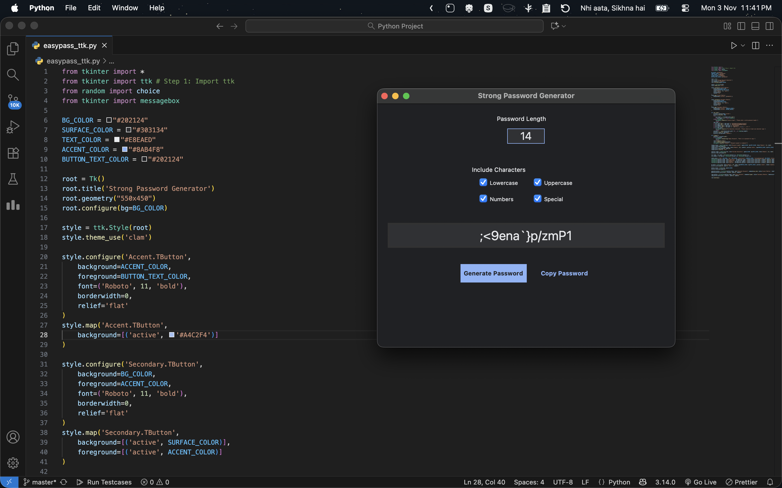

Terminal version

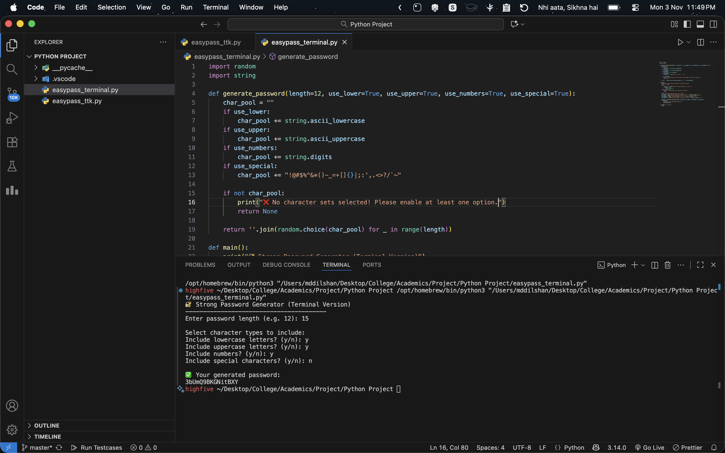

CHAPTER 5: CONCLUSION AND FUTURE WORK

5.1 Conclusion

The Easypass Strong Password Generator successfully provides a secure, efficient, and user-friendly solution for generating strong and complex passwords. The application ensures high randomness, customization flexibility, and complete privacy, as all operations are executed locally without requiring an internet connection.

This project highlights the practical implementation of Python’s GUI development using Tkinter and demonstrates how security-focused tools can enhance user awareness and data protection in modern digital environments. Overall, Easypass fulfills its goal of promoting better password hygiene and simplifying the process of creating strong credentials.

5.2 Future Work

The project can be further enhanced with the following improvements and features:

Integration of a password strength meter to provide real-time feedback on password robustness.

Implementation of a secure local database for storing passwords in encrypted form.

Export functionality to save generated passwords in text or CSV formats.

Inclusion of a light/dark mode toggle for improved user experience.

Development of a web or mobile version to increase accessibility and usability across platforms.

