**Introduction**: N-bit arithmetic logic unit circuit that includes addition, subtraction, multiplication, shift, and logical and, or, not, and xor

**Purpose**: Select specific unit using control input and perform the arithmetic as such

**Materials used**: Nexys4 DDR board with Artix -7 FPGA, USB cable, laptop, Vivado Software.

**Results**:

Explanation of multiplier

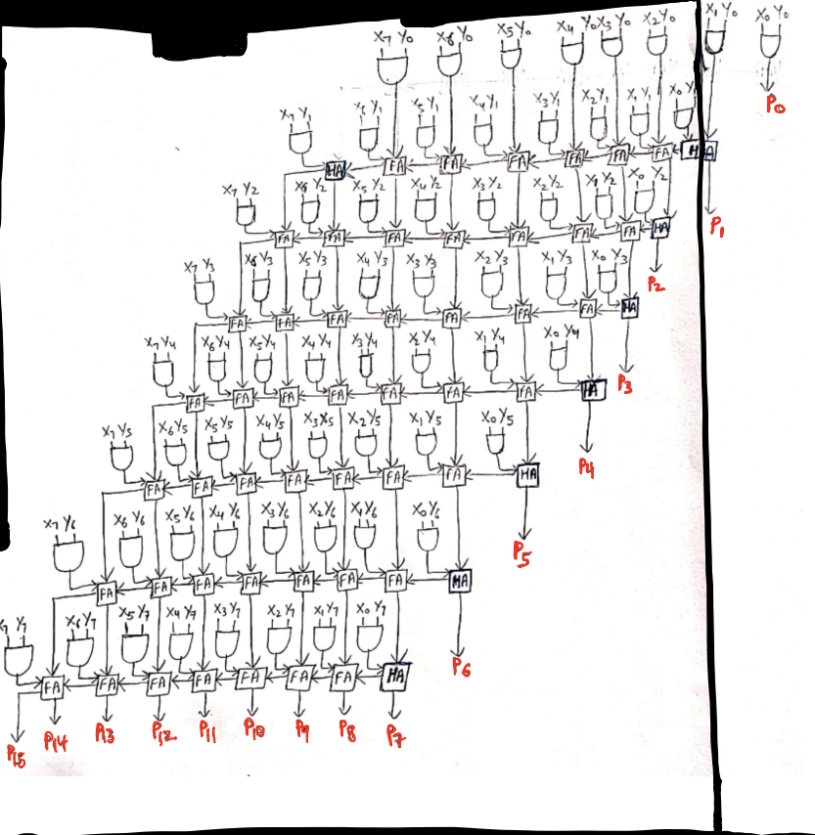

Schematic

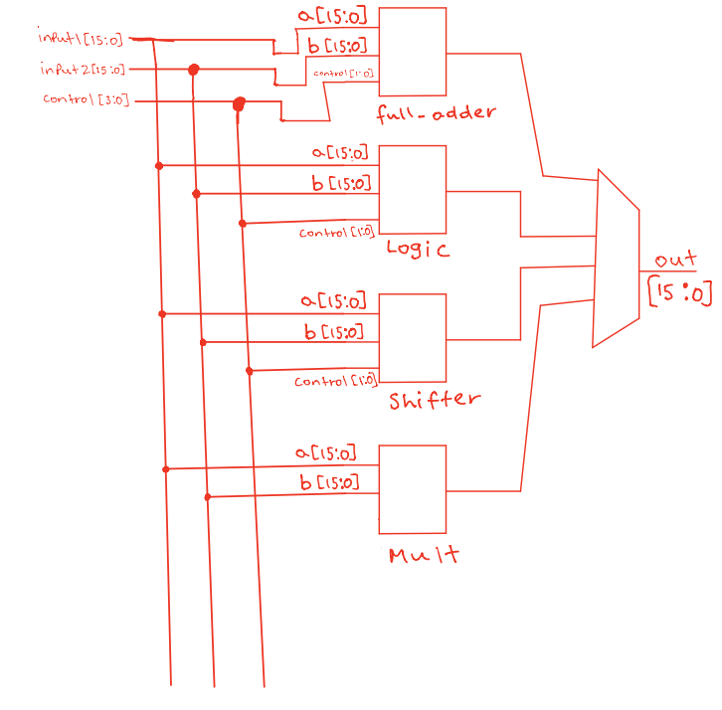

**Waveform**

8X8 file waveform

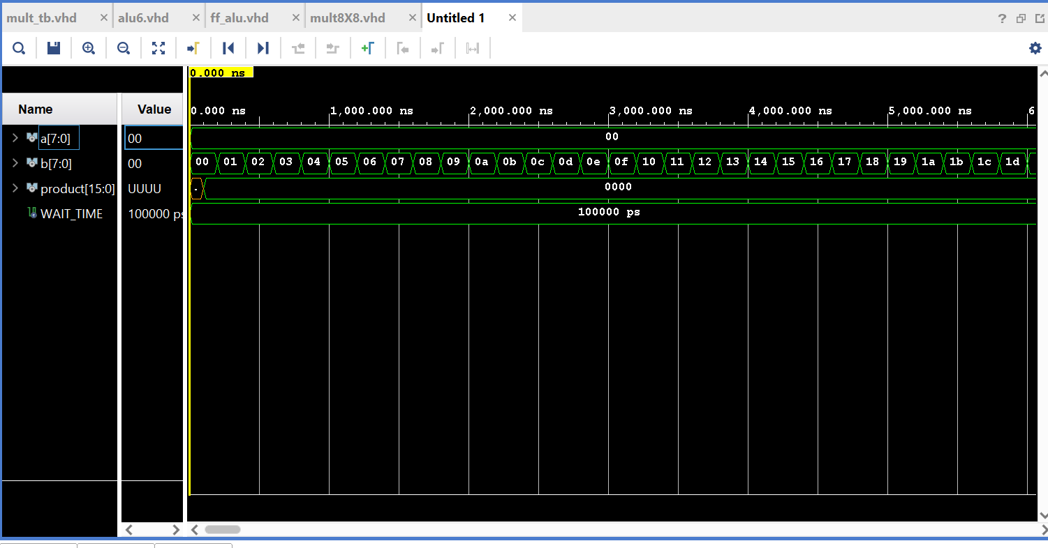

8X8 text file

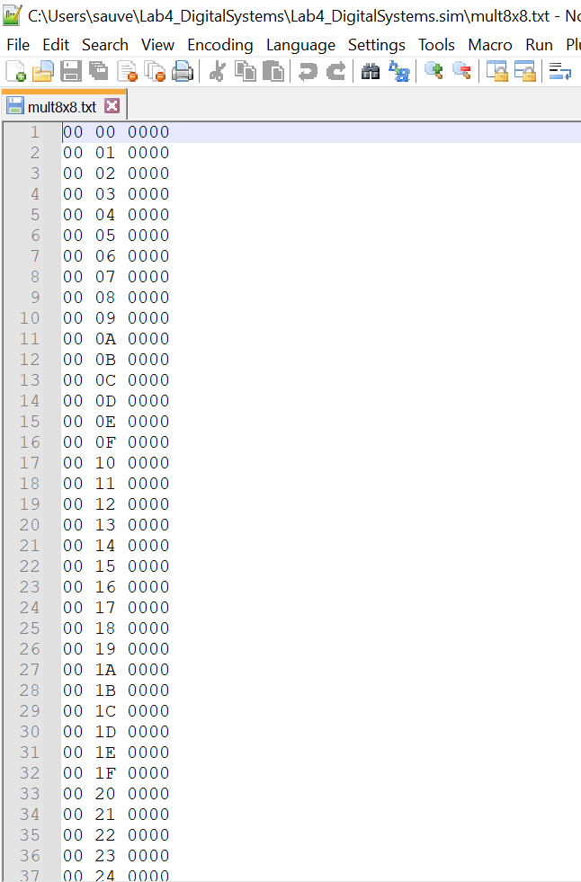

Mult_tb working waveform

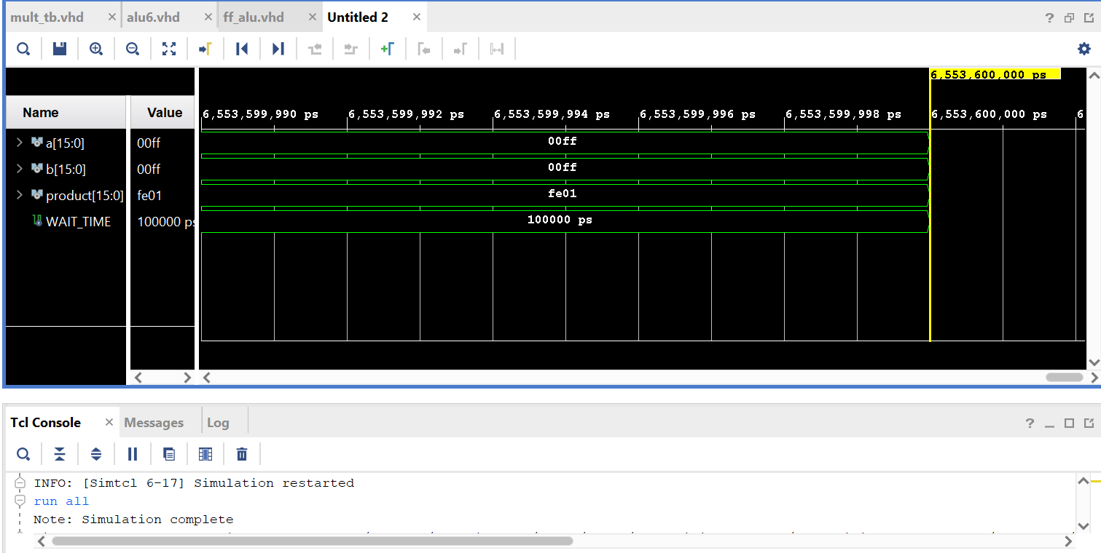

Mult_tb Incorrect waveform

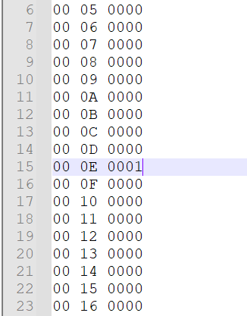

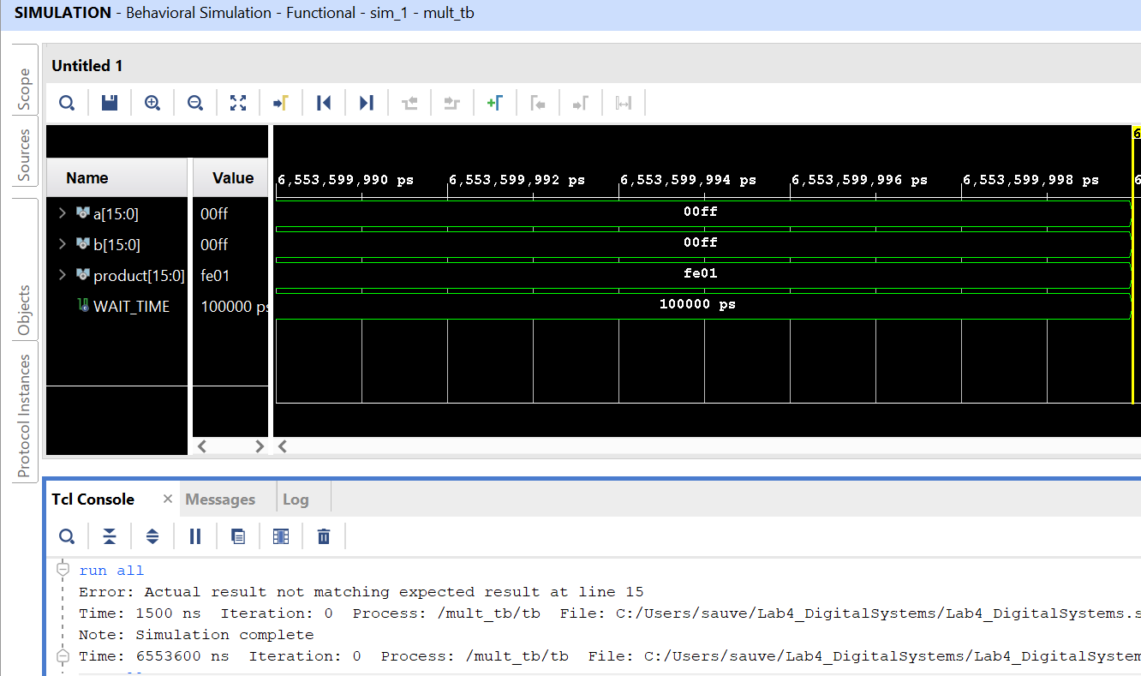

Alu_tb waveform

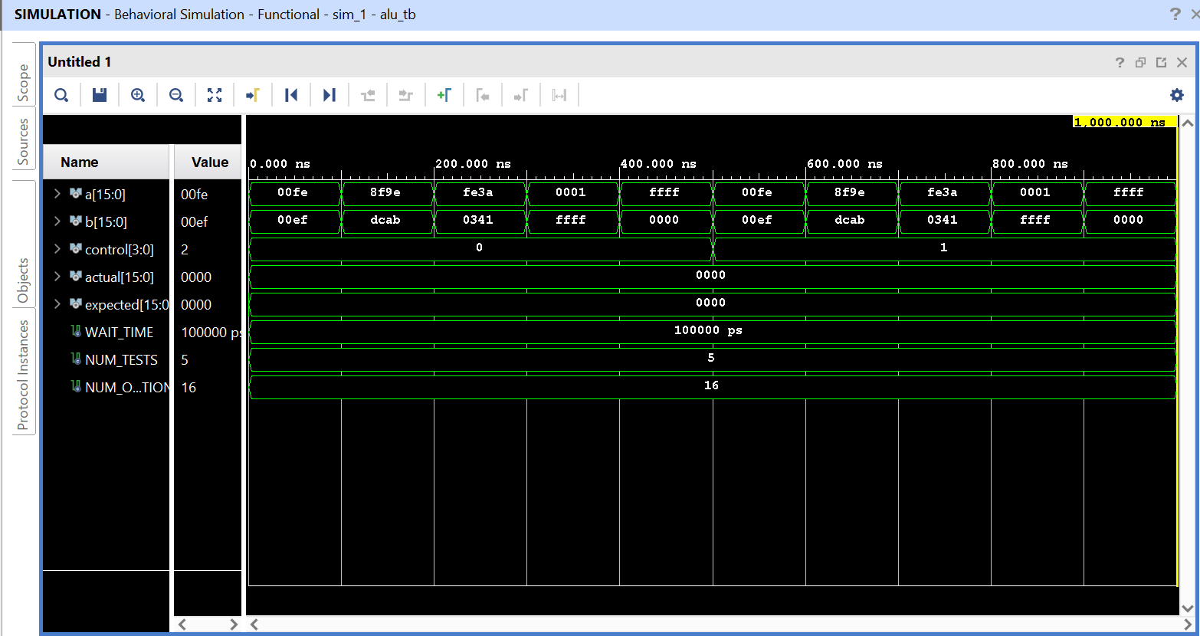

**Flip flop schematic**

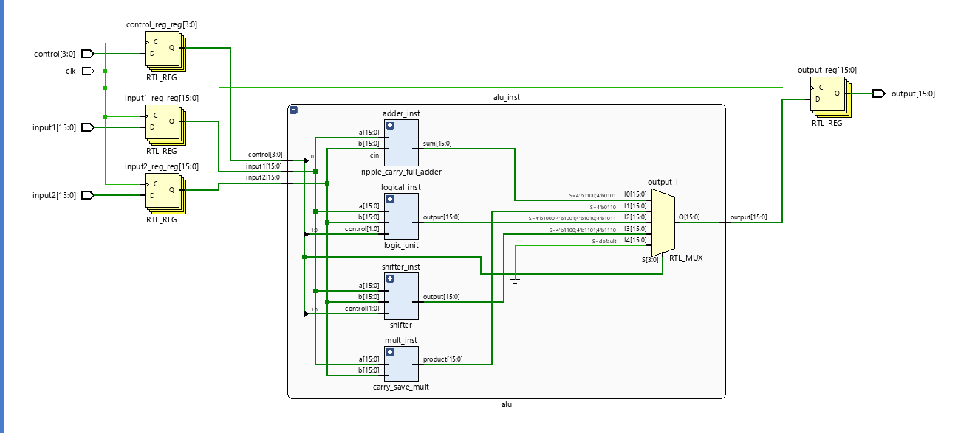

**Table of info**

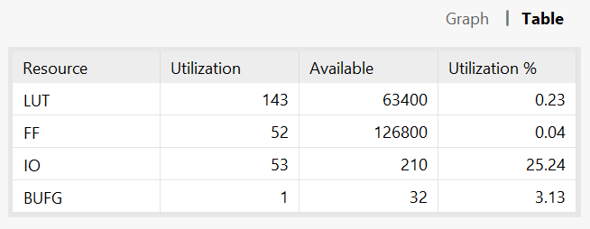

**Time and Area Report for ALU**

|  |  |  |  |  |  |  |
| --- | --- | --- | --- | --- | --- | --- |
| **Slices**  **LUT’s used** | **Slices used** | **Slack** | **CPD** | **M. Frequency** | **Logic levels** | **Data path Delay** |
| **143** | **47** | **3.593 ns** | **6.407ns** | **156,079.288 MHz** | **9** | **6.408 ns** |

**CPD = Required – Slack**

**CPD = 10 – 3.593**

**Frequency in MHz = (1/CPD) * 10^6**