
UNIT INFORMATION
UNIT CODE
UNIT NAME
ASSESSMENT TYPE
PROJECT TITLE
STUDENT INFORMATION
STUDENT NAME
STUDENT ID
BRANCH
BATCH

1. Introduction — Purpose and Scope
Purpose: to automate the core end-to-end purchase journey of the public Demoblaze demo e-commerce site (https://www.demoblaze.com/) using Selenium WebDriver with TestNG, replacing repetitive manual smoke/regression checks with a repeatable, self-documenting suite.
Scope covered (5 automated test cases, classes DemoBlazeTest / BaseTest):
- TC01 – Home page smoke test: title, PRODUCT STORE heading (id + XPath cross-check), URL.
- TC02 – Product selection: Phones category → Samsung galaxy s6 → heading + price verification.
- TC03 – Add to cart: JS alert handling and cart-content verification.
- TC04 – Cart management: two products, findElements list + loop, Delete flow, dynamic cart-total check.
- TC05 – Checkout validation: invalid (empty Name/Card) alert path + valid fictitious purchase with success-message assertion.
Out of scope: user signup/login, real payments, API/performance/security testing, cross-browser matrix (Chrome only for this submission). All order data used is fictitious test data.

2. Test Environment
Exact versions captured from this machine at report time (verified via java -version, mvn -version, Chrome file version, IntelliJ build info, and pom.xml / surefire XML):
Component | Version / Detail
Java (runtime) | Oracle JDK 20.0.2 (build 20.0.2+9-78, 64-bit)
Java (project config) | maven.compiler.source/target = 17; IntelliJ language level JDK_17
Maven | Apache Maven 3.9.14
Selenium | selenium-java 4.47.0 (from pom.xml)
TestNG | 7.10.2 (test scope, from pom.xml)
Browser | Google Chrome 153.0.8010.54 (chrome.exe ProductVersion)
ChromeDriver | Managed automatically by Selenium Manager (no manual driver binary)
IDE | IntelliJ IDEA 2025.2.4 (Ultimate Edition, build IU-252.27397.103)
OS | Windows 11 (10.0, amd64)
Base URL | https://www.demoblaze.com/
Run command | mvn test (Surefire + TestNG, TestSuite)

3. Test Scenarios
Each test starts from a fresh browser (see §4), so tests are independent. Prices are read at runtime; no hard-coded totals.
Test-case ID | Objective | Steps (summary) | Test data | Expected result
TC01  Home Page Smoke | Verify store home page loads | 1. Open base URL  2. Wait id=nava  3. Read title, heading, URL  4. Screenshot | — (no input) | Non-empty title; PRODUCT STORE heading visible (id + XPath); URL contains demoblaze.com
TC02  Product Selection | Open S6 product detail | 1. Click Phones (linkText)  2. Click Samsung galaxy s6  3. Read h2.name + price  4. Screenshot | Product: Samsung galaxy s6 | Heading equals product name; price visible and contains "$"
TC03  Add to Cart | Add S6; handle alert; verify cart | 1. UI add (helper)  2. alertIsPresent → read/accept  3. Open Cart  4. Check rows  5. Screenshot | Product: Samsung galaxy s6 | Alert contains "Product added"; cart row contains S6
TC04  Cart Management | Add 2, delete 1, verify total | 1. Add S6 + Nokia lumia 1520  2. List rows + loop print  3. Delete Nokia  4. numberOfElementsToBe(1)  5. Parse total vs row price | S6 + Nokia lumia 1520 | 2 rows → 1 row; S6 remains; total == S6 row price
TC05  Checkout Validation | Invalid then valid purchase | 1. Add S6 → Cart → Place Order  2. Purchase with Name/Card empty → alert  3. Fill 6 fields → Purchase  4. Success heading → OK | Fictitious: Smoke Test User / Testland / Test City / 4111111111111111 / 12 / 2030 | Invalid → "Please fill out Name and Creditcard." + modal stays; Valid → "Thank you for your purchase!"

4. Project Design

4.1 Class structure
- BaseTest (abstract, src/test/java/BaseTest.java): shared WebDriver + WebDriverWait, BASE_URL, TIMEOUT_SECONDS=15, @BeforeMethod setUp(), @AfterMethod tearDown(), takeScreenshot() helper.
- DemoBlazeTest extends BaseTest (src/test/java/DemoBlazeTest.java): 5 @Test methods (tc01…tc05) + 3 reusable helpers: addProductToCartViaUi(), openCart(), parsePrice().
- src/main/java/com/org/Main.java: default scaffold, not used by tests (kept for Maven layout).

4.2 Setup (@BeforeMethod)
ChromeOptions options = new ChromeOptions();
if ("true".equalsIgnoreCase(System.getenv("HEADLESS"))) options.addArguments("--headless=new");
options.addArguments("--start-maximized");
driver = new ChromeDriver(options);
driver.manage().window().maximize();
driver.manage().timeouts().implicitlyWait(Duration.ofSeconds(0)); // explicit waits only
wait = new WebDriverWait(driver, Duration.ofSeconds(15));
driver.get(BASE_URL);

4.3 Cleanup (@AfterMethod)
@AfterMethod(alwaysRun = true)
public void tearDown() { if (driver != null) { try { driver.quit(); } catch (Exception ignored) {} finally { driver = null; } } }
alwaysRun = true guarantees the browser quits even when a test fails; each test therefore gets a fresh profile/cart (test independence).

4.4 Reusable data
SAMSUNG_S6 = "Samsung galaxy s6"; NOKIA_LUMIA = "Nokia lumia 1520";
TEST_NAME = "Smoke Test User"; TEST_COUNTRY = "Testland"; TEST_CITY = "Test City";
TEST_CARD = "4111111111111111"; // fictitious, demo site only
TEST_MONTH = "12"; TEST_YEAR = "2030";
BASE_URL = "https://www.demoblaze.com/"; TIMEOUT_SECONDS = 15;

5. Locator Strategy
Rule applied throughout: at least one non-XPath locator per test (id / linkText) plus XPath where structure or text-matching is needed. Implicit wait is 0; every lookup goes through an explicit wait.
Locator (as coded) | Type | Used in | Reason for selection
By.id("nava") | id (non-XPath) | TC01 | Stable unique id for PRODUCT STORE brand link; fastest and most readable.
//a[contains(text(),"PRODUCT STORE")] | XPath | TC01 | Text cross-check of same heading; proves XPath skill + guards id change.
By.linkText("Phones") | linkText (non-XPath) | TC02 + helper | Category tab has exact visible text; linkText is the most expressive choice.
//a[normalize-space()="Samsung galaxy s6"] | XPath | TC02 + helper | Product tile has no id; exact normalized text is the only stable hook.
//h2[@class="name"] | XPath | TC02 | Product-detail title; class+tag is stable on detail page.
//h3[contains(@class,"price-container")] | XPath | TC02 | Price block includes tax suffix; class-contains tolerates extra classes.
//a[text()="Add to cart"] | XPath | helper | Exact button text on detail page; no usable id.
//tbody[@id="tbodyid"]/tr | XPath | TC03/TC04 | Cart rows container; only reliable hook for row counting.
./td[2] , ./td[3] | Relative XPath | TC04 loop | Row-scoped title/price cells; avoids fragile absolute paths.
//tr[td[text()="Nokia lumia 1520"]]//a[text()="Delete"] | XPath | TC04 | Row-anchored delete: deletes the right product even if order changes.
By.id("totalp") | id (non-XPath) | TC04 | Cart total element; unique id, ideal for wait + read.
//button[text()="Place Order"] / //button[text()="Purchase"] / //button[text()="OK"] | XPath | TC05 | Modal buttons have no ids; exact text is stable.
By.id("orderModal"), By.id("name"), By.id("country"), By.id("city"), By.id("card"), By.id("month"), By.id("year") | id (non-XPath) | TC05 | Form fields/modal all expose stable ids; preferred over XPath.
//h2[contains(text(),"Thank you for your purchase")] | XPath | TC05 | Success heading is text-only; contains() tolerates whitespace/newlines.
By.linkText("Cart") | linkText (non-XPath) | openCart() | Top-nav cart link; semantic and stable.

6. Implementation — Waits, Actions, Alerts, Lists, Loops, Assertions

6.1 Waits (explicit only)
- Global: WebDriverWait(driver, 15 s); implicit wait set to 0 so timing is fully explicit and deterministic.
- visibilityOfElementLocated – headings, prices, modal, success message.
- elementToBeClickable – Phones, product links, Add to cart, Delete, Place Order/Purchase/OK.
- alertIsPresent – both Add-to-cart and invalid-checkout alerts (no Thread.sleep anywhere).
- presenceOfAllElementsLocatedBy + numberOfElementsToBe(tr, 1) – cart row load and delete synchronization.
- ExpectedConditions.or(rows present, total visible) in openCart() – cart page ready under both states.

6.2 Actions (click / sendKeys / navigation)
- click(): category, product, cart, modal buttons, row Delete, OK dismissal.
- sendKeys(): all six order-form fields (name, country, city, card, month, year).
- driver.get(BASE_URL): fresh navigation inside addProductToCartViaUi() so helpers are self-contained.
- window maximize + --start-maximized; optional HEADLESS env flag for CI.

6.3 Alerts
Alert alert = wait.until(ExpectedConditions.alertIsPresent());
String text = alert.getText(); // e.g. "Product added" / "Please fill out Name and Creditcard."
Assert.assertTrue(text.contains(...)); alert.accept();
Add-to-cart uses contains("Product added") because the live site has shown both "Product added" and "Product added."; invalid checkout asserts "Please fill out Name and Creditcard." then verifies the modal is still open and no success heading exists.

6.4 Lists and loops
List<WebElement> cartRows = wait.until(presenceOfAllElementsLocatedBy(By.xpath("//tbody[@id='tbodyid']/tr")));
for (WebElement row : cartRows) {
String title = row.findElement(By.xpath("./td[2]")).getText();
String price = row.findElement(By.xpath("./td[3]")).getText();
System.out.println("TC04 - Cart item: " + title + " | Price: " + price);
}
boolean present = rows.stream().anyMatch(r -> r.getText().contains(SAMSUNG_S6));

6.5 Assertions (TestNG Assert)
- TC01: assertNotNull/assertFalse(title), assertTrue(heading displayed ×2), URL contains demoblaze.com.
- TC02: assertEquals(heading, product name), price contains "$".
- TC03: alert contains "Product added"; cart stream-match for S6.
- TC04: assertEquals(rows, 2) → assertEquals(remaining, 1); remaining contains S6 / not Nokia; assertEquals(actualTotal, expectedTotal) with dynamic parsePrice().
- TC05: invalid alert text; modal still displayed; success heading absent-then-present with text check.

7. Test Execution — TestNG Result and Screenshots
Command: mvn test. Report sources: target/surefire-reports/TestSuite.txt, TEST-TestSuite.xml, emailable-report.html. Last full run: 5 tests, 0 failures, 0 errors, 0 skipped, elapsed 70.14 s.
Test method | Description | Status | Evidence screenshot
tc01HomePageSmokeTest | TC01 – Home Page Smoke | PASSED | TC01-HomePage-*.png
tc02ProductSelection | TC02 – Product Selection | PASSED | TC02-ProductSelection-*.png
tc03AddToCart | TC03 – Add to Cart | PASSED | TC03-AddToCart-*.png
tc04CartManagement | TC04 – Cart Management | PASSED | TC04-CartManagement-*.png
tc05CheckoutValidation | TC05 – Checkout Validation | PASSED | TC05-CheckoutSuccess-*.png

Overall: Tests run: 5, Failures: 0, Errors: 0, Skipped: 0 — BUILD SUCCESS.
Console also prints per-test diagnostics (title, heading, price, alert texts, cart rows, totals) and "Screenshot saved: target/screenshots/…" lines; screenshots below are embedded from target/screenshots of the passing run.
[ Screenshot TC01 — Home page — PRODUCT STORE heading and title check ]
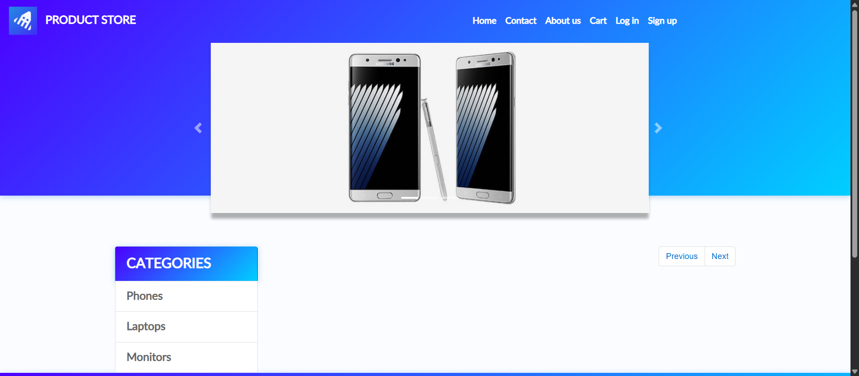
Figure 7.1 — TC01: TC01-HomePage-1790246840794.png (actual captured evidence, target/screenshots/).
[ Screenshot TC02 — Product detail — Samsung galaxy s6 heading + price ]
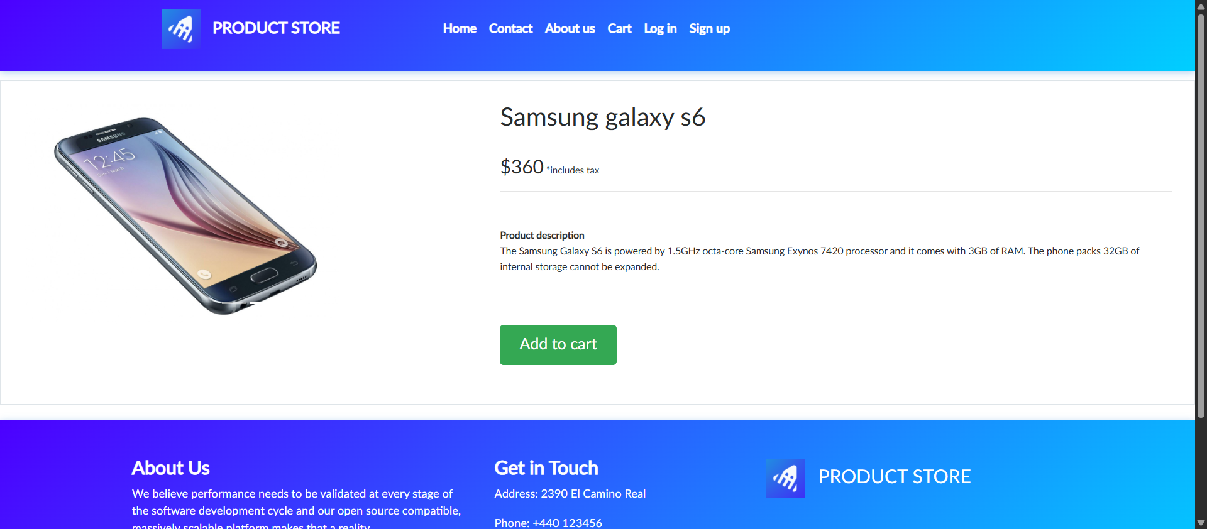
Figure 7.2 — TC02: TC02-ProductSelection-1790246848626.png (actual captured evidence, target/screenshots/).
[ Screenshot TC03 — Cart after Add-to-cart alert accepted ]
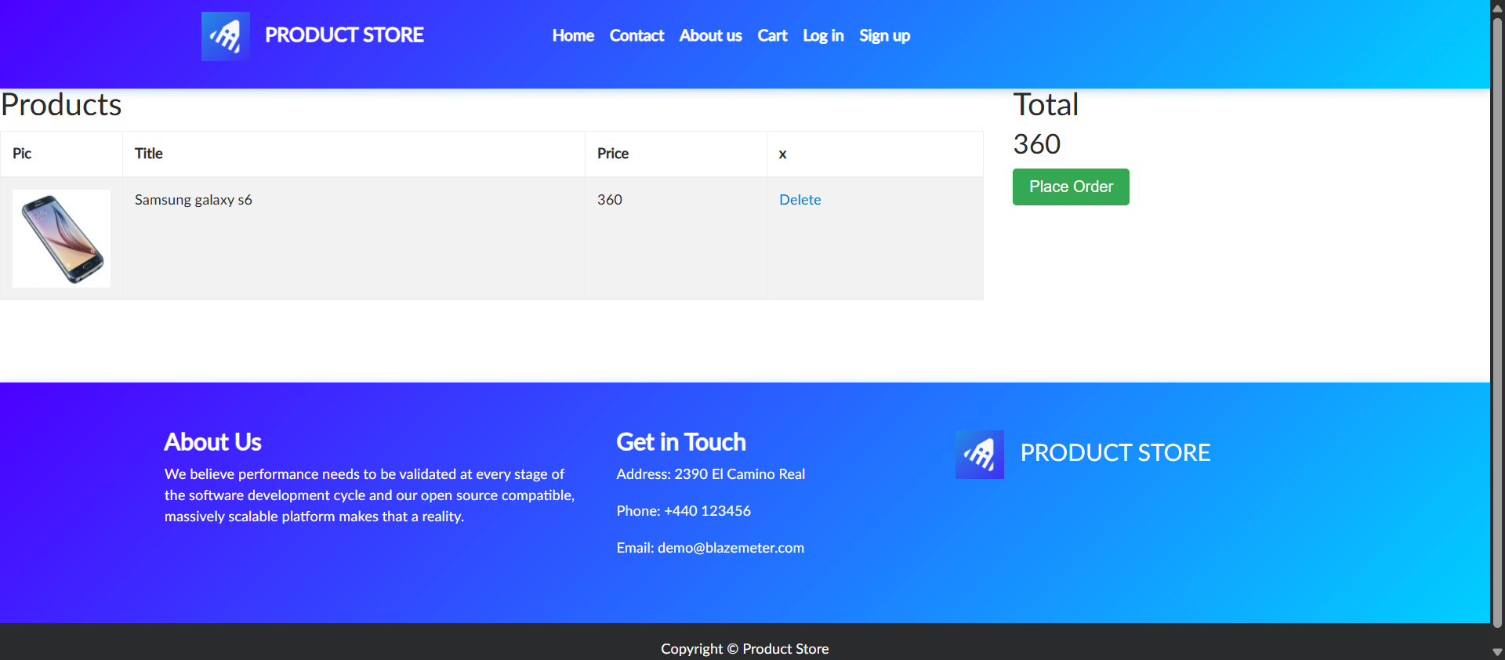
Figure 7.3 — TC03: TC03-AddToCart-1790246864962.png (actual captured evidence, target/screenshots/).
[ Screenshot TC04 — Cart management — single remaining row + total ]
Figure 7.4 — TC04: TC04-CartManagement-1790246886568.png (actual captured evidence, target/screenshots/).
[ Screenshot TC05 — Checkout — purchase success confirmation ]
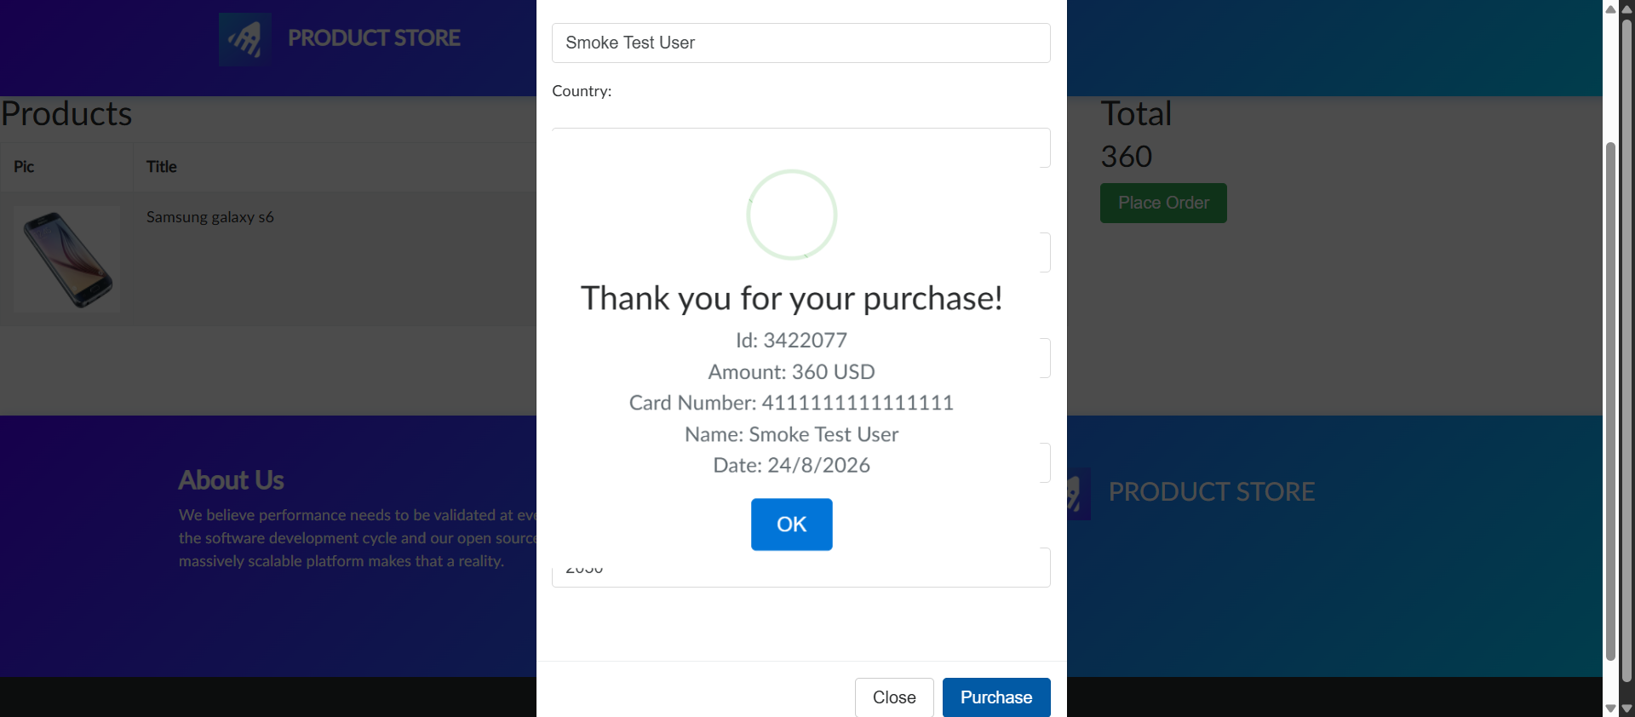
Figure 7.5 — TC05: TC05-CheckoutSuccess-1790246901857.png (actual captured evidence, target/screenshots/).
[ Additional TestNG report screenshot — paste emailable-report.html / IntelliJ run panel here ]
How to capture it: run `mvn test`, open target/surefire-reports/emailable-report.html (or index.html), screenshot the 5-passed summary, and paste below this label.

8. Issues and Limitations
- Public-site volatility: Demoblaze is a live demo store; product prices, alert punctuation ("Product added" vs "Product added."), and modal timing can change. Mitigated with contains-checks and runtime price parsing instead of hard-coded totals.
- Timing sensitivity: cart table re-renders after Delete; mitigated with numberOfElementsToBe(tr, 1) rather than sleep. Slow networks may still need the 15 s explicit timeout raised.
- Test independence cost: fresh browser per test (clean cart) makes each run open/close Chrome 5 times (~70 s total); faster but state-coupled alternatives (single login/cart reuse) were deliberately avoided for reliability.
- Assumptions: Chrome + Selenium Manager driver is available; internet access to demoblaze.com; fictitious checkout data (4111111111111111) is accepted by the demo site and triggers no real transaction.
- Known non-issue: Main.java scaffold is unused; suite entry point is TestNG via Maven Surefire, not main().

9. Conclusion — Summary of Achieved Automation Coverage
All 5 planned scenarios (TC01–TC05) are automated and passing (5/5, 0 failures), covering the critical purchase funnel: landing → category → product detail → add-to-cart alert → cart list/delete/total → invalid + valid checkout. The suite demonstrates the required techniques — explicit waits, id/linkText + XPath locators, alert handling, findElements lists with loops/streams, dynamic assertions, per-test setup/cleanup, and screenshot evidence — and can be re-run with a single `mvn test`. Recommended next steps: parameterize products via TestNG @DataProvider, add login/signup tests, and wire the suite into CI with HEADLESS=true.

Appendices

Appendix A — Selected Source-Code Extracts
[ Appendix A1 — BaseTest.java (setup, cleanup, screenshot helper) — full file follows ]
import org.openqa.selenium.OutputType;
import org.openqa.selenium.TakesScreenshot;
import org.openqa.selenium.WebDriver;
import org.openqa.selenium.chrome.ChromeDriver;
import org.openqa.selenium.chrome.ChromeOptions;
import org.openqa.selenium.support.ui.WebDriverWait;
import org.testng.annotations.AfterMethod;
import org.testng.annotations.BeforeMethod;
import java.io.File;
import java.io.IOException;
import java.nio.file.Files;
import java.nio.file.Path;
import java.nio.file.Paths;
import java.nio.file.StandardCopyOption;
import java.time.Duration;
// Common setup for all Demoblaze tests: browser control + reusable data + cleanup.
public abstract class BaseTest {
// Reusable data: base URL and shared timeout (used by all test methods).
protected static final String BASE_URL = "https://www.demoblaze.com/";
protected static final int TIMEOUT_SECONDS = 15;
protected WebDriver driver;
protected WebDriverWait wait;
// Runs before every @Test: open Chrome, maximize, navigate to the store.
@BeforeMethod
public void setUp() {
ChromeOptions options = new ChromeOptions();
// Keep the suite headed by default (beginner-friendly); allows CI headless via env var.
if ("true".equalsIgnoreCase(System.getenv("HEADLESS"))) {
options.addArguments("--headless=new");
}
options.addArguments("--start-maximized");
driver = new ChromeDriver(options);
// Maximize explicitly as required (start-maximized may be ignored in some environments).
try {
driver.manage().window().maximize();
} catch (Exception ignored) {
// Non-fatal: continue even if maximize is not supported (e.g. headless).
}
driver.manage().timeouts().implicitlyWait(Duration.ofSeconds(0)); // rely on explicit waits only
wait = new WebDriverWait(driver, Duration.ofSeconds(TIMEOUT_SECONDS));
driver.get(BASE_URL);
}
// Guaranteed browser cleanup even if a test fails.
@AfterMethod(alwaysRun = true)
public void tearDown() {
if (driver != null) {
try {
driver.quit();
} catch (Exception ignored) {
// Browser already closed - nothing to do.
} finally {
driver = null;
}
}
}
// Test evidence helper: saves a PNG screenshot under target/screenshots.
protected void takeScreenshot(String testName) {
if (driver == null) {
return;
}
try {
File source = ((TakesScreenshot) driver).getScreenshotAs(OutputType.FILE);
Path dir = Paths.get("target", "screenshots");
Files.createDirectories(dir);
String safeName = testName.replaceAll("[^a-zA-Z0-9-_]", "_");
Path target = dir.resolve(safeName + "-" + System.currentTimeMillis() + ".png");
Files.copy(source.toPath(), target, StandardCopyOption.REPLACE_EXISTING);
System.out.println("Screenshot saved: " + target.toAbsolutePath());
} catch (IOException e) {
System.out.println("WARNING: could not save screenshot for " + testName + ": " + e.getMessage());
} catch (Exception e) {
System.out.println("WARNING: screenshot failed for " + testName + ": " + e.getMessage());
}
}
}
[ Appendix A2 — DemoBlazeTest.java TC01 + TC02 ]
import org.openqa.selenium.Alert;
import org.openqa.selenium.By;
import org.openqa.selenium.WebElement;
import org.openqa.selenium.support.ui.ExpectedConditions;
import org.testng.Assert;
import org.testng.annotations.Test;
import java.util.List;
/**
* Demoblaze smoke + regression suite (beginner level).
*
* Assumptions / limitations (documented as required):
* - Demo data may change: product prices are read at runtime instead of hard-coding,
* and cart-total is verified dynamically against the visible Samsung row price.
* - Alert after "Add to cart" is expected to contain "Product added" (site has shown
* both "Product added" and "Product added." historically), so a contains-check is used.
* - Missing Name/Card in the order form triggers alert "Please fill out Name and Creditcard."
* - All purchase data below is fictitious test data; no real payment/personal details are used.
* - Each test starts with a fresh browser (see BaseTest), so tests are independent and
* every cart test adds its own products first.
*/
public class DemoBlazeTest extends BaseTest {
// Reusable data: repeated product names and fictitious checkout details.
private static final String SAMSUNG_S6 = "Samsung galaxy s6";
private static final String NOKIA_LUMIA = "Nokia lumia 1520";
private static final String TEST_NAME = "Smoke Test User";
private static final String TEST_COUNTRY = "Testland";
private static final String TEST_CITY = "Test City";
private static final String TEST_CARD = "4111111111111111"; // fictitious, for demo site only
private static final String TEST_MONTH = "12";
private static final String TEST_YEAR = "2030";
// TC01 - Home Page Smoke Test: non-empty title + displayed PRODUCT STORE heading.
@Test(description = "TC01 - Home Page Smoke Test")
public void tc01HomePageSmokeTest() {
// Non-XPath locator (id) + XPath locator for the same heading.
WebElement storeHeadingById = wait.until(
ExpectedConditions.visibilityOfElementLocated(By.id("nava")));
WebElement storeHeadingByXPath = driver.findElement(
By.xpath("//a[contains(text(),'PRODUCT STORE')]"));
String title = driver.getTitle();
System.out.println("TC01 - Page title: '" + title + "'");
System.out.println("TC01 - Heading text: '" + storeHeadingById.getText() + "'");
Assert.assertNotNull(title, "Page title should not be null");
Assert.assertFalse(title.trim().isEmpty(), "Page title should be non-empty");
Assert.assertTrue(storeHeadingById.isDisplayed(), "PRODUCT STORE heading (id=nava) should be displayed");
Assert.assertTrue(storeHeadingByXPath.isDisplayed(), "PRODUCT STORE heading (XPath) should be displayed");
Assert.assertTrue(driver.getCurrentUrl().contains("demoblaze.com"), "URL should be the demo store");
takeScreenshot("TC01-HomePage");
}
// TC02 - Product Selection: open Phones, select S6, verify heading, print price.
@Test(description = "TC02 - Product Selection")
public void tc02ProductSelection() {
// Non-XPath locator (linkText) for the Phones category.
WebElement phonesCategory = wait.until(
ExpectedConditions.elementToBeClickable(By.linkText("Phones")));
phonesCategory.click();
// XPath locator for the product link.
WebElement samsungLink = wait.until(
ExpectedConditions.elementToBeClickable(
By.xpath("//a[normalize-space()='" + SAMSUNG_S6 + "']")));
samsungLink.click();
// Product detail heading + price (both XPath).
WebElement productHeading = wait.until(
ExpectedConditions.visibilityOfElementLocated(By.xpath("//h2[@class='name']")));
WebElement productPrice = wait.until(
ExpectedConditions.visibilityOfElementLocated(
By.xpath("//h3[contains(@class,'price-container')]")));
... (full file: 264 lines — see repo src/test/java/DemoBlazeTest.java) ...
[ Appendix A3 — DemoBlazeTest.java helpers (addProductToCartViaUi / openCart / parsePrice) — paste here if assessor wants them isolated ]
Space reserved — copy the three helper methods from DemoBlazeTest.java (lines 224–263) into this slot if your marker requires each appendix on its own page.

Appendix B — TestNG Execution Evidence
[ Appendix B1 — Surefire text summary (target/surefire-reports/TestSuite.txt) ]
-------------------------------------------------------------------------------
Test set: TestSuite
-------------------------------------------------------------------------------
Tests run: 5, Failures: 0, Errors: 0, Skipped: 0, Time elapsed: 70.14 s -- in TestSuite
[ Appendix B2 — Console log extract — paste mvn test output here ]
Space reserved — paste the TC01…TC05 System.out lines (titles, alert texts, cart rows, totals, "Screenshot saved" paths) from your latest `mvn test` run under this label.
[ Appendix B3 — emailable-report.html — paste screenshot or attach file here ]
Space reserved — attach or screenshot target/surefire-reports/emailable-report.html showing 5 passed tests.

Appendix C — Project Files Reference
- pom.xml → selenium-java 4.47.0, testng 7.10.2, compiler source/target 17.
- src/test/java/BaseTest.java (83 lines), src/test/java/DemoBlazeTest.java (264 lines).
- target/screenshots/TC*.png (5 PNGs), target/surefire-reports/ (TestSuite.txt, TEST-TestSuite.xml, emailable-report.html).

