Huisstijl Introductiepagina Edo Brand

# GRAFISCHE BASISELEMENTEN VAN EEN HUISSTIJL

## Logo

Volgt

## Typografie

Pagina Titel : Kodchasan (Sans Serif)

Belangrijke tekst : Charmonman (Serif)

Menu : Charmonman (Serif)

Content Titel : Fahkwang (Sans Serif)

Content : Abel (Sans Serif)

## Kleur

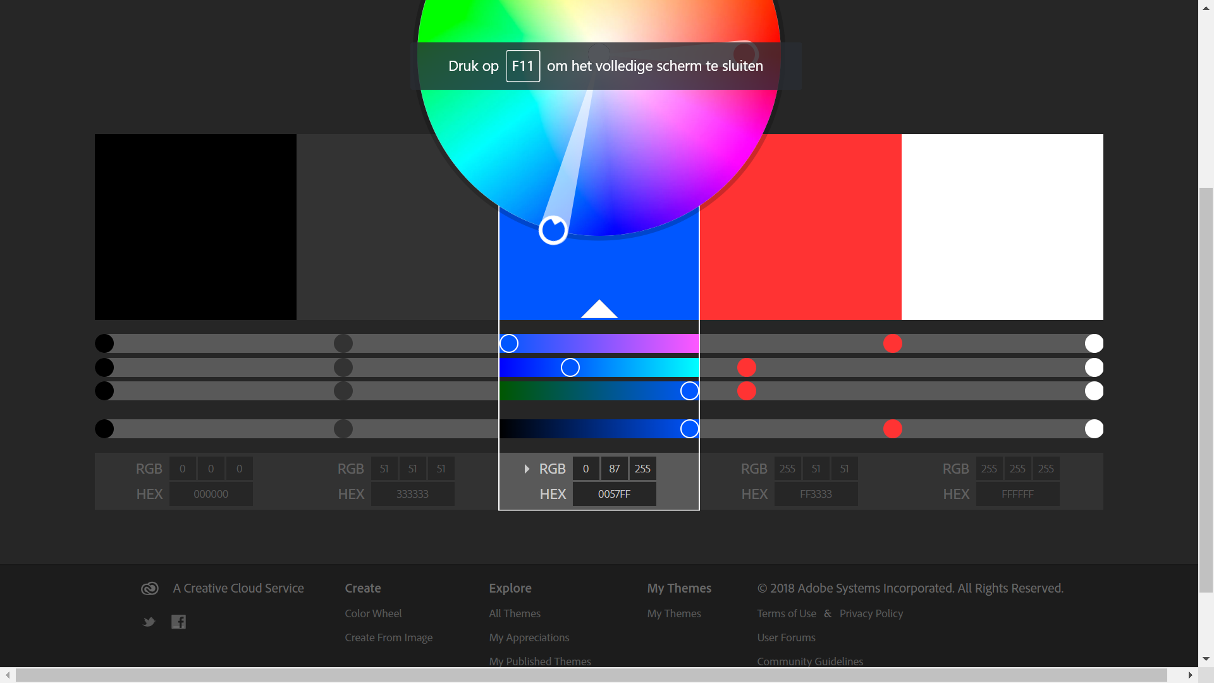

Zwart: #000000

Grijs: #333333

Electric Blue: #0057FF

Rood: FF3333

Wit: FFFFFF

## Vorm

Volgt

## Beeldmateriaal

Volgt

## Taal

Nederlands

Paralax

/* Parallax Effect */

/* .parallax {

/* The image used */

background-image: url("../images/wallpaper1.jpg");

height: 100%;

background-attachment: fixed;

background-position: center;

background-repeat: no-repeat;

background-size: cover;

}

/* .parallax2 {

/* The image used */

background-image: url("../images/wallpaper2.jpg");

height: 100%;

background-attachment: fixed;

background-position: center;

background-repeat: no-repeat;

background-size: cover;

}

/* .parallax3 {

/* The image used */

background-image: url("../images/wallpaper3.jpg");

height: 100%;

background-attachment: fixed;

background-position: center;

background-repeat: no-repeat;

background-size: cover;

}

/* .parallax4 {

/* The image used */

background-image: url("../images/wallpaper4.jpg");

height: 100%;

background-attachment: fixed;

background-position: center;

background-repeat: no-repeat;

background-size: cover;

}

/* .parallax5 {

/* The image used */

background-image: url("../images/wallpaper5.jpg");

height: 100%;

background-attachment: fixed;

background-position: center;

background-repeat: no-repeat;

background-size: cover;

}

/* .parallax6 {

/* The image used */

background-image: url("../images/wallpaper6.jpg");

height: 100%;

background-attachment: fixed;

background-position: center;

background-repeat: no-repeat;

background-size: cover;

}