How to export Enterprise Archtitect Files

- Open the EA file
- Select the ’Model’ node in the project browser
- Start export via Project → Documentation → HTML Report
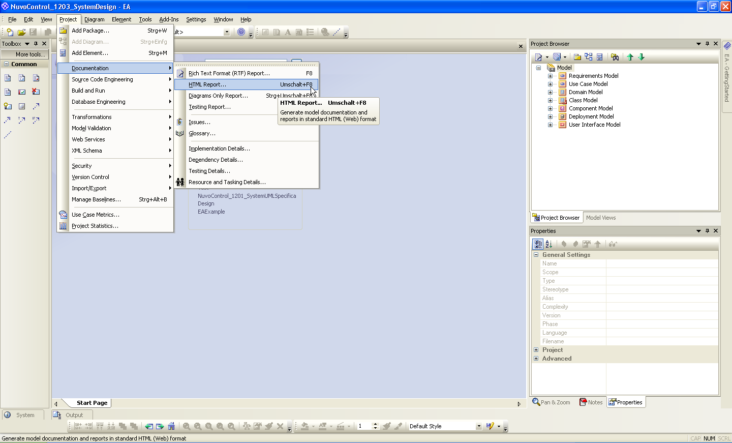
- Enter Title (use the same name as the EA file)
- Select corresponding destination directory
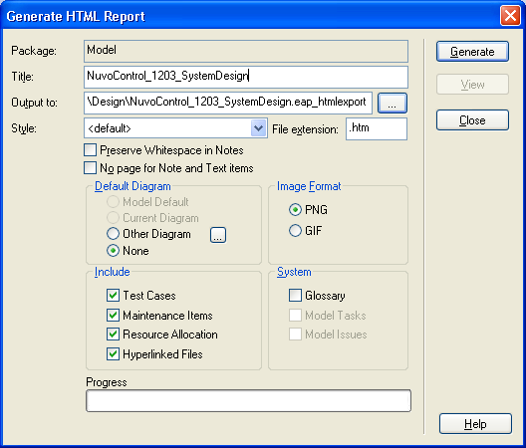
- Press Generate to start the html export
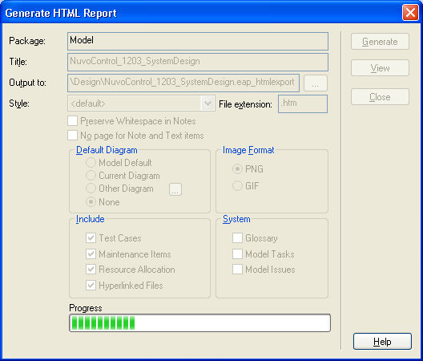
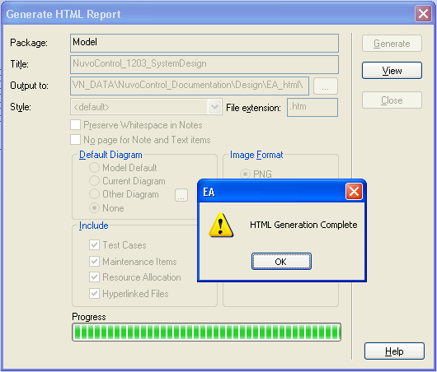
- Your are done

