Software Requirements Specification

for

Mumbai

Version 1.0 approved

Prepared by

Saideep Dicholkar

Adil Khatri

Chandan Choudhary

DreamTech

25/09/2017

Table of Contents

Table of Contents ii

1. Introduction 1

1.1 Purpose 1

1.2 Document Conventions 1

1.3 Intended Audience and Reading Suggestions 1

1.4 Product Scope 1

1.5 References 1

2. Overall Description 1

2.1 Product Perspective 1

2.2 Product Functions 2

2.3 User Classes and Characteristics 2

2.4 Operating Environment 2

2.5 Design and Implementation Constraints 2

2.6 User Documentation 2

2.7 Assumptions and Dependencies 2

3. External Interface Requirements 3

3.1 User Interfaces 3

3.2 Hardware Interfaces 3

3.3 Software Interfaces 3

3.4 Communications Interfaces 3

4. Other Nonfunctional Requirements 3

4.1 Performance Requirements 3

4.2 Safety Requirements 3

4.3 Security Requirements 4

4.4 Software Quality Attributes 4

4.5 Business Rules 4

5. Other Requirements 4

Appendix A: Glossary 4

Appendix B: Analysis Models 5

# Introduction

## Purpose

Our product satisfies the needs of Mumbai tourism. It will be helpful for tourists visiting Mumbai.

## Document Conventions

The document is developed based on the IEEE SRS standard.

## Intended Audience and Reading Suggestions

It is developed for tourists visiting Mumbai or people who want to know more about Mumbai. Also, students and developers can take advantage of this website and start web design and developing new websites.

## Product Scope

Our product satisfies the needs of Mumbai tourism. It will be helpful for tourists visiting Mumbai. This website will provide tourists with best hotels to stay as well as places for shopping, places to visit and provides some history about Mumbai.

## References

This System Requirement Specifications document is based on the guidelines of IEEE SRS format and refers to the guidelines set by IEEE.

# Overall Description

## Product Perspective

There are few existing web sites about Mumbai tourism but our web site provides short and crisp information. It provides maximum information in few clicks.

## Product Functions

It provides following details:

1) HOTELS TO STAY

2) PLACES TO VISIT

3) SHOPPING PLACES

4) HISTORY OF MUMBAI

5) PHOTOS OF MUMBAI

6) MAP

7) FEEDBACK FORM

## User Classes and Characteristics

It can be used by following users:

* Visitors

Users visiting website to find information about Mumbai

* Students

School students who are learning web development

* Developers

Open source for learning and doing further modifications as desired.

## Operating Environment

All Operating Systems.

## Design and Implementation Constraints

Firewall should not block social media sites as links have been provided for Instagram for owners of respective photographs. There are no such hardware requirements except for given minimum requirements. It works best on Chrome Browser with minimum resolution of 1024 X 768.The website will be maintained by Developers themselves.

## User Documentation

User Documentations such as online help, documentation, manual will be provided along with the website for easy use by user and troubleshooting any issues.

## Assumptions and Dependencies

We are assuming that user will have an internet connection along with a PC / Laptop with the required minimum specifications. Also, if any firewall used by user shouldn’t block social media sites which might lead to user not able to view the original photographer of photograph used in website. User’s browser should allow running scripts as the website uses JavaScript and having Allow Script option turned off might lead to issues and improper functioning of some functionalities. In future, we are thinking of using database to store and retrieve data for the website.

# External Interface Requirements

## User Interfaces

The User Interface is inspired by and based on Google’s Material Design Standards. The Material Design Standards states that the components are like layers of papers. They are flat as paper and have depth (shadow) depending on their height. Whenever a cursor is hovered on some component it’s depth increases giving a visual look of component being raised high. All this leads to a visually appealing website for users. The material design can be applied to buttons, images to look like cards and floating buttons and to other components as needed.

## Hardware Interfaces

The website can work on and be viewed on all Desktops based systems and on Mobile devices. The data required can be fetched from remote or local servers.

## Software Interfaces

The website uses PHP for connecting to Database. Database used is MySQL. Both PHP and MySQL are used to store the feedback taken from user and to send reply to the user accordingly. The feedback is taken from a Feedback form which includes user’s Name, E-mail and Message (Feedback). These entities get stored in our database.

For Maps we have used Google Maps API from Google for displaying Map on Website. This Map contains the API key which calls the Map API from Google Cloud Platform to display the Google Maps Data.

## Communications Interfaces

The website will use Database Server for storing the data and PHP for connecting the Database Server with Feedback form. HTTPS protocol will be used by website for communication and security purpose.

# Other Nonfunctional Requirements

## Performance Requirements

No such performance requirements except for the specified minimum requirements.

## Safety Requirements

No safety requirements as the website doesn’t do any kind of harm to the user on using the website.

## Security Requirements

All the Photos used in website belong to the owners of respective photographs and links to the owner’s Instagram account has been provided wherever the photos are used. If you find any photo which belongs to you and has not been given credits then please fill the Feedback form and do let us know. We will do the needful by giving you the credits.

## Software Quality Attributes

The website is responsive and adapts according to the device used to view the website.

## Business Rules

Website visitors can view all information available on website. Visitor can fill the Feedback form available on website for giving any kind of Feedback or if they have any Query. Admin can view and edit the database.

# Other Requirements

The Website uses Database to store the feedback taken from user. Database has been created using MySQL and connected using PHP.

Appendix A: Glossary

**IEEE:** Institute of Electrical and Electronics Engineers

**SRS:** Software Requirement Specifications

**PHP:** Hypertext Preprocessor (earlier called, Personal Home Page)

**MySQL:** Combination of "My", the name of co-founder Michael Widenius's daughter, and "SQL", for Structured Query Language.

**API:** Application Programming Interface

**HTTPS:** Hypertext Transfer Protocol Secure

Appendix B: Analysis Models

**Data Flow Diagram:**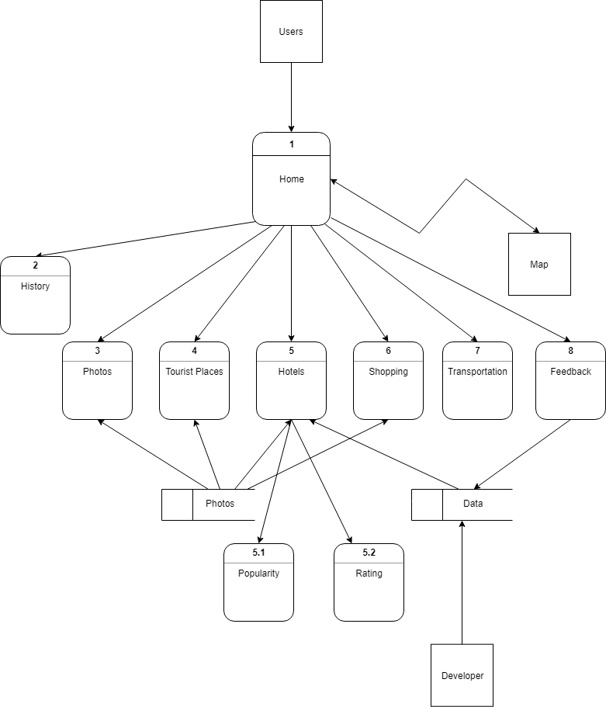

**Use Case Diagram:**

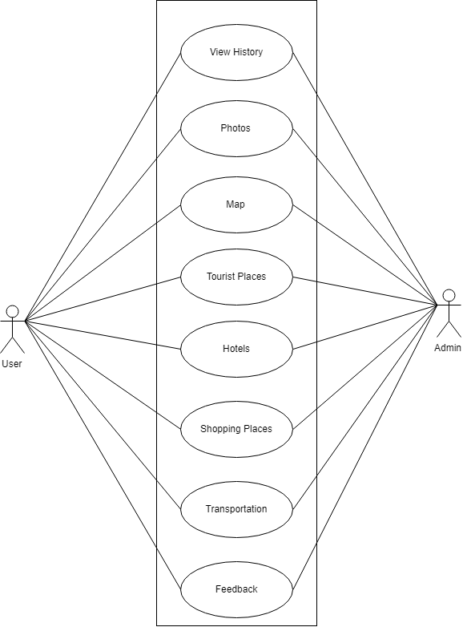

**Sequence Diagram:**

