INFO 2302: WEB TECHNOLOGIES
Activities for CSS: 03 Responsive design
NAME | Imran Hakim bin Mohd Norhisham
MATRIC NO | 2317783 | SECTION | 3
Instruction: -
- Please download the file CSS03.zip
- Unpackage the content into a folder
- Write the codes and remarks about what have changed in the web browser.
INSTRUCTIONS | CODE | REMARKS
Download grid.html and mymq.css |  | You will be learning how to use media queries
External link | Create the link to mymq.css in grid.html
This is the layout for desktop first with 4 column | display: grid;  gap: 20px;  grid-template-areas:  "head head head head"  "navi navi navi navi"  "content content content side"  "foot foot foot foot"  ;  grid-template-columns: 1fr 1fr 1fr 1fr; | 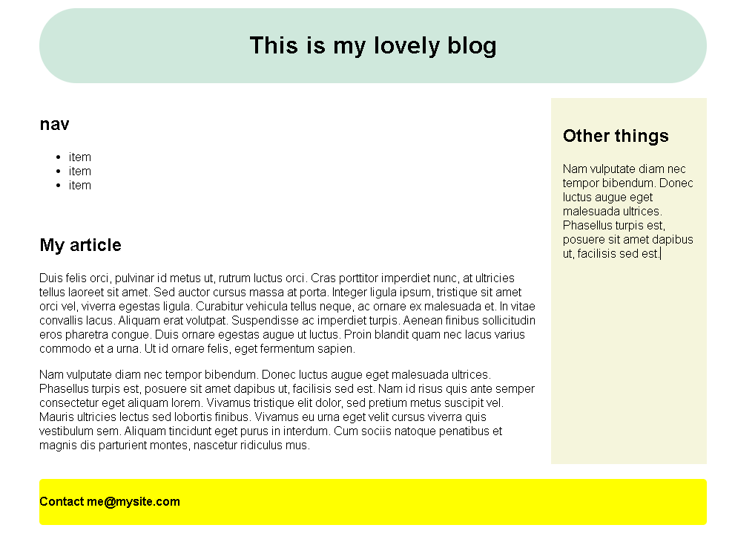
Open grid.html in the browser.  Choose inspect mode  Choose responsive design mode, and try different resolutions |  | 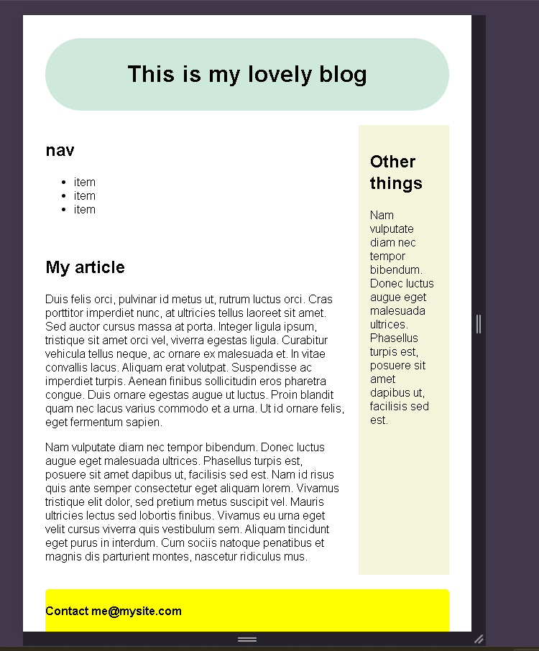
Adjust the layout for tablet design with 2 column |  | 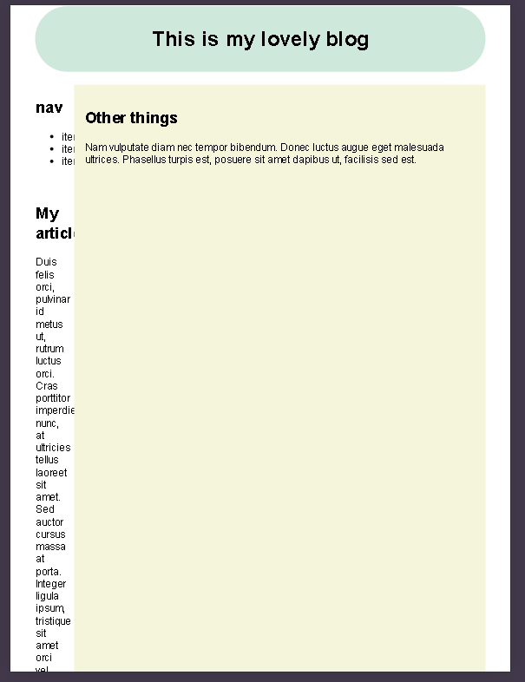
Adjust the layout for phone design with 1 column |  | 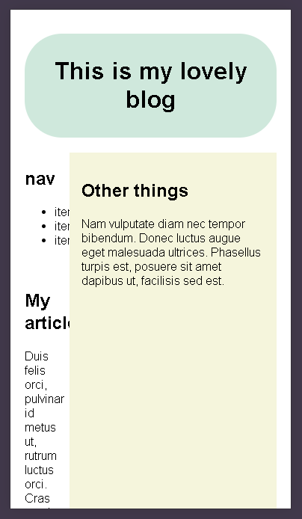
Choose the breakpoint for your media queries that can fit the tablet and phone and copy the above grid layout for tablet and phone.  Write the code into the mediaqueries curly bracket and | /* 2xl */  @media (max-width: 1536px) {}  /* xl */  @media (max-width: 1280px) {}  /* lg */  @media (max-width: 1024px) {}  /* md */  @media (max-width: 768px) {}  /* sm */  @media (max-width: 640px) {}  /* xs */  @media (max-width: 475px) {} | 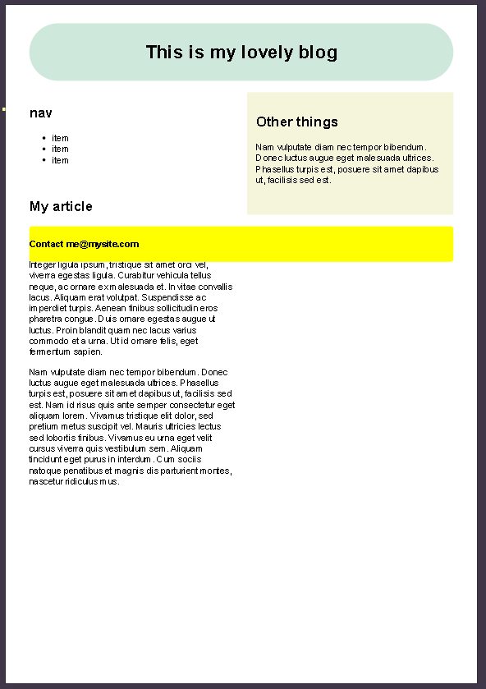  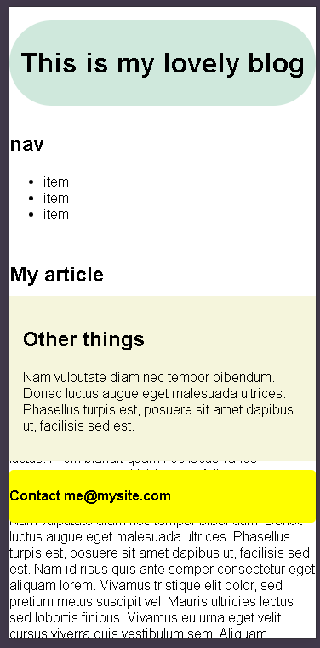
Use the responsive design mode to test your responsive design layout using grid |  | 