INFO 2302: WEB TECHNOLOGIES
Activities for CSS: 02 FLEX
NAME | IMRAN HAKIM BIN MOHD NORHISHAM
MATRIC NO | 2317783 | SECTION | 3
Instruction: -
- Please download the file CSS02.zip
- Unpackage the content into a folder
- Write the codes and remarks about what have changed in the web browser.
INSTRUCTIONS | CODE | REMARKS
Download flex01.html  Add the following code into .container {} |  | You will be learning how to use FLEX  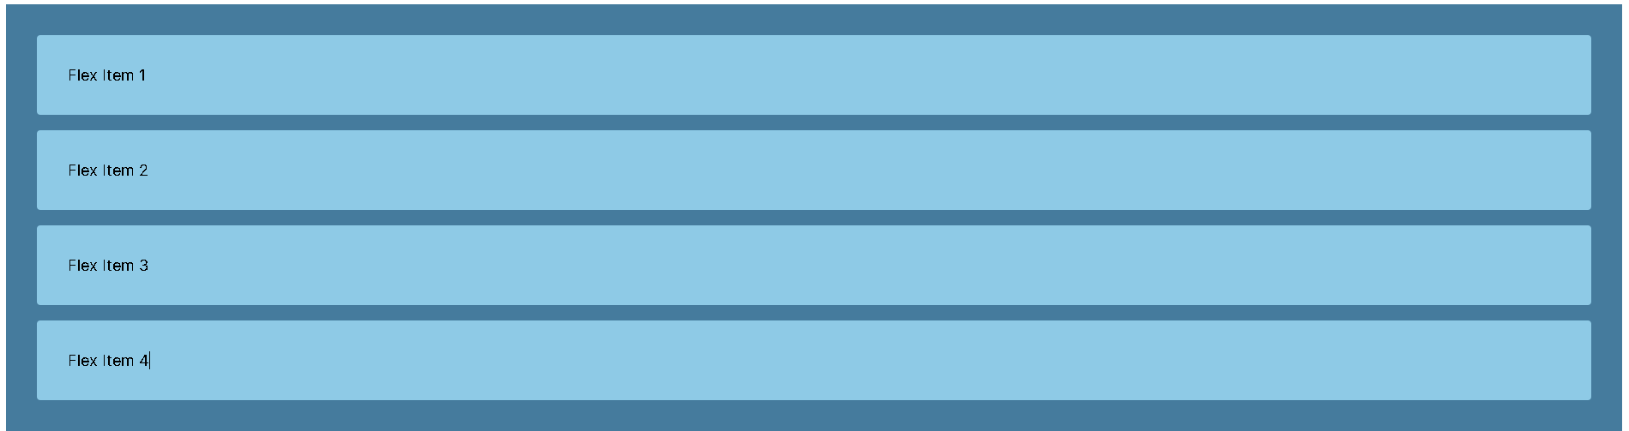
 | display: flex;
 | flex-direction: row;  Then Change the value row to:  - Row-reverse  - Column  - Colum-reverse | 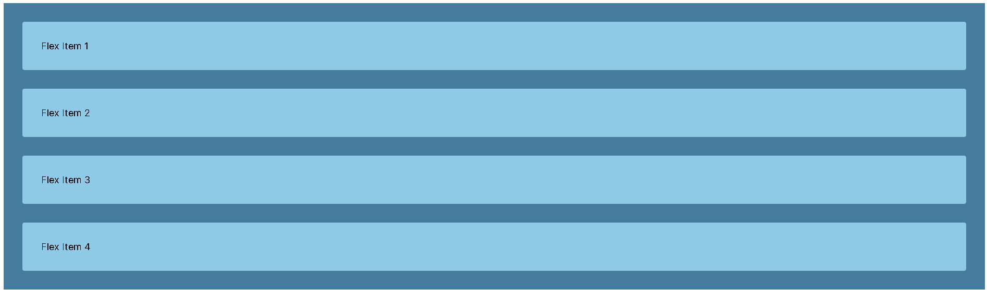  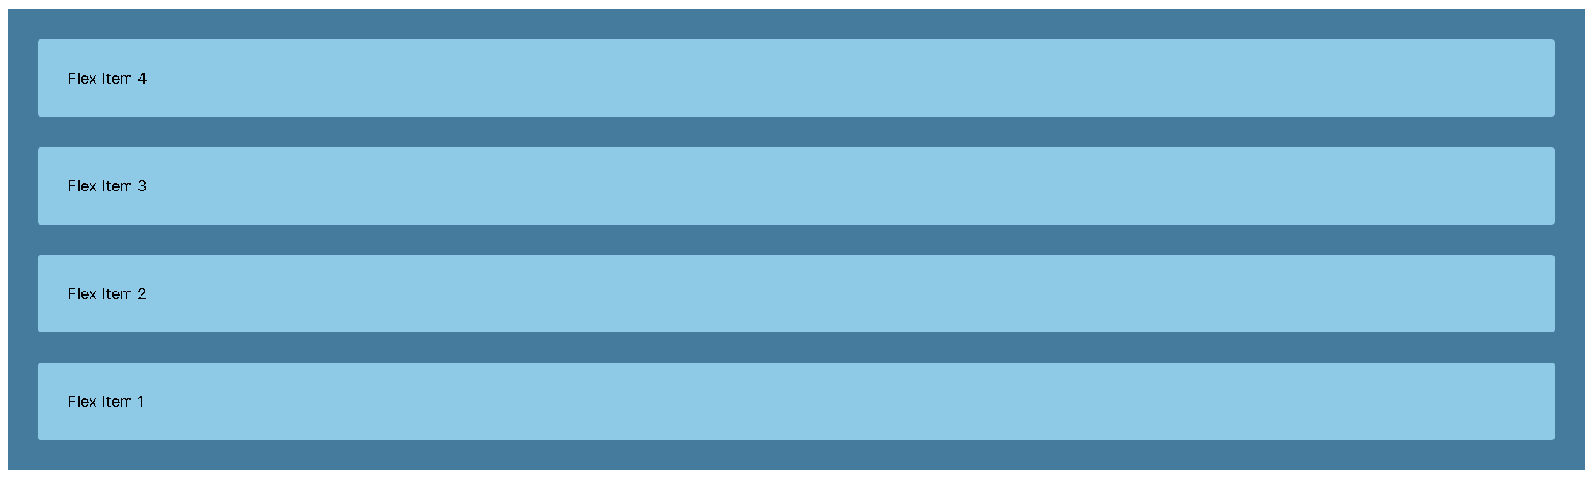
 | flex-wrap: nowrap;  Then change the value “nowrap” to “wrap” and resize your browser | 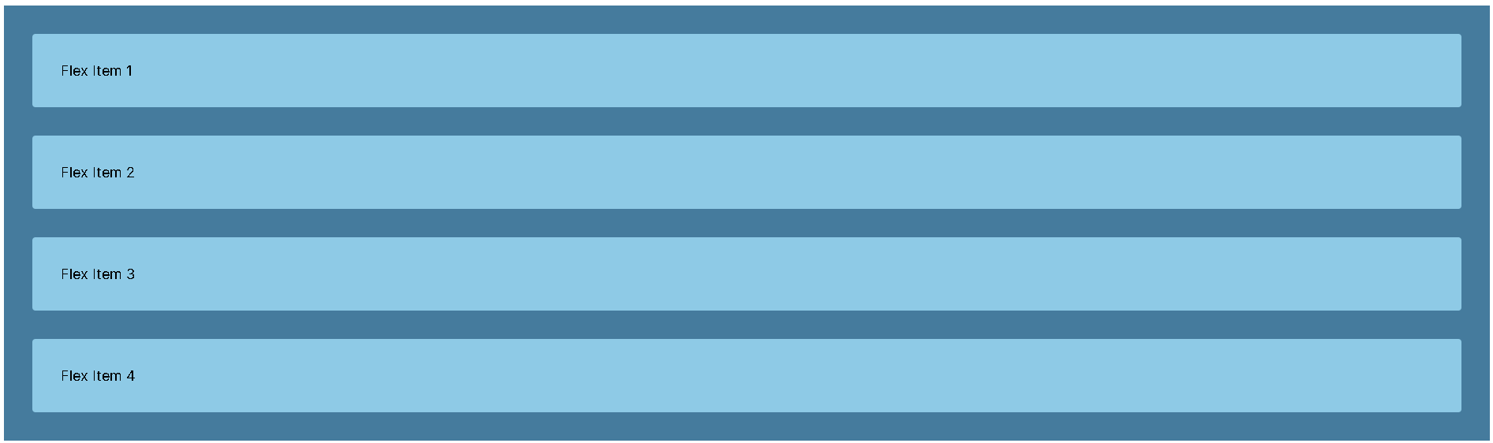  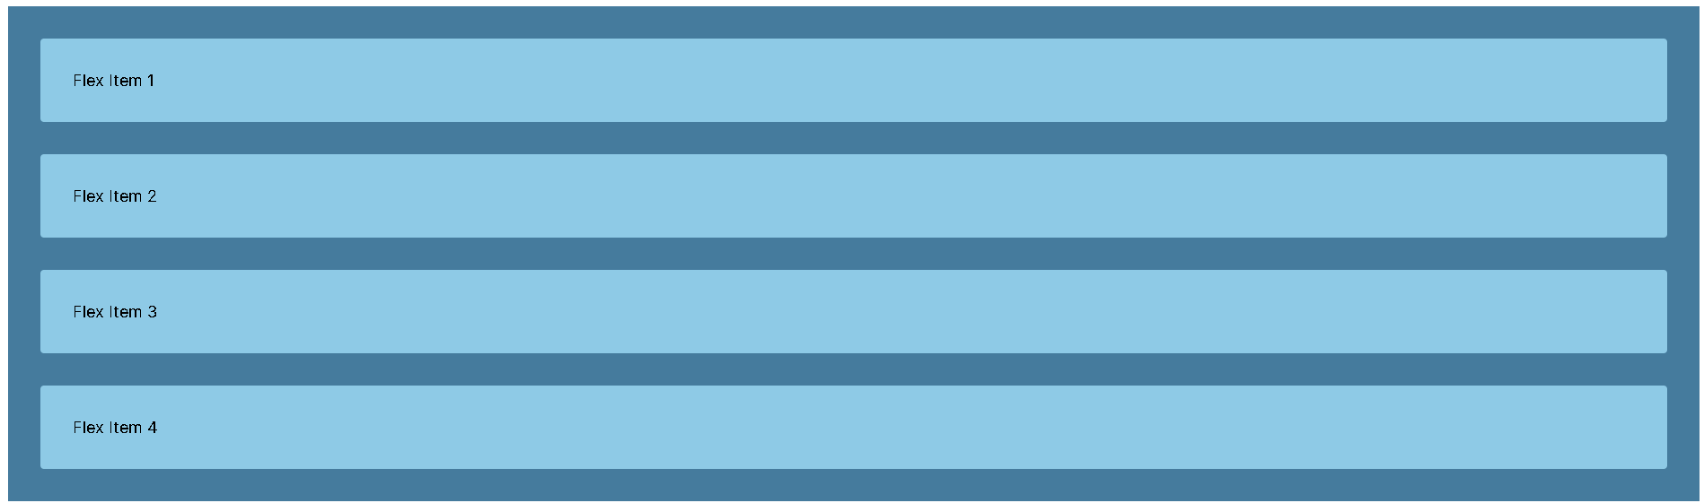
Download flex02.html and layout.css | Create the link to layout.css in flex02.html | You will learn how to do layout using FLEX  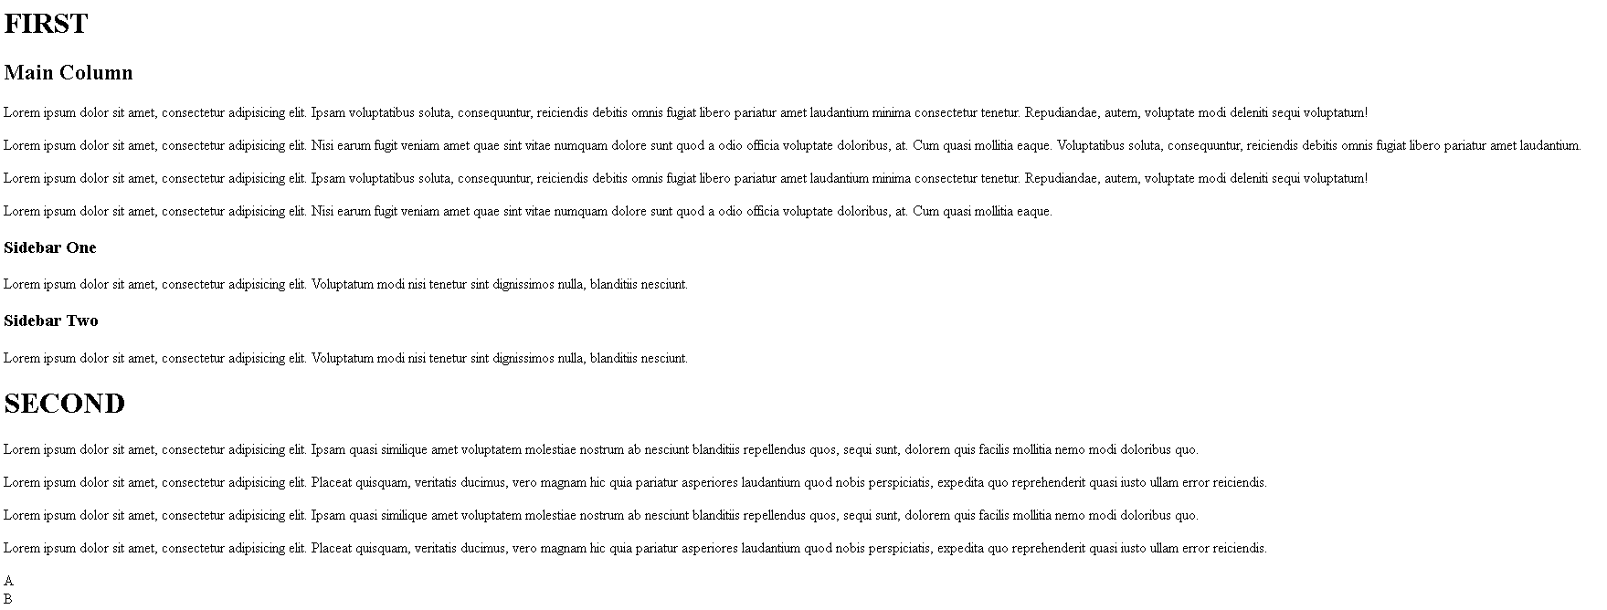
 | Insert display:flex; in the Parent flex | 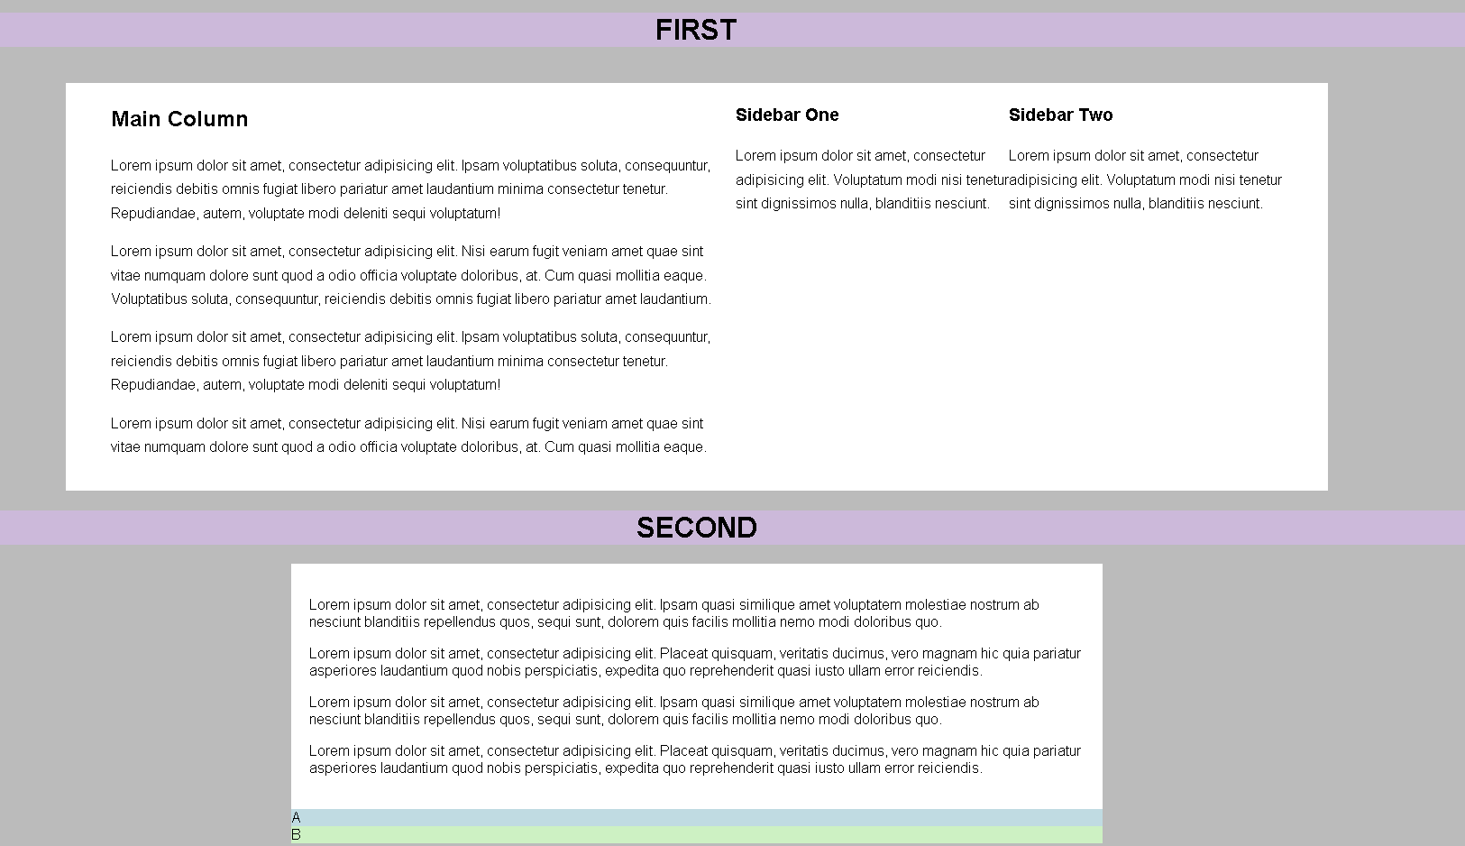
 | Insert the following values in each of the Child  - flex:4;  - flex:1;  - flex:1;  (play around with the numbers to get what layout you want | 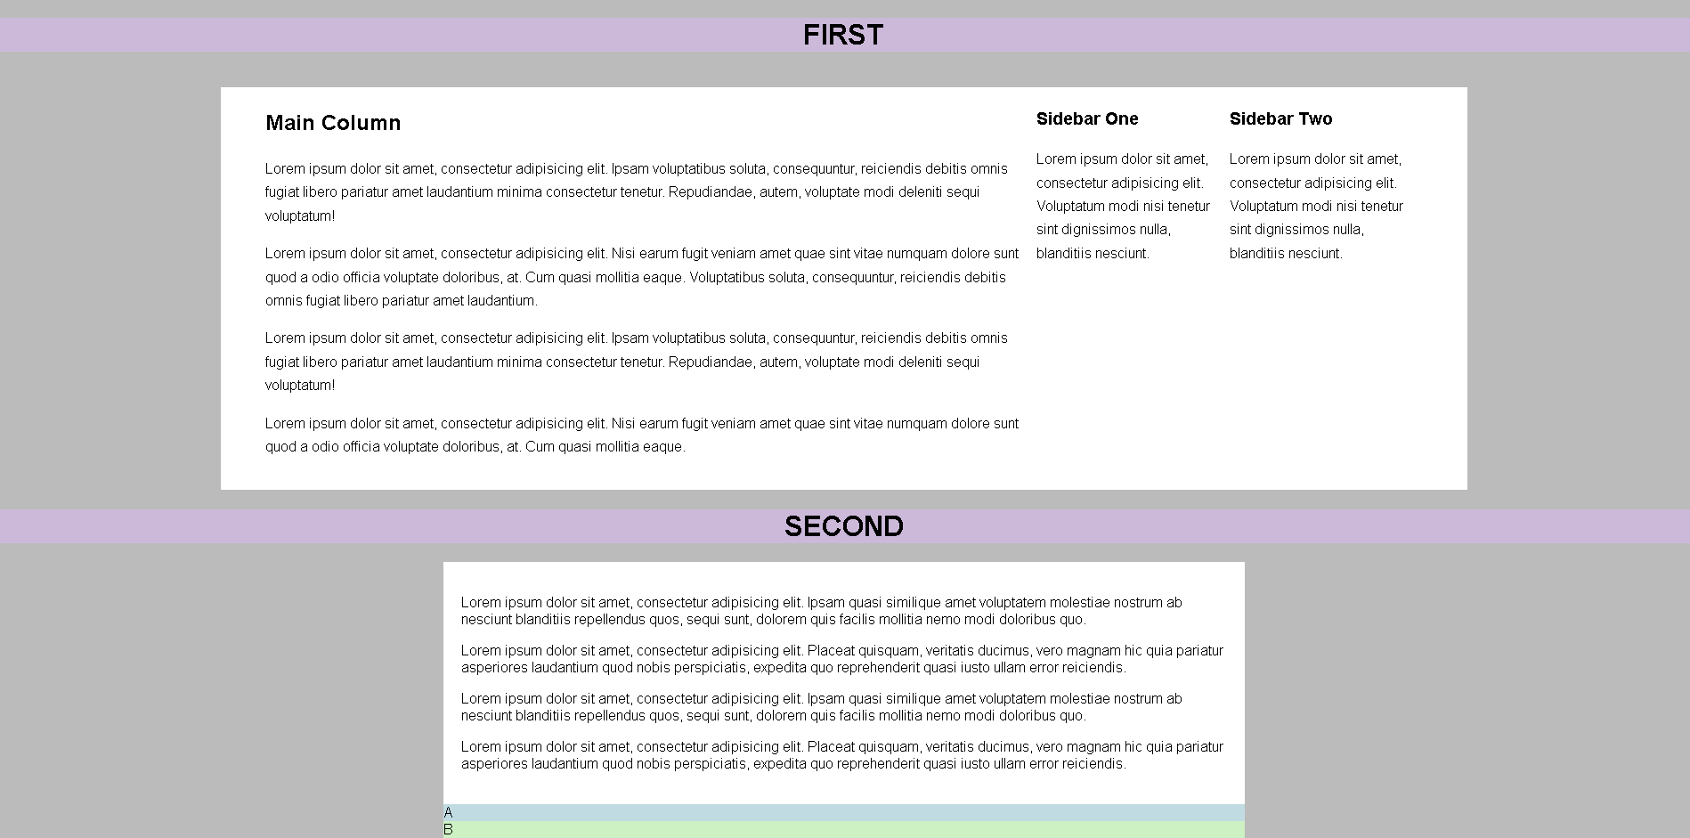
 | Insert the following values in each of the Child  - order:3;  - order:2;  - order:1;  (play around with the numbers to get what layout you want | 