INFO 2302: WEB TECHNOLOGIES
Activities for CSS: 02 GRID
NAME
MATRIC NO |  | SECTION
Instruction: -
- Please download the file CSS02.zip
- Unpackage the content into a folder
- Write the codes and remarks about what have changed in the web browser.
INSTRUCTIONS | CODE | REMARKS
Download grid.html and mygrid.css |  | You will be learning how to use GRID to do layout
External link | Create the link to mygrid.css in grid.html | 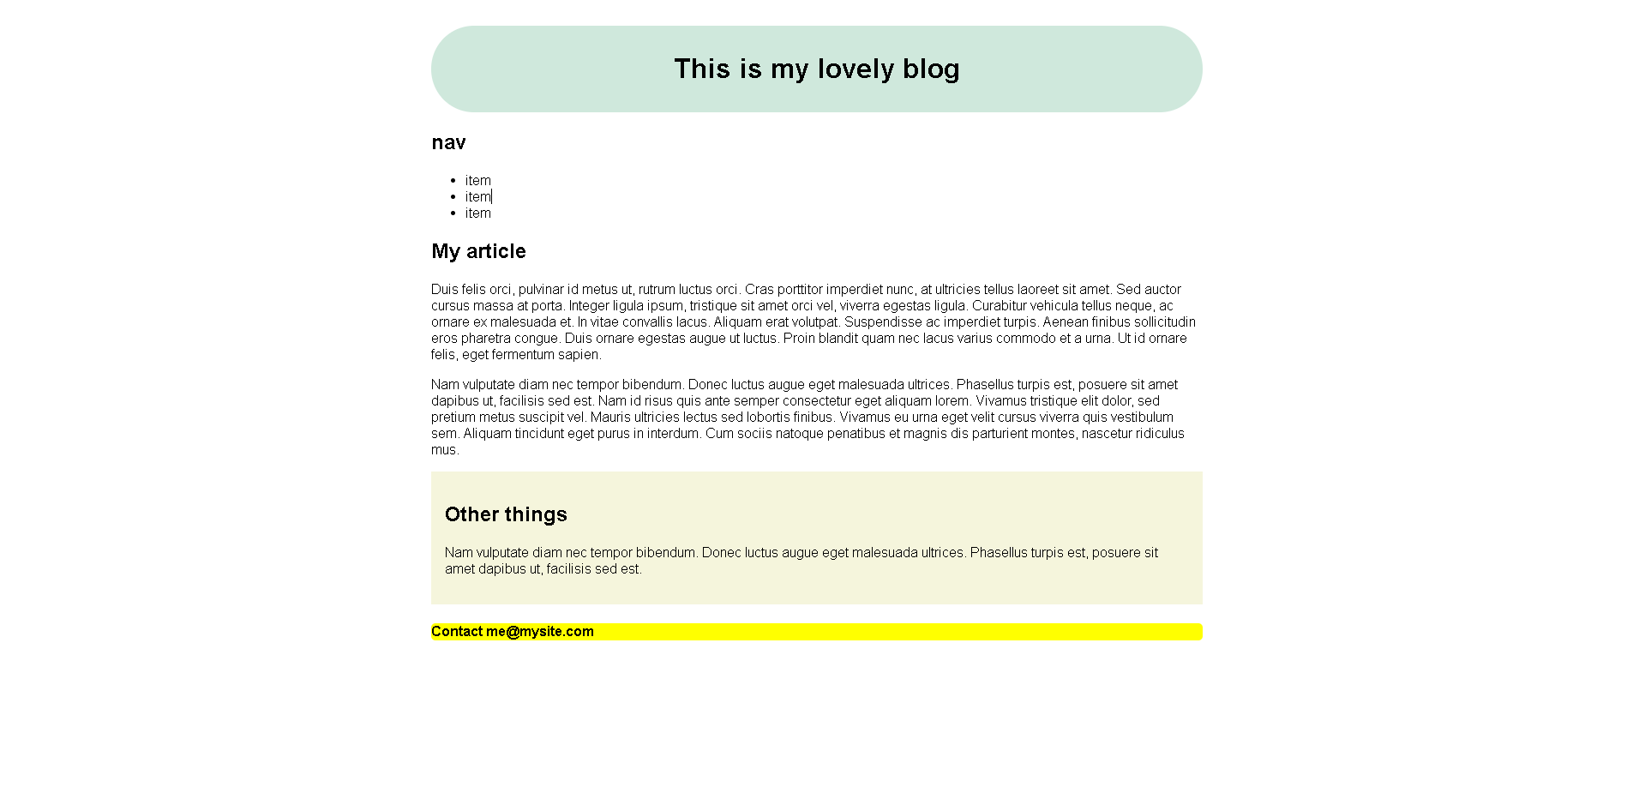
* Then tick the Grid display setting in the inspector view | Insert the following in the Parent  display: grid;  grid-template-columns: 1fr 1fr 1fr 1fr;  gap: 20px; | 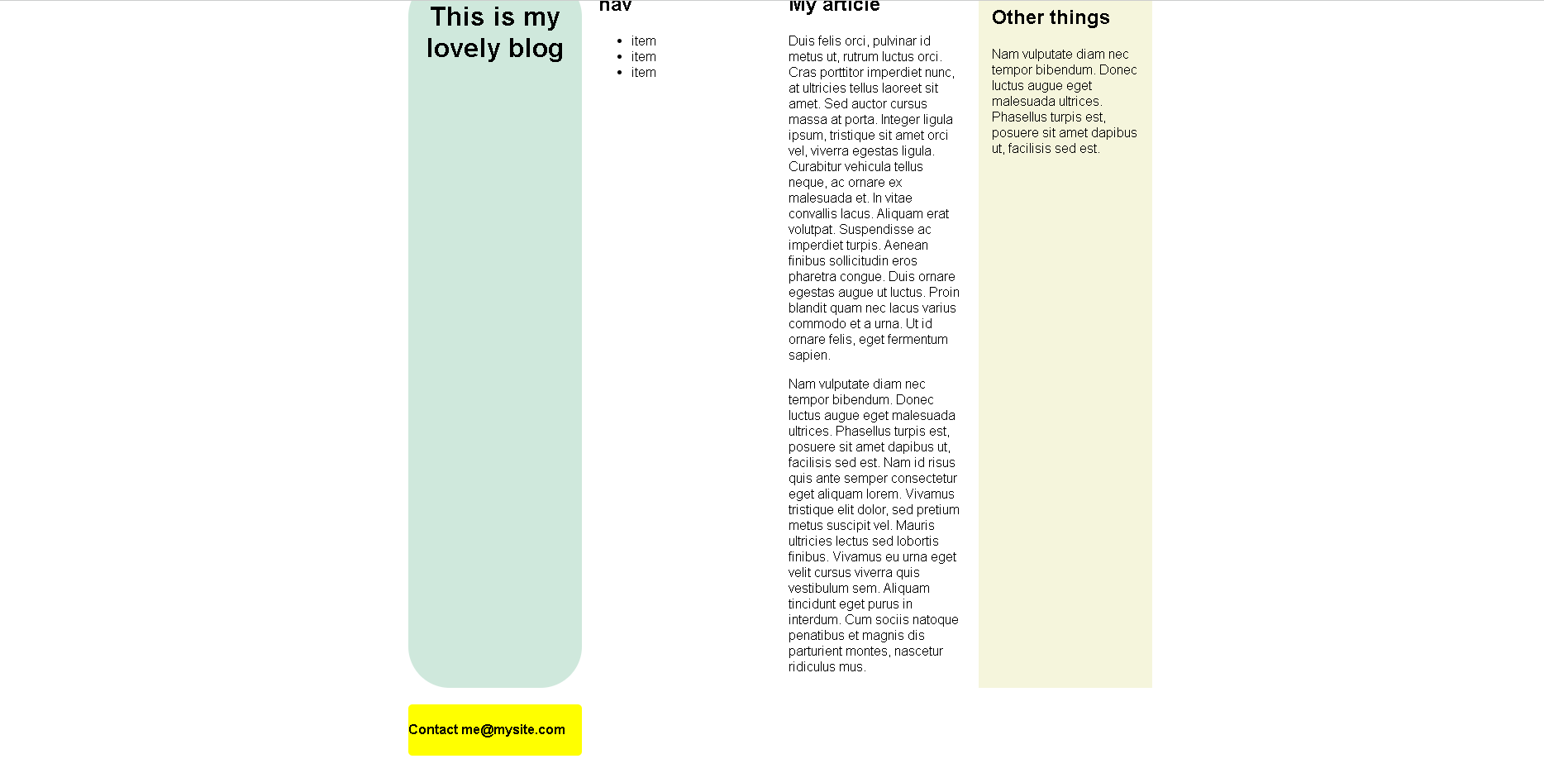
 | header{  grid-column: 1/span 4;  grid-row: 1;  }  nav{  grid-column: 1;  grid-row: 2;  }  article{  grid-column: 2/span 2;  }  aside{  grid-column: 4;  }  footer{  grid-column: span 4;  grid-row: 3;  } | 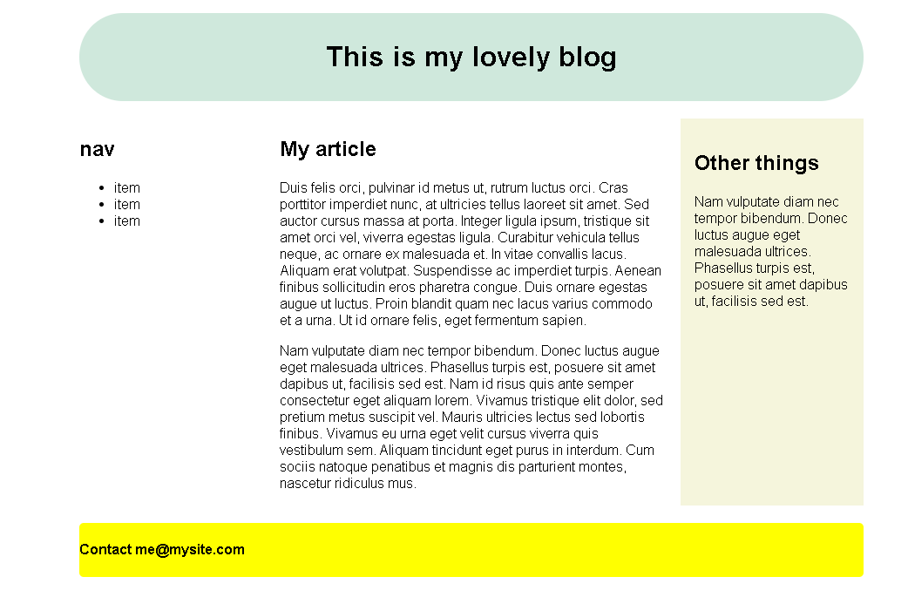
 | Create the link to mygrid2.css in grid.html | You will learn how to do layout using GRID
 | Insert the following in the Parent  display: grid;  gap: 20px;  grid-template-areas:  "head head head head"  "navi navi navi navi"  "content content content side"  "foot foot foot foot"  ;  grid-template-columns: 1fr 1fr 1fr 1fr; | 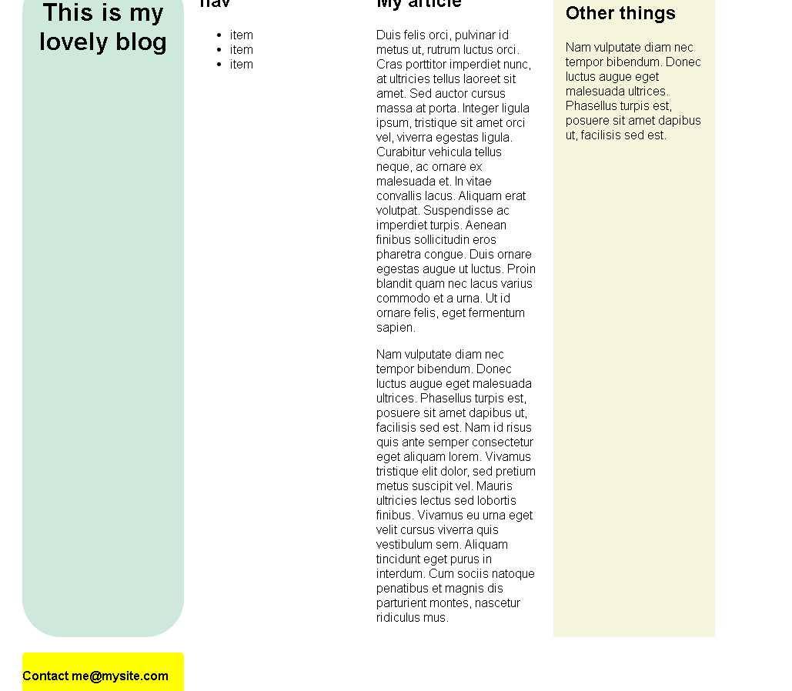
 | header{  grid-area: head;  }  article{  grid-area: content;  }  nav{  grid-area: navi;  }  aside{  grid-area: side ;  }  footer{  grid-area: foot;  } | 