Continuous Semantic Video Threat Detection: A Zero-Shot Frame-Level Matching Approach using SigLIP and Google Gemma

Author: Ritesh Verma
Hackathon: Solution Challenge 2026 - Build with AI
Team: Quantum Stack
Organization: Team Emogi
Keywords: Video Detection, SigLIP, Google Gemma, FastAPI, Semantic Search, Content Piracy, Multimodal Embeddings

Abstract
The rapid proliferation of unauthorized video reuploads across major platforms requires robust, continuous, and automated detection pipelines. This paper presents the Aegis Continuous Engine (Emogi Detection API), a lightweight, dual-stage architecture designed to identify pirated or altered video content. By integrating Google’s open-weights Gemma model for dynamic semantic search generation with SigLIP, a modern vision-language embedding model, for zero-shot frame-level visual matching, the system bypasses the fragility of traditional cryptographic hashing. Leveraging normalized vector similarity and semantic embedding alignment, the system demonstrates resilience against transformations such as compression, scaling, and moderate cropping. Architectural bottlenecks regarding concurrency and state management are also analyzed, with proposed future scaling via distributed systems.

1. Introduction
In the modern content creation ecosystem, identifying stolen or unauthorized clips is a continuous and asymmetrical battle. Traditional anti-piracy methods rely on cryptographic hashing (e.g., MD5, SHA-256), which fundamentally breaks upon the slightest manipulation of the video file, such as cropping, compression, or color grading.
The Aegis system transitions from rigid bitwise hashing to fluid semantic and spatial feature extraction. The core premise is to reduce a video to a discrete set of normalized visual embeddings. To find potential reuploads in the wild, the system leverages Google Gemma to semantically expand the video’s metadata into intelligent search queries. Suspected videos are then fetched and mathematically compared against the source embeddings in a continuous temporal loop.
2. System Architecture
The system operates on a client-server model utilizing a vanilla JavaScript frontend and a FastAPI backend. It decouples the ingestion phase from the continuous scanning phase, utilizing an asynchronous worker loop to poll platform APIs without blocking incoming web traffic.
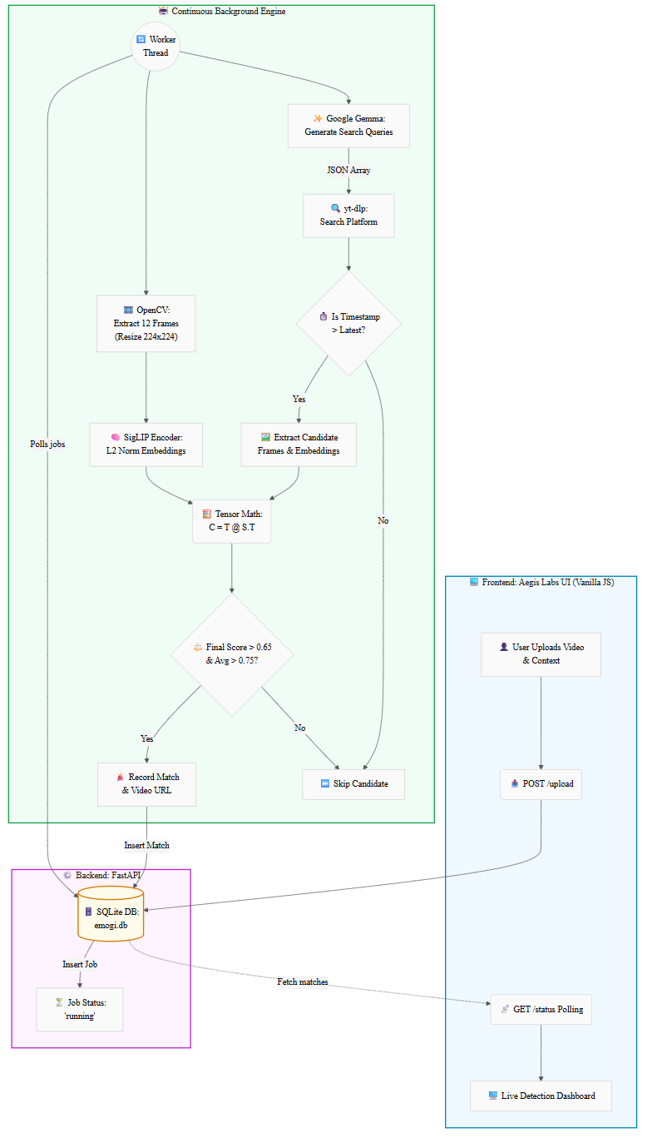

3. Methodology & Theoretical Framework
To build an effective detection engine, one must abstract away standard computer vision loops in favor of vector space projections. The true efficiency of this pipeline relies on the geometric properties of the embedding space.
3.1 Feature Extraction and L2 Normalization
The foundational step of the pipeline involves temporal downsampling and spatial transformation of the input video. Given a raw video stream, the system utilizes OpenCV to extract a discrete set of $N=12$ frames. Each frame $f_{i}$ is resized to a standardized dimension of $224×224$ pixels.
Let the set of extracted frames be denoted as $F=\{f_{1},f_{2},...,f_{N}\}$. Each frame $f_{i}$ is passed through the SigLIP image encoder, which maps the high-dimensional pixel space into a dense semantic vector space:
$$E_{i}=f_{\text{SigLIP}}(f_{i})$$
where $E_{i}∈R^{d}$ represents the embedding vector.
To enable efficient similarity computation, the system applies $L^{2}$ normalization:
$$||E_{i}||_{2}=\sqrt{\sum_{j=1}^{d}{(}e_{i,j})^{2}}$$
$${\hat{E}}_{i}=\frac{E_{i}}{||E_{i}||_{2}}$$
This ensures $||{\hat{E}}_{i}||_{2}=1$, allowing dot product to equal cosine similarity.
3.2 Tensor Multiplication for Frame Matching
Let source embeddings be $S∈R^{N×d}$ and target embeddings be $T∈R^{M×d}$.
$$C=TS^{⊤}$$
Each element represents cosine similarity:
$$C_{i,j}=T_{i}⋅S_{j}$$
Max similarity per frame:
$$m_{i}=\max_{1≤j≤N}(C_{i,j})$$
Thresholding:
$$I_{i}=\left\{\begin{matrix}1 & \text{if }m_{i}>τ \\ 0 & \text{otherwise}\end{matrix}\right.$$
$$R=\frac{1}{M}\sum_{i=1}^{M}{I_{i}}$$
$$A=\frac{1}{M}\sum_{i=1}^{M}{m_{i}}$$
$$\text{Final Score}=R×A$$
Detection condition: - Final Score > 0.65
- Average > 0.75

4. Semantic Search Space Generation using Google Gemma
To overcome limitations of heuristic keyword matching, Aegis integrates Google Gemma as a semantic query generation engine.
Given metadata (title, description, language, country), Gemma generates: - paraphrased titles
- colloquial variations
- translated phrases
- piracy patterns (shorts, edits, clips)
The output is constrained to structured JSON, ensuring deterministic pipeline integration.

5. Visual Analytics & Tensor State
Frame-to-frame cosine similarities can be visualized as a 2D matrix to analyze matching behavior.
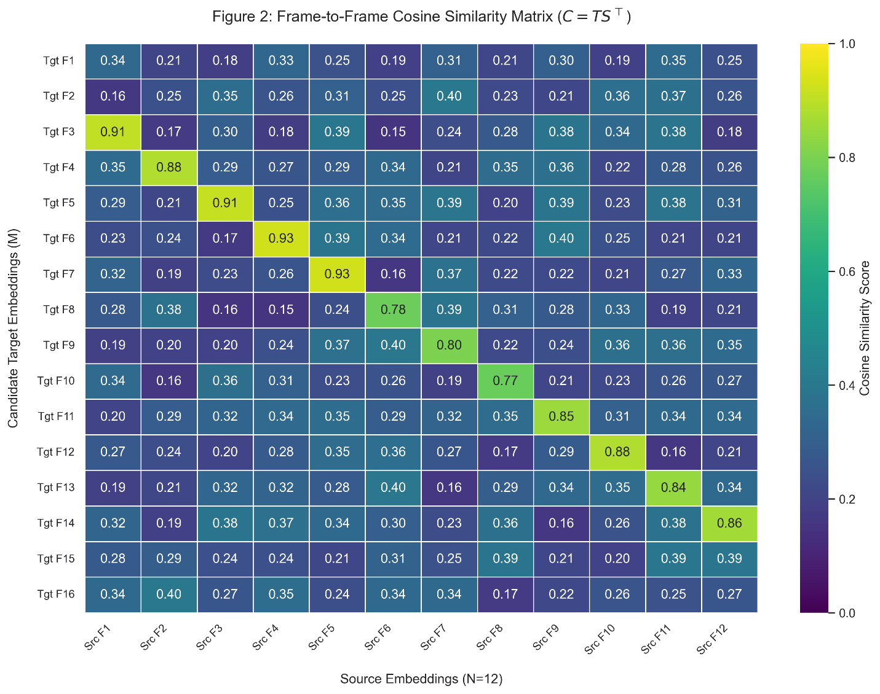

6. Critical Analysis & System Limitations
While the zero-shot application of SigLIP and Gemma is effective, several limitations remain:
Temporal Agnosticism: Frame order is ignored; DTW can fix this
Blocking Local I/O: Needs async/distributed execution
Database Concurrency: SQLite not scalable
Frame Sampling: Must sample across full timeline

6.1 Robustness to Visual Transformations
SigLIP embeddings improve resilience against:
Compression artifacts
Resolution changes
Moderate cropping
However, extreme cropping or partial reuse may reduce detection accuracy. Future work includes multi-crop embeddings and segment-based matching.

7. Conclusion
The Aegis Continuous Engine demonstrates an advanced application of multimodal AI to digital rights enforcement. The transition from bitwise hashing to semantic embedding-based similarity enables robust detection under real-world transformations. The adoption of SigLIP further enhances generalization compared to legacy CLIP-based systems. With future improvements in scalability and temporal modeling, Aegis represents a strong foundation for next-generation content protection systems.

8. Links
- Github: https://github.com/Imimi328/Aegis-Labs
- Webpage: https://aegis.emogi.space/
- Api: https://api.emogi.space/

