CIS 301 Final Project

COMPLETE THE 10 SECTIONS

1. Add the URL of the restaurant website on Netlify

[https://shocked-chicken.netlify.app](https://shocked-chicken.netlify.app/)

1. Add a screenshot of the wireframe for page 1: About US

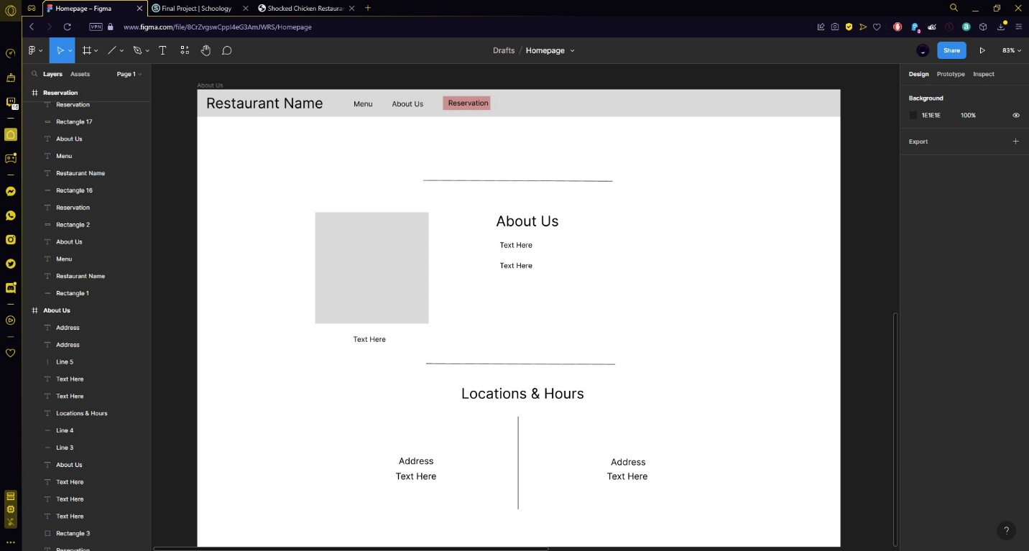

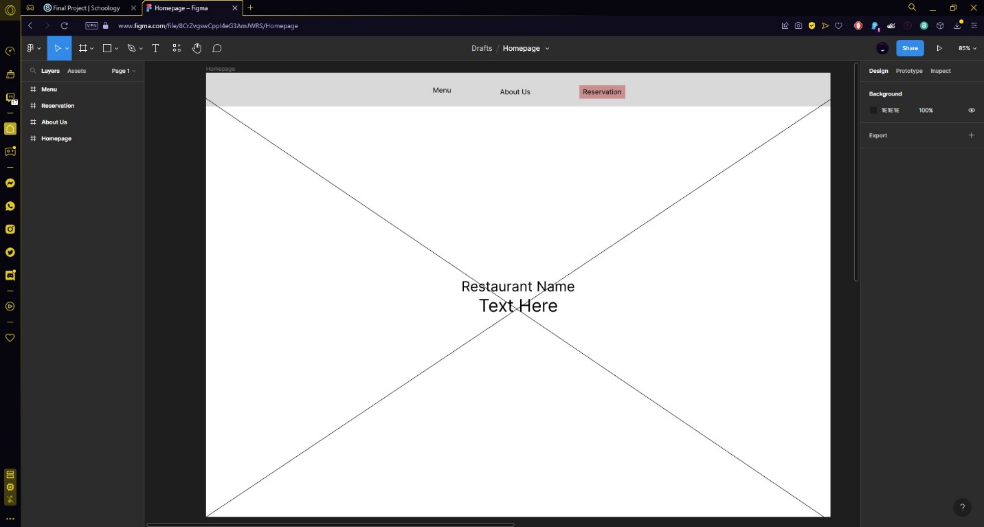

1. Add a screenshot of About Us page displayed in a browser

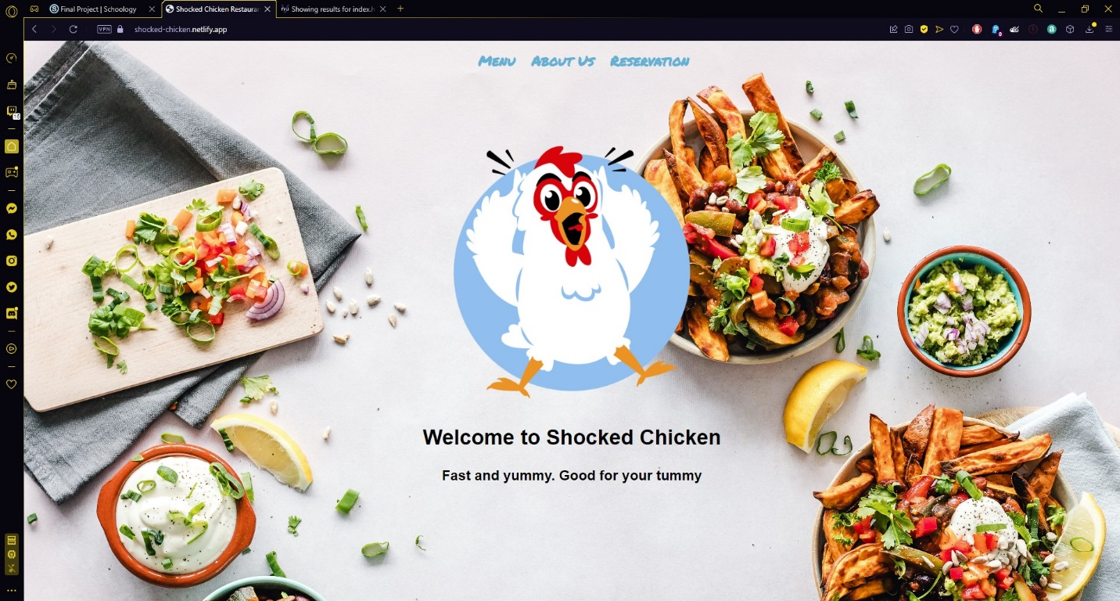

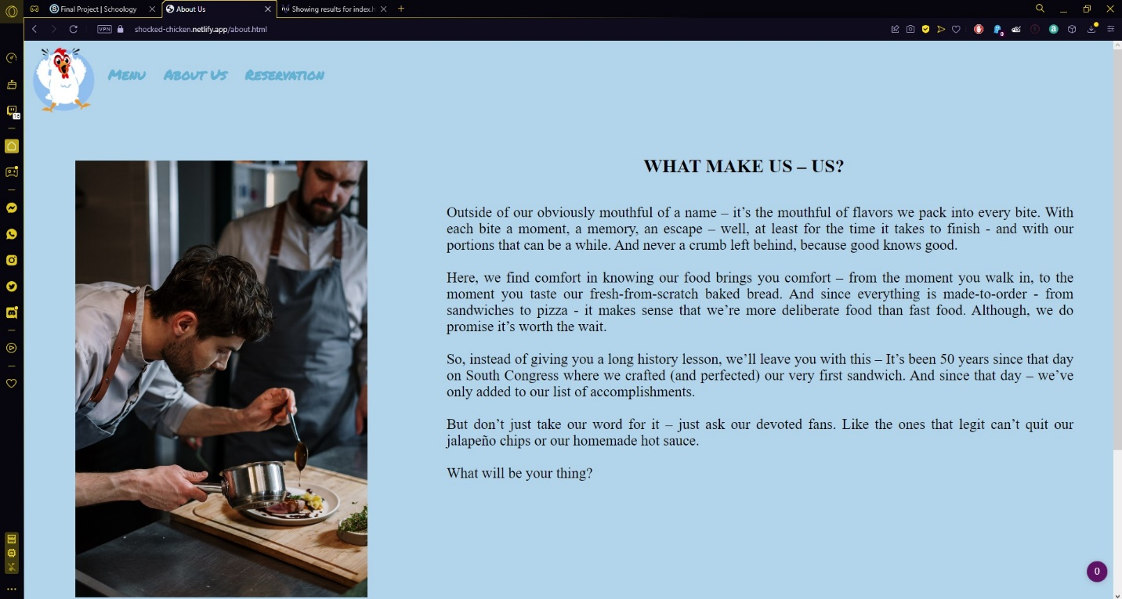

1. Add a screenshot the About US page validated using W3C MarkUp Validation Services

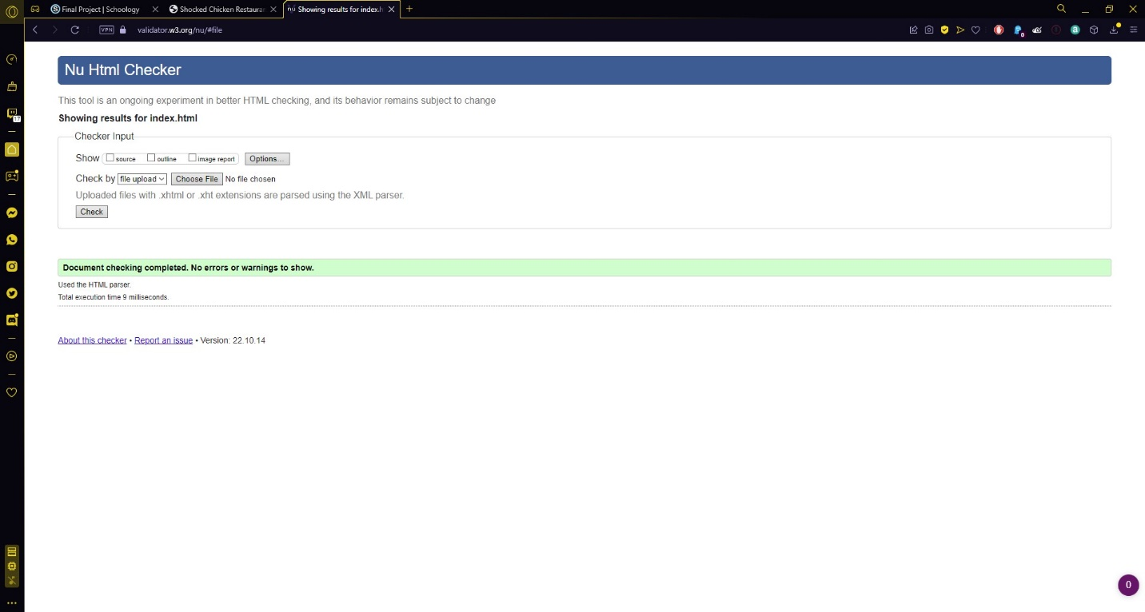

1. Add a screenshot of the wireframe for page 2: Menu

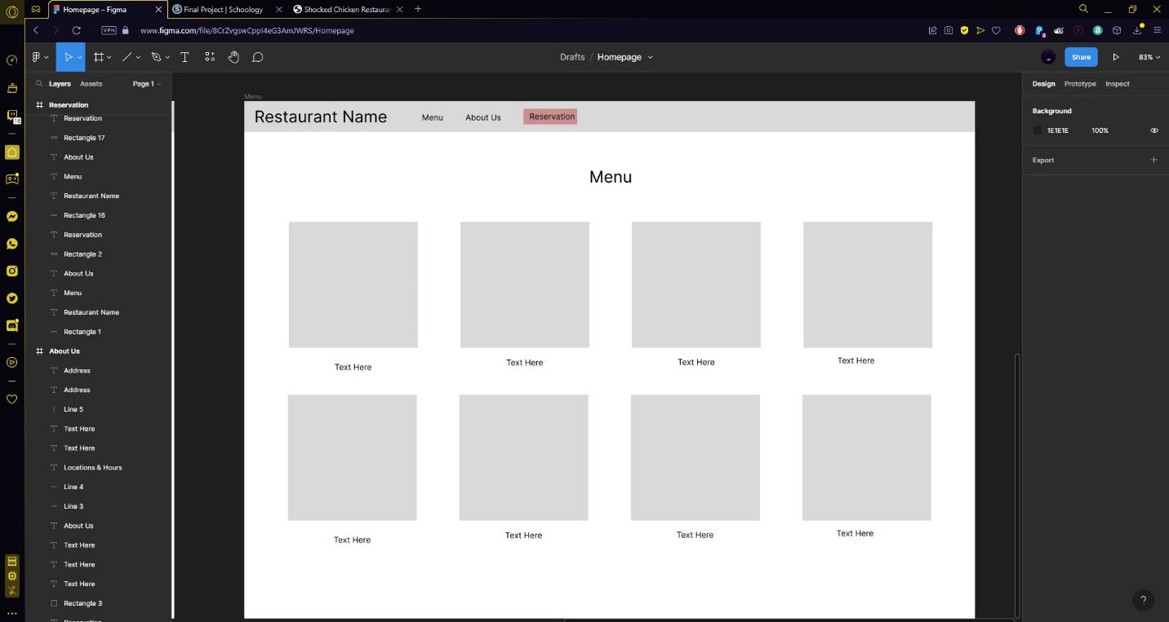

1. Add a screenshot of Menu page displayed in a browser

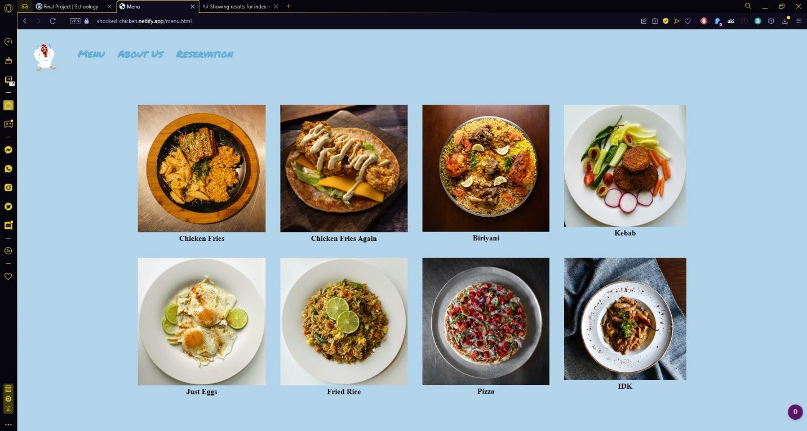

1. Add a screenshot the Menu page validated using W3C MarkUp Validation Services

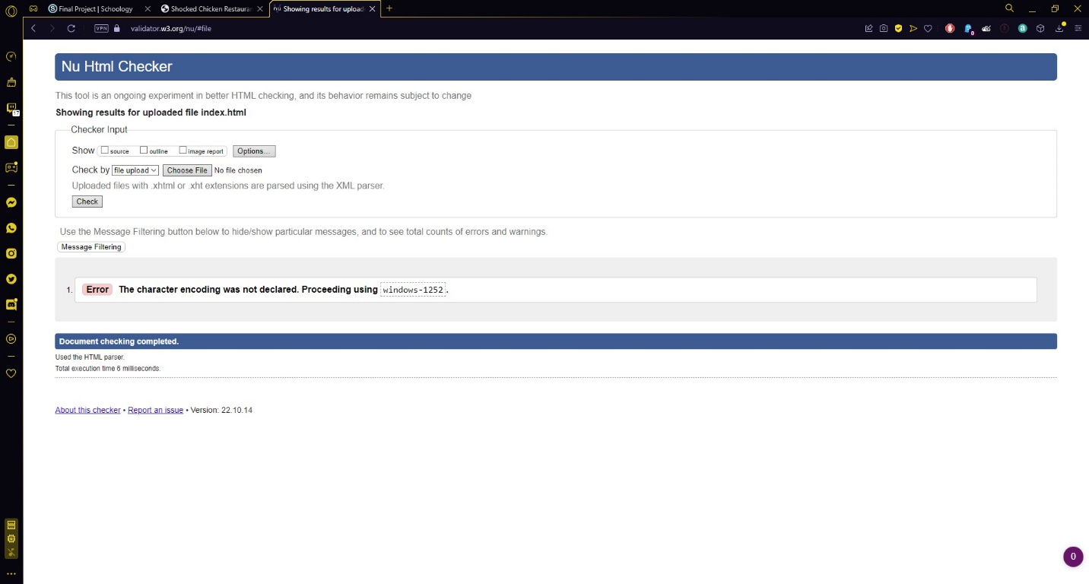

1. Add a screenshot of the wireframe for page 3: Reservation

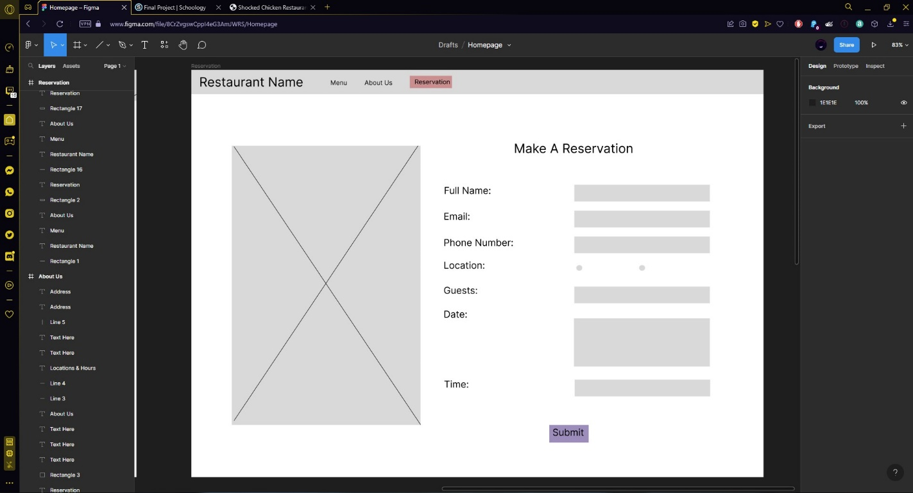

1. Add a screenshot of Reservation page displayed in a browser

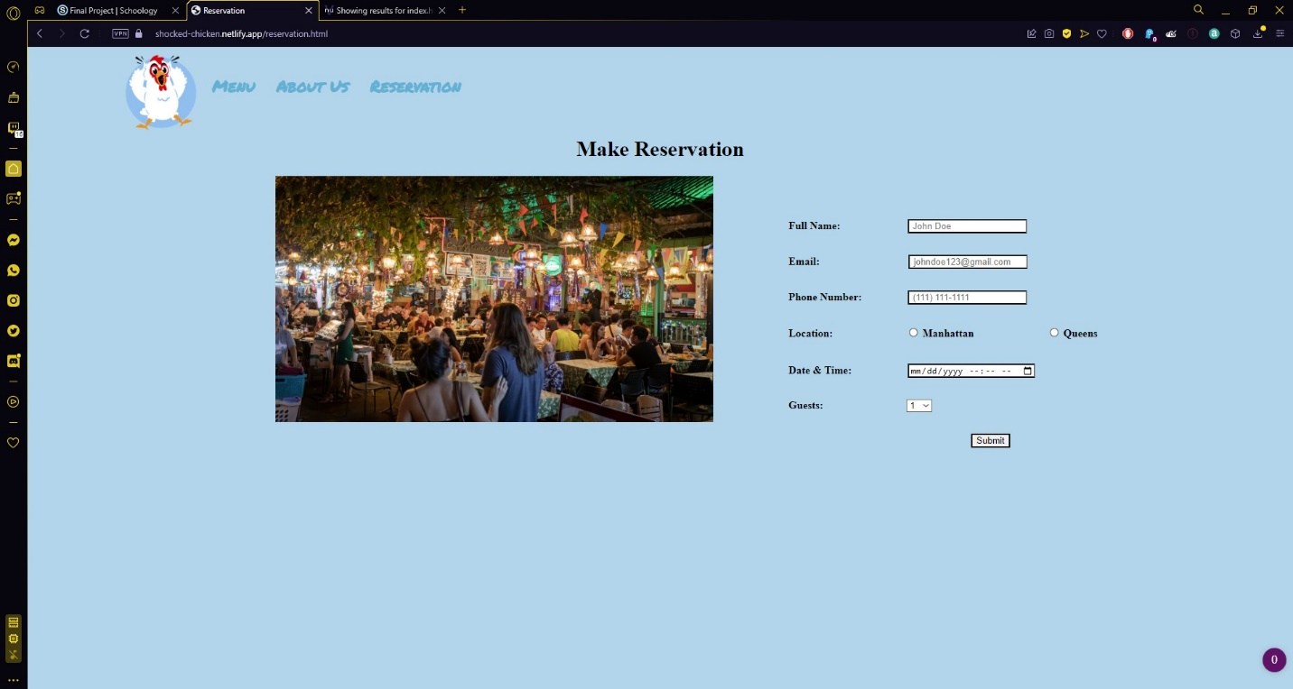

1. Add a screenshot the Reservation page validated using W3C MarkUp Validation Services

