Ch2_results
Research questions: How does community assembly change with elevation?
Does fine-scale environmental heterogeneity influence community assembly?

Methods

Study site
Species composition and functional trait data were collected from three sites spread over an elevation gradient spanning 1000 m: Golden Gate Highlands National Park (low site) at 2000 m a.s.l., Wistieshoek (mid site) at 2500 m a.s.l. and Bokong Nature Reserve (high site) at 3000 m a.s.l Figure 1. Mean annual air temperature is 12℃ at the low site, 10℃ at the mid site and 7℃ at at the high site. Total annual rainfall varies between the three sites, with the low site receiving 1310 mm, the mid site receiving 1558 mm and the high site receiving 913 mm (mean annual temperature and rainfall was calculated as the mean daily temperature and total rainfall between 22/05/2025 and 21/05/2026 measured by the nearest weather stations of the African Mountain Research Foundation). The low site is formally conserved as a National Park where livestock has been excluded, but with large herbivores like zebra, blue wildebeest and eland present at the site. The mid site is situated on land owned by the Batlokoa Royal House and the high site is situated in the Bokong Nature Reserve managed by the National Government of Lesotho. Livestock are not excluded from the mid or high site but were not observed at the sites. Mountain reedbuck, klipspringer and baboon have been observed at the mid site. Grey rhebuck, ice rat and rock hyrax are present at the high site. All three sites are located on basaltic bedrock.
Warning: package 'knitr' was built under R version 4.5.3
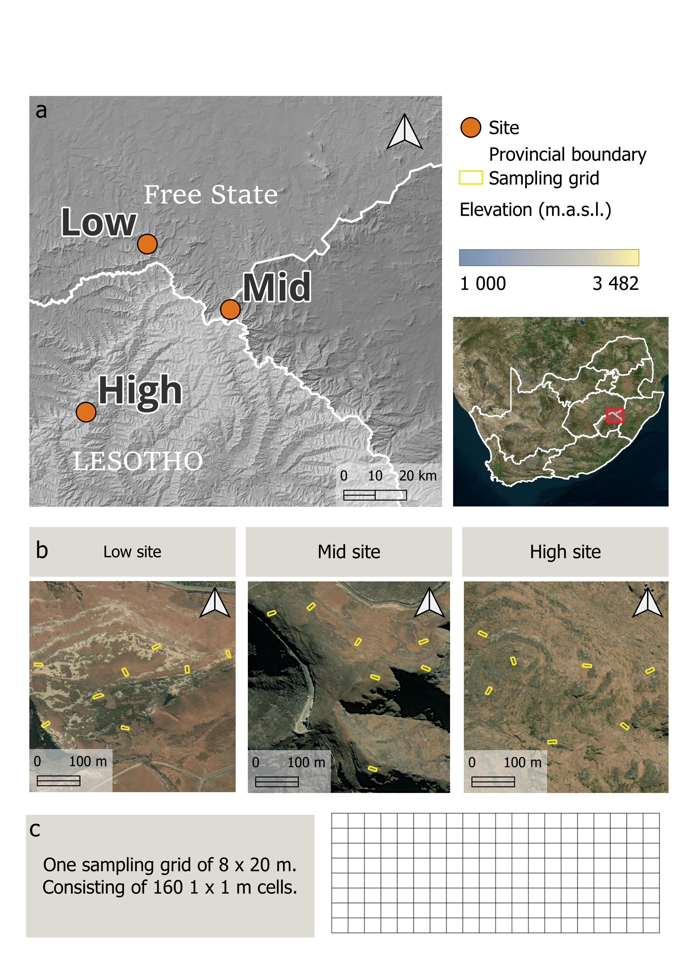
Figure 1: Site locations and sampling design in the Maloti-Drakensberg. a) Location of each of the three sites along the elevational gradient. b) Layout of the sampling grids at each site. c) A schematic of one sampling grid, consisting of 160 1 x 1m cells. This map was created in QGIS with Bing Maps Satellite Imagery.
At each site, species composition and functional traits were sampled using a grid design Figure 1 c. Each grid is 8 x 20 m, consisting of 160 contiguous 1 x 1 m cells. Eight grids were sampled at the low site, and seven were sampled at the mid and high site Figure 1 b. The grids were spaced > 80 m apart in each site and were positioned to encompass the full range of environmental conditions at the site, covering a range of topographies and vegetation characteristics. In addition, individual grids were orientated to capture as much local variation in vegetation and topography as possible. This sampling design has previously been applied in high-altitude and high-latitude systems to sample broad environmental gradients and allows the influence of fine-scale heterogeneity to be examined without the confounding effect of macroclimate or species pools (e.g., (Mod, le Roux, & Luoto, 2014; Momberg et al., 2021).
Vegetation surveys were conducted in the summer growing seasons between 2019-2023, wherein the identity and cover of each species in each cell was recorded, and a subset of species were measured for functional traits. The functional trait survey collected traits for many species at the two ends of each grid but sampled sparsely in the centre of the grid. A species was not sampled for functional traits in adjacent cells. Common species were sampled more frequently than rare species. The following traits were measured (following the standardised methods of (Perez-Harguindeguy et al., 2013): plant height, leaf area (LA), specific leaf area (SLA) and leaf dry matter content (LDMC). Thirty-five percent of species were measured for traits at least once, with these species comprising 87% of the total vegetation cover.
Several environmental variables were measured in each cell of each grid: Rock cover was visually estimated as the percentage of a cell covered by rock large enough to impede plant growth. Soil depth was measured by inserting a metal rod of 60 cm in length into the soil until further penetration was impeded. Soils deeper than 60 cm were given a depth of 61 cm. Three soil depth measurements were taken in each cell and the mean calculated. Northness was calculated as the cosine of the aspect of each cell. Slope height was measured as the vertical difference between the highest and lowest point in a cell. Surface heterogeneity was calculated as the standard deviation of elevation in a cell from a digital surface model. The digital surface model was created from drone imagery captured on XX date and… (I probably need to give more info on the imagery here, I will consult with Anika about what is appropriate). Soil moisture was measured in each cell more than 24hours after the last rainfall event, using a handheld time-domain soil moisture meter (FieldScout 300 TDR; Spectrum Technologies, Plainfield, IL, US) at a depth of 7.5 cm.
The mean soil moisture and temperature of the growing season were calculated using readings from Temperature-Moisture-Sensors (TMS, (Wild et al., 2019)). Six or seven TMS were placed in each grid, and recorded soil moisture and temperature readings every 15 minutes for one year (12 January 2023 – 21 January 2024). The start of the growing season was defined as the first day after 21 June when the minimum daily temperature of all loggers at a site were above 5℃. The end of the growing season was the first day before 21 June when all loggers at a site had a minimum daily temperature below 5℃. The growing season was from 23 August to 8 July at the low site, 1 September to 6 June at the mid site, and 10 October to 3 April at the high site. The mean soil moisture and temperature for the growing season was calculated for each logger and interpolated to all other cells in the grid. An inverse-distance-weighted interpolation algorithm was used with a power parameter of two. Cells with more than 50% rock were not used in the interpolation if they contained a logger and did not receive an interpolated value if they were without a logger. Cross validation showed that the interpolation algorithm could predict the soil moisture and temperature fairly well Table 5. [I am still a little bit unsure about the quality of this interpolation, these R2 values don’t actually look very good to me. I also tried linear modelling with environmental variables to predict soil moisture and temperature, but the soil moisture models perform very poorly. This is an easy place for a reviewer to poke a hole, and I don’t know if I’m covering my bases well enough at the moment.]
A principal component analysis was performed to identify the main axes of environmental variation across the three sites Figure 2. The following variables were selected to test whether fine-scale variation in community assembly is shaped by micro-environmental variation: mean soil temperature of the growing season, mean soil moisture of the growing season, rock cover, mean soil depth and surface heterogeneity.
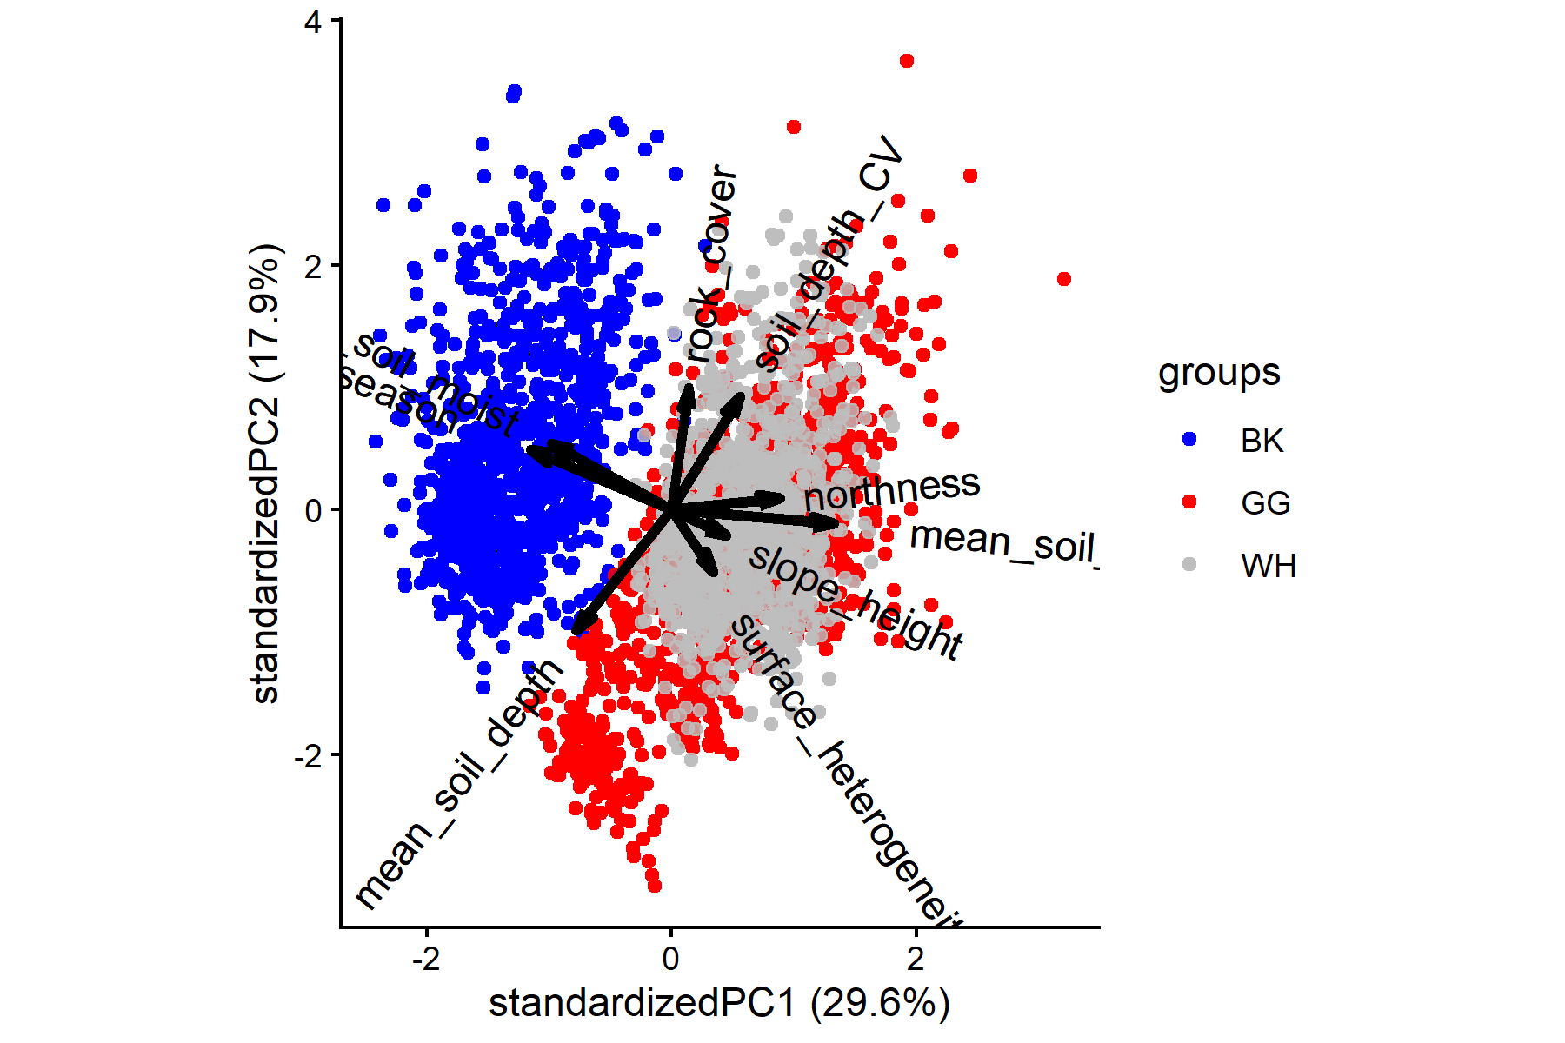
Figure 2: Principal component analysis of environmental variables measured in sampling grids

Statistical methods
To investigate community assembly along elevation and micro-environmental gradients, I will use a trait-based method which compares observed functional diversity to the functional diversity expected under a scenario of random assembly (add references here). To determine whether the community assembly mechanism is influenced by elevation, I will investigate the relationship between the functional diversity of the low, mid and high sites and elevation. Rao’s quadratic entropy (RaoQ) will be used as a metric of functional diversity. RaoQ is sum of the trait dissimilarity between all possible species pairs, weighted by the product of their relative abundances. It is calculated as follows:
$$RaoQ=\sum_{i=1}^{S-1}{\sum_{j=1}^{S}{d_{ij}}} p_{i} p_{j}$$
Where $p_{i}$ and $p_{j}$ is the percentage cover of species $i$ and $j$ in a community with a species richness of$s$. $d_{i}j$ is the dissimilarity between each pair of species $i$and $j$ , expressed as Euclidean distance(Botta-Dukát, 2005). RaoQ was calculated using the study-wide mean traits of species [I will see if I can rerun this with the site-level means of species].
A null-model approach was used to determine whether RaoQ was significantly different from the functional diversity expected under random assembly (Gotzenberger et al., 2016). Null models are a useful tool to gain insight into community assembly processes, however, they differ in their ability to detect different mechanisms. Thus, an appropriate null model must be chosen to test each assembly mechanism. Here, I followed the recommendations of Götzenberger et al. (2016) and selected the C5 null model to test for environmental filtering along elevation and micro-environmental gradients. The C5 null model shuffles the occurrences of each species across cells, such that the richness of each cell, the frequency of species, and species abundance stays the same as in the observed matrix. The total cover of cells, and the identity of species occurring in each cell are allowed to deviate from the observed matrix. When comparing the observed matrix to this null model, we can determine whether site composition is random after controlling for site richness and the commonness (number of occurrences) of species. This null model is appropriate to detect environmental filtering, with a low type I error rate (Götzenberger et al., 2016). To test whether the strength of environmental filtering varies along the elevation gradient, the null model pulled from the entire species pool to fill the null matrix (entire pool model). Thus, species exclusive to one site in the observed matrix could occur at any site in the null matrix. To test whether the strength of environmental filtering was related to variation micro-environmental conditions, we wanted to remove the filtering effect of macroclimate. Therefore, we restricted the species pool that the null model fills the matrix from to the site-level species pool (site pool model). This allowed us to determine whether micro-environmental conditions act as an additional filter after the filtering effect of macroclimate.
[I still want to run the other null model that is more appropriate for detecting limiting similarity. I’m a little overwhelmed by the prospect of presenting the results from two null models… We’ll see what the results look like]
To determine whether functional diversity is higher or lower than expected from random assembly, we calculated the standard effect size (SES) of RaoQ as a measure of deviance between the observed matrix and null model. SES is calculated as:
$$SES=\left(RaoQ_{observed}-μRaoQ_{null}\right)/σRaoQ_{null}$$
Where $RaoQ_{observed}$ is the observed RaoQ in a cell; $μRaoQ_{null}$ is the mean of RaoQ from 999 null models, and $σRaoQ_{null}$ is the standard deviation of RaoQ from 999 null models. If SES >0 functional diversity is higher than expected under null assembly, and it is interpreted as a signal of limiting similarity. If SES < 0, functional diversity is lower than expected under null assembly, and it is interpreted as a signal of habitat filtering. [maybe I should not quite make this so black and white, as competition could also lead to trait convergence]. SES was calculated for plant height, LA, SLA and LDMC, using the entire pool model and the site pool model.
To determine whether community assembly varies with elevation a linear mixed-effect model was used with the SES of each trait from the entire pool model as response, and elevation as a predictor. To determine whether micro-environmental variables were related to fine-scale variation in community assembly, separate linear mixed-effect models were built for each trait and each site. The SES of each trait from the site pool model was the response variable, and the following predictors were included: mean soil temperature of the growing season, mean soil moisture of the growing season, rock cover, mean soil depth and surface heterogeneity. In both analyses, grid was added as a random effect, and a spherical correlation structure was used to model the spatial autocorrelation between the cells of each grid. Modelling was performed using the nlme (Pinheiro, Bates, and R Core Team 2025) package in R 4.5.2 (R Core Team 2025).
To investigate the direction in which traits are filtered, the community-weighted mean (CWM) traits of each cell was calculated with the FD package (Laliberté, Legendre, and Shipley 2023). A linear mixed effect model with grid as a random effect and a spherical correlation structure was used to determine how CWM varies with elevation. General linear models were used to investigate how CWM traits vary with micro-environmental conditions [I used lm here because it is easier to make model predictions for graphing, but it is probably most appropriate to use the same mixed-effect model structure].

Results
2880 Cells were included in the analysis, with a total species richness of xx. Elevation did not have a consistent effect on the community assembly of different plant traits (Figure 1). Elevation shifted the assembly of plant height and LDMC from environmental filtering at the low elevation, to limiting similarity at the high elevation. Although communities generally became shorter with elevation (Figure 2a), the diversity of plant height was highest at the high elevation (Figure 3), indicating the presence of very short as well as very tall plants in the alpine. There was strong filtering for high LDMC values at the low elevation (indicated by the narrow CWM distribution). This filtering effect was weaker at the mid elevation, and selected for lower LDMC values on average. The assembly of LDMC shifted to trait divergence at the highest elevation, but once again showed on average more conservative strategies than at the mid elevation (Figure 2).
The assembly of leaf area shifted from being no different from random assembly, to environmental filtering at the mid and high elevation (Figure 1). Filtering was in the direction of larger leaves at the mid elevation, and smaller leaves at the high elevation (Figure 2). Environmental filtering was the dominant assembly mechanism at all elevations for SLA, although the filtering effect of SLA was weakest at the mid elevation (Figure 1). SLA was filtered toward conservative leaf-economic strategies at the low and high elevation, but more acquisitive strategies at the mid elevation (Figure 2).
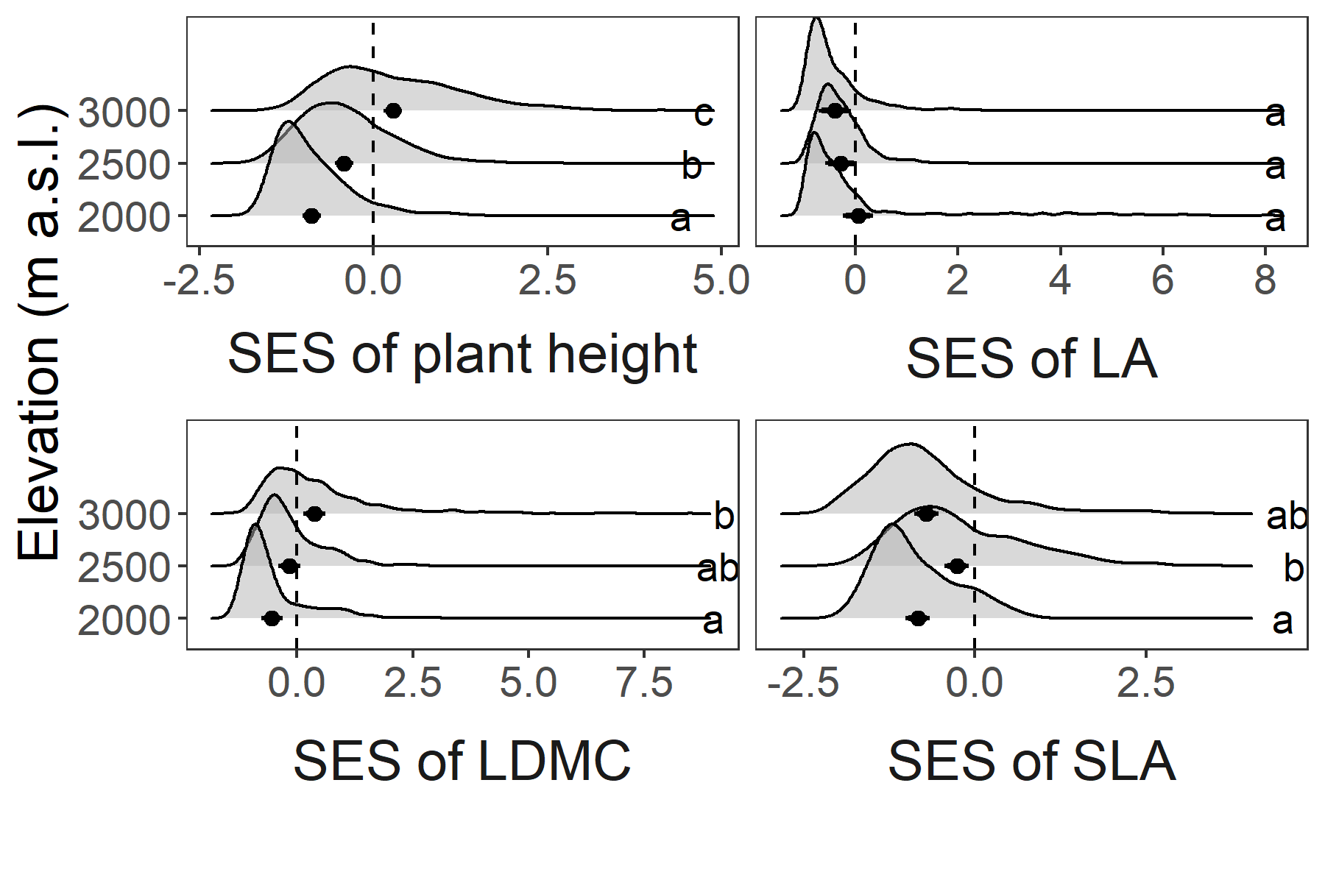
Figure 3: Distributions of standard effect sizes (SES) calculated with plant height, SLA, LDMC and leaf area along an elevational gradient. SES calculated with plant height, LDMC and leaf area used the traits on the log scale.
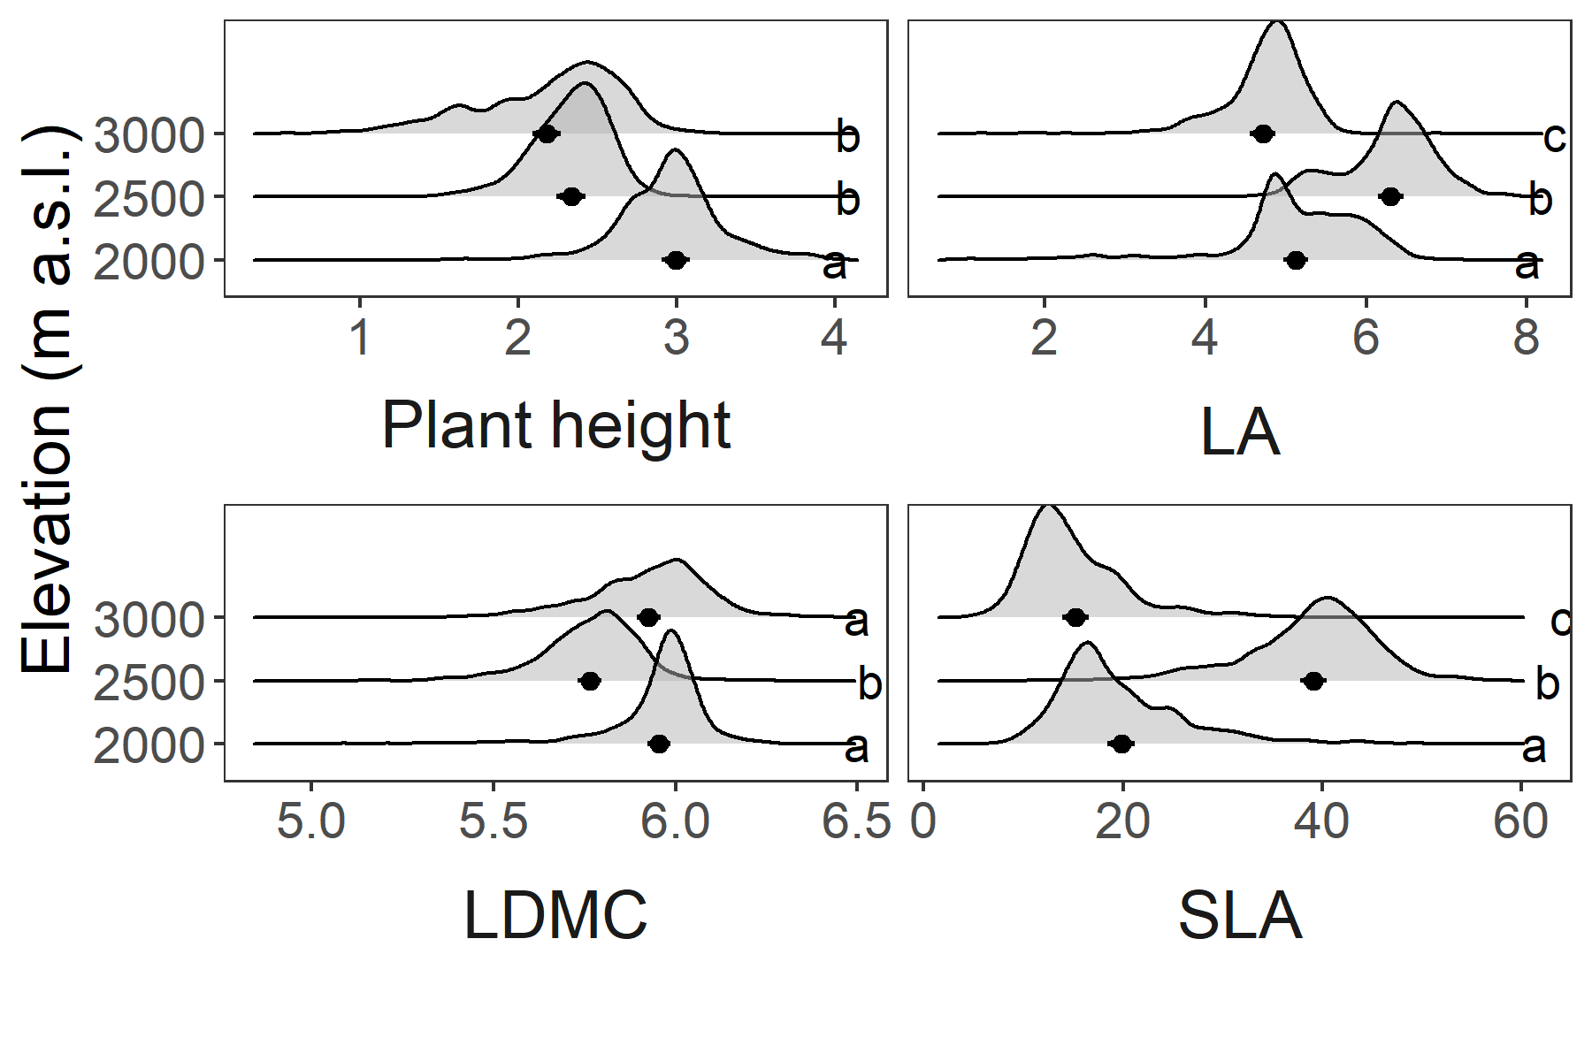
Figure 4: Community-weighted mean traits of cells at the low, mid and high elevation. Height, LDMC and leaf area are on the log scale.
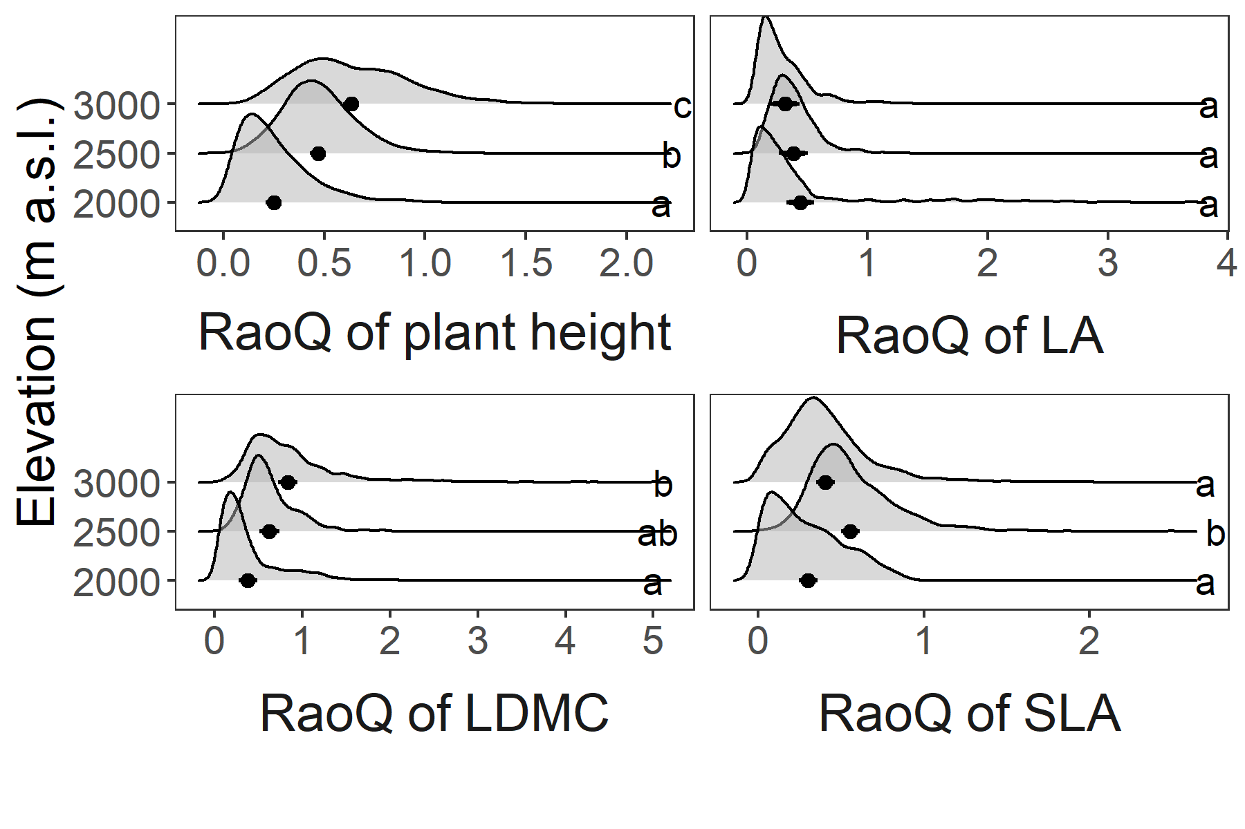
Figure 5: Trait diversity, calculated with RaoQ, of each trait along the elevation gradient
Micro-environmental factors were related to fine-scale variation in community assembly, although the relationships varied greatly between traits and sites. The models had low explanatory power, with R squared values generally below 0.1 (Table 1).
At the low site, soil temperature filtered size traits (height and leaf area) to shorter plants and smaller leaves (Table 2, Figure 4a,b). Surface heterogeneity was related to divergence of height, while soil moisture and soil depth were related to divergence in leaf area (Table 2). At the mid site, rock cover was related to divergence of height and LDMC, while soil depth and surface heterogeneity was related to divergence in leaf area (Table 3). Soil moisture was related to filtering of LDMC (Table 3), although this filtering effect was not strongly directional (LDMC did not change with soil moisture, Figure 4d). Soil depth was related to the filtering of SLA toward more acquisitive leaf-economic strategies (Table 3, Figure 4c). At the high site, soil moisture and surface heterogeneity was related to divergence in plant height, and rock cover was related to divergence of leaf area (Table 4). Soil depth had a filtering effect on leaf area, but was not strongly directional (Figure 4e). Surface heterogeneity was related to divergence of LDMC and SLA (Table 4). Divergence of SLA at the high site was also related to rock cover and soil temperature (Table 4).
Surface heterogeneity and rock cover were always related to divergence in size and leaf-economic traits. The directions of the effects of other micro-environmental variables on assembly were not consistent across sites.
Table 1: Marginal and conditional R2 values of micro-environmental models in predicting SES of each trait at the low, mid and high site.
Trait | Low |  | Mid |  | High
 | Marginal R² | Conditional R² | Marginal R² | Conditional R² | Marginal R² | Conditional R²
Height | 0.137 | 0.137 | 0.022 | 0.022 | 0.070 | 0.175
Leaf area | 0.334 | 0.601 | 0.085 | 0.213 | 0.036 | 0.052
LDMC | 0.010 | 0.476 | 0.038 | 0.247 | 0.017 | 0.231
SLA | 0.055 | 0.055 | 0.051 | 0.051 | 0.066 | 0.255

Table 2: Effects of microenvironmental variables on assembly of traits at the low site. Coefficients show the effect of microenvironmental variables on the SES calculated with each trait.
Trait | Height |  | Leaf area |  | LDMC |  | SLA
Variable | coefficient | p-value | coefficient | p-value | coefficient | p-value | coefficient | p-value
mean soil temperature | -0.266 | 0.001 | -0.262 | <0.001 | -0.078 | 0.834 | -0.053 | 0.077
mean soil moisture | -0.000 | 0.937 | 0.000 | 0.038 | 0.000 | 0.625 | 0.000 | 0.132
rock cover | 0.005 | 0.058 | 0.003 | 0.518 | 0.004 | 0.131 | 0.001 | 0.889
mean soil depth | -0.002 | 0.852 | 0.008 | 0.008 | -0.005 | 0.253 | 0.006 | 0.197
surface heterogeneity | 1.679 | 0.005 | 0.285 | 0.615 | 0.141 | 0.825 | -0.975 | 0.146

Table 3: Effects of microenvironmental variables on assembly of traits at the mid site. Coefficients show the effect of microenvironmental variables on the SES calculated with each trait.
Trait | Height |  | Leaf area |  | LDMC |  | SLA
Variable | coefficient | p-value | coefficient | p-value | coefficient | p-value | coefficient | p-value
mean soil temperature | -0.033 | 0.882 | -0.009 | 0.978 | -0.175 | 0.470 | 0.039 | 0.833
mean soil moisture | -0.000 | 0.258 | 0.000 | 0.203 | -0.001 | 0.022 | -0.000 | 0.757
rock cover | 0.006 | 0.027 | 0.001 | 0.700 | 0.001 | 0.714 | 0.004 | 0.031
mean soil depth | -0.007 | 0.206 | 0.019 | <0.001 | 0.002 | 0.546 | -0.025 | <0.001
surface heterogeneity | 0.408 | 0.692 | 1.859 | 0.035 | 1.886 | 0.062 | 1.076 | 0.302

Table 4: Effects of microenvironmental variables on assembly of traits at the high site. Coefficients show the effect of microenvironmental variables on the SES calculated with each trait.
Trait | Height |  | Leaf area |  | LDMC |  | SLA
Variable | coefficient | p-value | coefficient | p-value | coefficient | p-value | coefficient | p-value
mean soil temperature | 0.152 | 0.575 | 0.102 | 0.085 | 0.082 | 0.662 | 0.238 | 0.024
mean soil moisture | -0.000 | 0.049 | 0.000 | 0.399 | -0.000 | 0.771 | 0.000 | 0.073
rock cover | 0.002 | 0.523 | 0.004 | 0.021 | 0.004 | 0.197 | 0.008 | <0.001
mean soil depth | 0.004 | 0.092 | -0.006 | 0.013 | 0.004 | 0.144 | -0.003 | 0.255
surface heterogeneity | 8.369 | <0.001 | -1.281 | 0.146 | 3.340 | <0.001 | 1.903 | 0.032

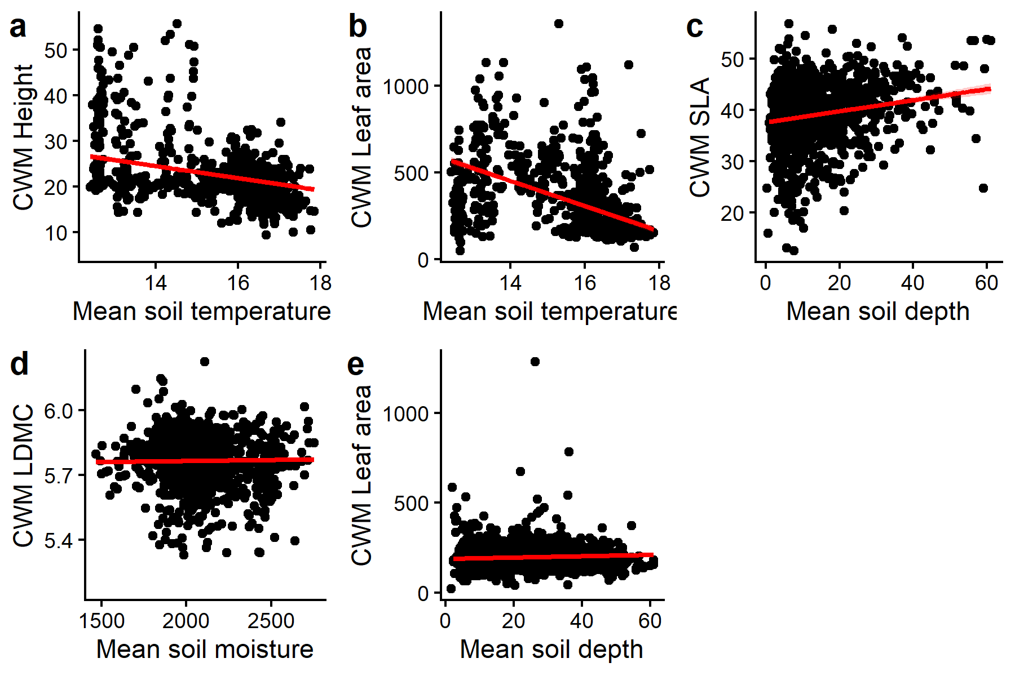
Figure 6: Direction of environmental filtering by micro-environmental variables on community-weighted mean traits at the low (a,b), mid site (c) and high elevation (d). LDMC is shown on the log scale.

Appendix
Table 5: Cross validation results from inverse-distance-weighted interpolation of the mean soil moisture and mean soil temperature of the growing season. Grid number is the unique ID of each grid in each site.Number of loggers are the number of TMS loggers used to create the interpolated temperature or moisture surface. $R^{2}$ is the squared Pearson correlation coefficient between the observed and interpolated temperature or moisture value. The root mean square error is the square root of the mean squared difference between observed and interpolated values in the grid. The bias is the mean of the differences between observed and interpolated values in the grid.
Site | Grid number | Variable | Number of loggers | R² | Root mean square error | Bias
low | 1 | mean soil moisture | 8 | 0.157 | 311.153 | -25.53239148
low | 2 | mean soil moisture | 7 | 0.009 | 330.456 | 1.17139679
low | 3 | mean soil moisture | 7 | 0.321 | 326.419 | -52.23917194
low | 4 | mean soil moisture | 7 | 0.006 | 311.145 | -44.00383866
low | 5 | mean soil moisture | 8 | 0.597 | 236.927 | 32.23132805
low | 6 | mean soil moisture | 8 | 0.045 | 443.880 | 119.77371500
low | 7 | mean soil moisture | 7 | 0.604 | 413.051 | 10.85596223
low | 8 | mean soil moisture | 7 | 0.943 | 289.390 | -21.28149274
mid | 1 | mean soil moisture | 8 | 0.069 | 152.700 | 22.33186294
mid | 2 | mean soil moisture | 7 | 0.739 | 297.210 | -50.01941758
mid | 3 | mean soil moisture | 7 | 0.820 | 220.530 | -31.50150761
mid | 4 | mean soil moisture | 7 | 0.485 | 228.515 | 20.76374332
mid | 5 | mean soil moisture | 7 | 0.931 | 412.386 | 19.94319690
mid | 6 | mean soil moisture | 7 | 0.453 | 264.053 | -4.94502584
mid | 7 | mean soil moisture | 7 | 0.504 | 360.675 | 8.82936999
high | 1 | mean soil moisture | 8 | 0.725 | 417.379 | -24.39207627
high | 2 | mean soil moisture | 8 | 0.377 | 205.670 | -2.35734840
high | 3 | mean soil moisture | 6 | 0.006 | 366.708 | -39.82072256
high | 4 | mean soil moisture | 7 | 0.879 | 251.858 | 26.25882521
high | 5 | mean soil moisture | 8 | 0.128 | 315.865 | -54.09572020
high | 6 | mean soil moisture | 8 | 0.000 | 467.492 | 0.51784515
high | 7 | mean soil moisture | 7 | 0.272 | 491.124 | 81.53533999
low | 1 | mean soil temperature | 8 | 0.454 | 1.280 | 0.05457967
low | 2 | mean soil temperature | 7 | 0.597 | 0.329 | 0.02852805
low | 3 | mean soil temperature | 7 | 0.029 | 0.378 | -0.05995268
low | 4 | mean soil temperature | 7 | 0.322 | 0.643 | -0.05245196
low | 5 | mean soil temperature | 8 | 0.255 | 0.931 | -0.20041795
low | 6 | mean soil temperature | 8 | 0.660 | 1.026 | 0.11660040
low | 7 | mean soil temperature | 7 | 0.779 | 0.705 | -0.01411296
low | 8 | mean soil temperature | 7 | 0.577 | 0.784 | -0.01074312
mid | 1 | mean soil temperature | 8 | 0.279 | 0.586 | 0.02695301
mid | 2 | mean soil temperature | 7 | 0.587 | 0.576 | -0.04634858
mid | 3 | mean soil temperature | 7 | 0.090 | 0.466 | 0.01938760
mid | 4 | mean soil temperature | 7 | 0.868 | 0.109 | 0.00302956
mid | 5 | mean soil temperature | 7 | 0.609 | 0.243 | -0.02796860
mid | 6 | mean soil temperature | 7 | 0.239 | 0.463 | -0.05958197
mid | 7 | mean soil temperature | 7 | 0.072 | 0.437 | -0.11124718
high | 1 | mean soil temperature | 8 | 0.008 | 0.511 | -0.07628346
high | 2 | mean soil temperature | 8 | 0.582 | 0.590 | -0.08948552
high | 3 | mean soil temperature | 6 | 0.003 | 0.455 | 0.01339610
high | 4 | mean soil temperature | 7 | 0.498 | 0.410 | 0.04244677
high | 5 | mean soil temperature | 8 | 0.477 | 0.434 | -0.04592572
high | 6 | mean soil temperature | 8 | 0.505 | 0.628 | -0.10715800
high | 7 | mean soil temperature | 7 | 0.674 | 0.558 | 0.02247341

Laliberté, Etienne, Pierre Legendre, and Bill Shipley. 2023. FD: Measuring Functional Diversity (FD) from Multiple Traits, and Other Tools for Functional Ecology. https://doi.org/10.32614/CRAN.package.FD.
Pinheiro, José, Douglas Bates, and R Core Team. 2025. Nlme: Linear and Nonlinear Mixed Effects Models. https://svn.r-project.org/R-packages/trunk/nlme/.
R Core Team. 2025. R: A Language and Environment for Statistical Computing. Vienna, Austria: R Foundation for Statistical Computing. https://www.R-project.org/.

