**Session: 1 Introduction & Namespace**

* Microsoft has introduced it is design to simple, modern, General purpose, Object Oriented Language.
* Part contain : Eg :- java(class, object, interface, inheritance)
* C# it’s a part of dot net Framework
  + Provide: - **BCL (Base Class Libraries) :** Without BCL can’t write Code
  + Known as Building Block.
  + **CLR (Common Language Runtime):** Core Component of Application used to convert **MSIL (Microsoft Intermediate Language)** code to native.
    - Provide execution and run the program.
    - It provide multiple language support.

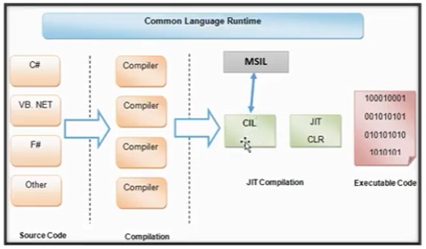

EG:-- having 10 method but you are calling **only one.**

* **C#** **Used For:** Windows Application or Desktop or Console or WinForms Application.
* Creation of Application: - Mobile, Web, Gaming: unity.
* Its always come with dot net framework without dot net framework it won’t run and compile code.
* C# Compiler Convert the code into CIL (Common Intermediate Language) converted to native to the os.
* Its runtime process by the jit compiler.
* once the process done then code execute by cpu.

**Jit Compiler**: - Just in Time Compiler

Msil Contain all Codes but jit only call the function which we required.

NATIVE CODE

OR

CPU SPECIFIC CODE

**Namespace**

* It’s a container. And it’s a keyword (predefined).
* It used to organise your code and its collection of class structs delegates enums.
* Using. (Dot) you can access the member of namespace.
  + **EG:-** Namespace Session1{ class MySession{ method(){….}…. }….}
  + **Session1.**MySession.method();
* 2 class doesn’t have the same name.
* Namespace Contain different packages: and its precome with dot net framework. EG: **- Using System;**
* If u don’t want to use namespace then u can use **FQN** (Fully Qualified Name).

**Eg:-** System(Nmspc).Console(Clss).WriteLine(“Message”)(Method);

**Using system; >> For Reducing Namespace used Again and again.**

**Eg:-** Console(Clss).WriteLine(“Message”)(Method);

**Nested Namespace:**

* Namespace within namespace.
* 2 classes with the same name can be created in 2 difrnet namespace.