Fairfield University

BS Software Engineering Program

CodeFighter User Manual

Group 5

Samuel Nguyen, Carlos Urena, Jack Foley, Marydjina Barionette, Joey Graham

Software Engineering Methods SW401

Amalia Rusu

November 21st, 2016

***Table Of Contents***

*CodeFighter Application User Manual*

Introduction ………..……………………………………………………………………..……………. 2

Application Setup ……………………………………………………………………………………….3

Launching the Application ……………………………………………………………………………...4

Setting up the Program for Use …………………………………………………………………...…..5

**Working with the Program …………………………………………………………………………..6**

Main Menu……………………………………………………………………………………………….6

Login……………………………………………………………………...……………………………...7

Instructions ……………………………………………………………………………………………...8

Level Select …………………………………………………………………………………………..…9

Game …….. …………………………………………………………………………………………...10

Pause Menu …………………………………………………………………………………………...12

Game Over ………………….…………………………………………………………………………13

Introduction

CodeFighter is a fun, yet educational defense game that engages students to learn new technological methodologies. Its ultimate goal is to teach the different aspects of black box and white box testing. Through this unique apparatus, it forces students to think in a strategic manner in order to complete the game.

/*Throughout the game you’ll notice trivial questions that will be displayed about these two complex testing methodologies. Given the response is correct, the monsters will be defeated and you’ll move on to the next wave. */

Application Setup

In Browser:

It can also run on any device that can use web browsers that support WebGL. No downloads or extensions required.

Locally:

There is minimal action the client needs to take to set up this application. The latest version can run on a variety of platforms such as MacOS, Linux, and Windows. To run, along with the application, user must have the game files: CODEFIGHTER_DATA.

Launching Application

Once the application starts up, you will see the main menu screen. Here you can click various options such as play, login, and instructions. To play the game as a guest select “PLAY”. To start the game as a user you will be prompted to enter your login credentials. If you are a new user, you will either need to create a new username and password or you can play as a guest. If you choose to play as a guest, the information will not be saved.

(See Main Menu)

Setting up the Program for Use & Progression

Once you start the game, you will then proceed to a screen where you can choose three different levels. As you play the game the levels get progressively more difficult. As you beat each level, a screen will prompt you to go to the next level and continue the game. Once you finish the last level, the game will tell you you’ve won.

**Working with the Program**

Main Menu

Upon opening the application, you will be greeted with the Main Menu, a navigation system that will serve as a hub for all system functions. Version 1.0 offers the following Menu Options:

PLAY: allows the user to Bypass a login screen and play CODEFIGHTER as a guest.

LOGIN: allows the user to login and retrieve his/her data. This will enable the user to save his/her save data, for later access.

LEADERBOARDS: Allows the user to check his/her rankings compared to other players.

INSTRUCTIONS: contains a quick tutorial to get the user acclimated with the game controls, mechanics, and meaning.

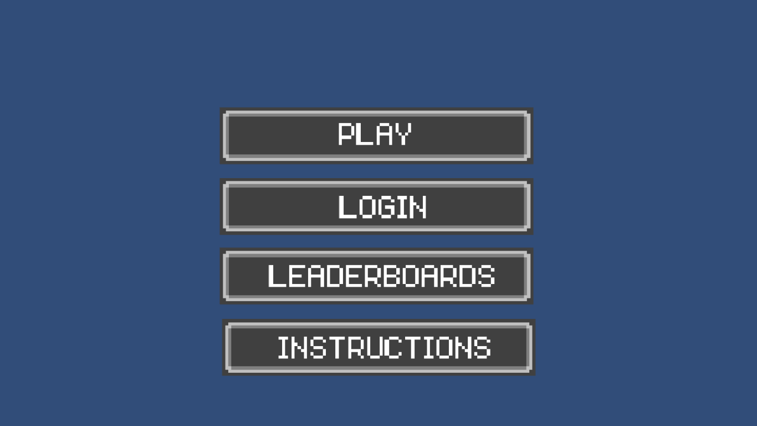

Login

At the login screen, the user enters their username and password, then clicks the submit button. If the username and password are correct, there is a welcome message and the user is admitted to the game. If the username and password are incorrect, a message appears telling the user that this is the case, and then the user must try again. The user has unlimited attempts to satisfy the correct criteria. If you are a new user, you will either need to create a new username and password or you can play as a guest. If you choose to play as a guest, the information will not be saved.

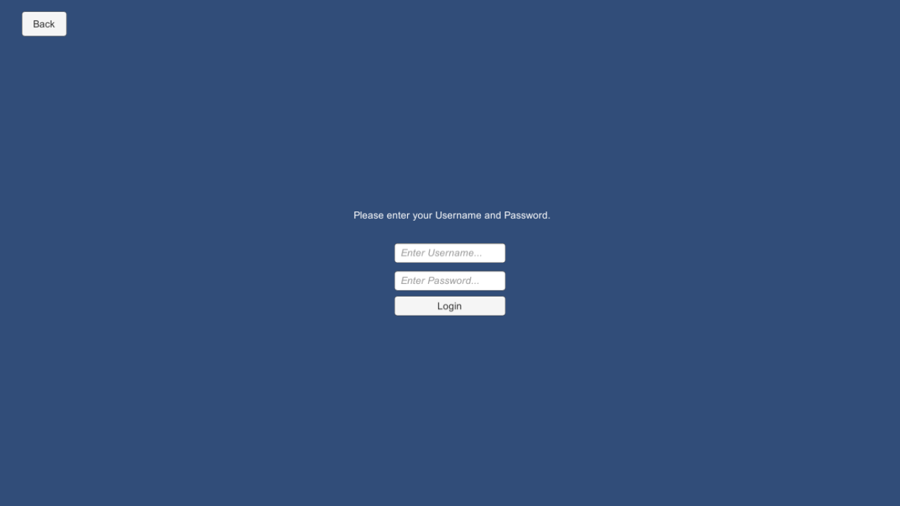

Instructions

The instructions provided step-by-step directive to how to play the game. The User starts off on the introduction page as the game welcomes you to CodeFighter. The User is directed to press, “Next”, then they will be shown the first page of the instructions manual. There is a “Back” and a “Next” button. When the user is done, they will press, “Next” and will be shown the next page of the instructions.There is the same two buttons as before. If the user needs to be reminded of something from the first page, they can go back but they will press “Next” to continue to move forward. The last page gives the option to go back or “go to the menu”.

Level Select

Once you enter the game you’ll come to a screen that has different levels shown. Select the first level as each level is locked until you complete the previous level. Once you complete a level, you will be brought back to the “Level Select” screen where the next level will be unlocked where you can proceed to click the next unlocked level. You will find the game will get progressively harder including harder trivial questions about black box and white box testing.

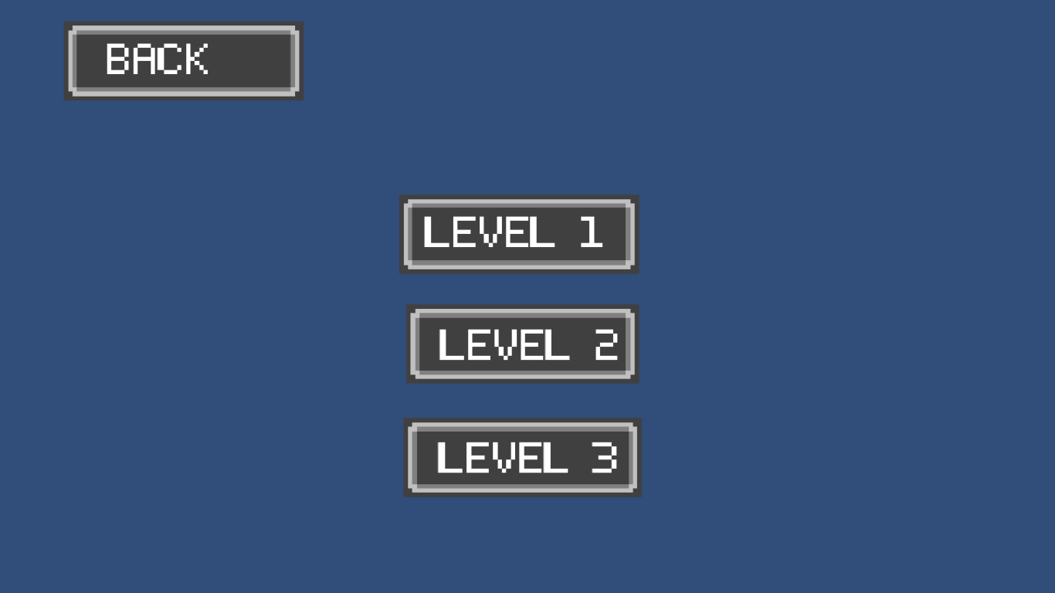

Game

By select a level in level select, you will be directed to your selected level. There are various properties and functions in the game module

Start:

The green cube. Enemies spawn here at the start of each wave

Node:

Areas where turrets can be placed

Non path and water points

Path:

Path the enemies follow. Turrets cannot be placed here

Terrain:

Non path areas where turrets cannot be placed.

Ex: Water and lava

End:

The red cube. Enemies terminate here after each wave. Deciments amount of lives

Lives

This displays your amount of live. Decays with enemies reaching end

Count Down Timer:

Count down seconds between each wave

Money:

Money accumulated, used to buy turrets

Turrets:

Weapon used to destroy monsters

Standard: Can target only black box monsters. Single target attack

Cannon: Can target only black box monsters. Explosion attack

Lazer: Can target only white box monsters: Slows only

Shop:

Shows the price of each turrets. Can select and move to place turrets on nodes only

Black Box Monster:

Monster the standard and cannon guns can target. Untargetable by laser

White Box Monster:

Monster that cannot be targeted but slowed by lazer gun

Can be killed by question answer

Question Select:

Press spacebar to answer question to kill white box monsters

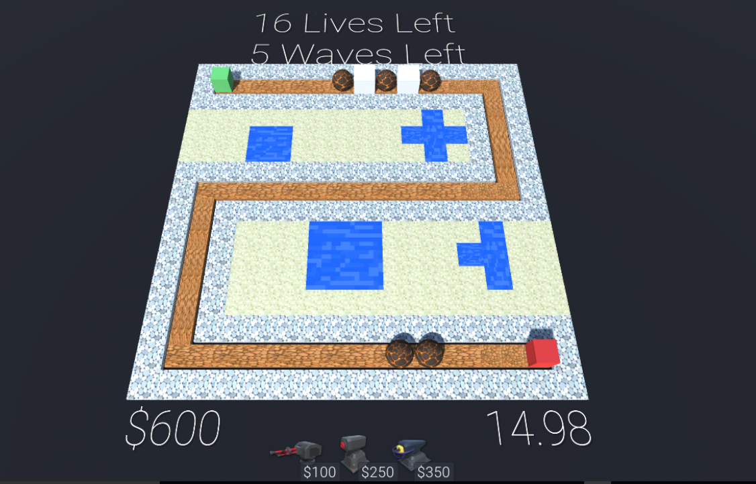

Pause Menu

If you want to pause the game at any time, be sure to click the “P” key. When the game is paused, you can either retry the level or go back to the main menu. When ready, be sure to click continue to continue playing the game.

Retry starts the level over

Menu proceed to main menu

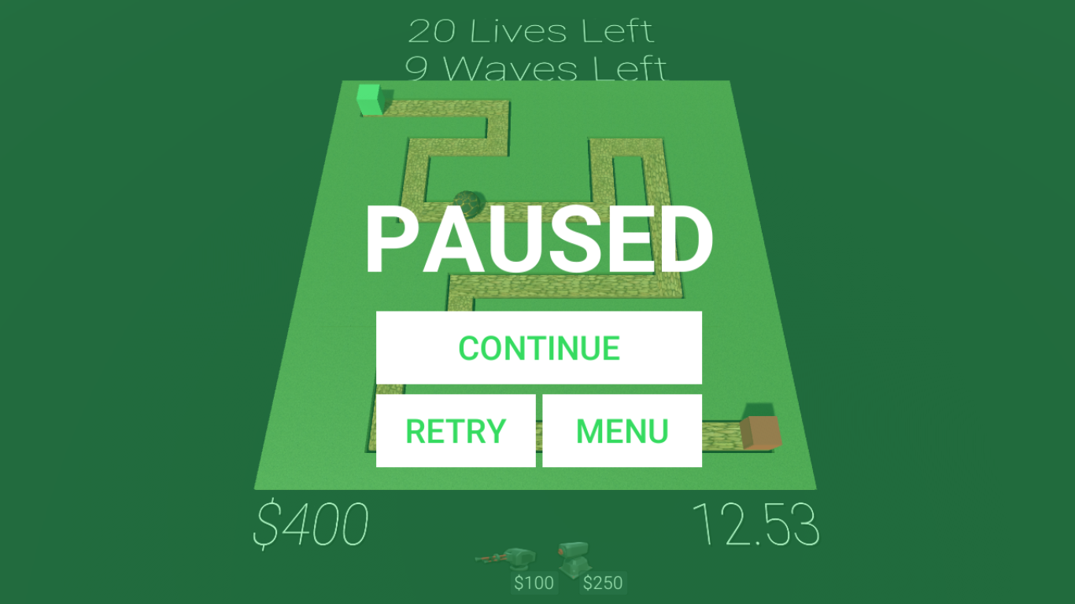

Game Over

If you run out of lives on any level, the Game Over screen will pop up indicating you have lost the game. In the event of this happening, select “MENU” to go back to the main menu and try again.

