**SCREENSHOTS**

1. Loading the dataset into Pandas Dataframe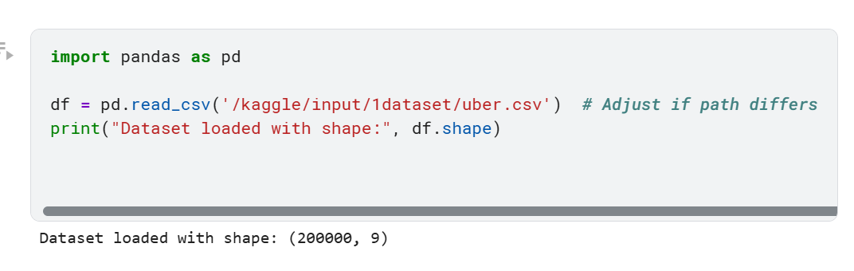
2. Comprehensive EDA: dataset, structure, data types and quality.

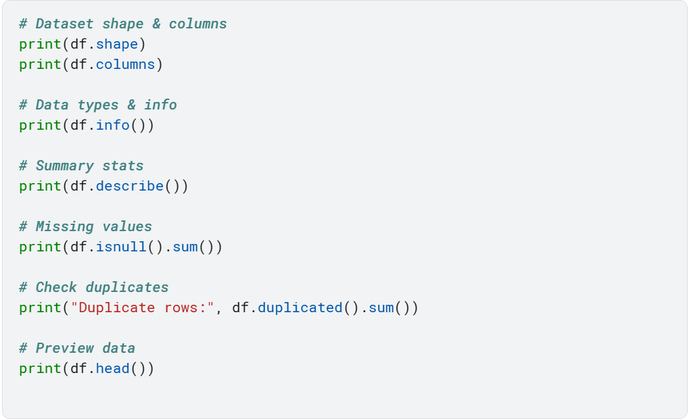

1. Handling missing values and cleaning data

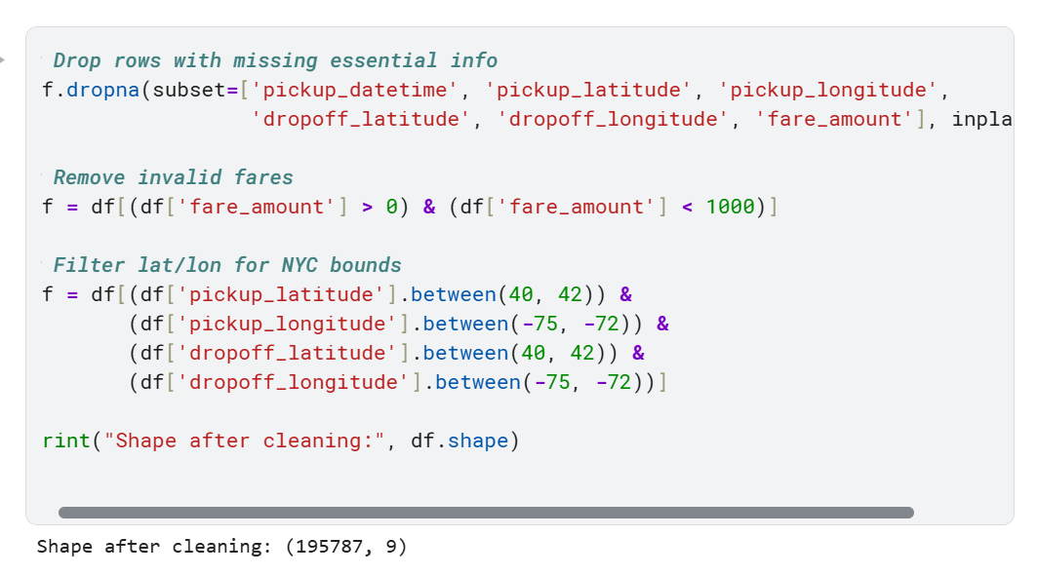

1. Exporting cleaned data for Power BI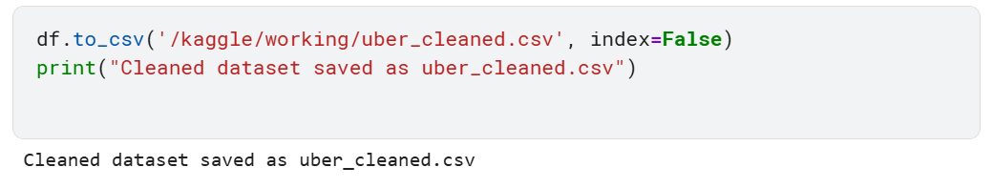
2. EDA
3. Descriptive statistics (mean,median,mode,std, quartiles, outliers)

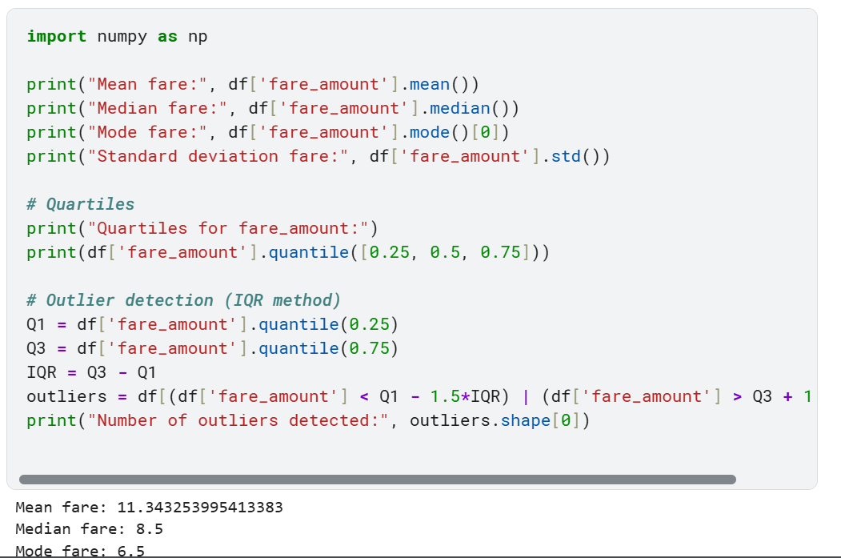

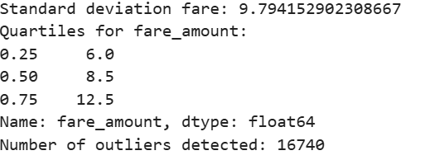

1. Visualizing fare distribution(histogram, box plot)

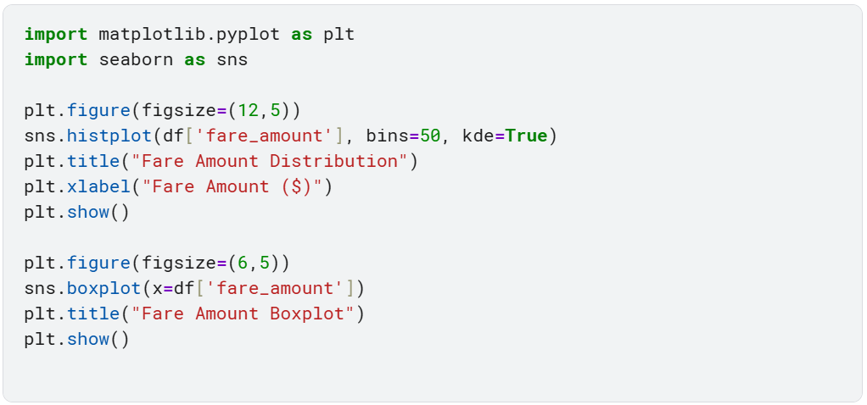

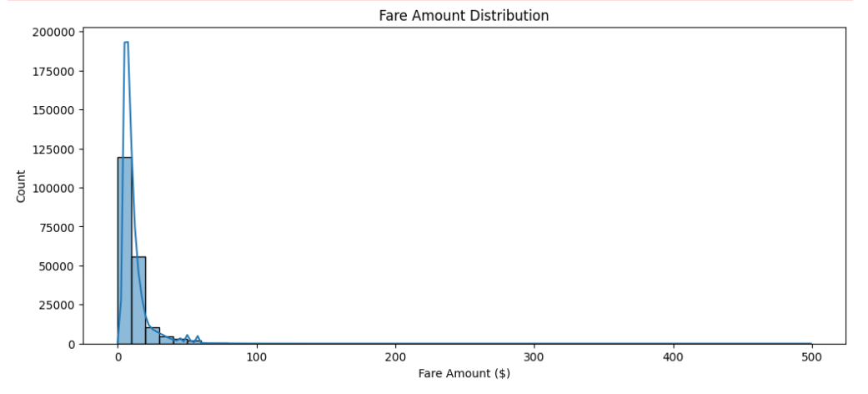

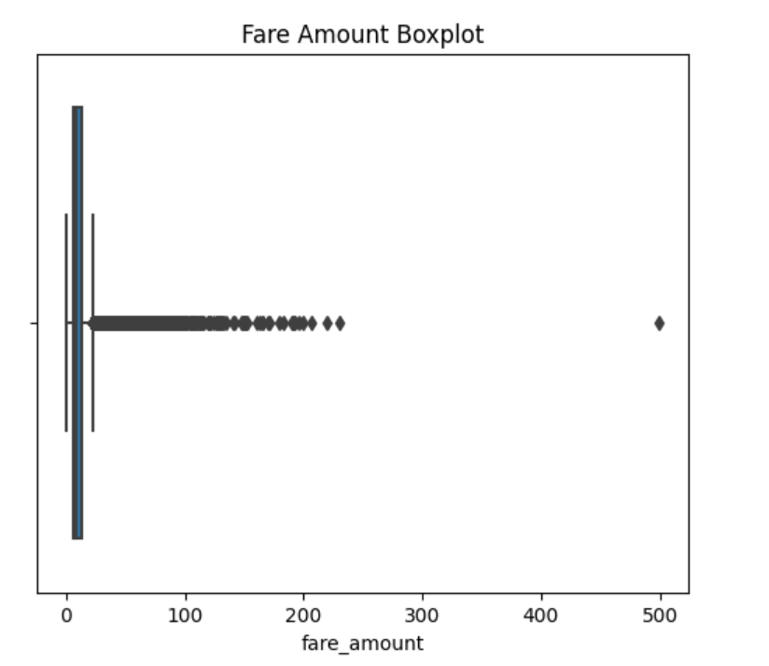

1. Analyzing relationships: fare vs distance, fare vs time of day

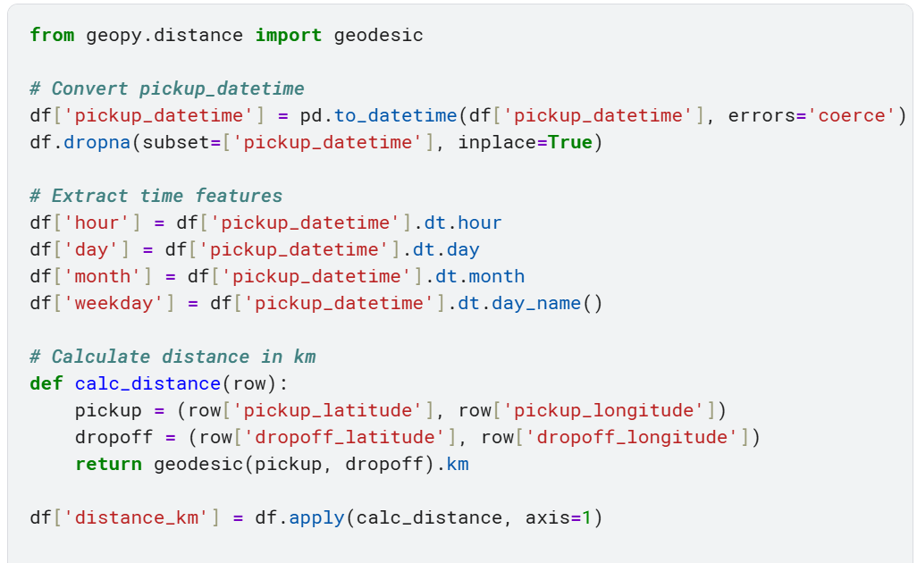

Visualizing realtionships:

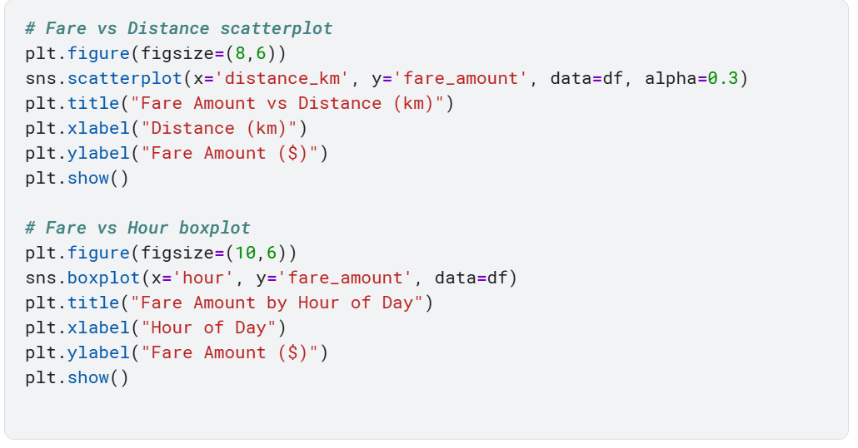

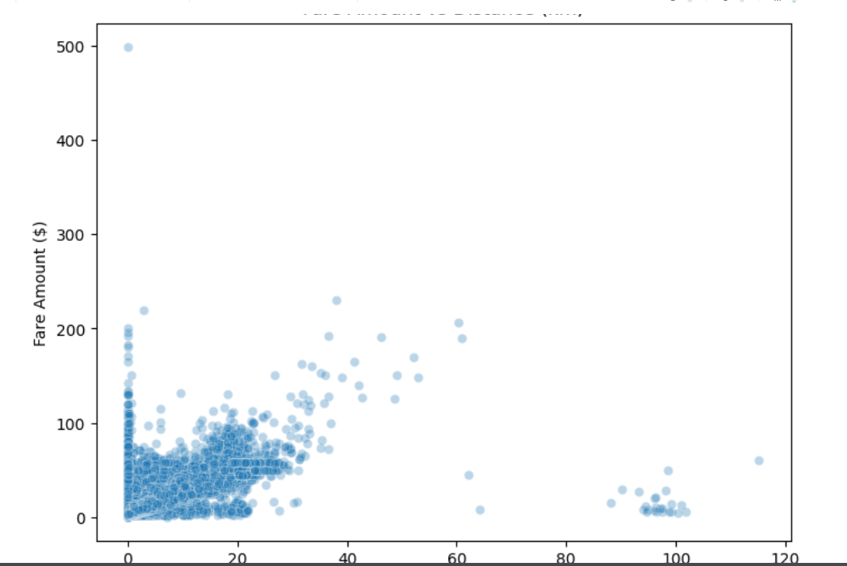

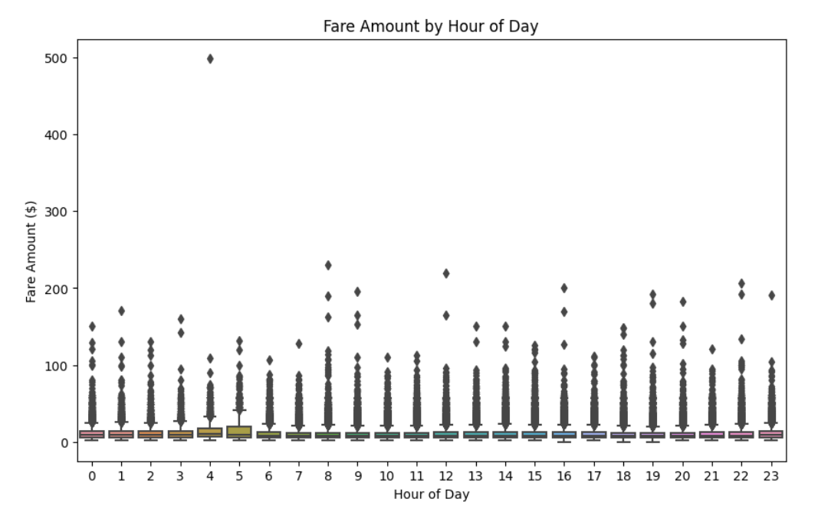

1. Feature Engineering
2. Creating features such as hours, day, month, weekday, peak time.

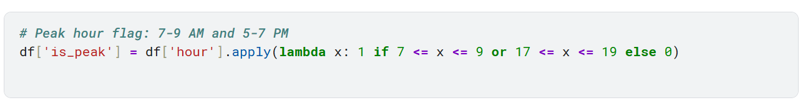

1. Encoding categorical variables (weekday)

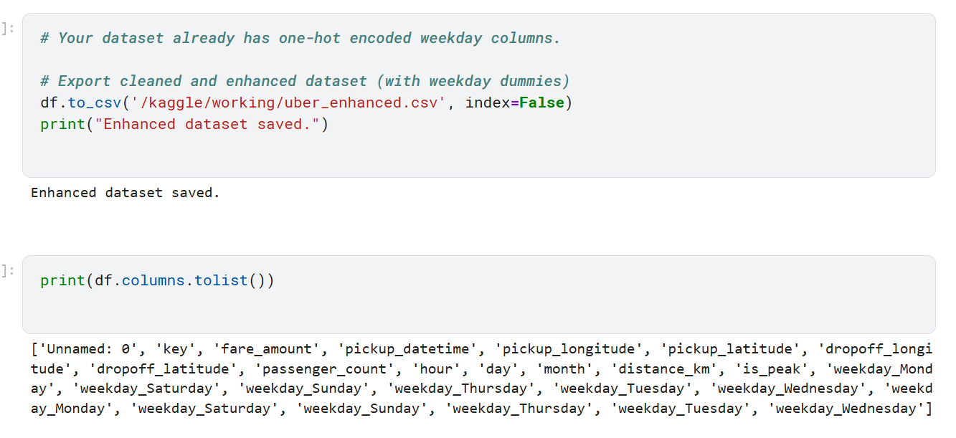

1. Save enhanced dataset for Power BI

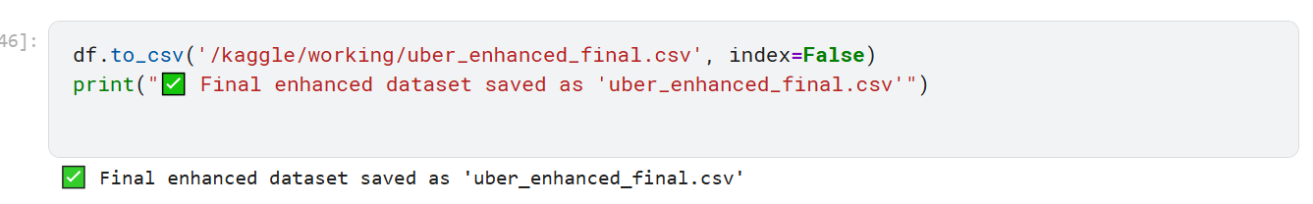

1. Exporting and loading the enhanced cleaned file to Power BI

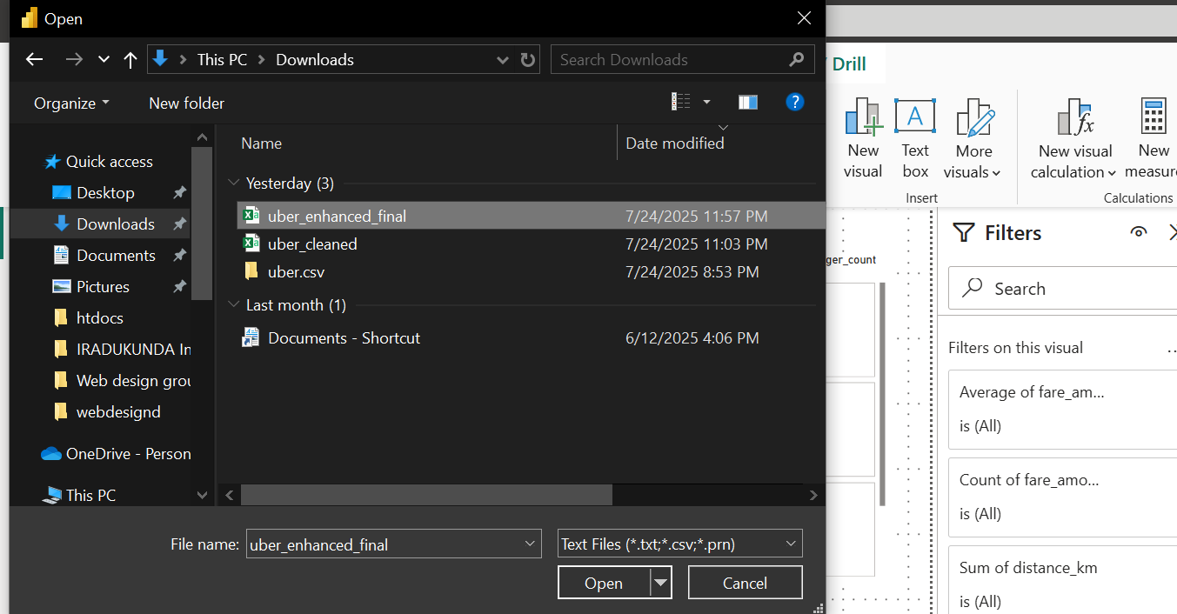

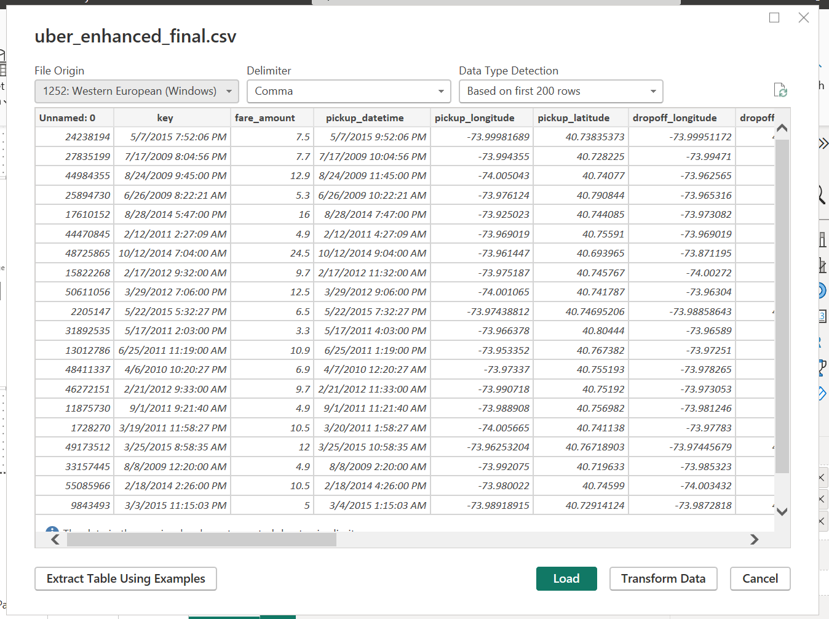

1. The visuals

