Formal Methods Project
User Guide

System Requirements

Software Requirements
Component | Requirement
Operating System | Windows 10/11, Linux, or macOS (Python + Tkinter environment)
Python Version | Python 3.10+ recommended
Git (optional) | Required only if using "Clone + load" in Part 2
GUI Support | Tkinter must be available in Python installation

Python Dependencies
From requirements.txt:
python-sat>=0.1.8.dev0

Notes:
- PySAT is required for SAT verification and MWP features.
- If PySAT is missing, the app still opens, but SAT-based actions show warnings/instructions.
Installation and Run Commands

Step-by-Step Setup
- Open terminal (PowerShell/Command Prompt).
- Go to the project folder that contains ui_app.py:
cd "c:\Users\ABC\OneDrive\Documents\Sem 6\formal methods\project\Formal-Methods-Project"
- Install dependencies:
python -m pip install -r requirements.txt
- Run the main GUI:
python ui_app.py

Optional Run Modes
Run with a specific XML directly:
python ui_app.py path/to/model.xml
Run Person 1 console flow:
python main_p1.py
Run SAT layer self-test:
python sat_solver.py

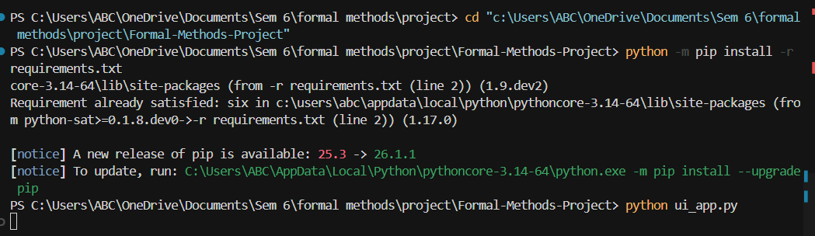
Tool Overview
This project is a Feature Model Analysis desktop tool with two major parts in one interface.

Part 1 (Feature-model side):
- Load feature model XML
- Interactively select features in a tree
- Verify configuration feasibility with SAT
- View logic formulas, constraints, MWP, and text diagram

Part 2 (Code-impact side):
- Load a local codebase folder or clone from Git URL
- Create feature-to-file mapping
- Extract lightweight file dependencies
- Derive feature-level dependencies
- Detect model-vs-code inconsistencies
- Compute impacted files for currently selected features

Main window title: Feature Model Analysis Tool
Main tabs: How to test, Verification, Logic, Constraints, MWP, Diagram, Code Impact (Part 2)
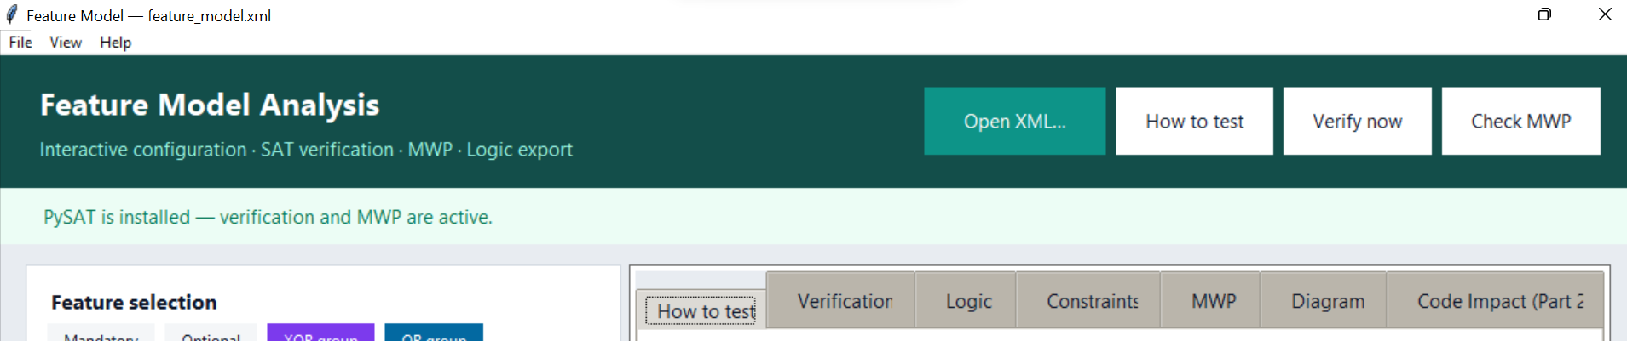

Part 1 User Guide — Feature Model + SAT

Loading the XML Model
- Click Open XML… (top bar), or use File → Open XML…
- Select an XML model file (example: feature_model.xml)
- After loading: left panel shows Feature selection tree with checkboxes; Logic/constraints/diagram tabs are populated; Verification auto-runs shortly after selection updates.
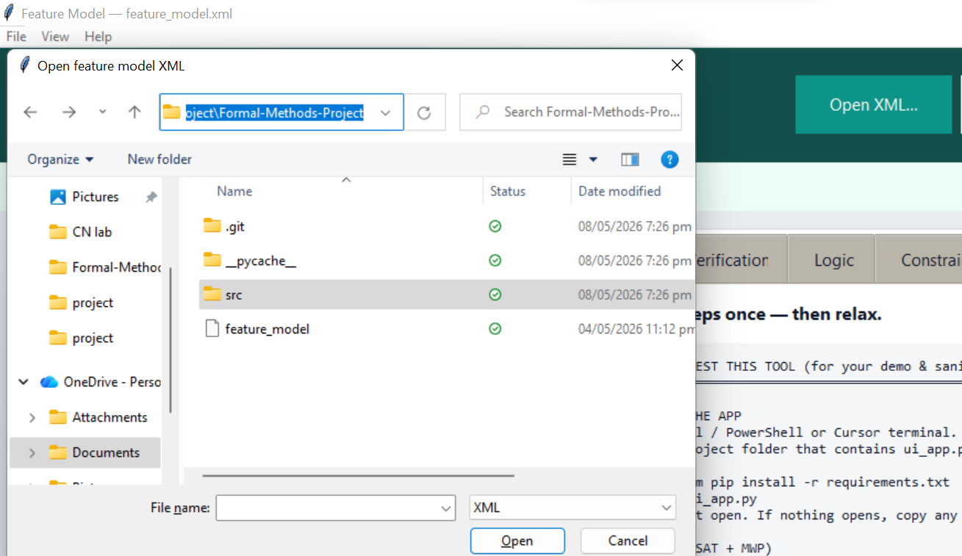

Tree Legend and Interaction Rules
Legend shown in UI: Mandatory, Optional, XOR group, OR group.

Behaviour implemented in UI:
- Root feature is fixed ON ("root · always on").
- Selecting a feature auto-selects its ancestors.
- Mandatory sibling/child propagation is enforced where applicable.
- XOR exclusivity is enforced: selecting one XOR member unselects other members in that group.
- Turning a feature OFF deselects descendants.
- For selected parents with empty group choices, UI may auto-pick the first group member to maintain group consistency.

Select mandatory chain button:
- Clears optional selections
- Selects structurally mandatory features in root-first order
- Lets propagation set valid defaults for groups

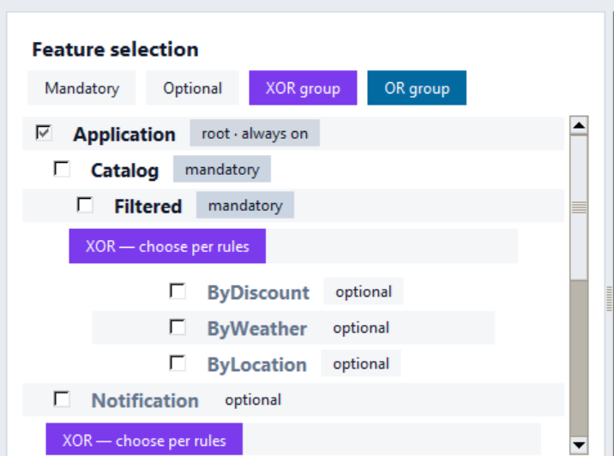
Verification Tab (SAT Feasibility)
Verification is updated automatically (debounced) and also via the Verify now button.

Top status in tab:
- Feasible configuration (valid)
- Not feasible (invalid)
- Verification needs PySAT (dependency missing)

Read-only outputs: Summary, Violations & hints. If invalid, hints may suggest required additions.

Important: Verification checks both cross-tree constraints (fast pre-check) and full SAT satisfiability of the exact selected/unselected set.
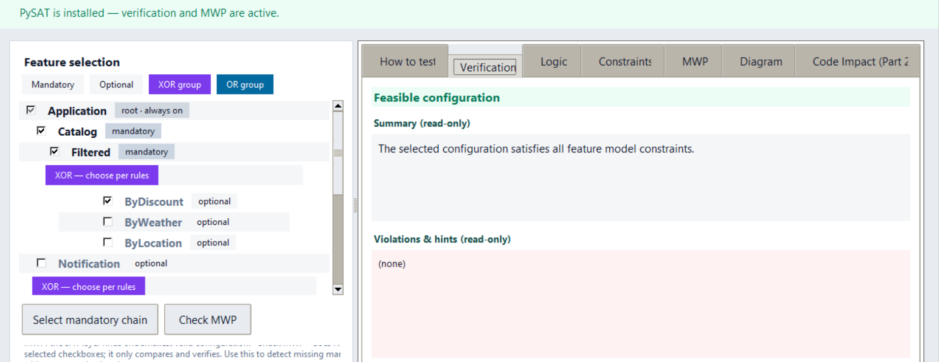
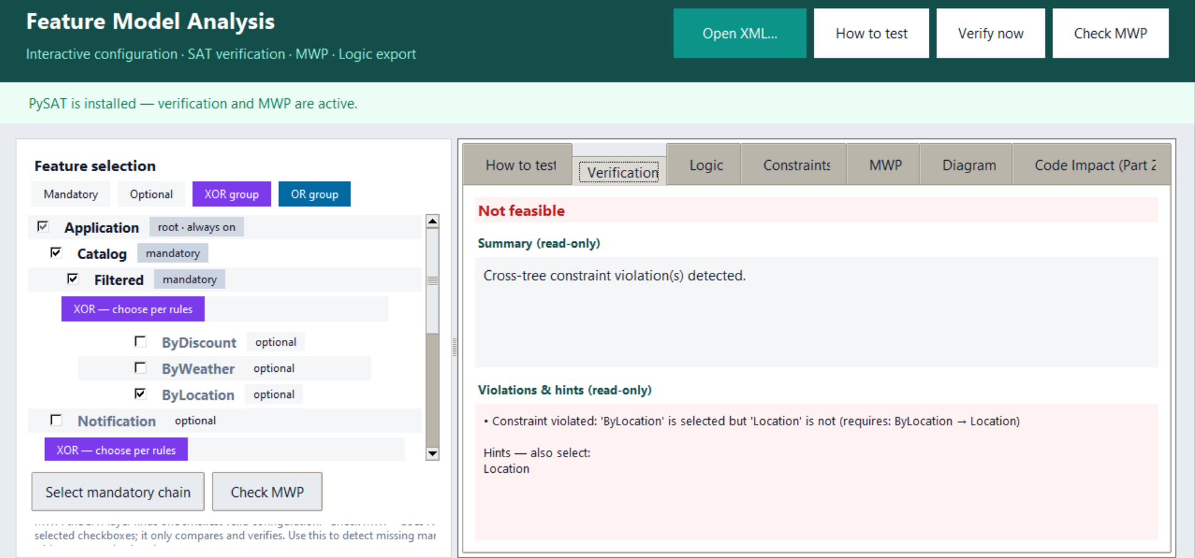

MWP Tab and “Check MWP” Usage
MWP tab shows: current selection validity/reason, MWP validity + note, feature list in MWP.

Check MWP button (top bar or tree card):
- Verifies current selection
- Refreshes MWP info
- Compares current selection vs MWP
- Does NOT auto-modify your checkboxes

MWP strategy in solver:
- Include mandatory features
- Pick first member in each selected XOR group
- Pick first member in each selected OR group
- Set others false, SAT-check result
- Fallback to SAT model if heuristic combination fails

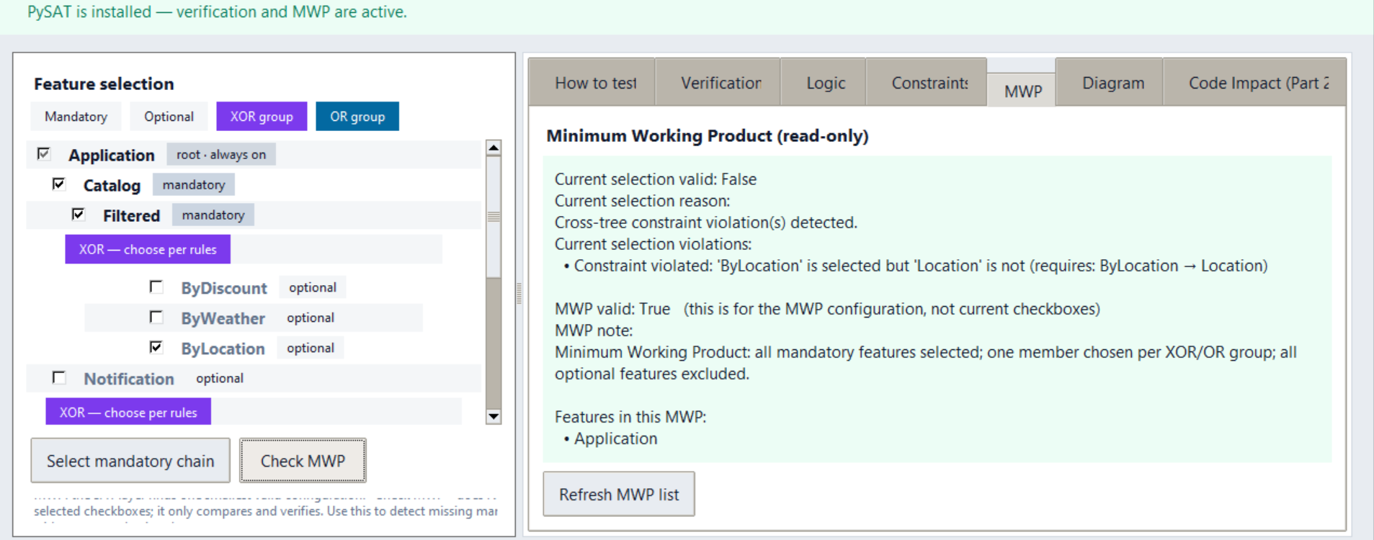

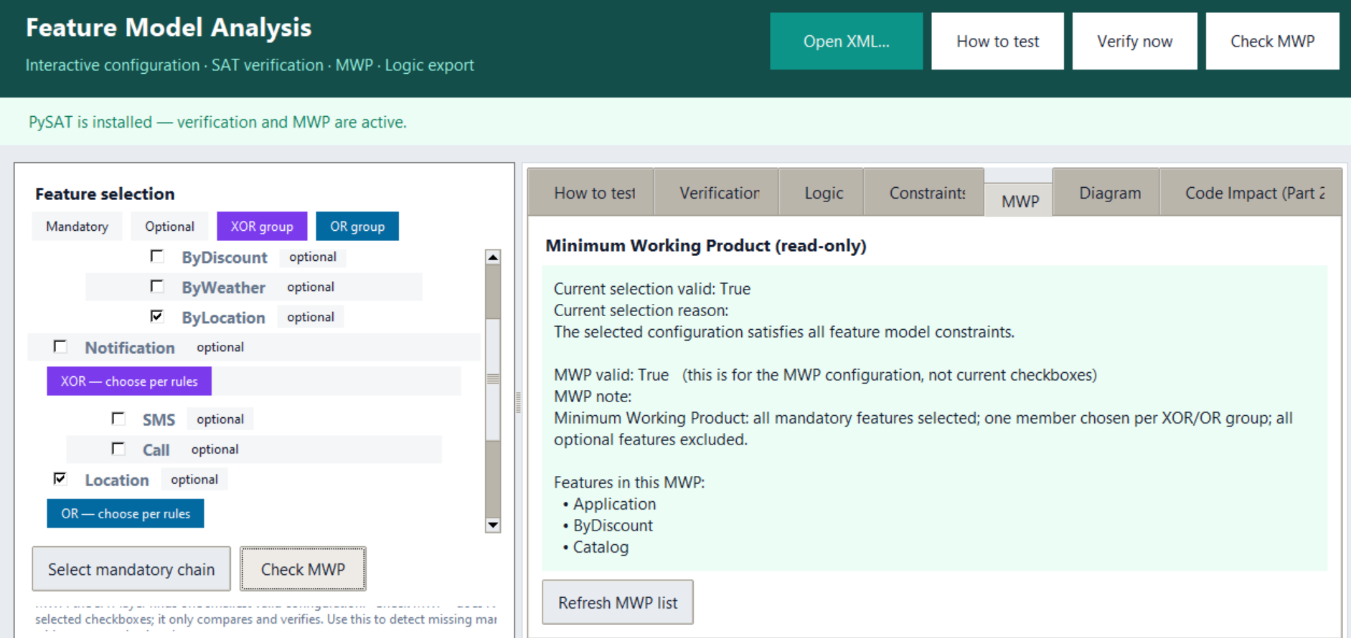
Where Logic Formulas Are Shown
Logic tab: Shows all translated formulas grouped by rules, and combined AND formula.
Constraints tab: Shows each cross-tree constraint — English text (if present), Boolean expression (if present), and propositional form.
Diagram tab: Shows text hierarchy for report screenshots.

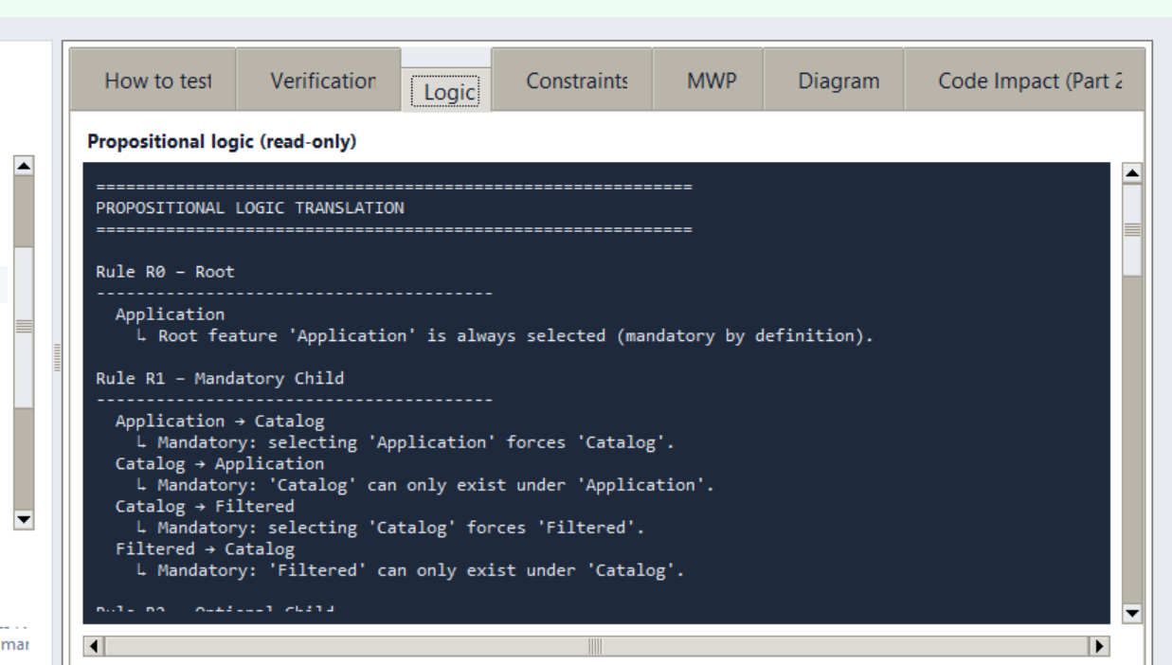

Part 2 User Guide — Feature-to-Code Impact Analysis

Input Sources (Folder or Git URL)
UI elements in Code Impact (Part 2) tab: Codebase folder, Browse folder, Load codebase, Git repo URL, Clone + load.

Workflow A — Local folder:
- Click Browse folder
- Choose codebase directory
- Click Load codebase

Workflow B — Git repo:
- Paste repository URL in the Git repo URL field
- Click Clone + load
- Tool clones a shallow copy and auto-loads it

After load, the app reports: codebase path and files discovered count.

Scanned code extensions: .py, .js, .ts, .java, .cpp, .c, .h, .hpp
Ignored directories: .git, node_modules, __pycache__, .venv, venv

Feature-to-File Mapping (Minimum 5 Features)
Mapping box label: Feature-to-file mapping (editable box; one per line).

Buttons: Open mapping editor, Apply mapping, Run Part 2 analysis.

Mapping format rules:
- One mapping per line
- Use colon separator: FeatureName: relative/path1.py, relative/path2.py
- Feature name must exist in loaded feature model
- Each mapped file path must exist in discovered file list
- At least 5 mapped features is expected (warning if fewer)

Example entries:
Application: ui_app.py, fm_core.py
Catalog: fm_core.py, src/xml_parser.py
Filtered: src/xml_parser.py, sat_solver.py
ByLocation: src/xml_parser.py
Payment: sat_solver.py, main_p1.py
Location: src/xml_parser.py

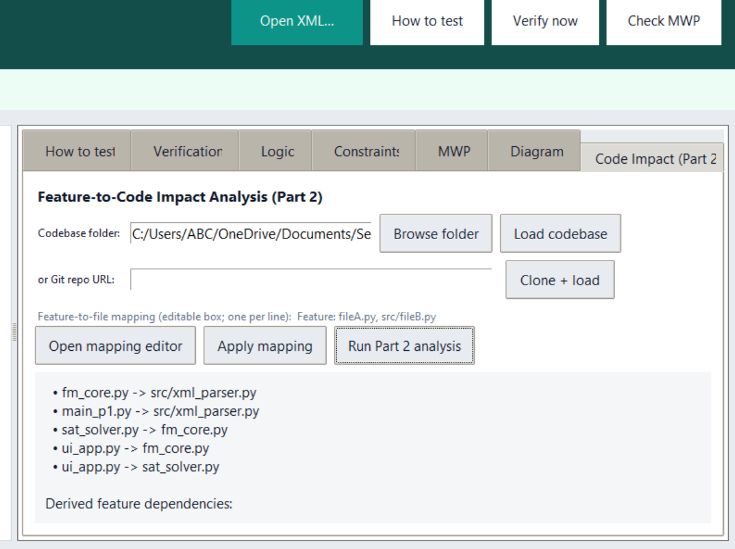

Running Analysis and Output Content
- Load XML (Part 1 prerequisite)
- Load codebase (folder or clone)
- Enter mapping lines
- Click Apply mapping
- Click Run Part 2 analysis

Output panel reports:
- Code files count
- Mapped features count
- File dependencies found
- Feature-to-code mapping list
- File-level dependencies
- Derived feature dependencies
- Consistency analysis
- Impact analysis for currently selected features
- Impacted files (direct + indirect dependency closure)

Dependencies and Inconsistency Logic
File dependencies: Extracted via lightweight parsing of imports/includes.
Feature dependencies: Derived from file dependencies through ownership mapping.

Consistency analysis compares:
- Model edges (from R5/R6 implication-style cross-tree formulas)
- Code-derived feature edges

Reported inconsistency types:
- Hidden dependency — in code but missing in model constraints
- Incorrect/missing in code mapping — present in model but no evidence in code mapping/dependencies

XML Format Expectations

Required Structure
Top-level structure expected by parser:
- Root tag: <featureModel>
- At least one top-level <feature> under root
- First top-level <feature> is treated as root feature
- Optional <constraints> section with multiple <constraint> entries

Feature Definitions
Direct feature node format:
<feature name="FeatureName" mandatory="true|false"> ... </feature>

Rules implemented:
- Root is always mandatory by definition
- If mandatory is absent, parser treats child as optional (False)
- mandatory="true" makes it mandatory
- Group children are handled through <group> blocks

Group Definitions
Supported group format:
<group type="xor"> ... </group>
<group type="or"> ... </group>
Only xor and or are valid group types. Any other group type raises a parser error.

Constraint Definitions
Inside <constraints>:
<constraint>
<englishStatement>...</englishStatement> (optional)
<booleanExpression>...</booleanExpression> (optional)
</constraint>

booleanExpression is converted with simple replacements (implies/requires/excludes handling). English heuristics support common patterns (requires/excludes/if-then), else marked as manual translation needed.

Sample model includes: "The Location feature is required to filter the catalog by location." — translated as ByLocation → Location.

Translation Rules (User Summary)
The tool translates feature model structure into propositional logic rules:

Rule | Description
R0 | Root always selected
R1 | Mandatory parent-child bi-implication (parent → child, child → parent)
R2 | Optional child implies parent (child → parent)
R3 | XOR groups (at least one + pairwise exclusion + child→parent)
R4 | OR groups (at least one + child→parent)
R5/R6 | Cross-tree requires/excludes

For grading details and full rule documentation, see: TRANSLATION_RULES.md

Honest limitation note: There is no interactive "ask user for manual formula" popup flow in the current UI. If English parsing is ambiguous, the translator stores a [Manual translation needed]: ... text in propositional output.
Troubleshooting

XML Load Fails / Bad XML
Symptoms: Error popup "XML error"; tabs remain unpopulated.

Checks:
- Verify XML is well-formed
- Ensure at least one top-level <feature>
- Ensure every <feature> has a name attribute
- Ensure group type is only xor or or

PySAT Not Installed
Symptoms: Banner asks to install PySAT; Verification tab says "Verification needs PySAT"; MWP unavailable.

Fix:
- Run: python -m pip install python-sat
- Restart the app

Codebase Load Issues (Part 2)
Symptoms and fixes:
- "Select a local folder first." → Choose folder and click Load codebase
- "Folder not found" → Verify path exists
- "git command not found" → Install Git or use local folder flow
- Git clone error → Check URL/access/network

Mapping Errors
Common causes:
- Missing : in mapping line
- Unknown feature name in mapping
- Feature mapped without files
- File paths not found in discovered list

Fix:
- Use exact feature names from loaded XML
- Use relative file paths exactly as scanned

Empty or Weak Analysis Results
If dependencies are few/none:
- Lightweight parser may miss dynamic imports or non-standard patterns
- Add/adjust mapping for better evidence coverage

If inconsistency list is empty:
- Update mapping to include stronger cross-feature file links
- Re-run analysis

If codebase has no supported source files:
- Use project with supported extensions (.py, .js, .ts, .java, .cpp, .c, .h, .hpp)
Rubric Alignment Checklist (For Graders)
Use this quick checklist during evaluation:

# | Checklist Item
1 | XML model successfully loads in GUI
2 | Tree shows mandatory/optional and XOR/OR clearly
3 | Feature selection updates verification result
4 | SAT validity/invalidation behaviour demonstrated
5 | MWP tab shows valid minimal configuration and feature list
6 | Logic tab displays translated formulas and combined formula
7 | Constraints tab shows parsed/translated constraints
8 | Part 2 can load local folder
9 | Part 2 can accept Git URL via Clone + load
10 | File count is shown after codebase load
11 | Mapping of at least 5 features is applied
12 | Part 2 analysis runs and prints file dependencies
13 | Feature-level dependencies are derived
14 | At least one inconsistency is discussed (or process to surface it is explained)
15 | Impacted files are shown for current selected features

[SCREENSHOT: Verification tab valid/invalid example]


[SCREENSHOT: Code Impact tab with completed analysis output]


Quick Demo Script (Optional for Presentation)
Launch with python ui_app.py
Open feature_model.xml
Show tree legend and toggle XOR/OR behaviour
Trigger invalid config (e.g., ByLocation without Location) and show Not feasible
Open Logic tab and point to ByLocation → Location
Open MWP tab and click Check MWP
Open Code Impact (Part 2) tab, load folder, apply mapping, run analysis
Highlight dependencies, inconsistencies, and impacted files output

