Digital Transformation and the African Community
Name: Emmanuel Kipkoech
Course: Computer Science
Registeration Number: C026-01-0963/2022
Institution:Computer Science and IT

Introduction
Digital transformation is rapidly reshaping African communities through the adoption of mobile technologies, internet connectivity, digital financial services, and online platforms. Across urban and rural settings, technology has become a tool for economic empowerment, education, communication, and innovation. However, the digital shift also reveals inequalities such as the digital divide, gender disparities in access, and generational gaps in technological literacy. This photographic essay explores how digital transformation is influencing African society, highlighting both its opportunities and challenges, while emphasizing the importance of gender awareness and inclusive participation in technological advancement.

Photo 1: Mobile Money and Everyday Transactions

Explanation:
This image captures individuals using mobile money services for daily transactions. Mobile financial platforms have revolutionized economic participation in Africa by enabling secure, fast, and accessible financial services. Women and youth entrepreneurs particularly benefit from these digital systems, which reduce barriers to banking and promote financial inclusion.

Photo 2: Youth and Smartphone Culture

Explanation:
This photograph should depict young people actively engaging with smartphones—whether for social media, education, or entrepreneurship. Digital tools provide access to global knowledge and opportunities. However, this transformation also raises concerns about digital dependency, misinformation, and unequal access among disadvantaged groups.

Photo 3: Women in Digital Entrepreneurship

Explanation:
This image should highlight women utilizing digital platforms to run businesses, market products, or provide services. Gender awareness is essential in ensuring women have equal access to digital tools, training, and financial support. Digital transformation has the potential to reduce traditional gender barriers and promote economic independence.

Photo 4: Digital Learning in Schools or Community Centers
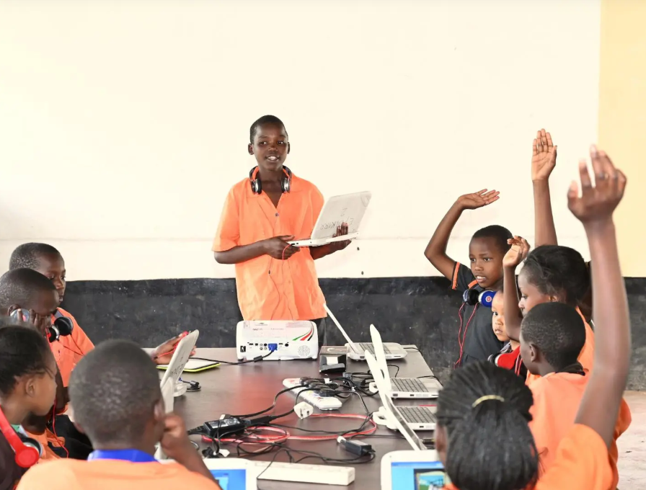
Explanation:
This photograph should show students or community members using computers, tablets, or online learning platforms. Digital education expands access to knowledge beyond geographical limitations. However, the digital divide between urban and rural areas remains a challenge that requires inclusive policies and infrastructure development.

Photo 5: Rural vs Urban Digital Access
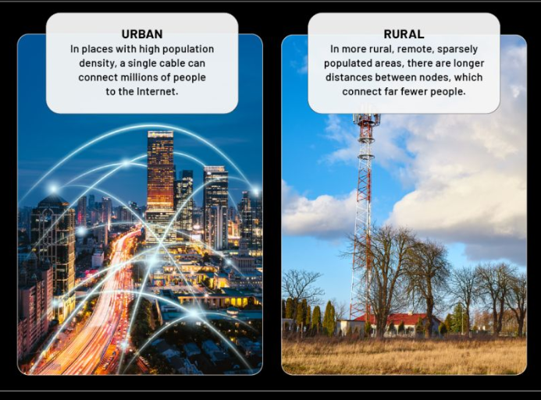
Explanation:
This image should contrast digital access between urban and rural environments. While cities often enjoy better connectivity and technological infrastructure, rural communities may struggle with limited network coverage and device affordability. Addressing this gap is crucial for equitable digital transformation across African societies.

Conclusion
Digital transformation is redefining African communities by fostering innovation, economic growth, and social connectivity. Nevertheless, inclusive development requires attention to gender equality, accessibility, and digital literacy. By promoting equitable participation in technological advancement, African societies can harness digital transformation as a tool for sustainable development and cultural evolution.

