Evidence of Professional Online Presence
Name: Emmanuel Kipkoech
Registration Number: C026-01-0963/2022

Introduction
In today’s digital era, maintaining a professional online presence is essential for career development, networking, and knowledge sharing. As a software engineering student, online platforms provide opportunities to showcase technical skills, collaborate with professionals, and participate in global discussions. Below is evidence of five professionally relevant online platforms demonstrating active engagement and professional growth.

1. LinkedIn Account
Platform URL/Username: https://www.linkedin.com/in/emmanuel-kipkoech-06576a2b0/
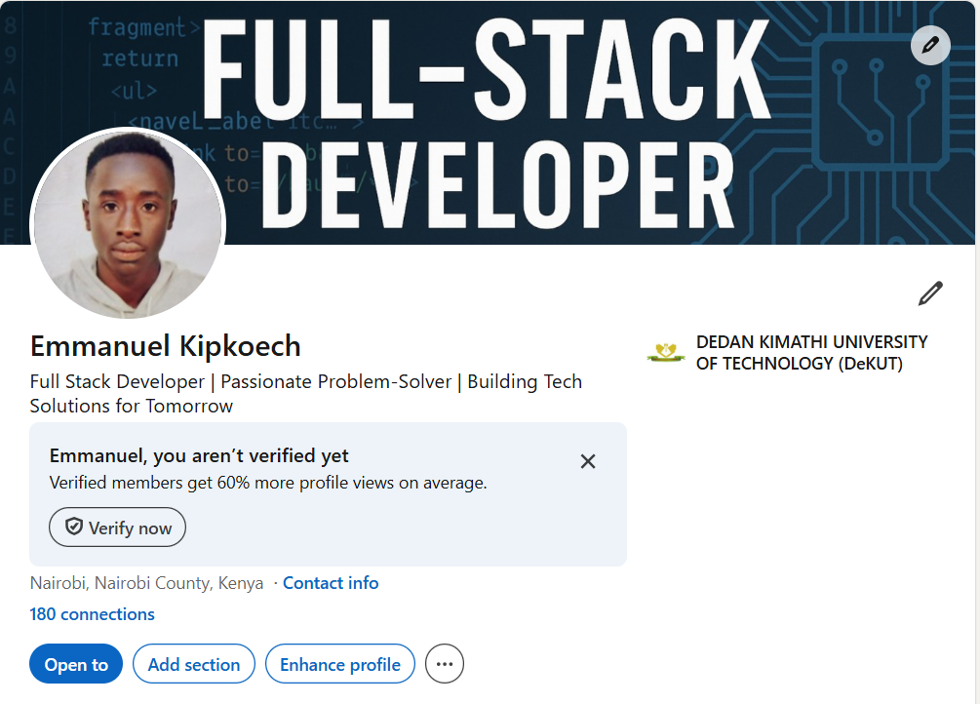
Professional Relevance Explanation:
This platform contributes to my professional development by enabling networking, knowledge sharing, collaboration, and showcasing my skills and projects. Through active participation, I strengthen my digital identity and remain engaged with current industry trends.

2. GitHub Account
Platform URL/Username:https://github.com/Imman9
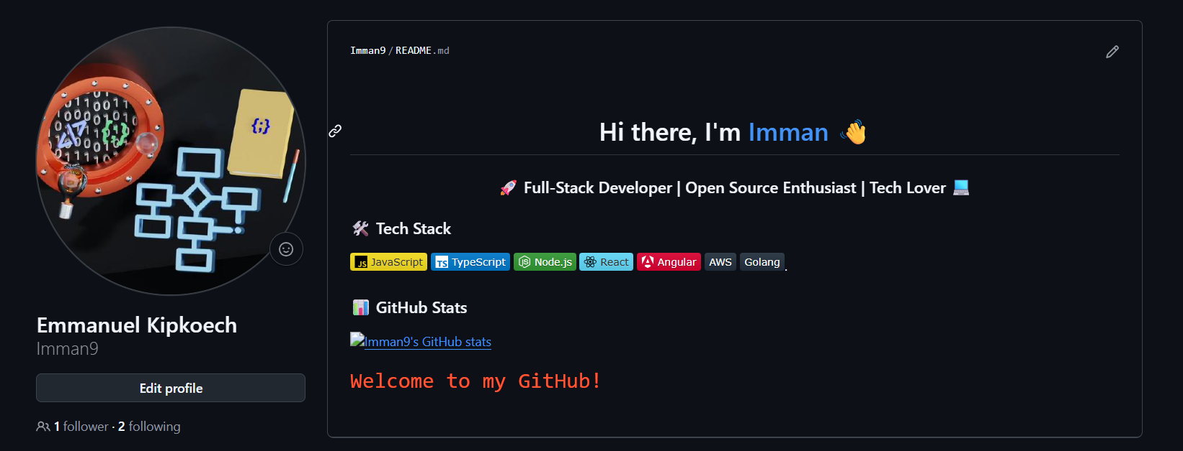
Professional Relevance Explanation:
This platform contributes to my professional development by enabling networking, knowledge sharing, collaboration, and showcasing my skills and projects. Through active participation, I strengthen my digital identity and remain engaged with current industry trends.

3. Twitter / X Account
Platform URL/Username: https://x.com/stilldrey6
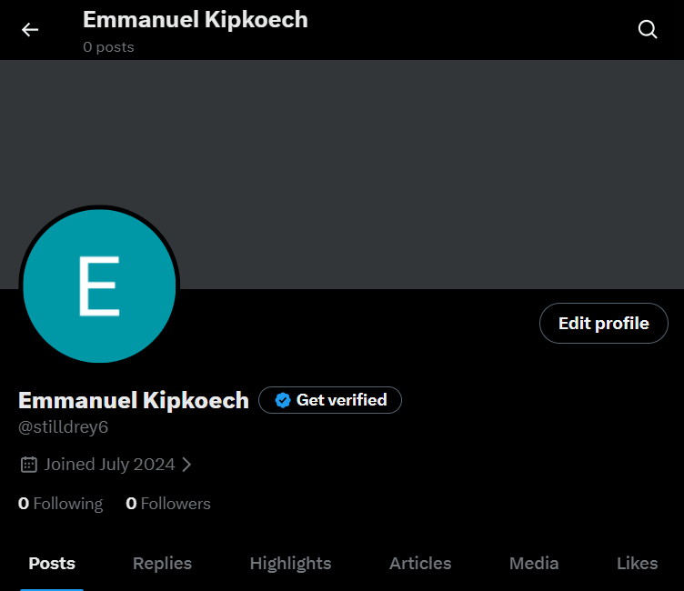
Professional Relevance Explanation:
This platform contributes to my professional development by enabling networking, knowledge sharing, collaboration, and showcasing my skills and projects. Through active participation, I strengthen my digital identity and remain engaged with current industry trends.

5. YouTube / Vlog / Professional Instagram
Platform URL/Username: https://www.instagram.com/s.t.i.l.l_d.r.e.y/

Professional Relevance Explanation:
This platform contributes to my professional development by enabling networking, knowledge sharing, collaboration, and showcasing my skills and projects. Through active participation, I strengthen my digital identity and remain engaged with current industry trends.

Reflection
Maintaining a professional online presence enhances credibility, expands professional networks, and creates opportunities for collaboration and employment. By actively engaging on these platforms, I demonstrate continuous learning, technical competence, and commitment to professional growth in the field of software engineering.

