Customer Churn Analysis Report
AnalystLab Africa Data Analytics Internship Program
Week 1 Business Analytics Case Study

Prepared by: Ahanonu Immanuel
Date: August 2026

Executive Summary
This report presents an exploratory analysis of a telecommunications customer churn dataset with over 7k customers and a churn rate of 26% to identify the key factors influencing customer churn and provide actionable recommendations for improving customer retention.
Digging into the data using Python for cleaning and exploratory analysis, and Power BI for the interactive report, I took notice of five factors that stood out as the biggest churn drivers: contract type, tenure, internet service, payment method, and whether the customer had tech support.
The clearest pattern: customers on month-to-month contracts churned the most, especially the ones paying by Electronic Check and using Fiber Optic internet service - that combination kept showing up as the highest-risk group. On the other end, customers locked into longer-term contracts, or who had add-ons like Tech Support, exhibited significantly higher retention rates.
Based on these findings, the report recommends targeted retention strategies; making it easier and more appealing for customers to move onto longer contracts, tightening up the Fiber Optic service experience, and pushing adoption of value-added services like Tech Support to reduce churn and improve long-term customer loyalty.

Business Problem
Customer churn is a major challenge in the telecommunications industry because losing existing customers directly affects revenue and increases the cost of acquiring new ones. The company has a churn rate of about 26% and up to $139k of monthly revenue lost. This project aims to identify the key factors influencing customer churn and provide data-driven recommendations to help the company improve customer retention and make informed business decisions.
Objective
The objective of this analysis is to examine customer churn patterns within a telecommunications company, identify the key factors that influences customer attrition, and segment customers based on their churn behavior. Through exploratory data analysis and visualization, the study aims to generate practical business insights and recommend data-driven strategies that can improve customer retention and also support informed decision-making.

Methodology
I conducted the analysis using the Telecom Customer Churn dataset. Data cleaning and preprocessing involved handling missing values and correcting data types in the TotalCharges column, and preparing the dataset for analysis. Exploratory Data Analysis (EDA) was performed using Python with the Pandas, Matplotlib, and Seaborn libraries to examine customer characteristics, identify churn patterns, and explore relationships between key variables. I also created a Power BI report to present interactive visualizations and support business decision-making.

Customer Base Overview
The customer base is predominantly composed of non-senior citizens, with a relatively balanced distribution between male and female customers. Most customers are subscribed to month-to-month contracts (up to 55%), while Fiber Optic and DSL (44% and 34% respectively) are the primary internet service options. Electronic Check is the most commonly used payment method, and the customer base spans both new and long-term subscribers. Additionally, the distribution of monthly charges indicates that customers are spread across multiple pricing tiers, reflecting a diverse range of service plans.

Customer Segmentation
While analyzing the dataset, I identified several customer segments with varying levels of churn risk. This included customers on month-to-month contracts which exhibited the highest churn rates, especially those using Fiber Optic internet service and Electronic Check payment method (customer attrition of up to 60%). I also observed that customers with shorter tenures, higher monthly charges, and no Tech Support were also more likely to leave the company. In contrast, customers on one-year and two-year contracts, as well as those subscribed to Tech Support, demonstrated significantly higher retention rates. These findings highlight distinct customer segments that the company should prioritize in their retention strategy.
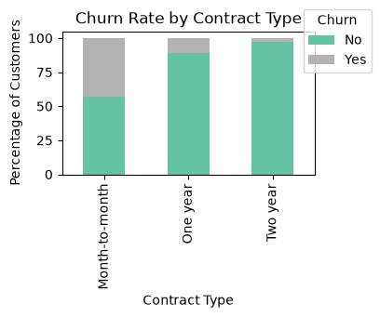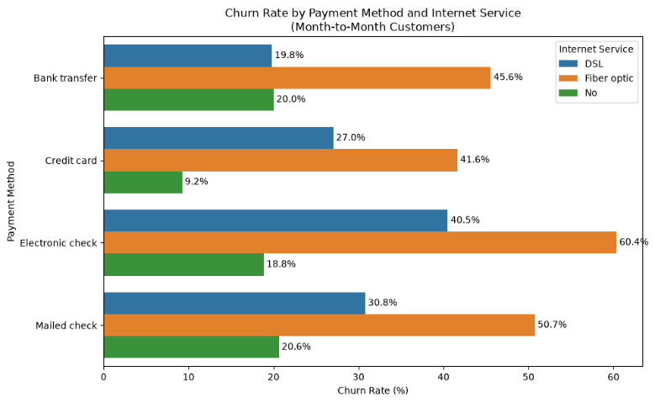
Fig.1 Fig.2

Key Business Insights
- Contract type is the strongest predictor of customer churn, with customers on month-to-month contracts showing substantially higher churn rates (over 42% which is nearly 4 times the rate of one-year contract customers) than those on one-year (11%) or two-year (close to 3%) contracts. This matters because month-to-month contracts lack the lock-in of longer terms, so those customers leave far more readily without any penalty or loss.
- Fiber Optic customers are more likely to churn than customers using DSL or no internet service, suggesting potential concerns related to pricing, service quality, or customer expectations. Since Fiber Optic is typically a premium offering with higher average revenue per user, higher churn here means that the company is disproportionately losing more profitable customers which hits revenue and lifetime value harder than equivalent losses among DSL or non-internet users.
- Customers who pay via Electronic Check experience the highest churn rates, indicating that convenient payment methods like Bank and Credit Card are associated with customer retention.
- Customer tenure is negatively associated with churn, with newer customers being significantly more likely to leave than long-term customers.
- The highest-risk customer segment comprises customers on month-to-month contracts using Fiber Optic internet and Electronic Check payments, making them the primary target for retention initiatives. Targeting them first means the company protects more revenue per retention action than if you spread efforts across lower-risk customers.

Business Risks
- High churn among month-to-month customers poses a significant risk to recurring revenue and increases the cost of acquiring replacement customers.
- Elevated churn among Fiber Optic customers may indicate underlying issues with service quality, pricing, or customer satisfaction, potentially affecting the company's competitive position.
- High attrition among new customers suggests weaknesses in customer onboarding and early engagement, limiting customer lifetime value and increasing long-term acquisition costs.

Business Opportunities
- Increase adoption of long-term contracts by offering incentives and loyalty rewards to encourage customers on month-to-month plans to commit to longer subscriptions.
- Expand the adoption of value-added services, such as Tech Support and Online Security, through bundled packages or promotional offers to improve customer satisfaction and retention.
- Implement targeted retention campaigns for high-risk customer segments mentioned above to reduce churn through personalized offers, proactive engagement, and service improvements.

Management Recommendations
- Focus on converting month-to-month customers to longer-term contracts by offering discounts, loyalty rewards, or bundled packages to reduce churn among month-to-month subscribers. Even a modest conversion rate can significantly lower overall churn and protect revenue, since these customers are among the most at risk and often the easiest to retain with the right offer.
- Improve Fiber Optic value and reliability by resolving service quality issues and introducing competitively priced tiers or loyalty bundles to close the retention gap with DSL customers.
- Promote automatic payment methods by encouraging customers who use Electronic Check to switch to bank transfer or credit card payments through incentives and awareness campaigns.
- Invest heavily in the first few months of a customer’s journey by making onboarding more personal and anticipatory through schedule check-ins, offering timely help, and presenting relevant upgrades or loyalty incentives early on.
- Increase adoption of value-added services, such as Tech Support and Online Security, through bundled plans and promotional campaigns to improve customer satisfaction and retention.
- Build a churn-risk scoring system for early intervention by combining tenure, contract type, and payment method into a risk score that flags customers before cancellation intent forms, triggering proactive outreach.

Conclusion
This analysis identified the key factors influencing customer churn and highlighted the customer segments most at risk of leaving the company. Contract type, tenure, internet service, payment method, and Tech Support emerged as the primary drivers of churn, with customers on month-to-month fiber optic plans and using an electronic check as a payment method exhibiting the highest churn risk. By implementing targeted retention strategies, improving service offerings, and encouraging long-term customer engagement, the company can reduce customer attrition, enhance customer satisfaction, and improve long-term business performance.

