Real-Time Chat
Project description: stack, database design, ER schema, message flow and milestones

1. Overview
Users join a room, type a message, and everyone in that room sees it instantly without refreshing. Messages are stored, so a user who joins late or reloads sees the history.

Goals
- Understand how WebSockets differ from request/response HTTP, and why STOMP adds rooms on top.
- Design a small relational schema and justify each index.
- Handle the hard parts of real-time systems: ordering, duplicates, reconnection, and trusting the sender.

In scope
- Multiple rooms, live messaging, persistent history, reconnection, and authentication (M7).
- A plain HTML/JS client and an automated test suite.

Out of scope
- Horizontal scaling across several server instances, file uploads, end-to-end encryption, and push notifications. Section 9 explains the first one.

2. Stack choice
Layer | Choice | Why | Alternative considered
Language / build | Java 21 (LTS), Maven | Same toolchain as your other Spring projects; Spring Boot 3 needs Java 17+. | Gradle (no real difference here)
Backend framework | Spring Boot 3.x: Web, WebSocket, Data JPA, Validation, Security (from M7) | Starters cover every layer; the request flow you learned in Level 1 stays the same. | Quarkus, Micronaut
Real-time protocol | WebSocket with STOMP and the built-in simple broker | STOMP adds destinations and publish/subscribe, so rooms need no custom routing code. | Raw WebSocketHandler (you build rooms yourself), SSE (server to client only), polling (wasteful, laggy)
Database | H2 in-memory for M0–M5, PostgreSQL from M6 | H2 removes setup friction early; PostgreSQL is needed to study real indexes and EXPLAIN. | MySQL (works the same way)
Frontend | Plain HTML/JS with @stomp/stompjs from a CDN | Keeps the lesson on the WebSocket lifecycle, not on component state. | React (a good rewrite after M6)
Authentication | Spring Security with JWT, BCrypt password hashes | Needed so the server, not the client, decides who the sender is. | Session cookies
Testing | JUnit 5, Spring Boot Test (random port), WebSocketStompClient | Lets automated tests act as real chat clients. | Manual two-tab testing only (not repeatable)

3. Architecture
The system has two data paths, kept separate so each stays simple:
- Live path (WebSocket): new messages. The server saves a message, then broadcasts it to the room’s subscribers.
- History path (REST): past messages. The client asks for them over normal HTTP and the server reads the database.
The /app prefix routes a message to your code. The /topic prefix goes straight to the broker, which fans it out to every subscriber.

REST endpoints
Method | Path | Purpose
GET | /rooms | List rooms.
POST | /rooms | Create a room. Body: {"name":"general"}.
GET | /rooms/{roomId}/messages | History. Params: limit (default 50, 1–100), beforeId (older than), afterId (newer than). Never both. Returns oldest first.
POST | /auth/register, /auth/login | M7. Register, then log in to receive a JWT.

STOMP destinations
Direction | Destination | Purpose
Client sends to | /app/chat/{roomId} | Handled by a @MessageMapping method. Body: {"content":"hello"}.
Client subscribes to | /topic/room/{roomId} | Receives every saved message for that room.
Client subscribes to | /user/queue/errors | Receives validation errors for that user only.

4. Database design

Tables
Table | Columns | Notes
users | id, username (unique), password_hash, created_at | Passwords stored as BCrypt hashes, never plain text.
rooms | id, name (unique), created_by (FK), created_at | One row per chat room.
room_members | room_id, user_id, joined_at | Composite primary key. Many-to-many link between users and rooms; used for access control from M7.
messages | id, room_id (FK), sender_id (FK), content, sent_at | The only high-volume table. Append-only.

DDL (PostgreSQL)
CREATE TABLE users (
id BIGINT GENERATED ALWAYS AS IDENTITY PRIMARY KEY,
username VARCHAR(30) NOT NULL UNIQUE,
password_hash VARCHAR(100) NOT NULL,
created_at TIMESTAMPTZ NOT NULL DEFAULT now()
);

CREATE TABLE rooms (
id BIGINT GENERATED ALWAYS AS IDENTITY PRIMARY KEY,
name VARCHAR(50) NOT NULL UNIQUE,
created_by BIGINT NOT NULL REFERENCES users(id),
created_at TIMESTAMPTZ NOT NULL DEFAULT now()
);

CREATE TABLE room_members (
room_id BIGINT NOT NULL REFERENCES rooms(id) ON DELETE CASCADE,
user_id BIGINT NOT NULL REFERENCES users(id) ON DELETE CASCADE,
joined_at TIMESTAMPTZ NOT NULL DEFAULT now(),
PRIMARY KEY (room_id, user_id)
);

CREATE TABLE messages (
id BIGINT GENERATED ALWAYS AS IDENTITY PRIMARY KEY,
room_id BIGINT NOT NULL REFERENCES rooms(id) ON DELETE CASCADE,
sender_id BIGINT NOT NULL REFERENCES users(id),
content VARCHAR(1000) NOT NULL CHECK (length(btrim(content)) > 0),
sent_at TIMESTAMPTZ NOT NULL DEFAULT now()
);

CREATE INDEX idx_messages_room_id_id ON messages (room_id, id DESC);

Design decisions
- Order by `id`, display `sent_at`. The identity id is the order clients trust and the cursor for afterId/beforeId. sent_at is for display only.
- One composite index serves both history queries. (room_id, id DESC) answers “latest N in a room” and “newer than id X in a room” without sorting.
- Length is enforced twice. @Size(max = 1000) in Java gives a friendly error; the column limit and CHECK protect the data if the Java layer is bypassed.
- Delete rules. Deleting a room deletes its messages and memberships (CASCADE). Deleting a user is blocked while they have messages (RESTRICT), so history is not silently rewritten.
- Temporary schema before M7. Until authentication exists, messages has sender_name VARCHAR(30) instead of sender_id, rooms.created_by is absent, and room 1 (“general”) is seeded. M7 migrates to the schema above.

Core queries
-- latest 50 messages in room 1, oldest first
SELECT * FROM (
SELECT * FROM messages WHERE room_id = 1 ORDER BY id DESC LIMIT 50
) t ORDER BY id;

-- everything newer than the last message the client saw
SELECT * FROM messages WHERE room_id = 1 AND id > :lastSeenId ORDER BY id LIMIT 100;

5. ER schema
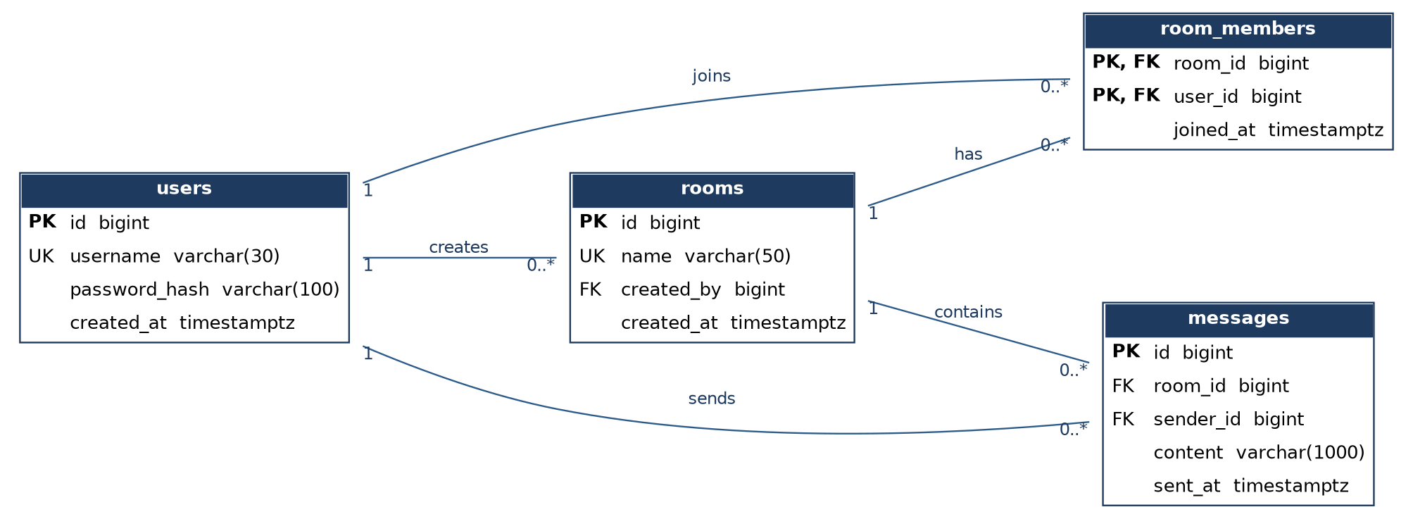
Relationship | Cardinality | Foreign key | On delete
user creates room | 1 : many | rooms.created_by | RESTRICT
user sends message | 1 : many | messages.sender_id | RESTRICT
room contains message | 1 : many | messages.room_id | CASCADE
user joins room | many : many | room_members (both columns) | CASCADE on both sides

6. Message-handling flow
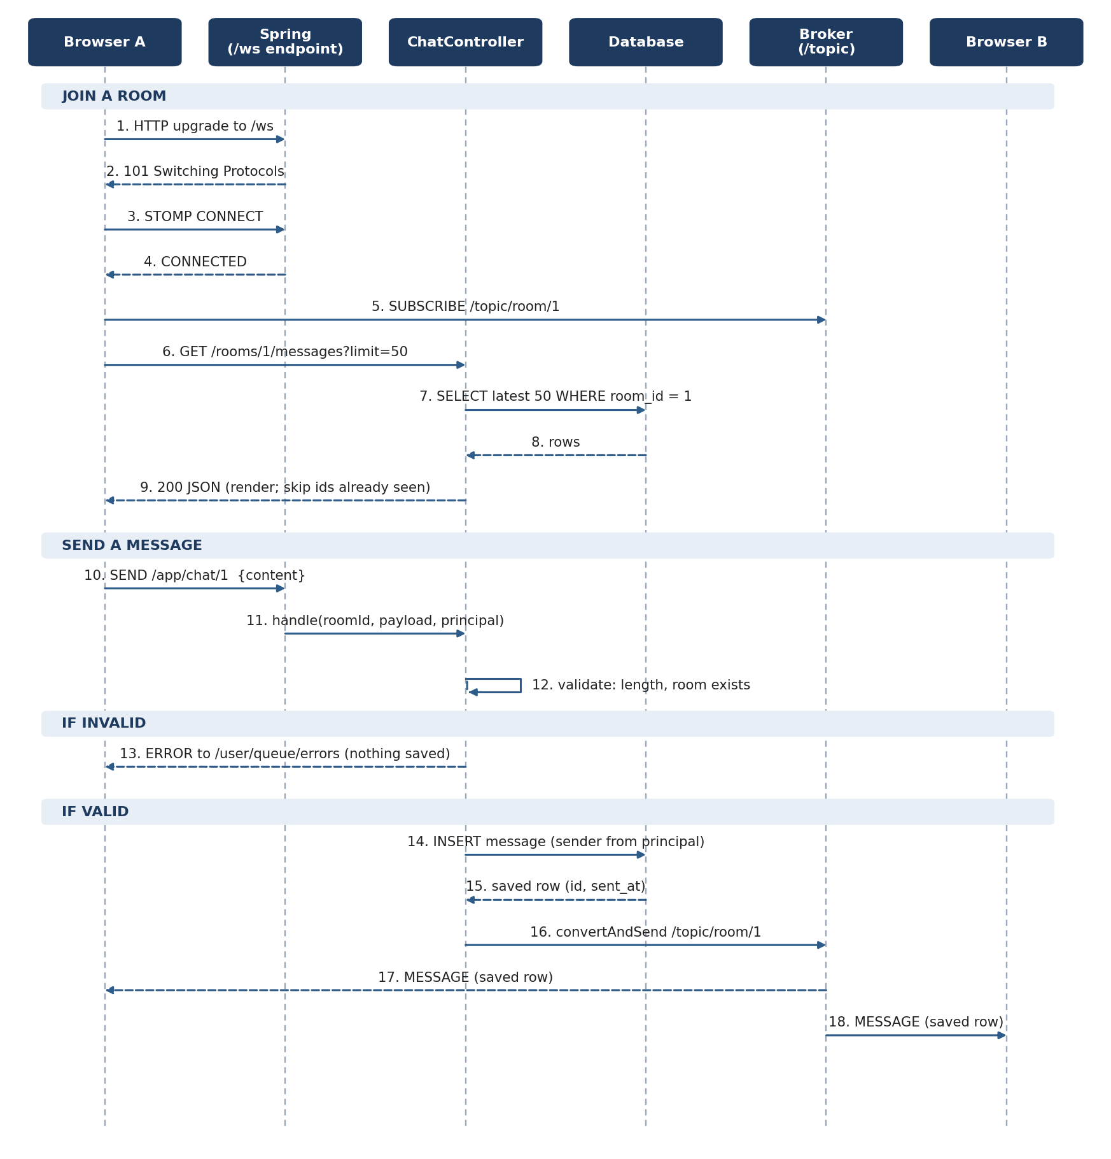

Rules the flow enforces
- Subscribe first, then fetch history. If the client fetched history first, a message sent between the fetch and the subscribe would be lost. Subscribing first and skipping ids already rendered means no gaps and no duplicates. (This reverses the order in the earlier chat overview, which had the gap.)
- Save, then broadcast. If the insert fails, nobody sees a message that does not exist.
- The server sets the sender. From M7 the sender comes from the authenticated Principal, never from the payload.
- Invalid input stays private. An error goes only to the sender’s /user/queue/errors; nothing is saved or broadcast.

7. Milestone checklist
Write each test before the code for that milestone. A milestone is done when every row passes. Seed data for M1: room 1 has messages with ids 1, 2, 3 and contents one, two, three.

M0. Skeleton
Input | Expected result | Done
Run the application | Starts on port 8080 with no errors; database connects.
GET /rooms/1/messages (no messages yet) | 200 with [].
GET /rooms/999/messages | 404.

M1. History endpoint
Input | Expected result | Done
GET /rooms/1/messages?limit=2 | two, three (latest 2, oldest first).
GET /rooms/1/messages (no limit) | All 3 messages (default limit 50).
?limit=0 and ?limit=101 | 400 for both.
?beforeId=3&limit=10 | one, two.
?afterId=1 | two, three.
?afterId=1&beforeId=3 | 400 (the two cursors cannot be combined).

M2. Live path
Input | Expected result | Done
Clients A and B subscribe to /topic/room/1; A sends {"content":"hello"} to /app/chat/1 | Both receive a message with content hello, a non-null id and sentAt within 2 seconds.
Client C subscribed to /topic/room/2 during the same send | C receives nothing within 1 second.
Connect to /ws from an origin not in the allowed list | Connection refused.

M3. Persistence and ordering
Input | Expected result | Done
Send hello (as in M2), then GET /rooms/1/messages | History contains hello; row count increased by exactly 1.
Send m1, m2, m3 back to back | Subscribers receive them in that order; ids strictly increasing.
Make the repository throw on save (mocked) | Nothing is broadcast; sender gets an error on /user/queue/errors.

M4. Validation
Input | Expected result | Done
Content "" and content " " (spaces only) | Rejected; nothing saved or broadcast.
Content of 1000 a characters | Accepted.
Content of 1001 a characters | Rejected.
Send to /app/chat/999 (unknown room) | Rejected.
Malformed JSON: {"content": | Error returned; the WebSocket connection stays open.

M5. Browser client
Input | Expected result | Done
Two tabs on room 1; type hi in tab A | Appears in tab B in under 1 second.
Tab C on room 2 | Does not show hi.
Send <b>hi</b> | Displayed as literal text, not bold.
Reload a tab after 60 messages | Latest 50 shown, in order, no duplicates.

M6. Reconnection and de-duplication
Input | Expected result | Done
Tab A goes offline (DevTools); tab B sends 3 messages; tab A returns online | Tab A fetches ?afterId=<last id seen> and shows the 3 messages once, in order.
Stop the server for 10 seconds, then restart | Client shows “reconnecting” and reconnects within the reconnectDelay (5 s) after the server is back.
A message arrives between the subscribe and the history response | It appears exactly once.

M7. Authentication
Input | Expected result | Done
POST /auth/register with {"username":"alice","password":"correct-horse-9"} | 201.
Register alice again | 409.
Register with password abc | 400 (minimum 8 characters).
Log in with a wrong password / the correct password | 401 / 200 with a JWT.
STOMP CONNECT without a token / with alice’s token | Rejected / connected.
As alice, send {"sender":"mallory","content":"hi"} | Saved and broadcast with sender alice; mallory is ignored.
GET /rooms/1/messages without a token | 401.

M8. Presence and measurement (optional)
Input | Expected result | Done
Two users connected; one closes the tab | Online list shows both, then only one within 10 seconds.
Seed 1,000,000 messages in one room; run the “latest 50” query with and without the composite index | EXPLAIN shows an index scan with the index. Record both timings in your README.

8. Definition of done
- Every milestone row above passes, and the automated tests run with one command.
- A README with the sequence diagram, the ER diagram, and the design decisions from section 4.
- The project lives in a Git repository with a commit per milestone.

9. Known limits
- Single instance only. enableSimpleBroker keeps subscriptions in memory. With two server copies, users on different copies would not see each other’s messages. The fix is an external broker (RabbitMQ or Redis pub/sub).
- Id order is not commit order. Under heavy concurrent writes, a message with a lower id can commit after one with a higher id, so an afterId fetch could skip it. Acceptable at this scale; worth knowing.
- No rate limiting. A single user can flood a room. Add per-user limits as an extension.
- Token in the STOMP `CONNECT` header. Browsers cannot set custom headers on the WebSocket handshake itself, which is why authentication happens at the STOMP layer.

