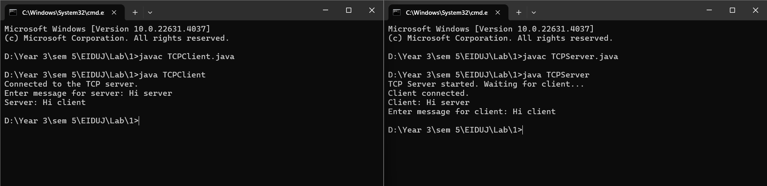

Client Server

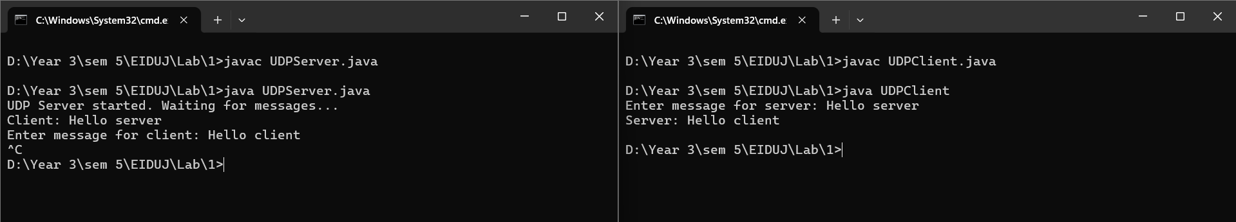

Server Client

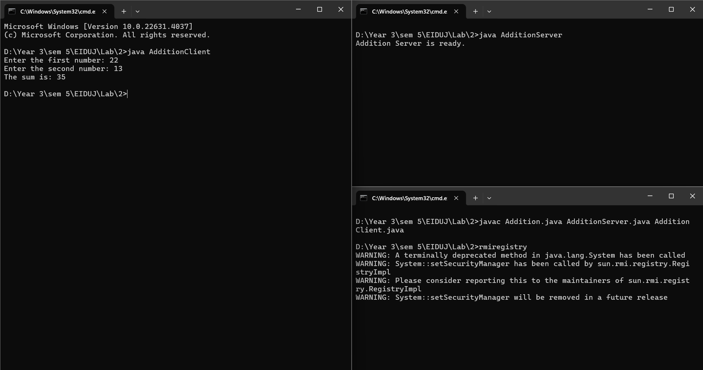

RMIRegistry running

Client Server