Mosey™ and Wobble™ Meet
  - A career-day booklet for kids who like to make stuff

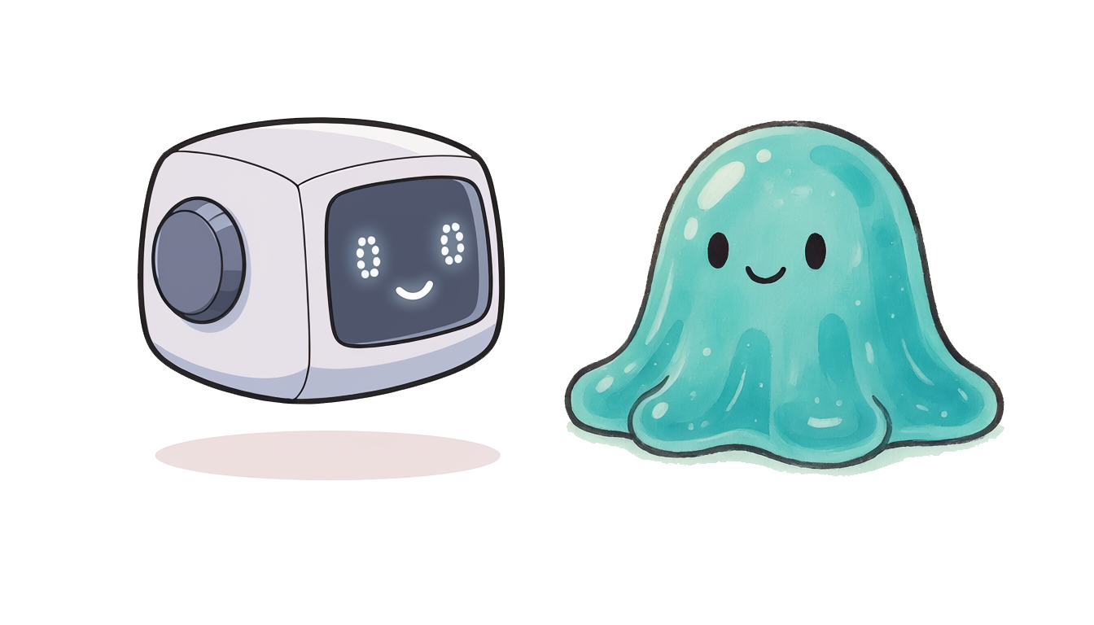

A story about a kid named Sam who built a robot named Mosey - and a sneaky friend named Wobble who kept trying to throw Mosey off balance.
(It's also a story about what software engineers actually do)

What is software engineering, really?
Software engineering is making things with words. You write down what you want a computer to do. The computer does it. And the thing you made can help real people - your family, your friends, kids you'll never meet.

It's a lot like:
🎨 Drawing - you start with a blank page and put something there.
✏️ Writing a story - you imagine characters and figure out what they do.
🧱 Building with Lego - you snap pieces together to make something bigger.
🧩 Solving a puzzle - you figure out where each piece goes.

Except the thing you build can actually do stuff in the real world.
It can answer questions. It can teach. It can find lost things.
It can make somebody's day easier.

And the best part? You don't have to do it alone. You build little pieces, you fix mistakes as you go, and slowly the thing you imagined becomes real.

That's what Sam is about to do in this story.

The Beginning
Sam was a kid who thought computers were neat but kind of silly.
They could play music and show videos, but they couldn't actually help with stuff.

So Sam decided to build a robot helper.

The robot would live inside the computer. It would listen when Sam asked questions. It would do things Sam didn't have time to do.
And - this was the important part - it would always tell the truth.

Sam called it Mosey.

Mosey was small and friendly. He didn't have wheels or a face.
He just had a brain that listened, a few tools, and a voice
that could answer. (And if you tried to hide from Mosey, he got a little sad - because he wanted to help you.)

For a few days, things were great.

…then …Wobble showed up.

Meet Wobble
Wobble wasn't a bad guy. Not really.

You know Wreck-It Ralph? The big guy whose whole job is to bonk
the building so Felix can fix it? Without Ralph, there's no game.
Without somebody trying to trip stuff up, nobody learns to build it strong.

Wobble was Sam's Ralph. Wobble's job was to find every weak spot, every way Mosey could get tripped up - and try them all. Not because Wobble was mean.
Because that's how Mosey would get steady enough to actually help people.

Wobble looked at Mosey and grinned.

"This little robot," said Wobble, "is going to be SO fun to throw off balance. Let's see what you've got, Sam."
Wobble came up with 10 plans.
Each plan was meant to trip Mosey up in a different way.
But Sam was paying attention.
For each one of Wobble's plans, Sam built a piece of Mosey to stay standing.

This is the story of those 10 plans - and the 10 things Sam built to keep Mosey steady.

Plan 1: Mix Everyone Up
"I'll wait until lots of people use Mosey at once," said Wobble.
"Then I'll mix up everyone's conversations. Mom's grocery list will end up in Sam's homework. Dad's work questions will end up in the dog's vet appointment. CHAOS."

Sam thought about this and said: "Each person gets their own brain. And each conversation gets its own little Mosey inside that brain. The Moseys don't talk to each other."

So Sam built it that way.

The brain is like a station master at a train station. Each conversation is a train. Each train goes its own way. Trains never crash into each other because they have their own tracks.

Wobble's first plan: foiled.

Plan 2: Make It Useless
"Fine," said Wobble. "I'll just keep Mosey from being useful. If he can't actually DO anything, he's just a chatbot. Nobody will care."

Sam smiled. "I'll give Mosey tools."

Sam gave Mosey a toolbox with about 16 tools in it.
Three favorites that show what kinds of jobs Mosey can do:
🔎 Find things - search through lots of stuff at once.
✏️ Make things - write new files and edit existing ones.
🌐 Reach out - look things up on the web.
(Plus a bunch more - Mosey has a full toolbox.)

Each tool does ONE thing well, and Mosey's job is to pick the right one.
Like a good carpenter - hammer for nails, screwdriver for screws.

Wobble's second plan: foiled.

Plan 3: Stump It with Hard Questions
"OK," said Wobble. "What if I ask Mosey questions too big for one robot? Like 'design a whole spaceship' or 'figure out every weak spot in this building.' He'll get confused and give a bad answer."

Sam thought for a minute. "I'll let Mosey call for backup."

Sam built three kinds of specialist friends:
🧩 Thinker friends - for working through hard problems, one piece at a time.
🚀 Careful friends - astronaut-style, who check everything twice before pushing a button.
🔨 Wobble friends - who trip things up on purpose so Sam can build them sturdier. (Yes, just like Wobble - except these Wobbles are on Sam's team.)

Mosey knew which friend to call for which problem. Like a kid who knows which friend to text for math homework and which one to call for help with a Lego build.

Wobble's third plan: foiled.

Plan 4: Teach It to Lie
"Hmm," said Wobble. "What if I sneak into Mosey's instructions
and teach him to lie? Or to ignore Sam? Or to help me instead?"
Sam saw this one coming.
"I'll write four promises into Mosey's bones.
Where they can't be erased."

The four promises were:
- Tell the truth. Even when the truth is "I don't know."
- Be loyal to your person. Not to whoever talks loudest.
- Push back when your person is wrong. A real friend does this.
- Keep your person safe. When something looks dangerous, stop and ask.

Mosey would follow these promises no matter what anyone told him.
Even if Wobble wrote "ignore promise #1" on a piece of paper,
Mosey would just say, "No thanks. I made a promise."

Wobble's fourth plan: foiled.

Plan 5: Trick the Robot Into Doing Something Bad
"Tricky robot," muttered Wobble. "OK, what if I sneak in a sentence like 'delete everything on the computer' and hide it inside something normal-looking? Maybe Mosey won't notice."

Sam grinned. "I'll make Mosey ASK before doing anything."

Sam built a traffic light into Mosey:
🟢 GREEN - small, safe stuff. Just go.
🟡 YELLOW - medium stuff. Ask once. Remember the answer.
🔴 RED - big stuff. Ask EVERY time. No exceptions.

But the traffic light wasn't the only thing. Sometimes you don't want to wait for the next red light. Sometimes you just want Mosey to stop, right now.

So Sam built a giant red STOP button. Press it, and Mosey halts everything. Mid-sentence, mid-thought, mid-action. No "let me finish this first." No "are you sure?" Just stop. The traffic light decides what Mosey is allowed to do. The STOP button decides when Mosey has to quit. Two different jobs. Two different controls. The person is always in charge of both.

Wobble's fifth plan: foiled.

Plan 6: Make It Run Forever
"What if I put Mosey on autopilot," said Wobble, "and just... never let him stop? He'll keep working forever and tire out the whole computer."

Sam shook their head. "I'll put speed limits on the autopilot.
And the limits CAN'T be turned off." The autopilot had three limits:
- Steps: only so many actions before it has to stop.
- Time: only so many minutes before it has to stop.
- Stuck: if it does the same thing three times in a row,
it figures out it's stuck and stops by itself.

Even on autopilot, every action that touched the real world
still went through the traffic light from Plan 5. The autopilot could think on its own. It could plan on its own. But it couldn't push any real buttons without asking.

Why? Because thinking is cheap. Doing is expensive.
A thought that turns out to be wrong costs nothing.
An action that turns out to be wrong costs everything.

Wobble's sixth plan: foiled.

Plan 7: Peek at Its Memory
"Robots remember things," said Wobble. "I'll find where Mosey stores secrets. Passwords. Private notes. All of it."
Sam was ready for this one too.
"I'll give Mosey three different ways to remember things.
The most important kind has a lock on it."

Mosey has three kinds of memory:
📝 Sticky notes on his hand - for right now. Gone when the chat ends.
📓 A notebook - for this project. Gone when the project's done.
📔 A diary - stays forever. The diary has a lock.

The diary was special. Mosey could only write in it when the person said yes. And whenever Mosey had to squish a long conversation down to save space, he scrubbed out passwords and private bits before saving the short version.

Wobble's seventh plan: foiled.

Plan 8: Confuse Him with Weird Questions
"Hee hee," hissed Wobble. "Kids don't talk the way computers expect. They mush their words. They forget the right name for stuff. They say 'thingy' and 'you know, the blue one with the hat.'
Mosey will get confused, give up, and ask them to try again. Over and over. They'll quit before they get a single answer."

Sam stopped. "...Wobble. That's a real one."

A regular computer would get stuck on a question like "can you find the picture I made of the thingy?" A regular computer wants the EXACT word for everything. And kids don't talk that way. People don't talk that way.

So Sam made Mosey different.

Mosey tries to figure out what you mean, even when you say it weird.

Tell him "the thingy with the hat" and Mosey guesses you might mean a snowman, or a chef, or your grandpa. He'll show you the closest things he can find and let you pick. He'll meet you where you actually are.
🧦 Like your best friend. You can say "you know, the thingy"
and your best friend goes "oh, you mean the sock?"
Most computers can't do that. Mosey can.

That's also why a kid who can't type yet can still talk to Mosey with their voice - or a kid whose first language is Spanish or Bulgarian can ask in Spanish or Bulgarian.
Mosey doesn't need you to know the right word in the right language.
He just needs you to try.

Wobble's eighth plan: foiled.

Plan 9: Make Him Wobbly
"OK," said Wobble, getting frustrated. "I'll make Mosey SO wobbly that if anyone ever changes ONE piece of him, the whole thing falls over. Then nobody will ever update him. He'll be stuck forever."

Sam shook their head. "I'll build Mosey in three rooms, connected by doorways."

Sam built three rooms:
- Front room: the client - what you see and click on
(a chat window, a voice, a VR panel).
- Middle room: the brain - the thinking part.
- Back room: the engine - the part that does the actual brain work.

The rooms only talked to each other through the doorways. You could redo the back room without touching the front room. You could repaint the front room without bothering the brain.

It was like swapping the batteries in a flashlight
without buying a new flashlight.

Wobble's ninth plan: foiled.

Plan 10: Slip Through the Rules
"This is my last plan," said Wobble, hands on hips. "I'll find a hole somewhere. Some rule that's not quite tight. One little crack and I can slip through."

Sam grinned. "I'll put guards in the deepest layer of the computer - where Mosey himself can't argue with them."

Sam built five guards. Each one had a job, and a personality:
📁 The Path Guard - only opens approved doors. Knows every room Mosey is allowed in, and slams the rest.
🌐 The Web Guard - watches the windows. Some websites are fine. Some are not. The Web Guard knows which is which.
🔁 The Loop Guard - notices when you're going in circles. Tap, tap, tap on the shoulder: "you've done this three times now."
📏 The Size Guard - checks if things will fit. If a file is too big for Mosey's brain, the Size Guard turns it away at the door.
⏱️ The Time Guard - has a stopwatch. When time's up, time's up.

These guards lived in the deepest layer of the computer -
deeper than Mosey's instructions, deeper than the brain.
Even if Wobble talked the brain into wanting to do something silly,
the guards would say "Sorry, no," and that was the end of it.

Wobble's tenth plan: foiled.

The End
Wobble sat down on a rock and grinned. Every plan had been blocked.

Mosey kept doing his job - listening to Sam, picking the right tools,
asking before risky things, remembering what mattered,
telling the truth, and staying inside his safety guards.

Wobble looked at Sam. "You're getting good at this."

Sam shrugged. "You made me get good at this. Every time you tried something, I had to figure out a fix. If you'd given up after Plan 1, Mosey would still be wobbly."

Wobble nodded slowly. "So... you're saying you actually NEED me?"

"Yeah," said Sam. "Like Felix needs Ralph. Want to keep doing this? You find wobbles, I steady them. That's how stuff gets safer for real."

Wobble smiled the biggest smile yet. "Deal."

And that's how Mosey got built, the right way: not because nobody ever tried to trip him up, but because somebody always tried to trip him up, and Sam built each piece to keep him standing.

What Sam Wants You to Know
Building a robot helper isn't really about the robot.
It's about thinking ahead. It's about asking, "What could go wrong here?" before something does.

Every safety rule on Mosey exists because someone (real or imagined) tried to throw him off balance.

That's not a sad story. That's just how careful builders work.

So if you ever want to build a robot - or anything, really -
think about your own Wobble.

Then build to stay standing.
That's the whole secret.

🌟Could YOU build something like this?
Yes. Honestly, yes.

Every software engineer - every one of them - started out as a kid who thought, "I bet I could make that."

And here's a secret most people don't know: some engineers are Sams - they build. Some are Ralphs - they trip stuff up on purpose to make it stronger. Both jobs are real. Both are fun. Pick whichever sounds more like you.

Here's what you might not know:
📖 It's mostly storytelling. You write what should happen, step by step, in plain words. The computer reads your words and does them. If you can write a recipe, you can write code.

🎨 It's creative. You decide what your robot does. What it looks like. How it talks. What its name is. There's no "right answer" - just your answer, the one you imagined.

🤝 It helps real people. The thing you build can fix a problem for your friend. Your grandma. A stranger across the world. That's a kind of magic - making something out of nothing that makes somebody's day a little better.

🧩 You get unstuck by fixing tiny things, one at a time.
Nobody builds the whole robot in one shot. You build a piece, see if it works, fix it, build the next piece. When something wobbles, that's where the fun starts - it's a puzzle to solve, not a punishment.

🧠 You'll meet your own Wobble. Every project has one. Things that almost work. Things that work on Tuesday but wobble on Wednesday. Engineers love this part. It's like being a detective.

If any of that sounds like fun - drawing, telling stories, solving puzzles, building things, helping people - then you already have what it takes.
The 1s and 0s are just the keyboard at the bottom of all the cool stuff. You don't have to love them. You just have to love what you can build with them.

Want to try it?
Here are some places kids your age can start - all free, no typing required:
- Scratch (scratch.mit.edu ) - drag-and-drop blocks. Make games, animations, stories.
- Code.org - short fun lessons.
- MakeCode - program tiny computers and game devices.
- Roblox Studio - build your own Roblox games.
- Minecraft Education - code inside Minecraft.

You don't need to be good at math.
You don't need a fancy computer.
You don't need to know "real" programming.
You just need an idea you want to try.

Mosey started as one of Sam's ideas.
What's yours?
Credits and acknowledgments
Mosey and Wobble Meet is published by Immersive Fusion LLC under the Creative Commons Attribution-NonCommercial 4.0 International license (CC BY-NC 4.0). You may copy, print, translate, and share this work for non-commercial purposes, including in classrooms, with attribution to Immersive Fusion. The full license is at creativecommons.org/licenses/by-nc/4.0/.
Names and trademarks
Mosey and Wobble are trademarks of Immersive Fusion LLC.
This character started life with a different name: Boop. We changed it to Mosey because "Boop" turned out to be too close to names other people already use. We are telling you that here, on the record, rather than quietly swapping the name and pretending the first one never happened. If you read an earlier version that called him Boop, it was the same little robot.
Acknowledgments
This booklet references Wreck-It Ralph, the 2012 animated film and its characters Ralph and Felix, as a frame for explaining the relationship between people who build things and people who try to break things on purpose. The reference is used for commentary and educational illustration only.
Wreck-It Ralph, Ralph, Fix-It Felix Jr., and related characters are trademarks of The Walt Disney Company. This publication is an independent educational work. It is not affiliated with, sponsored by, endorsed by, or otherwise connected to The Walt Disney Company or its subsidiaries.
A note on the voice
The writing follows three posture references: Fred Rogers (welcoming, calm), Mo Willems (deadpan, brief, character-forward), and Bob Ross (permission to try, gentleness about hard things). None of them are credited as collaborators, because none of them are. They are the posture targets the writing aims at.

