Recruitment Methods for Colorado River Immersive Modeling Project
IRB Protocol # 14808
January 22, 2026

Overview
This document lays out the different methods—those already approved and new—that we are using to recruit collaborators to join immersive modeling sessions. The methods are:
- Email to people who provided a letter of collaboration for the proposal (Approved).
- Email to recruit other people (Approved).
- Response email to people who reach out to participate in a model session (Approved).
- Request for Prior Short Conversation with Potential Collaborators (Approved).
  - Step 1. Email invitation for a 20-minute conversation (Approved).
  - Step 2. Hold 20-minute conversation (Approved).
  - Step 3. Follow up email to people we held an initial 20 minute conversation with who expressed interest to collaborative in a model session (approved).
- Meet in-person, such as at a conference (Submitted as an amendment to this protocol).
  - Step 1. Initial in-person encounter.
  - Step 2. Share flier and exchange contact information.
  - Step 3. Follow up email to people who expressed interest to join a session.
All of the methods share the same ½ page poster board with full study information so potential collaborators can make an informed decision about whether to join a model session (Approved). We provide a copy of this poster board at the end of this document for reference. We also provide a copy of the flier for Method #5, Step 2.

Method 1. Recruitment email to people who provided a letter of collaboration for the proposal (Approved)
Dear ____,
Thank you for your letter of collaboration (last winter)! We are ready for a first immersive model session!! If you still wish to collaborate, please share a few days/times you are available for a 2-hour model session.
The model we will use [[Short description of model we will use for the session. For example: … is for a Lake Mead alternative that uses the principle of divide reservoir inflow.]] During the model session, you will immerse in a water user role. You will have opportunities to consume and bank water in response to the user’s available water, others choices, and the real-time discussion of choices.
This online poster board provides more information about the study including goals, what we request of collaborators, data to collect, how stored, risks, and possible benefit – link [[HERE]]. The model repository is here: [[URL]] – we will introduce everything so you do not need to review the model prior to a session .
You are welcome to invite anyone else to a session – coworkers, friends, family. In fact an immersive model session goes better with 2 to 4 collaborators.
If you have questions please reach out to me at david.rosenberg@usu.edu or 435.797.8689. Please reach out to the Utah State University Institutional Review Board (IRB) if you have questions or concerns and want to speak to someone outside of the research team (irb@usu.edu). This letter is sent as part of Utah State University IRB protocol #14808.
We look forward to hear from you!
David Rosenberg
Professor
Utah Water Research Lab
Utah State University

Method 2. Recruitment email to other people (Approved).
Dear ______,
We invite you to collaborate in an immersive online collaborative model session for Colorado River management. We want to include your perspectives on stabilizing and recovering Lake Mead storage for extreme low inflows and storage! During a model session, you will immerse in a water user role. You will have opportunities to consume and conserve water in response to the user’s available water, others choices, and the real-time discussion of choices. The attached ½-page poster board provides more information about the study including goals, what we request of collaborators, data to collect, how stored, risks, and possible benefit – link [[HERE]].
We are planning 2-hour model sessions on the following dates:
- LIST OF SESSIONS
If you wish to collaborate, please indicate your availability for any of these dates by response to this email.
We hope you are available for at least one model session. If you have questions please reach out to Principal Investigator Dr. David Rosenberg at david.rosenberg@usu.edu. Please reach out to the Utah State University Institutional Review Board (IRB) if you have questions or concerns and want to speak to someone outside of the research team (irb@usu.edu). This letter is sent as part of Utah State University IRB protocol #14808.
We look forward to hear from you.

Regards,

David Rosenberg
Professor
Utah Water Research Lab
Utah State University

Method 3. Response email to people who reach out to participate in a model session
Dear ____,
Thank you for your interest to participate in an immersive model session! Please share a few days/times you are available for a 2-hour model session.
The model we will use [[Short description of model we will use for the session. For example: … is for a Lake Mead alternative that uses the principle of divide reservoir inflow.]]
This online poster board provides more information about the study including goals, what we request of collaborators, data to collect, how stored, risks, and possible benefit – link [[HERE]].
You are welcome to invite anyone else to a session – coworkers, friends, family. In fact an immersive model session goes better with 2 to 4 collaborators .
If you have questions please reach out to me at david.rosenberg@usu.edu or 435.797.8689. Please reach out to the Utah State University Institutional Review Board (IRB) if you have questions or concerns and want to speak to someone outside of the research team (irb@usu.edu). This letter is sent as part of Utah State University IRB protocol #14808.
We look forward to hear from you!
David Rosenberg
Professor
Utah Water Research Lab
Utah State University

Method 4.

Overview of Request for Prior Short Conversation with Potential Collaborators for Immersive Modeling for Colorado River Management
The Golden Circle Approach
Overview of the Logic
- Why
  - If you would like to explore, pick apart, and possibly improve new strategies to manage Colorado River water in a friendly and fun space with a low time commitment, we have an opportunity for you!
- How
  - We are hosting immersive online collaborative model sessions for Lake Mead based on the principle of division of reservoir inflow. In only one model session, you will immerse in and personify a water user role. You will then decide how much to consume and conserve in response to your available water, others choices, and the real-time discussion of choices. At the session end, we will ask which, if any, new insights you took away from the session and how to improve strategies. No modeling experience is necessary!
- What
  - All you have to do is join a 2-hour model session!

Step 1. Invitation for 20-minute Conversation
Hi [NAME]!

I'm [Research Team Member Name]. I'm studying environmental engineering at Utah State University and am a student researcher working with David Rosenberg (Utah State University) and Erik Porse (University of California Agriculture and Natural Resources).

I saw you attended a recent Colorado River Water User’s Association Conference. I would like the opportunity to talk for about 20 minutes to hear more about your work for Colorado River water. I’d also like to share for a few minutes about our immersive online collaborative modeling project [Brief description of the model].

If you would like to meet, could you please suggest a day/time that would work for you?
Looking forward to your reply.

If you want to reach out to the project lead, you can reach him at david.rosenberg@usu.edu; 435-797-8689. The project number is IRB-14808.

Step 2. 20-min Conversation

[Introductions]

[Ask them to discuss their work]

[Follow up with questions such as “Why are you ...”, "Can you talk more about ....?"]

[The Pitch]

[Why] If you are a person who likes to explore, pick apart, and possibly improve new strategies to manage Colorado River water in a friendly and fun space with a low time commitment, we have an opportunity for you!

[How, Talk through the How part of the Golden Circle above]

[What] Would you be interested to join a 2-hour model session?

[Wait. Let them think and/or ask follow-up questions]

[If No] Thank them for their time.

[If Yes]. Can you share a few days/times that would work for you?
[Schedule a time].
I will shortly send a calendar invite.
I will also send an email with more information about the project. [This email will be the short version of our original one that includes the ½ page poster board and the step where informed consent will occur.]
One or two days before the session, I will send a reminder and a link to the immersive model we will use in the session.

Step 3. Follow up email to people we held an initial 20 minute conversation with who expressed interest to collaborate in a model session.

____,

Thank you for your interest to participate in an immersive model session!

This online poster board provides more information about the study -- link [[HERE]].

You are welcome to invite anyone else to a session – coworkers, friends, family. In fact an immersive model session goes better with 2 to 4 collaborators .

If you have questions please reach out to me at david.rosenberg@usu.edu or 435.797.8689. Please reach out to the Utah State University Institutional Review Board (IRB) if you have questions or concerns and want to speak to someone outside of the research team (irb@usu.edu). This letter is sent as part of Utah State University IRB protocol #14808.

We look forward to see you on ______!

[Researcher Name]
[Organization]

Method 5. Meet in-person, such as at a conference (Submitted as an amendment to this protocol).
Step 1. The in-person encounter.

[Introductions]

[Ask them to discuss their work]

[Follow up with questions such as “Why are you ...”, "Can you talk more about ....?"]

[Describe our project, such as the Why and How in Prior Approved Method #4 Request for 20-minute conversation]

[What] Would you be interested to join a 2-hour model session?

[Wait. Let them think and/or ask follow-up questions]

[If No]. Thank them for their time.

[A. If Yes and want to schedule a time now].

[Schedule a time]

[Share a flier] (see end of this document for a copy)

[Ask for their contact information, e.g. share a business card or write down their email address, phone, etc.].

I will send an email with more information about the project. [This email will be the short version of our original one that includes the ½ page poster board and the step where informed consent will occur. See step 2A just below]

I will also shortly send a calendar invite.

One or two days before the session, I will send a reminder and a link to the immersive model we will use in the session.

[B. If Yes and want to wait to schedule a time]

[Ask for their contact information, e.g. share a business card or write down their email address, phone, etc.].

[Share the flier; see end of the document for a copy]

I will send an email with more information about the project. [This email will be the short version of our original one that includes the ½ page poster board and the step where informed consent will occur. See step 2B just below]

Step 2A. Follow up email to people who said yes in-person to join a model session and scheduled a time.

____,

Thank you for your interest to participate in an immersive model session!

This ½ page online poster board provides more information about the study -- link [[HERE]].

You are welcome to invite anyone else to a session – coworkers, friends, family. In fact an immersive model session goes better with 2 to 4 collaborators .

If you have questions please reach out to me at david.rosenberg@usu.edu or 435.797.8689. Please reach out to the Utah State University Institutional Review Board (IRB) if you have questions or concerns and want to speak to someone outside of the research team (irb@usu.edu). This letter is sent as part of Utah State University IRB protocol #14808.

We look forward to see you on ______!

Step 2B. Follow up email to people who said yes in-person to join a model session and want to wait to schedule a time.

____,

Thank you for your interest to participate in an immersive model session!

We have upcoming model sessions scheduled on:

- T
- T

If none work, can you please suggest 1 or 2 alternative days/times?

This ½ page online poster board provides more information about the study -- link [[HERE]].

You are welcome to invite anyone else to a session – coworkers, friends, family. In fact an immersive model session goes better with 2 to 4 collaborators .

If you have questions please reach out to me at david.rosenberg@usu.edu or 435.797.8689. Please reach out to the Utah State University Institutional Review Board (IRB) if you have questions or concerns and want to speak to someone outside of the research team (irb@usu.edu). This letter is sent as part of Utah State University IRB protocol #14808.

We look forward to schedule a model session!

For Reference: ½ page poster board with full study information so potential collaborators can make an informed decision about whether to join a model session (Approved) 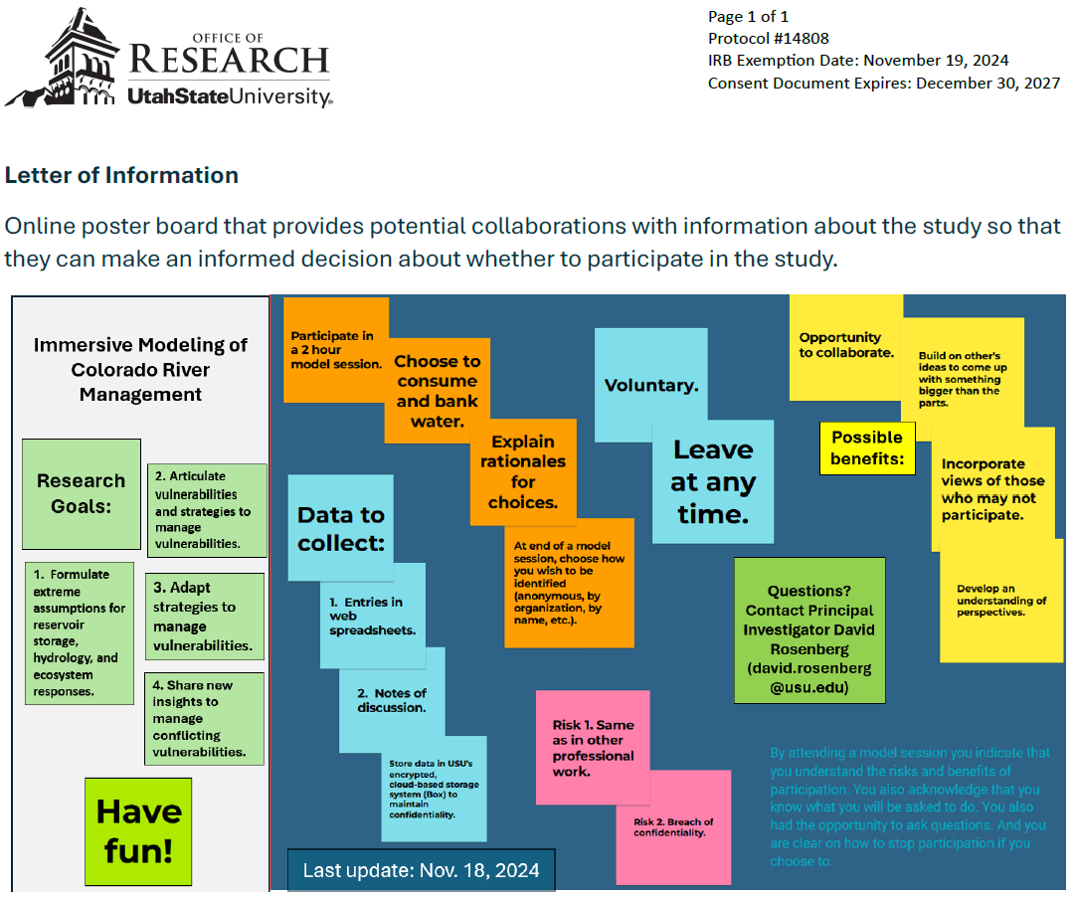
Flyer to hand out during in-person encounters.
