Letter of Information
Online poster board that provides potential collaborations with information about the study so that they can make an informed decision about whether to participate in the study.
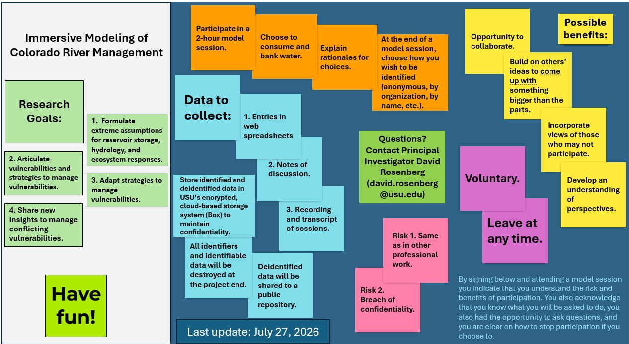

Screen Capture of Qualtrics survey for informed consent - https://usu.co1.qualtrics.com/jfe/form/SV_1QUAADrAQfM1Foq
