Qualtrics form where potential collaborators can share their email address and availabilities to join a model session. This is for Method #8, Steps 2 and 3.

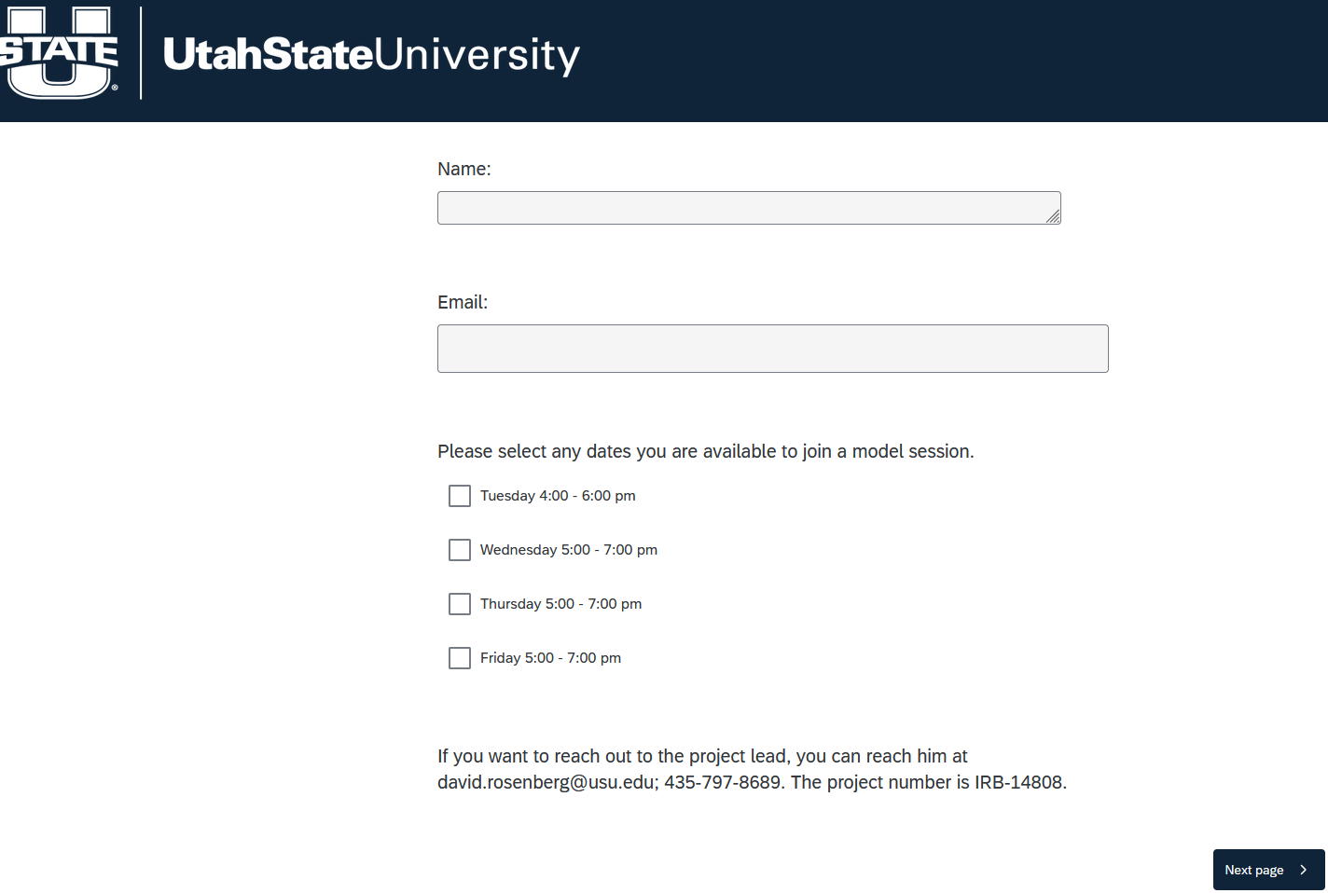
Screen after a potential participant clicks “Next page >”


