The Lake Mead Water Conservation Program: Reducing User’s Conflicting Risks of Declining Flows with more Autonomy and Adaptation.

David Rosenberg¹, Brittany Fager¹, Anabelle Myers¹, Erik Porse²
July 9, 2026
¹Professor, Phd student, and undergraduate researcher, Department of Civil and Environmental Engineering and Utah Water Research Lab, Utah State University, Logan, Utah, 84322-8200. ORCID: https://orcid.org/0000-0003-2163-2907. A.M.ASCE. Email: david.rosenberg@usu.edu, Brittany.fager@usu.edu, a02369941@usu.edu.
²Director and Associate Cooperative Extension Specialist, California Institute for Water Resources, Univ. of California Agriculture and Natural Resources, Univ. of California, Davis, 2801 Second St., #152, Davis, CA 95618. ORCID: https://orcid.org/0000-0002-6691-2104. A.M.ASCE. Email: eporse@ucanr.edu.

Abstract
Since 2007, California, Arizona, Nevada, and Mexico have voluntarily reduced their Colorado River water use from legal entitlements by 4.4 million acre-feet with 3.6 million acre-feet presently remaining in Lake Mead. These efforts kept Lake Mead storage above critical elevations through the recent 20-year (and ongoing) dry period. The voluntary water conservation program works on the assumption that the annual physically available water―reservoir inflow minus evaporation―exceeds legal entitlements of 9.0 million acre-feet per year. This assumption is challenged as the Colorado River Basin becomes more arid. Additionally, as reservoir storage declines towards catastrophic elevations, users face difficulty to access and withdraw their conserved water. We suggested two novel improvements that switch conservation accounting of reductions from historical entitlements to reductions from the annual physically available water. One suggestion proportionally reduces credits for conserved water. A second suggestion creates a new protection account to be managed by Reclamation and separate water accounts for each user. Each year, Reclamation takes a first share of the physically available water equal to reservoir evaporation to sustain the protected volume. The users then divide the remaining inflow and consume, conserve, and/or trade within their account balances. Both suggestions have potential benefits to stabilize and recover Lake Mead storage while increasing users autonomy to manage their differing and sometimes conflicting risks of declining flows. These strategies can serve as examples for other water systems that face aridity, declining reservoir storage, and user conflicts.
Key words: Hoover Dam, Intentionally Created Surplus (ICS). Water Use Reduction, Water Rights, Reservoir Hedging, Drought.

Introduction
Drawdown of reservoirs across the western United States and uncertainty in future water supply put agricultural users, urban users, Tribal Nations, and ecosystems at risk of water shortages (Jasechko and Perrone, 2021). Communities with varied access to water sources, capital, and information face different levels of risk (Allaire and Acquah, 2022; Cutter et al., 2003; Cutter et al., 2000; Meehan et al., 2020; Mileti, 1999; Pace et al., 2022; Thomas et al., 2019; Wakhungu et al., 2021). With aridity and water scarcity, goals of systemwide managers to protect critical reservoir elevations can conflict with goals of users to continue deliveries. User, Tribal, and ecosystem goals can also conflict with each other (Hecht et al., 2020; Hegwood et al., 2022; Rosenberg, 2024). One strategy to reduce conflict is to allow each user to voluntarily conserve water in reservoirs and later withdraw their water when flows may be lower.
Within the Colorado River Basin, the voluntary Lake Mead water conservation program is the most successful and adaptive component of present Colorado River operations. The existing program allows Arizona, California, and Nevada water users to voluntarily reduce consumption from their legal entitlements, keep the conserved water in Lake Mead, and withdraw conserved water at a future point in time subject to some constraints. The program was created as part of the 2007 Interim Guidelines (USBR, 2007b) and expanded in the 2019 Lower Basin Drought Contingency Plan (USBR, 2019). Basin water managers typically call the program Intentionally Created Surplus (ICS) or “assigned water”. Due to continued reservoir declines, a second mandatory water use reduction program requires Arizona, Nevada, and California to reduce deliveries from historical entitlements as Lake Mead draws down (Kuhn and Fleck, 2019; USBR, 2007a; USBR, 2019). Shortages increase as Lake Mead’s level declines. Minutes 319 and 323 to the 1944 United States - Mexico treaty set up similar voluntary water conservation mandatory shortage programs for Mexico (IBWC, 2021).
There has been limited academic scholarship on the Lake Mead water conservation program. Grant (2007) wrote that the program was the “most imaginative” part of the 2007 Interim Guidelines and that the program will increase water supply or make supply more productive. Program participation amended the operating principle of "use it or lose it" common to laws that govern water use in many western states. Such practices do not incentivize conservation. If a water user consumes less than their legal entitlement, a state could potentially reclaim the allocation and assign the water right to a different user or use.
The program had modest activities through 2015 (Robison, 2017). Even with these activities, Lake Mead continued to draw down.
To promote higher engagement, scholars suggested to raise caps on allowed credits and debits (Fleck and Udall, 2021; Robison, 2017). Stelter (2022) suggested Utah adopt the same voluntary water conservation program using Flaming Gorge as the reservoir. Colby et al. (2025) suggested to assign up to 50% of conserved water to remain in Lake Mead as system water to create a balance of individual and collective resiliency. Huizar et al. (2023) reported difficulty to predict and model state’s water conservation choices. Rosenberg (2024) proposed and tested water accounts in a combined Lake Powell-Lake Mead system. Recently, the U.S. Bureau of Reclamation (USBR) proposed several ways to improve the program (now called Storage and Delivery) beginning in 2027 (USBR, 2026b). One option is to remove gaming between the voluntary water conservation and mandatory water shortage programs by tying mandatory shortages to the anticipated Lake Mead level if there was no voluntary activity (colloquially called “operational neutrality”). A second suggestion can move voluntarily conserved water upstream to Lake Powell to increase operational flexibility.
The voluntary Lake Mead water conservation program operates with the assumption that the annual Lake Mead inflow minus reservoir evaporation—the annual physically available water—exceeds legal entitlements. This assumption is challenged as the Colorado River Basin becomes more arid (Salehabadi et al., 2022; Salehabadi et al., 2024; Smith et al., 2022; Udall and Overpeck, 2017). At the 20th anniversary of the creation of the Lake Mead Water Conservation program, there is a need to ask if the program’s underlying assumptions are valid and sustainable. To address this knowledge gap, we ask and answer the following questions:
- How much water has the program conserved since its inception and how much of that water remains in Lake Mead?
- What, if any, other successes are associated with the program?
- What challenges does the program face as the Colorado River Basin becomes more arid?
- What is the role of user autonomy in increasing program participation and mitigating potential conflicting risks of water shortages?
This article provides an overview of the program, analyzes its operations to date, and capacity for future success. The analysis is broken into five sections. First, we provide definitions and examples of Lake Mead water conservation program activities (Section 2). Next, we share program successes and challenges (Sections 3 and 4). Finally, we share suggestions to increase user autonomy to manage risk with declining flows (Section 5). The suggestions switch reservoir accounting structures for tracking water from reductions of historical entitlements to water accounting based on apportionment of physical reservoir inflow. We illustrate some of many more autonomous and adaptive strategies that water users can adopt within a water accounting framework (Section 6). The next section discusses our suggestions in the context of prior work and lists additional benefits and limitations of water accounting. This work has potential benefits to stabilize and recover Lake Mead storage while increasing users autonomy to manage their differing and sometimes conflicting risks of declining and low Colorado River flow.

Definitions and Example Program Activities
Box 1. Definitions
Legal entitlements - The 4.4, 2.8, 0.3, and 1.5 million acre-feet per year volumes of water allocated to California, Arizona, Nevada, and Mexico under current Colorado River operations.
Water conservation - The voluntary and temporary reduction in water use from a historical allocation at one place at one point in time coupled with an increase in water use at the same place at a future point in time (or another location at the same or future point in time).
Water conservation account credit - The volume of water conserved and left in Lake Mead.
Water conservation account debit - The volume of water withdrawn, diverted, and consumed above a legal entitlement.
Water conservation account balance - The sum of all credits minus all debits from 2007 to present.
Reservoir protection level - The reservoir active storage volume (or elevation) set to provide a buffer against reservoir drawdown a catastrophic elevation. The present Lake Mead protection elevation is 1,020 feet which is 5.9 million acre-feet of active storage above the minimum power pool elevation of 955 feet.
Prohibition on program debits - The reservoir volume or elevation trigger below which water conservation program debits are prohibited. This trigger elevation has the purpose to prevent reservoir drawdown to catastrophic elevations. Presently, the trigger elevation is 1,025 feet.
Mandatory water use reduction – The volume of water a Lower Basin user or Mexico must reduce use below their legal entitlement. This volume is also referred to as a shortage. Shortages increase as Lake Mead draws down from elevation 1,090 feet towards 1,020 feet.
The existing voluntary Lake Mead water conservation program activities can be considered as reservoir withdraws below or above legal entitlements (credits and debits; Box 1; Examples 1 and 2). A water user (i) receives an annual account credit (A_{i}) of:
$A_{i}=max\left(E_{i}- D_{i}, 0\right), ∀i$ [Eq. 1]
Where E_{i} and D_{i} are user i’s annual legal entitlement and consumptive use (maf).
Example 1. Water conservation account credit. At the beginning of 2018, Arizona had a water conservation account balance of 126,800 acre-feet. In 2018, Arizona withdrew, diverted, and consumed 2.484 million acre-feet—216,000 acre-feet less than its historical allocation of 2.8 million acre-feet. As a result, Arizona's water conservation account was credited 216,000 acre-feet. At the end of 2018, Arizona's conservation account balance was 343,000 acre-feet (126,800 + 216,000 = 343,000 acre-feet). Arizona’s water conservation action raised Lake Mead's volume 216,000 acre-feet above the anticipated volume—the surplus in "Intentionally Created Surplus"—had Arizona withdrawn, diverted and consumed its historical allocation.
Example 2. Water conservation account debit. At the beginning of 2022, California had a water conservation account balance of 1.36 million acre-feet. In 2022, California withdrew, diverted, and consumed 4.51 million acre-feet of water—111,000 acre-feet of water above its legal entitlement. At the end of 2022, California had a water conservation account balance of 1.245 million acre-feet (1.36 – 0.111 = 1.245 million acre-feet). Lake Mead's storage reduced 111,000 acre-feet from the anticipated volume had California withdrawn its legal entitlement.
Program structure. The program limits credits and debits each year. The program also sets maximum water conservation account balances for the three Lower Basin states. The program also prohibits withdraws above legal entitlements when Lake Mead storage is at or below 6.0 million acre-feet (reservoir elevation of 1,025 feet). The program assesses a 5% reduction in the first year to cover increased reservoir evaporation associated with a higher Lake Mead level and surface area. The program assesses a 3% reduction in subsequent years.
Interactions with the mandatory Lake Mead water shortage program. Also introduced in the Interim Guidelines and expanded in the Lower Basin Drought Contingency Plan, mandatory water shortages increase as Lake Mead’s level declines from an elevation of 1,090 to 1,020 feet (Kuhn and Fleck, 2019; USBR, 2007a; USBR, 2019). Nonetheless, the 2019 DCP allows states and contractors to debit their voluntary water conservation account balances to meet their mandatory reductions in water use. This transfer is an administrative action and does not change Lake Mead level. Recently, the USBR (2026b) proposed to exclude mandatory shotrages (M_{i} [million acre-feet per year]) from the calculation of voluntary credits (Eq. 2).
$A_{i}=max\left(E_{i}-M_{i}- D_{i}, 0\right), ∀i$ [Eq. 2]
Here, A, E, and D are defined previously in Eq. 1.
We draw and report annual data on water conservation account balances, credits, and debits from USBR’s water accounting reports (USBR, 2026a). The data span the period 2007 to 2025.

Program Successes
- Since 2007, California, Arizona, and Nevada have collectively conserved and credited 4.4 million acre-feet of water (Figure 1).
- Of those credits, 3.6 million acre-feet of water remain in Lake Mead (Figure 2).
- Each state holds account balances of between 0.7 (Arizona) to 1.7 (California) million acre-feet (Figure 2).
- Account balances are often significant by comparison to consumptive use. For example, Nevada's 2025 water conservation account balance of 890,000 acre-feet is nearly 3 times its legal entitlement of 300,000 acre-feet and almost 4.5 times its recent consumptive use of near 200,000 acre-feet per year.
- Total conserved water has grown since 2016 (Figure 2).
- Participation has exceeded the upper limits for credits allowed by the Interim Guidelines (Figure 2). This excess shows the program has grown beyond the expectations of the designers of the program.
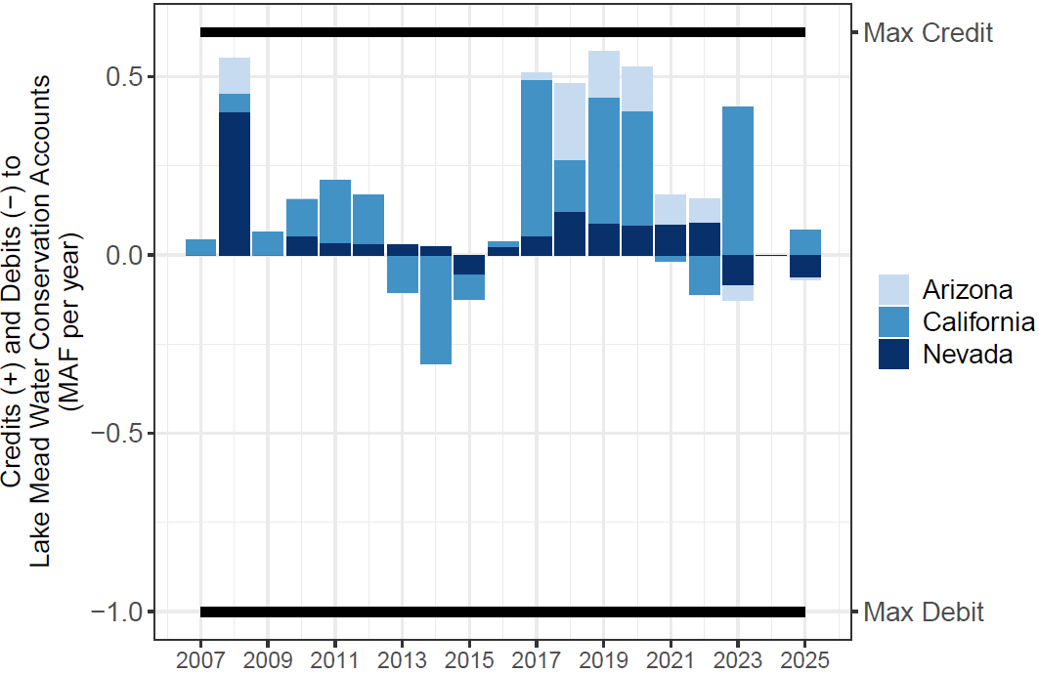
Figure 1. Lake Mead water conservation account annual credits and debits.

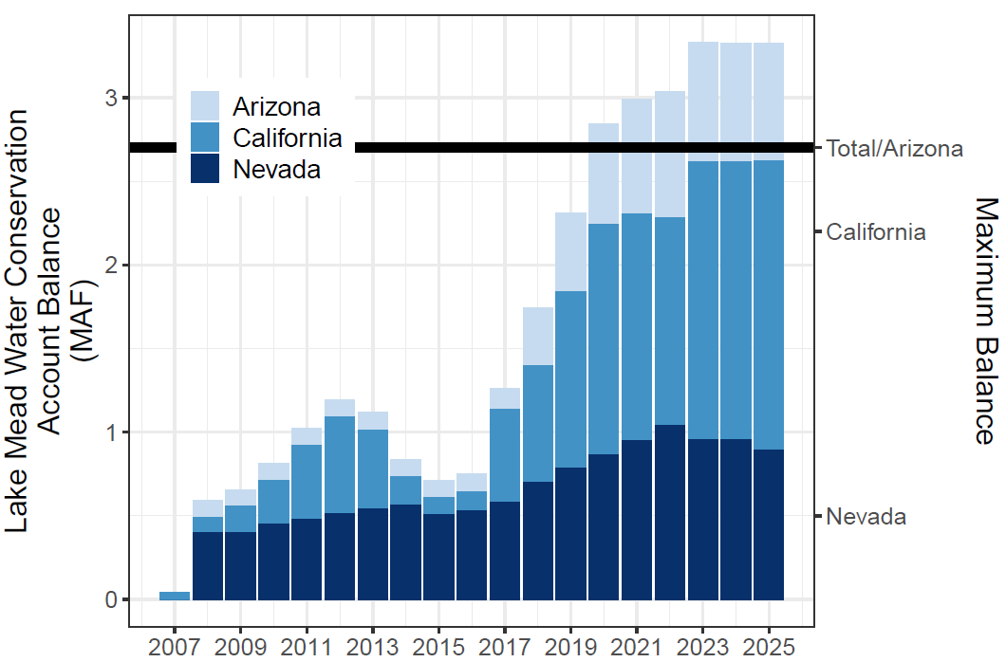
Figure 2. Lake Mead water conservation account balances.

- Mexico has conserved and credited 0.22 million acre-feet of water of which 0.13 million acre-feet remain in Lake Mead.
- The program has conserved more water than other voluntary, compensated, or mandatory Colorado River Basin water conservation program (Table 1; Allhands, 2021; UCRC, 2018; UCRC, 2024; USBR, 2021; USBR, 2026a)

Table 1. Colorado River Basin water conservation programs and accomplishments.

- States have some additional autonomy for reservoir withdraws and to manage vulnerability independent of other states activities. This autonomy reduces conflict.
- Since 2022, the water conservation program has kept Lake Mead’s storage above the 5.9 million-acre feet protection volume (elevation 1,020 feet) defined in the Lower Basin Drought Contingency Plan (Figure 3).

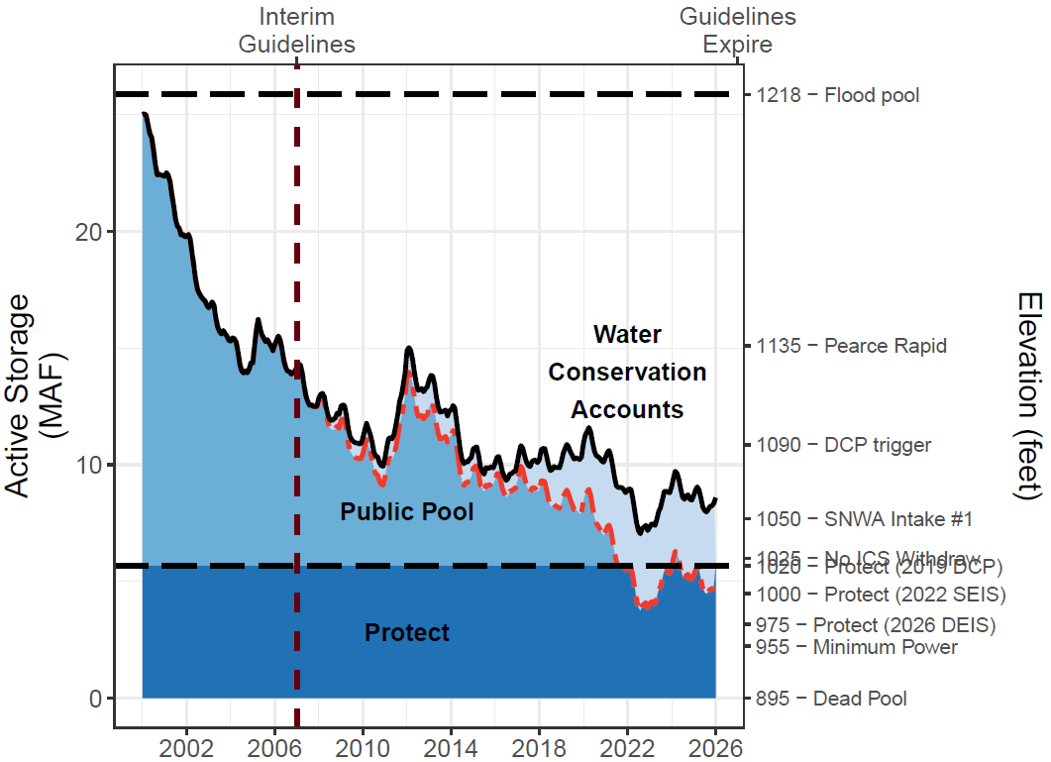
Figure 3. Lake Mead storage (solid black line), water conservation account balances (light blue fill), and anticipated lake volume absent the water conservation program (dashed red line). Since 2022, the conservation program has kept Lake Mead level above its protection elevation 1,020 feet (5.9 million acre-feet).

Program Challenges
Despite successes, there are challenges to motivating users to continue to conserve water and leave that water in Lake Mead. There are also challenges to access conserved water as inflow and reservoir storage decline.
Reservoirs can draw down quickly. States and contractors conserved water with the understanding that this water would be accessible for withdraw in the future. With a June 26, 2026 elevation of 1,045.6 feet (7.37 million acre-feet active storage), multiple years of debits can drawdown Lake Mead close to the protection elevation in a few years. Within the current conservation framework, Lower Basin states and Mexico loaned the Colorado River system 3.6 million acre-feet of water, which some or all they may want to recover in the future. Absent systemwide goals, once users perceive that Lake Mead will drawdown close to the protection volume, they may race to debit their water conservation account balances to access their conserved water.
Motivating additional voluntary water conservation is challenging. As reservoir storage draws down to the protection volume, states and contractors face increasing difficulty to access and withdraw their conserved water. Their prior conserved water becomes a stranded asset. This challenge can also spur conflicts if:

  - Multiple states simultaneously want to withdraw conserved storage, which results in Lake Mead dropping below its protection elevation. States would need to agree on smaller withdraws that keep Lake Mead at or above the protection elevation.
  - One state withdraws their conserved water which draws down Lake Mead storage towards the protection volume. This activity will prevent other states in future years from drawing on their conserved water.
  - Other states and users take counter measures to increase their ability to access conserved water with the undesired effect to further draw down Laken Mead.

Tribal, environmental, and municipal water needs are not explicitly included. The Lake Mead water conservation program is built on legal entitlements to states, which were developed at a time that did not include key water needs that we recognize in the 21st Century. These needs include water for Tribal Nations and multi-species conservation between Hoover Dam and the Northern International Boundary with Mexico. Counter-intuitively, Lake Mead storage above an elevation of 1,135 feet, will submerge the Pearce Rapid and allow invasive fish in the reservoir to swim upstream to the detriment of native fish in Grand Canyon. There is also ongoing debate about what is the minimum volume of supply for municipal use, health, and safety.
Reservoir inflows are not considered in conservation accounting. The voluntary water conservation program functions under the assumption that the annual Lake Mead inflow minus evaporation—the annual physically available water—exceeds the sum of legal entitlements of 9.0 million acre-feet per year to California, Arizona, Nevada, and Mexico. When this assumption is false, Lake Mead will draw down even as states leave conserved water in Lake Mead. Essentially, states got credit for water conservation activity even though the physical water never entered the reservoir. There are two cases when the assumption is valid and invalid (Figure 4).

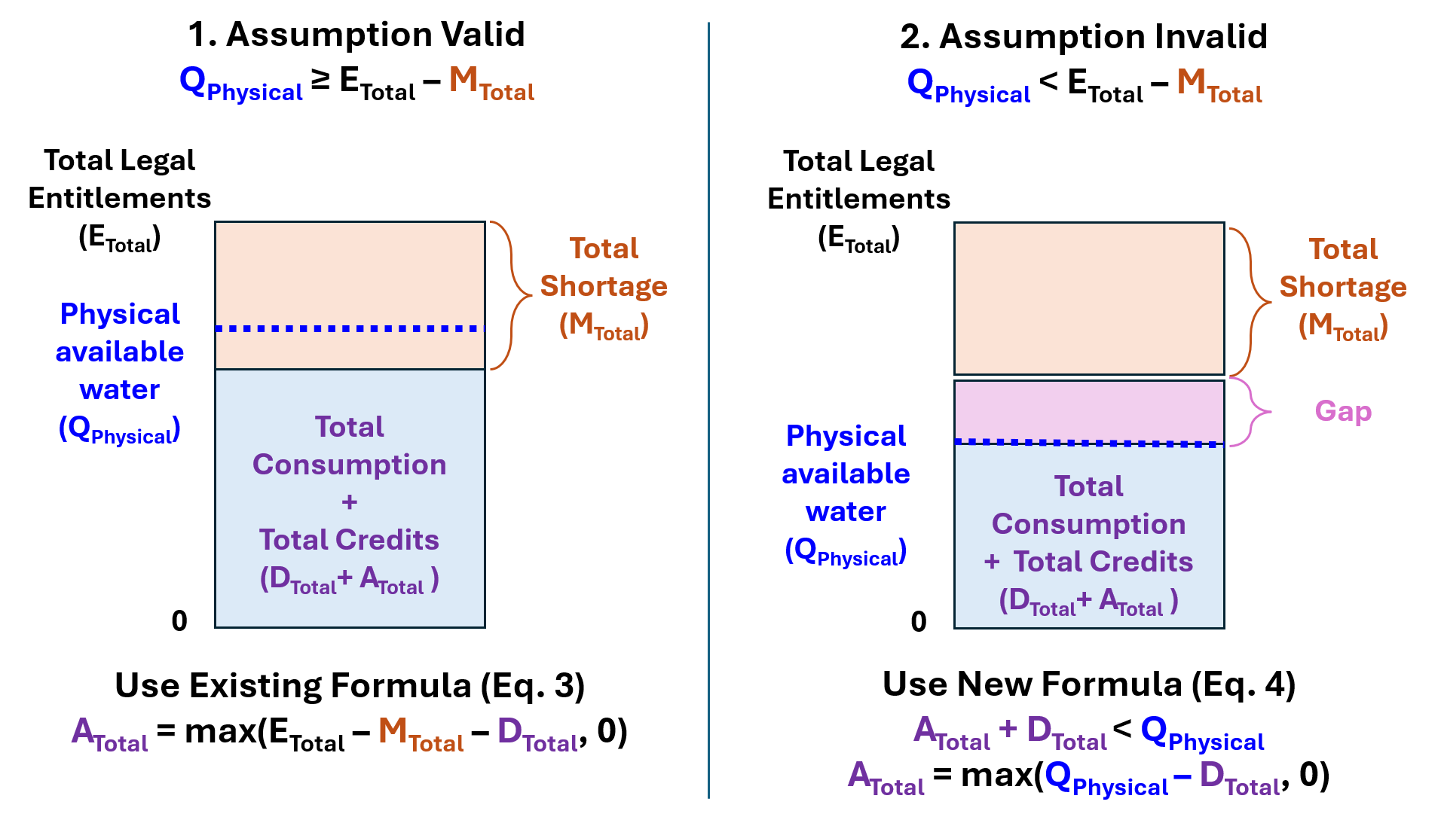
Figure 4. Conceptual models showing when the assumption that Physically Available Water (Q_{Physical}) exceeds Total Legal Entitlements minus Total Mandatory Shortages (E_{Total} – M_{Total}) is valid (Case 1, left) or invalid (Case 2, right). In Case #2, there is a gap between Total Legal Entitlements and the Physical Available Water that the Total Shortage does not fill.

The two cases can also be more precisely described mathematically. Summing Eq. 2 over all users gives the total of all awarded credits (A_{Total} [million acre-feet]) as the larger of:
$A_{Total}=maximum\left(E_{Total}-M_{Total}- D_{Total}, 0\right)$ [Eq. 3]

In case 1, the annual Physically Available Water (Q_{Physical} [million acre-feet per year]) exceeds Total Legal Entitlements minus Total Mandatory Shortages (Q_{Physical} ≥ E_{Total} $-$ M_{Total}). In this case [E_{Total} $-$ M_{Total} $-$ D_{Total}] is positive and max([a positive number], 0) is that positive number. Thus, full credits A_{Total} are correctly awarded (Eq 3; Fig. 4, Case #1).

However, in a Case #2 when the annual Physically Available Water is less than the Total Legal Entitlements minus Total Mandatory Shortages (Q_{Physical} < E_{Total} $-$ M_{Total}), there is a gap between the Total Legal Entitlements and Physically Available Water that the Total Mandatory Shortages do not fill (Figure 4, Case #2). In this case, Eq. 3 will incorrectly award credits A_{Total} because there was insufficient reservoir inflow.

We estimate that 0.8 million acre-feet of the total 4.4 million acre-feet of voluntary Lake Mead water conservation program activity through 2025 were credited even though sufficient water did not flow into Lake Mead (Figure 5).
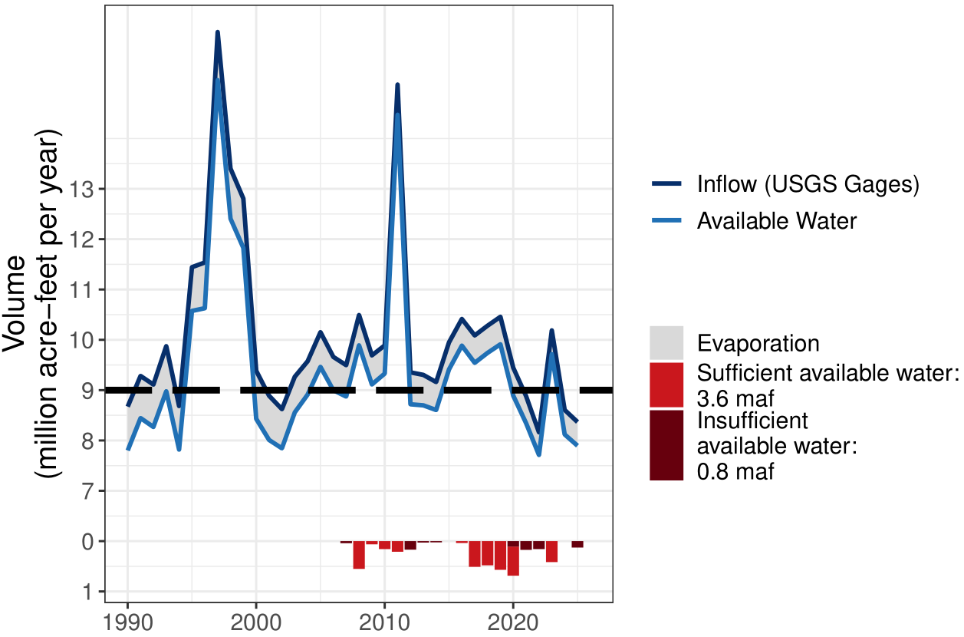
Figure 5. Annual Lake Mead inflow (dark blue), evaporation (grey), physically available water (light blue), and conservation credits (bright red bars) in relation to total legal entitlements of 9.0 million acre-feet (black horizontal dashed line). When the available water was less than legal entitlements, conserved water was credited even though that water did not flow into Lake Mead (dark red bars).

Conditions where the Physically Available Water is less that Total Legal Entitlements will increasingly occur as future Colorado River flows become more volatile and risk of reservoir level declines increase (Table 2). For example, with a Lake Powell release of 7.0 million acre-feet per year and Total Legal Entitlements of 9.0 million acre-feet per year, Total Mandatory Shortages must exceed 1.5 maf per year for there to be sufficient physically available water to award all requested credits. When the Lake Powell release is 6 million acre-feet as in Water Year 2025-2026, Total Mandatory Shortages must exceed 2.6 maf per year.

Table 2. Conditions of Lake Powell releases and Lower Basin shortages where there is sufficient physically available water to award all requested credits. When there is insufficient water, the gap is calculated. All columns million acre-feet per year.

Strategies to Motivate Conservation and Increase User Autonomy
There are numerous ways to design a program to motivate voluntary, uncompensated water conservation. First, USBR can raise the elevation trigger that prohibits withdraws of prior conserved water. This strategy would preserve more water in storage. Second, USBR can set a storage trigger that requires mandatory water use reductions to the anticipated Lake Mead storage volume if there was no voluntary water conservation activity (i.e., the dashed red line in Figure 4)(City of Phoenix, 2024; Pitt et al., 2024; USBR, 2026b). Third, updated policies can allow Tribal users to participate. Updated policies could also allow water conservation for later releases for multi-species conservation or pulse flows to the Colorado River delta. Finally, new operational policies that split conserved water between Lake Powell and Lake Mead can provide more flexibility in operations to sustain ecosystems in Grand Canyon, or create a system pool to be managed by USBR (Rosenberg, 2023; Rosenberg, 2024; USBR, 2026b).
Here we describe two novel program improvements that motivate water conservation behavior while give users more autonomy to manage their risks of water shortages in the face of aridity. Both strategies switch the conservation accounting from reductions from historical entitlements to reductions from the annual physically available water.
Proportional Scaling. In this strategy, we only credit water that physically flowed into the reservoir and can be stored for later release. Never allow total annual assigned credits (A_{total}) and consumptive use to exceed total annual physically available water (Eq 4):

$\sum_{i}{\left(D_{i}+A_{i}\right)} ≤Q_{Physical}$ or $A_{Total}≤max\left(Q_{Physical}- D_{Total}, 0\right)$ [Eq. 4]
This strategy uses a proportional scaling factor to assign each user’s credits within the physically available water (Eq. 5):

$A_{i}=max\left({E_{i}-M}_{i}- D_{Total}, 0\right)∙min\left(1, \frac{Q_{Physical}}{D_{Total}+A_{Total}}\right), ∀i$ [Eq. 5]
If total claims D_{Total} + A_{Total} ≤ Q_{Physical}, there is sufficient physically available water, the multiplier is 1, and everyone receives their full requested credits (A_{i}). If total claims exceed the physically available water, the multiplier is $\frac{Q_{Physical}}{D_{Total}+A_{Total}}$ < 1, which reduces all requested credits by a proportion. Reducing credits in this way would encourage water conservation at larger Lake Powell releases and higher Lake Mead storage.

Water Accounting. In this framework, the Lake Mead elevation and corresponding storage volume are defined for a protection account—to be managed by Reclamation (PV₀ [million acre-feet]). In each year t, the protection account is allocated a first share of the Lake Mead inflow to offset the annual Lake Mead evaporation (Eq. 6). The remaining reservoir inflow is divided among the water users. Each user i can consume water within their account balance (B_{i,t} [million acre-feet]; Eq 7). Users carry over any positive end-of-year account balances to the next year. The Lake Mead storage volume in year t (V_{t} [million acre-feet]) is the sum of the Lake Mead protection account and the other user’s water account balances (Eq 8).
${PV}_{t+1}={PV}_{t}{ + USBR Share of Inflow}_{t}-{Evaporation}_{t},$ $∀t$ [Eq. 6]
$B_{i,t+1}=B_{i,t}+ {Share of Inflow}_{i,t}-D_{i,t}, ∀i$ [Eq. 7]
$V_{t}={PV}_{t}+ \sum_{i}{B_{i,t}}, ∀t$ [Eq. 8]
Because each user must maintain a zero or positive account balance ($B_{i,t}≥0$), the protection account prevents further draw down to critical levels, even with extreme low reservoir storage and inflow. The annual Lake Mead inflow is typically known at the beginning of the year because the annual Lake Powell release—that is set in Fall of each year—is often 85 to 91% of Mead inflow (Rosenberg, 2022; Wang and Schmidt, 2020). With water accounting, each user can an withdraw some up to all of their account balance at any time and at any Lake Mead storage volume. This ability gives users more autonomy to adapt their consumption and conservation activities as system conditions change. Water accounts can be created for any users or uses such as Tribal Nations or endangered species conservation programs. Additionally, there is no elevation trigger that prohibits withdraws of conserved water, thus providing users additional autonomy and adaptability.

Illustrations of Water Accounting
Like Huizar et al. (2023), it is difficult to predict and model user’s water consumption and conservation choices, and corresponding Lake Mead storage volumes. Prediction is difficult because with more autonomy, users can adapt their choices year-to-year for a variety of reasons that are not readily coded into simulation models and rules. Here, we instead use collaborator choices in recent immersive, online, collaborative modeling sessions to illustrate a few possibilities of water accounting. Within a session, collaborators immersed in and personified a Lake Mead user. The user roles were Reclamation (protection volume), California, Arizona, Nevada, Mexico, and Tribal Nations of the Lower Basin. Each year, we choose and revealed the Lake Mead inflow. The model apportioned the inflow among the user accounts. Then, each collaborator consumed, conserved, or traded within their account balance. Collaborators carried over account balances to the next year, which also kept Lake Mead storage above the protection volume. Each collaborator participated in one session and each session lasted ~ 2 hours. Otherwise, sessions followed the structure of prior immersive modeling work (Rosenberg, 2024).
Figure 6 shows results from one session where the person who immersed in the Reclamation role choose a protection volume of 6.3 million acre-feet (1,030 feet). The remaining collaborators reserved 1.4 to 2.0 million acre-feet in their accounts, keeping Lake Mead storage above the protection elevation even with inflows of 3.8, 6.3, and 4.0 million acre-feet—inflows lower than observed.
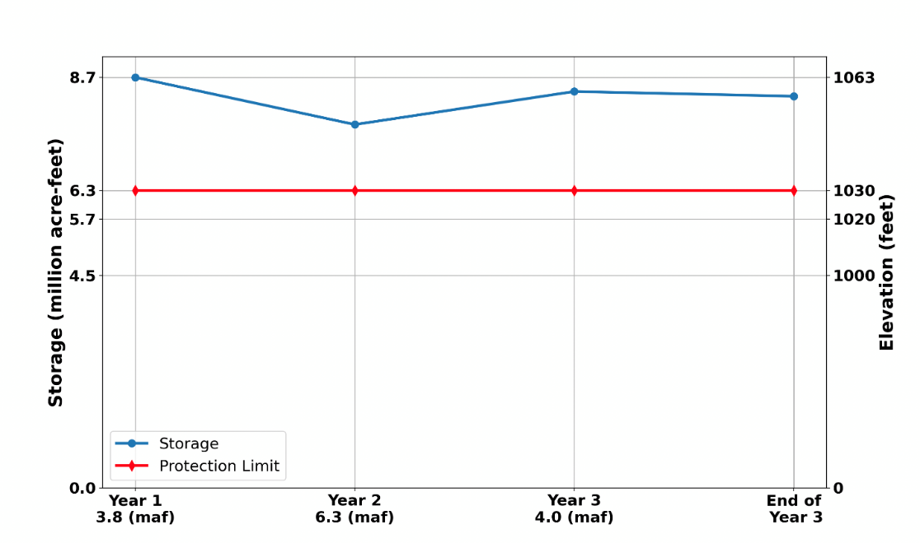
Figure 6. Collaborator choice for Lake Mead protection elevation (red) during a recent immersive model session. The blue line shows the resulting reservoir storage/elevation with inflows of 3.8, 6.3, and 4.0 million acre-feet per year. The area between the red and blue lines is the total volume the other collaborators conserved water and account balances.

Across 7 sessions, collaborators who immersed in and personified the Reclamation role chose Lake Mead protection elevations from 970 to 1,030 ft (2.9 to 6.3 million acre-ft of active storage; Figure 7). Across these model sessions, years, and inflows as low as 3.8 million acre-feet per year, Lake Mead storage was maintained at 100 to 280% of the chosen protection volume (blue circles in Figure 2). Lake Mead storage stayed above the protection volume when collaborators who personified users conserved some of their available water for use in future years and/or the person who immersed in the Reclamation role purchased some water from other users to add to the protection account volume. For example, Federal purchases of settled, unused water from an account representing the Tribal Nations of the Lower Basin provided income for Tribes to build expensive potable water supply systems or repair aging infrastructure. People who role played Reclamation sometimes sold some protection water to bail out users who had very low account balances (red diamonds in Figure 2).
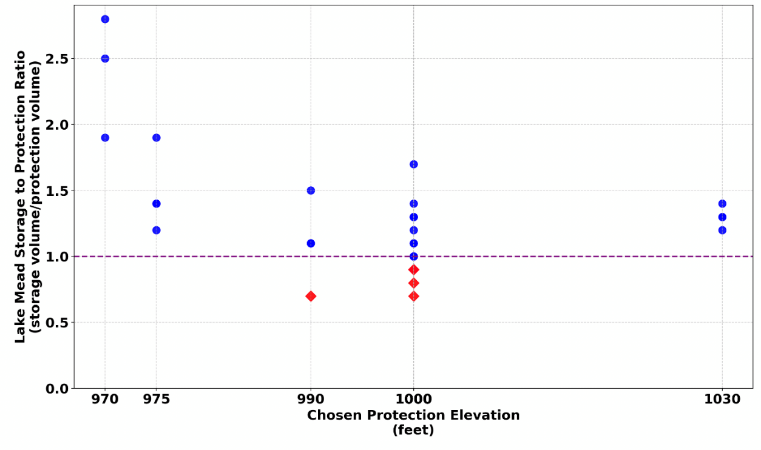
Figure 7. Lake Mead protection elevations chosen in recent immersive modeling sessions (x axis) and resulting storage was expressed as a fraction of the chosen protection volume (y axis). Inflows were 3.8, 6.3, and 4.0 million acre-feet per year. Blue circles above the purple dashed line of 1.0 showed sessions and years where collaborators maintained Lake Mead storage at or above the protection elevation. In some instances, the collaborator immersing in the Reclamation role chose to sell some of the protection water to bail out users who had low account balances (red diamonds). 6 – sessions.
These examples illustrate some of many more autonomous and adaptive strategies that water users can adopt within a water accounting framework.

Discussion
We report numerous Lake Mead water conservation program successes, including that the program has conserved more water than any other Colorado River Basin conservation program to date. Presently, some now 3.6 million acre-feet of conserved water remains in Lake Mead—quadruple the volume of ~ 700,000 acre-feet reported through 2015 (Robison, 2017). Since 2022, conservation efforts by California, Arizona, Nevada, and Mexico have kept Lake Mead above its protection elevation of 1,020 feet set in the 2019 Lower Drought Contingency Plan.
To expand program participation and increase operational flexibility, prior researchers suggested to raise caps on water conservation account balances (Fleck and Udall, 2021; Robison, 2017). In 2020, total account balances exceeded the 2.7 million acre-feet maximum balance defined in the 2019 Drought Contingency Plan (USBR, 2019). A second suggestion would allow movement of voluntarily conserved water from Lake Mead upstream to Lake Powell (USBR, 2026b).
Other proposals placed additional constraints on the program that we believe will limit participation and user autonomy. For example, Colby et al. (2025) suggested that 50% of conserved water remain in Lake Mead as system water. Reclamation proposed to tie mandatory shortages to the anticipated Lake Mead level if there was no voluntary water conservation activity (USBR, 2026b). They also proposed to exclude mandatory reductions from the calculation of voluntary credits. Larger shortages that trigger at higher reservoir levels will help Lake Mead. But there is also a downside. Shortages will vary year-to-year in response to volatile Colorado River flow and Lake Mead or system storage. Swings in shortages limit user’s autonomy and make it difficult for user’s to plan future water use.
All of the proposals fail to address two challenges of the existing Lake Mead water conservation program. First, as Lake Mead draws down, it becomes more difficult for users to withdraw their conserved water. Second, credits are awarded as reductions from legal entitlements rather than reductions from the physically available reservoir inflow. This later challenge means Lake Mead can continue to drawdown even as users voluntarily conserve some water. Each challenge is exacerbated as reservoir inflow declines, a situation that will occur more frequently as the basin becomes more arid (Salehabadi et al., 2024; Udall and Overpeck, 2017) .
Both of our proposals address the challenge of sustainability head on. Our first proposal constrains total water consumption and credits to be less than the annual reservoir inflow. Our second proposal apportions reservoir inflow among Reclamation and the users and allows users to consume, conserve, and trade within their water account balance. There are several other benefits of our proposals, all of which increase user autonomy and adaptability.
- Current water conservation account balances can be rolled over to be the Year 0 water account balance, allowing users to access their prior conserved water. Roll-over also means the existing voluntary Lake Mead water conservation program can be sunset.
- Water accounting allows Reclamation and water users to more autonomously manage their differing interests and risks. For Reclamation, this is where to set the reservoir protection elevation. Reclamation does not need to consult with the other users. The other water users can more independently adapt their decisions to consume water, conserve water for future use, and trade in response to their account balances, others choices, the discussion of choices, and their perceptions—or fears—of future low flow. There can also be discussion of the (a) volumes, and (b) prices for Reclamation and users to purchase water from each other—purchase volumes and prices that may change from year to year as water becomes more scarce or available.
- Sunset the existing mandatory water shortage program. A Reclamation protection account prevents Lake Mead drawdown to catastrophic levels.
- Water accounting more transparently and flexibly allows use within the physically available water. Thus, there is no need for shortage operations contingent on the anticipated reservoir level had users not conserved water (operational neutrality).
- Prioritize reservoir evaporation as the highest consumptive use by allocating a first share of Lake Mead inflow to the Reclamation protection account to offset reservoir evaporation. This prioritization corrects a shortfall of existing Colorado River operations that ignore reservoir evaporation.
- Water accounting can be coordinated with other proposals for Lake Powell releases. A Lake Powell release plus gains through Grand Canyon become the inflow to Lake Mead. Reclamation can then take the first share of inflow equal to Lake Mead evaporation to sustain the Lake Mead protection account balance.
There are also limitations of our proposals.
- Apportionment of Lake Mead inflow. Apportionment of inflow among users can be done by priority, pro rata, a combination, percentage splits of shortages in the Lower Basin Alternative (Buschatzke et al., 2024), or another method. In the 4th method, a user’s share of the reservoir inflow is their historical allocation minus the agreed-on shortage volume (Appendix A). Difficult decisions about apportionment are ultimately political choices for where, when, how much, and for which purposes to consumptively use Colorado River water. Until users reach agreement, we suggest to allocate reservoir inflow to increase the Lake Mead protection account balance. This set up may encourage users to reach agreement so they can access water.

- Tradeoffs. The selection of a Lake Mead protection volume creates a tradeoff between the protection account volume managed by Reclamation and the remaining reservoir storage available to other users. Setting a lower protection volume increases the storage for other users. Setting a higher protection volume reduces the storage available to other users, potentially limiting the roll over of existing water conservation account balances. For example, if the accounting program started on June 23, 2026 (Lake Mead elevation 1,045.6 feet; 7.4 million acre-feet active storage) and Reclamation selected a Lake Mead protection elevation of 1,000 feet (4.5 million acre-feet of active storage), then users could only roll over 2.9 of the existing 3.6 million acre-feet in the water conservation program. Setting a protection elevation of 975 feet (3.2 maf of active storage) would allow the complete roll over of all existing conserved water with 0.6 maf of unassigned storage. This storage could be assigned to users such as Tribal Nations, who were previously excluded from participation.

Conclusions
Since 2007, California, Arizona, Nevada, and Mexico have voluntarily reduced their Colorado River water use from legal entitlements by 4.4 million acre-feet with 3.6 million acre-feet presently remaining in Lake Mead. These efforts kept Lake Mead storage above critical elevations through the recent 20-year (and ongoing) dry period. The Lake Mead water conservation program works on the assumption that the annual physically available water―reservoir inflow minus evaporation―exceeds legal entitlements of 9.0 million acre-feet per year. This assumption is challenged as the Colorado River Basin becomes more arid. Additionally, as reservoir storage declines towards catastrophic elevations, users face difficulty to access and withdraw their conserved water. We suggested two novel improvements that switch the conservation accounting of reductions from historical entitlements to reductions from the annual physically available water. One suggestion proportionally reduces credits for conserved water. A second suggestion creates a new protection account to be managed by Reclamation and separate water accounts for each user. Each year, Reclamation takes a first share of the physically available water equal to reservoir evaporation to sustain the protected volume. The users then divide the remaining inflow and consume, conserve, and/or trade within their account balances. Both strategies have potential benefits to stabilize and recover Lake Mead storage while increasing users autonomy to adaptively manage their differing and sometimes conflicting risks of declining flows. These strategies can serve as examples for other water systems that face aridity, declining reservoir storage, and user conflicts.

Data Availability
The data, models, and code used to generate Figures 1, 2, 3, and 5, and Table 2 are available at (Rosenberg, 2026). The data, models, and code used to generate Figures 6 and 7 are available at (Myers et al., 2025). Note: on final submission, the separate repositories will be combined into one Hydroshare repository with subfolders for each work.

Appendix A. Estimate Shares of Annual Lake Mead Inflow from Prior Agreed Apportionment of Shortages.
This appendix demonstrates a method to estimate Mexico’s and each Lower Basin state’s share of the annual Lake Mead inflow from prior agreed upon apportionment of shortages. A user’s legal entitlement minus their prior agreed-on water shortage volume (Buschatzke et al., 2024; Table A1) becomes the share of reservoir inflow (Table A2).
Table A1. Prior agreed Lower Basin shortages and shares of shortages (Buschatzke et al., 2024).

Table A2. Share of Lake Mead inflow by volume and percentage.
Example calculations of share of Lake Mead inflow by volume and percentage (Table A2) are:
- Total Lake Mead inflow [B] = 9.0 ─ Total Shortage [A].
  - For example, a total shortage of 0.4 maf yields a Lake Mead inflow of 9.0 ─ 0.4 = 8.6 maf per year.

- Share of Reservoir Inflow:
  - Arizona [C] = 2.8 ─ Share of Shortage as Volume in Table A1.
    - For example, at 8.6 maf of reservoir inflow, Arizona’s share is 2.8 ─ 0.28 = 2.52 maf.
  - Nevada [D] = 0.3 ─ Share of Shortage as Volume in Table A1.
    - For example, at 8.0 maf of reservoir inflow, Nevada’s share is 0. 3 ─ 0.03 = 0.27 maf.
  - California [E] = 4.4 ─ Share of Shortage as Volume in Table A1.
    - For example, at 7.5 maf of reservoir inflow, California’s share is 4.4 ─ 0.44 = 3.96 maf.
  - Mexico [F] = 1.5 ─ Share of Shortage as Volume in Table A1.
    - For example, at 7.5 maf of reservoir inflow, Mexico’s share is 1.5 ─ 0.25 = 1.25 maf.

- Total Reservoir Inflow [G] = [C] + [D] + [E] + [F]

- A user’s Percent of Reservoir Inflow is their share by volume divided by the total volume.

  - Arizona [H] = [C] / [G]
  - Nevada [I] = [D] / [G]
  - And so forth.

- Total Percentage of Reservoir Inflow [L] = [H] + [I] + [J] + [K] = 100%.

References
Allaire, M., and Acquah, S. (2022). "Disparities in drinking water compliance: Implications for incorporating equity into regulatory practices." AWWA Water Science, 4(2), e1274. https://doi.org/10.1002/aws2.1274.
Allhands, J. (2021). "It could take at least 500,000 acre-feet of water a year to keep Lake Mead from tanking." Arizona Republic, November 8, 2021. https://www.azcentral.com/story/opinion/op-ed/joannaallhands/2021/11/08/lake-mead-could-get-extra-water-from-lower-basin-annually/6306601001/.
Buschatzke, T., Hamby, J. B., and Entsminger, J. (2024). "Lower Basin Alternative for the Post-2026 Coordinated Operation of the Colorado River Basin." https://www.snwa.com/assets/pdf/lower-basin-alternative-letter-march2024.pdf [Accessed on: August 14, 2024].
City of Phoenix. (2024). "Additional concepts for consideration - City of Phoenix." https://www.usbr.gov/ColoradoRiverBasin/documents/post2026/alternatives/2024-05-08_Additional_Concepts_for_Consideration_City_of_Phoenix_508.pdf.
Colby, B., Hansen, K., and Sorensen, K. (2025). "Policy Nook — Policy Note: Tough Tradeoffs in the Colorado River Basin." Water Economics and Policy, 11(04), 2471002. 10.1142/s2382624x24710024.
Cutter, S. L., Boruff, B. J., and Shirley, W. L. (2003). "Social Vulnerability to Environmental Hazards*." Social Science Quarterly, 84(2), 242-261. https://doi.org/10.1111/1540-6237.8402002.
Cutter, S. L., Mitchell, J. T., and Scott, M. S. (2000). "Revealing the Vulnerability of People and Places: A Case Study of Georgetown County, South Carolina." Annals of the Association of American Geographers, 90(4), 713-737. https://doi.org/10.1111/0004-5608.00219.
Fleck, J., and Udall, B. (2021). "Managing Colorado River risk." Science, 372(6545), 885-885. https://doi.org/10.1126/science.abj5498.
Grant, D. L. (2007). "Collaborative Solutions to Colorado River Water Shortages: The Basin States' Proposal and Beyond." Nevada Law Journal, 8, 964
https://heinonline.org/HOL/Page?handle=hein.journals/nevlj8&id=980&collection=journals&index=.
Hecht, J. S., Vogel, R. M., McManamay, R. A., Kroll, C. N., and Reed, J. M. (2020). "Decision Trees for Incorporating Hypothesis Tests of Hydrologic Alteration into Hydropower&#x2013;Ecosystem Tradeoffs." Journal of Water Resources Planning and Management, 146(5), 04020017. https://doi.org/10.1061/(ASCE)WR.1943-5452.0001184.
Hegwood, M., Langendorf, R. E., and Burgess, M. G. (2022). "Why win–wins are rare in complex environmental management." Nature Sustainability. https://doi.org/10.1038/s41893-022-00866-z.
Huizar, L., Díaz, S., Lansey, K., and Arnold, R. (2023). "Water Supply in the Lower Colorado River Basin: Effectiveness of the 2019 Drought Contingency Plan." Journal of Environmental Engineering, 149(10), 04023058. doi:10.1061/JOEEDU.EEENG-7324.
IBWC. (2021). "Minutes between the United States and Mexican Sections of the IBWC." United States Section, https://www.ibwc.gov/Treaties_Minutes/Minutes.html [Accessed on: July 22, 2021].
Jasechko, S., and Perrone, D. (2021). "Global groundwater wells at risk of running dry." Science, 372(6540), 418-421. https://doi.org/10.1126/science.abc2755.
Kuhn, E., and Fleck, J. (2019). Science Be Dammed: How Ignoring Inconvenient Science Drained the Colorado River, University of Arizona Press.
Meehan, K., Jepson, W., Harris, L. M., Wutich, A., Beresford, M., Fencl, A., London, J., Pierce, G., Radonic, L., Wells, C., Wilson, N. J., Adams, E. A., Arsenault, R., Brewis, A., Harrington, V., Lambrinidou, Y., McGregor, D., Patrick, R., Pauli, B., Pearson, A. L., Shah, S., Splichalova, D., Workman, C., and Young, S. (2020). "Exposing the myths of household water insecurity in the global north: A critical review." WIREs Water, 7(6), e1486. https://doi.org/10.1002/wat2.1486.
Mileti, D. S. (1999). Disasters by Design: A Reassessment of Natural Hazards in the United States, Joseph Henry Press, Washington, D.C.
Myers, A., Rosenberg, D., Akbar, H., and Porse, E. (2025). "Immersive Model for Lake Mead Based on the Principle of Divide Reservoir Inflow." Hydroshare. https://www.hydroshare.org/resource/1fcd5325c0a7400099f1698bc72cecd7/.
Pace, C., Fencl, A., Baehner, L., Lukacs, H., Cushing, L. J., and Morello-Frosch, R. (2022). "The Drinking Water Tool: A Community-Driven Data Visualization Tool for Policy Implementation." International Journal of Environmental Research and Public Health, 19(3), 1419. https://www.mdpi.com/1660-4601/19/3/1419.
Pitt, J., Miller, B., Funk, A., Rice, M., Hawes, T., Moran, K., and Porterfield, S. (2024). "Conservation Groups’ Cooperative Conservation Alternative for Post-2026 Colorado River Guidelines Operations and Strategies." Reclamation. https://www.usbr.gov/ColoradoRiverBasin/documents/post2026/alternatives/2024-03-29_Final_Letter_re_Cooperative_Conservation_508.pdf.
Robison, J. A. (2017). "The Colorado River Revisited." University of Colorado Law Review, 88(3). https://heinonline.org/HOL/Page?handle=hein.journals/ucollr88&id=511&collection=journals&index=.
Rosenberg, D. (2026). "Lake Mead Water Conservation Program Analysis." Github, Utah State Unviersity. https://github.com/dzeke/ColoradoRiverCollaborate/tree/main/LakeMeadWaterConservationProgramAnalysis.
Rosenberg, D. E. (2022). "Adapt Lake Mead Releases to Inflow to Give Managers More Flexibility to Slow Reservoir Drawdown." Journal of Water Resources Planning and Management, 148(10), 02522006. https://doi.org/10.1061/(ASCE)WR.1943-5452.0001592.
Rosenberg, D. E. (2023). "Colorado River Basin Water Accounts: Provoke discussion about more adaptive reservoir operations." Hydroshare.org. https://doi.org/10.4211/hs.090be1e69e734c8991a1c4d8f9b9e21c.
Rosenberg, D. E. (2024). "Lessons from immersive online collaborative modeling to discuss more adaptive reservoir operations." Journal of Water Resources Planning and Management, 150(7). https://doi.org/10.1061/JWRMD5.WRENG-5893.
Salehabadi, H., Tarboton, D. G., Udall, B., Wheeler, K. G., and Schmidt, J. C. (2022). "An Assessment of Potential Severe Droughts in the Colorado River Basin." JAWRA Journal of the American Water Resources Association, 58(6), 1053-1075. https://doi.org/10.1111/1752-1688.13061.
Salehabadi, H., Tarboton, D. G., Wheeler, K. G., Smith, R., and Baker, S. (2024). "Quantifying and Classifying Streamflow Ensembles Using a Broad Range of Metrics for an Evidence-Based Analysis: Colorado River Case Study." Water Resources Research, 60(7), e2024WR037225. https://doi.org/10.1029/2024WR037225.
Smith, R., Zagona, E., Kasprzyk, J., Bonham, N., Alexander, E., Butler, A., Prairie, J., and Jerla, C. (2022). "Decision Science Can Help Address the Challenges of Long-Term Planning in the Colorado River Basin." JAWRA Journal of the American Water Resources Association, 58(5), 735-745. https://doi.org/10.1111/1752-1688.12985.
Stelter, D. (2022). "Towards a Utah Intentionally Created Surplus Program." Sustainable Development Law and Policy, 22(2), 4-21. https://heinonline.org/HOL/Page?collection=journals&handle=hein.journals/sdlp22&id=44&men_tab=srchresults.
Thomas, K., Hardy, R. D., Lazrus, H., Mendez, M., Orlove, B., Rivera-Collazo, I., Roberts, J. T., Rockman, M., Warner, B. P., and Winthrop, R. (2019). "Explaining differential vulnerability to climate change: A social science review." WIREs Climate Change, 10(2), e565. https://doi.org/10.1002/wcc.565.
UCRC. (2018). "Colorado River System Conservation Pilot Program in the Upper Colorado River Basin." Upper Colorado River Commission. http://www.ucrcommission.com/RepDoc/SCPPDocuments/2018__SCPP_FUBRD.pdf.
UCRC. (2024). "Colorado River System Conservation Pilot Program in the Upper Colorado River Basin." Upper Colorado River Commission. http://www.ucrcommission.com/wp-content/uploads/2024/06/2023_SCPP_Report_June2024.pdf.
Udall, B., and Overpeck, J. (2017). "The twenty‐first century Colorado River hot drought and implications for the future." Water Resources Research, 53(3), 2404-2418. https://doi.org/10.1002/2016WR019638.
USBR. (2007a). "Colorado River Interim Guidelines for Lower Basin Shortages and Coordinated Operations for Lakes Powell and Mead: Final Environmental Impact Statement." U.S. Bureau of Reclamation, Washington, D.C., https://www.usbr.gov/lc/region/programs/strategies/FEIS/index.html.
USBR. (2007b). "Record of Decision: Colorado River Interim Guidelines for Lower Basin Shortages and Coordinated Operations for Lakes Powell and Mead." U.S. Bureau of Reclamation. https://www.usbr.gov/lc/region/programs/strategies/RecordofDecision.pdf.
USBR. (2019). "Agreement Concerning Colorado River Drought Contingency Management and Operations." U.S. Bureau of Reclamation, Washington, DC. https://www.usbr.gov/ColoradoRiverBasin/dcp/index.html.
USBR. (2021). "Pilot System Conservation Program." U.S. Bureau of Reclamation, https://www.usbr.gov/lc/region/programs/PilotSysConsProg/pilotsystem.html [Accessed on: October 14, 2021].
USBR. (2026a). "Boulder Canyon Operations Office - Program and Activities: Water Accounting Reports." U.S. Bureau of Reclamation. https://www.usbr.gov/lc/region/g4000/wtracct.html.
USBR. (2026b). "Post-2026 Operational Guidelines and Strategies for Lake Powell and Lake Mead – Draft Environmental Impact Statement." U.S. Bureau of Reclamation. https://www.usbr.gov/ColoradoRiverBasin/post2026/draft-eis/.
Wakhungu, M. J., Abdel-Mottaleb, N., Wells, E. C., and Zhang, Q. (2021). "Geospatial Vulnerability Framework for Identifying Water Infrastructure Inequalities." Journal of Environmental Engineering, 147(9), 04021034. https://doi.org/10.1061/(ASCE)EE.1943-7870.0001903.
Wang, J., and Schmidt, J. C. (2020). "Stream flow and Losses of the Colorado River in the Southern Colorado Plateau." Center for Colorado River Studies, Utah State University, Logan, Utah. https://qcnr.usu.edu//coloradoriver/files/news/White-Paper-7.pdf.

