Lake Mead Water Conservation Program: Successes, Challenges, and Insights to Increase Sustainability and User Autonomy Post-2026

August 16, 2024
The Lake Mead water conservation program is the most successful Colorado River basin conservation program to date. How to increase sustainability and user autonomy to manage their climate vulnerability while leverage prior negotiations and decrease conflict? One insight—switch to water accounting based on reservoir inflow.

Overview
This piece has the purpose to explain and provide insights to improve the Lake Mead water conservation accounting program because in my view the program is the most successful and adaptive component of present Colorado River operations. In one sentence—the program allows Lower Basin users to voluntarily reduce use from their historical allocation, keep the conserved water in Lake Mead, and withdraw the conserved water at a future point in time subject to some constraints. This adaptivity allows Lower Basin users to more autonomously manage their climate vulnerability independently of other users. The program was created as part of the 2007 Interim Guidelines (e.g., USBR, 2007) and expanded in the 2019 Lower Basin Drought Contingency Plan (USBR, 2019). The Guidelines and Colorado River experts refer to the program as Intentionally Created Surplus (ICS). Minutes 319 and 323 to the 1944 United States - Mexico treaty set up a similar water conservation program for Mexico (IBWC, 2021). The water conservation program was set up and operates with the assumption that annual Lake Mead inflow minus evaporation—the annual available water—exceed historical allocations. This assumption is challenged as the Colorado River Basin becomes more arid. The next section reviews prior scholarship on managing climate vulnerability. Section 3 gives example program operations, including their effect on Lake Mead storage. Subsequent sections share 10 program successes and 3 challenges. A final section shares 3 insights to increase program sustainability and water user autonomy to manage their climate vulnerability while leverage prior negotiations and decrease conflicts post 2026. The main insight is to switch to water accounting that uses annual reservoir inflow to determine the water available to release and conserve. More sustainability and autonomy mean fewer negotiations and less stress for basin partners both now and in the future.

Literature Review
Drawdown of Colorado River reservoirs and uncertainty in future water supply put agricultural users, urban users, Tribal Nations, and ecosystems at risk of water shortages (Jasechko and Perrone, 2021). Communities are differently vulnerable due to inequitable access to water infrastructure and information (Allaire and Acquah, 2022; Meehan et al., 2020; Pace et al., 2022; Thomas et al., 2019; Wakhungu et al., 2021). System goals to protect critical reservoir elevations conflict with user goals to sustain deliveries. User, Tribal, and ecosystem goals also conflict with each other (Hecht et al., 2020; Hegwood et al., 2022; Rosenberg, 2024).
Grant (2007) described the Lake Mead water conservation program and innovations. He wrote that the program was the “most imaginative” part of the 2007 Interim Guidelines and that the program will increase water supply or make supply more productive. Kuhn and Fleck (2019) described the mandatory water conservation in the Interim Guidelines tied to declining Lake Mead storage. They did not mention the voluntary water conservation program. Stelter (2022) suggested Utah adopt the same water conservation program using Flaming Gorge as the reservoir. Various agency webpages overview the program (e.g., CAP, 2022).
There is a need to identify management paradigms where users can more autonomously manage their climate vulnerability independently of other users. There is also a need to provide insights into why and how decisions are made to manage risk

Program Examples
I find it helpful to describe Lake Mead water conservation program activities as reservoir withdraws below or above historical allocations. Withdraws below a historical allocation is a water conservation account credit while a withdraw above a historical allocation is an account debit (Box 1). I provide examples of program credits and debits (Tables 1 and 2). I also list program constraints and show activity from 2007 to 2023.
Box 1. Definitions
Historical allocations - The 4.4, 2.7, 0.3, and 1.5 million acre-feet per year volumes of water allocated to California, Arizona, Nevada, and Mexico under current Colorado River operations.
Water conservation - The voluntary and temporary reduction in water use from a historical allocation at one place at one point in time coupled with an increase in water use at the same place at a future point in time (or another location at the same or future point in time).
Water conservation account credit - The volume of water conserved and left in Lake Mead.
Water conservation account debit - The volume of water withdrawn, diverted, and consumed above a historical allocation.
Water conservation account balance - The sum of all credits minus all debits from 2007 to present.
Reservoir protection level - The reservoir active storage volume (or elevation) set to provide a buffer against reservoir drawdown to the minimum power pool. The Lake Mead protection elevation is 1,020 feet which is 5.9 million acre-feet of active storage above the minimum power pool elevation of 955 feet.
Prohibition on program debits - The reservoir volume or elevation trigger below which water conservation program debits are prohibited. This trigger elevation has the purpose to prevent reservoir drawdown below the protection elevation. Presently, the trigger elevation is 1,025 feet.
Example 1. Water conservation account credit (Table 1). At the beginning of 2018, Arizona had a conservation account balance of 126,800 acre-feet. In 2018, Arizona withdrew, diverted, and consumed 2.484 million acre-feet—216,000 acre-feet less than its 2.7 million acre-foot historical allocation. Arizona's water conservation account was credited 216,000 acre-feet. At the end of 2018, Arizona's conservation account balance was 343,000 acre-feet (126,800 + 216,000 acre-feet). Arizona’s water conservation action raised Lake Mead's volume 216,000 acre-feet above the anticipated volume—the surplus in "Intentionally Created Surplus"—had Arizona withdrawn, diverted and consumed its historical allocation.
Example 2. Water conservation account debit (Table 2). At the beginning of 2022, California had a water conservation account balance of 1.36 million acre-feet. In 2022, California withdrew, diverted, and consumed 4.51 million acre-feet of water -- 111,000 acre-feet of water above its historical allocation. At the end of 2022, California had a water account balance of 1.245 million acre-feet. Lake Mead's storage reduced 111,000 acre-feet from the anticipated volume had California withdrawn its historical allocation.
Program constraints. The program limits credits and debits each year. The program set maximum water conservation account balances for the three Lower Basin states. The program also prohibits debits—withdraw above historical allocations—when Lake Mead storage is at or below 6.0 million acre-feet (elevation 1025 feet). The program assesses a 5% reduction in the first year to cover increased reservoir evaporation associated with a higher Lake Mead level and surface area. The program assesses a 3% reduction in subsequent years.
Table 1. Example Arizona water conservation account credit in 2018. | Table 2. Example California water conservation account debit in 2022

Interactions with mandatory water conservation program are complex. The 2007 Interim Guidelines and 2019 Drought Contingency Plan specify increasing volumes of mandatory reductions in reservoir withdraws as Lake Mead level declines from elevation 1,090 towards 1,020 feet. The 2019 DCP allows states and contractors to debit their water conservation account balance to meet their mandatory reductions in water use. This transfer is an administrative action and does not change Lake Mead level. I am unclear whether states and contractors can recover those transfers at a future period in time.
The water conservation program functions under the assumption that annual Lake Mead inflow minus evaporation—the annual available water—exceeds the sum of the historical allocations of 9.0 million acre feet per year. Reclamation reports annually water conservation account credits, debits, and balances (USBR, 2021a). At the end of 2023, the Lower Basin States collectively conserved and credited 4.1 million acre feet of water while debiting 790,000 acre-feet (Figure 1). Present account balances are 3.3 million acre-feet (Figure 2). The reports show no reductions for evaporation.
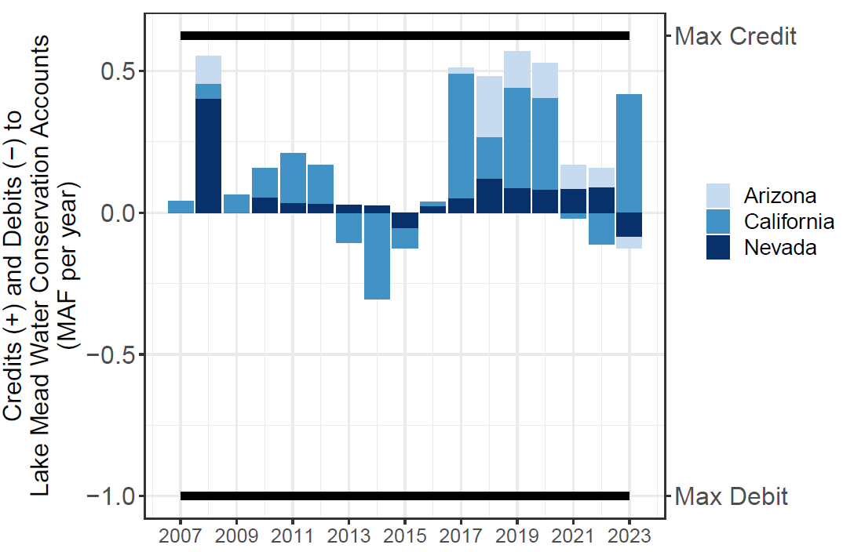  Figure 1. Lake Mead water conservation account annual credits and debits. | 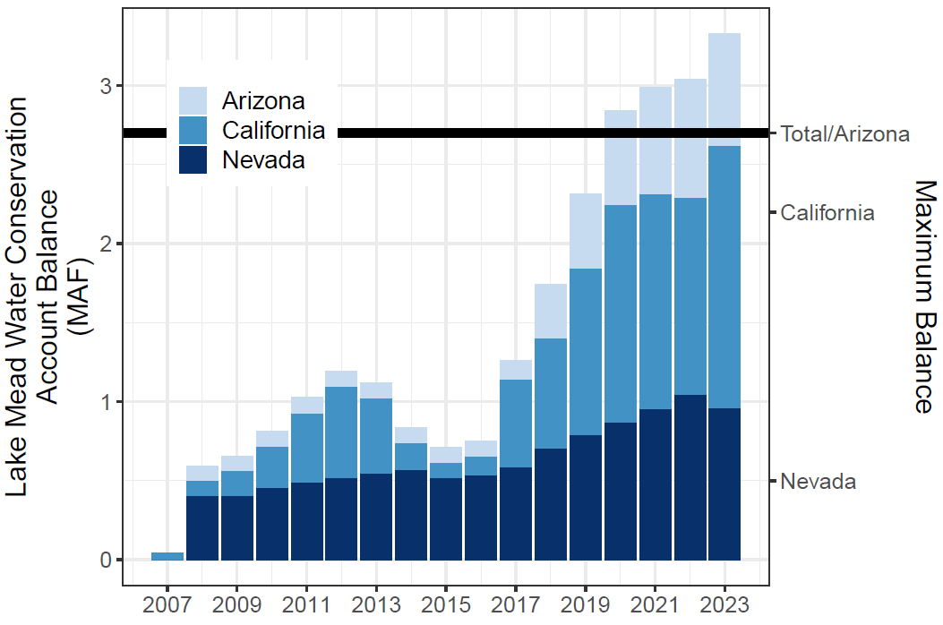  Figure 2. Lake Mead Water Conservation Account Balances.

Successes
- Since 2007, the Lower Basin states have collectively conserved and credited 4.1 million acre-feet of water (Figure 1)!!!
- The Lower Basin states have presently conserved and left in Lake Mead 3.3 million acre-feet of water (Figure 2)!!!!
- Each state has participated at levels above or near 1 million acre-feet (Figure 2).
- For example, Nevada's 2023 water conservation account balance of 955,000 acre-feet is almost 5 times it recent consumptive use of near 200,000 acre-feet per year.
- Program participation has grown in recent years (Figure 2).
- Participation has exceeded the upper limits for credits allowed by the Interim Guidelines (Figure 2). This excess shows the program has grown beyond the expectations of the designers of the program.
- The program has conserved more water than other voluntary, compensated, or mandatory Colorado River Basin water conservation program (Table 3; Allhands, 2021; UCRC, 2018; UCRC, 2024; USBR, 2021a; USBR, 2021b)
Table 3. Colorado River Basin water conservation programs and accomplishments.
- States have more autonomy to set their reservoir withdraws and manage their vulnerability independent of other states activities. This autonomy reduces conflict.
- Since 2022, the Lower Basin States water conservation program efforts kept Lake Mead’s storage above the 5.9 million-acre feet protection volume (elevation 1,020 feet; Figure 3).
- Program participation jettisoned the principle of "use it or lose it" common to the laws that govern water use in many western states, including California, Arizona, and Nevada. Use it or lose it is a disincentive to conserve water because if a contractor uses less than their historical allocation over a number of years, the state can reclaim the allocation and assign the water right to a different user who can put the water to use.

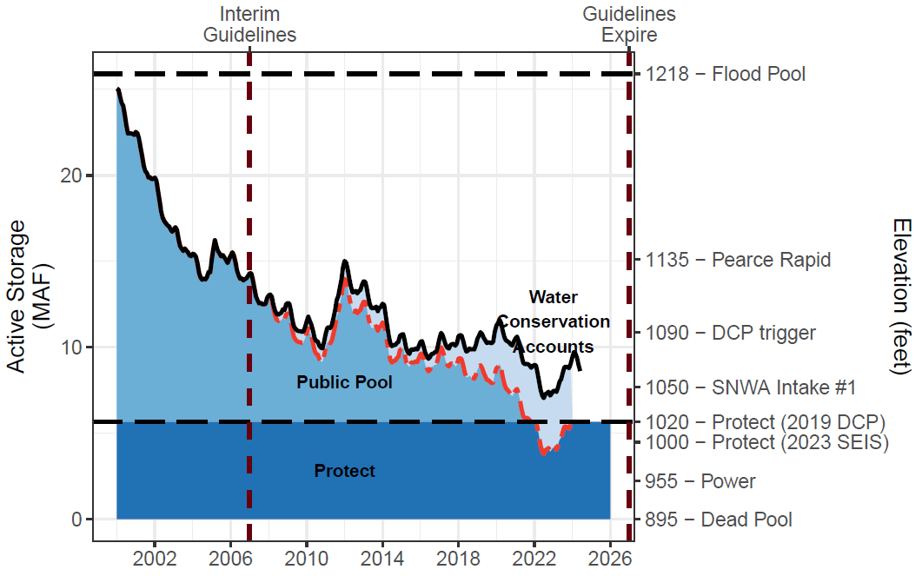
Figure 3. Lake Mead Storage (solid black line), Water Conservation Account Balances (light blue fill), and anticipated lake volume absent the water conservation program (dashed red line). The conservation program kept Lake Mead level above elevation 1020 feet (5.9 million acre-feet) during low lake levels in 2022.

Challenges
There are 3 core challenges to continue the water conservation program:
- Fast reservoir drawdown. States and contractors conserved water with the understanding that they can withdraw that water in the future. With multiple years of debits, Lake Mead can drawdown close to the protection elevation in a few years. Put another way: the Lower Basin states loaned the Colorado River system 3.3 million acre-feet of water. The users will want to call in the loan at some point. Once the users perceive Lake Mead will drawdown close to the protection volume, they may race to debit their water conservation account balances to access their conserved water.

- Motivate additional voluntary water conservation―credits―as reservoir storage draws down to the protection volume because states and contractors face increasing difficulty to access and debit their water conservation account balances. Their prior conserved water becomes a stranded asset. This challenge can also engender several conflicts:

  - Multiple states desire to debit their accounts so that the total debits will drawdown Lake Mead below its protection elevation. The states will need to negotiate lower debits that keep Lake Mead at or above the protection elevation.
  - State A debits their account and decreases Lake Mead storage towards the protection volume. This activity prevents States B and C in future years to debit their accounts.
  - Other states and users take counter measures to increase their ability to access conserved water with the undesired effect to lower Laken Mead storage.

- Stabilize and recover reservoir storage when a key component that defines the water available for release―reservoir inflow―is not included in the design of a water conservation program. Thus, Lake Mead continues to draw down even as states credit their water conservation accounts. This situation has already happened over the past decade! This scenario occurs when Lake Mead inflows minus evaporation are less than historical allocations (Figure 4). Essentially, states got credit for voluntary water conservation activity even though the physical water never entered the reservoir. I estimate that 0.7 million acre-feet of the total 4.1 million acre-feet of program conservation efforts were credited when sufficient water did not flow into Lake Mead (Figure 4).
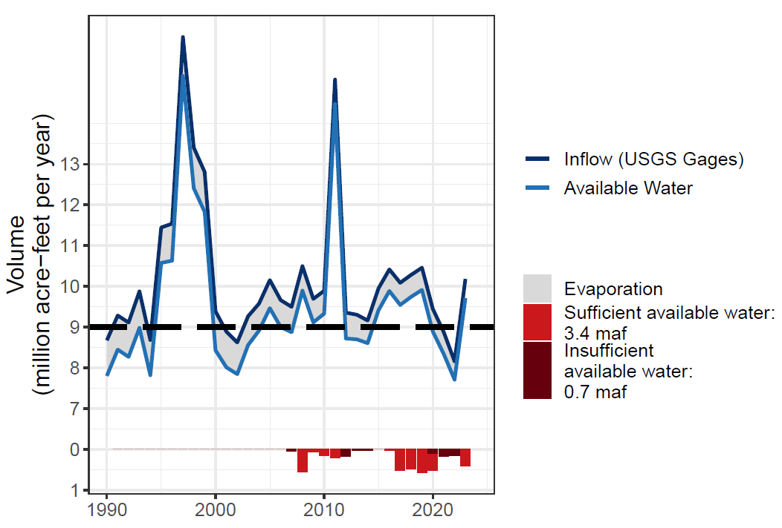
Figure 4. Lake Mead Inflow, Evaporation, Available Water, and Conservation Credits with and without sufficient available water.

Insights to Increase Sustainability and User Autonomy
There are numerous ways to combine the key components―reservoir inflow, evaporation, current storage, trigger to prohibit debits, and protection volume―of a reservoir water conservation program. Thus there are numerous ways to design a voluntary, uncompensated program to help sustain and recover reservoir storage. Here I share insights that engage more components of the water available to release and conserve. These insights increase water user autonomy to more independently manage their climate vulnerability while leverage prior negotiations. More independence and fewer negotiations means less stress for basin partners now and in the future.
- Raise the elevation trigger that prohibits debits to water conservation accounts. This insight can help create a larger buffer against drawdown to the reservoir protection volume and thus to the minimum power pool. This insight can help address challenge #1 by slowing drawdown to the reservoir protection volume. This insight will acerbate challenge #2 by stranding conserved water earlier. This insight will require a new negotiation to set the new trigger elevation. States and contractors may have different views on how high to set the new trigger elevation based on their current water conservation account balances and their actual or perceived need to debit their water conservation accounts.

- Set the Lake Mead storage criteria that require mandatory water conservation to the anticipated Lake Mead storage volume had the voluntary water conservation program not existed. This insight seeks to address Challenges #1 and #5 by requiring larger mandatory conservation earlier and reducing gaming between the voluntary and mandatory water conservation programs. This insight may have unintended consequences to acerbate challenges #1, 2, 3, and 4 and the associated conflicts. For example, when the anticipated Lake Mead storage volume absent voluntary water conservation falls below the reservoir protection volume, states and contractors may face increasing pressure to access their conserved water sooner (debit their account). The desire to access conserved water sooner will speed drawdown of the actual storage to the protection volume.
Box 2. Steps for a Water Accounting Program.
- Set the reservoir protection volume. Reservoir storage will always stay above this amount because account balances must always be positive. Present conversations suggest setting the Lake Mead protection volume between 4.0 and 5.7 million acre-feet of active storage (elevations 1,000 to 1,020 feet).
- Divide the present active storage above the protection volume among the user accounts. One intuitive division is by user's current water conservation account balances (rollover). Allocate additional active storage (public pool in Figure 3) to accounts for Tribal Nations, the Colorado River Delta, and/or other users.
- Estimate the year's available water as Lake Mead inflow minus evaporation. Inflow is the annual Lake Powell release plus 600,000 to 1 million acre-feet of gains along Grand Canyon (Rosenberg, 2022; Wang and Schmidt, 2020; Figure 4). Since 1990, annual Lake Mead inflow varied from 8 to 16 million acre-feet.
- Divide the year's available water among the water accounts. Here, share of available water is the historical allocation minus the user’s agreed on shortage volume (Appendix A).
- New water account balance. Add the share of available water (Step D) to the water account balance (Step B).
- Each user withdraws and conserves within their account balance. Users independently manage their climate vulnerability.
- Subtract the withdraw amount from the water account balance to specify the new account balance at the beginning of the next year.
- Return to Step C for the next year.

- Switch from water conservation accounting to water accounting. Water accounting works on the principle of division of each year's available water―reservoir inflow minus evaporation―rather than divide larger mandatory shortages tied to declining reservoir storage. Lake Mead active storage becomes the protection volume plus the sum of all water user account balances. Users independently withdraw or conserve up to their account balance. Users more autonomously manage their vulnerability independent of others. Water accounts allow users to carry over water to the next year. Users can access all of their prior conserved water at any time in any amount (rollover). The water accounting preserves the protection volume and there is no trigger to prohibit debits because water account balances must always be zero or positive. Water accounting leverages prior shortage sharing agreements, including the recent Lower Basin Alternative (Buschatzke et al., 2024). A user’s share of the available water is their historical allocation minus the agreed-on shortage volume (Appendix A). Program designers can also create accounts for communities excluded from river management such as Tribal Nations and Colorado River Delta. The accounting has 8 steps (Box 2).
The Lake Mead water accounts also preserve flexibility to operate Lake Powell to prevent drawdown to its protection volume, benefit Grand Canyon ecosystems, sustain hydropower generation, and other purposes because there is no longer mandatory water conservation (tied to declining Lake Mead or system storage). Lake Powell releases rather specify when Lake Powell water becomes available to Lake Mead and Lower Basin users.

Conclusions and Next Steps
The Lake Mead water conservation program is the most successful Colorado River basin conservation program to date. Since 2007, Lower Basin users have conserved 4.1 million acre-feet of water with 3.3 million acre-feet presently remaining in Lake Mead. These efforts have kept Lake Mead storage above the protection volume. The program works on the assumption that the annual available water―reservoir inflow minus evaporation―exceeds historical allocations. This assumption is challenged as the Colorado River Basin becomes more arid. There is also a challenge to motivate voluntary water conservation as reservoir storage draws down to the protection volume because states and contractors face increasing difficulty to access and debit their conserved water. How to increase sustainability and user autonomy to manage their conflicting climate vulnerability while leverage prior negotiations and decrease conflict? One insight—switch to water accounting based on reservoir inflow.
We intend to build an online collaborative model to allow basin partners to explore Lake Mead water accounting based on reservoir inflow (Rosenberg, 2024). During a model session, collaborators make extreme assumptions for hydrology, ecosystem responses, and starting reservoir storage. Collaborators then immerse in water user roles. They decide how much water to release and conserve in response to their available water, other’s choices, and real-time discussion of choices. As researchers, we want to learn:
- Why basin partners choose assumptions and how extreme.
- Why and how basin partners manage their risk of uncertain future water supply.
- Which new insights they take from a model session.
We believe these discussions can help inform how to more adaptively manage and reduce conflicting system, user, Tribal, and ecosystem vulnerabilities. Reach out by email to david.rosenberg@usu.edu if you have read this far and want to join a collaborative model session.

Authors
David E. Rosenberg | Utah State University | http://rosenberg.usu.edu | david.rosenberg@usu.edu

Data Availability
The data, models, and code used to generate tables and figures in this manuscript are available for download at https://github.com/dzeke/ColoradoRiverCollaborate/tree/main/LakeMeadWaterConservationProgramAnalysis.

Appendix A. Estimate Shares of Annual Lake Mead Available Water.
This appendix estimates Mexico’s and each Lower Basin state’s share of the annual Lake Mead available water – annual reservoir inflow minus evaporation. A user’s share of the annual available water is their historical allocation minus the prior agreed-on water shortage volume (Buschatzke et al., 2024; Table A1).
Table A1. Prior agreed Lower Basin shortages and shares of shortages (Buschatzke et al., 2024).

Table A2. Share of available water as volume and as percentage.
Calculations of available water as volume and percentage (Table A2) are:
- Total Available Water [B] = 9.0 ─ Total Shortage [A].
  - For example, a total shortage of 0.4 maf yields an available water of 9.0 ─ 0.4 = 8.6 maf.

- Share of Available Water:
  - Arizona [C] = 2.8 ─ Share of Shortage as Volume in Table A1.
    - For example, at 8.6 maf of available water, Arizona’s share is 2.8 ─ 0.28 = 2.52 maf.
  - Nevada [D] = 0.3 ─ Share of Shortage as Volume in Table A1.
    - For example, at 8.0 maf of available water, Nevada’s share is 0. 3 ─ 0.03 = 0.27 maf.
  - California [E] = 4.4 ─ Share of Shortage as Volume in Table A1.
    - For example, at 7.5 maf of available water, California’s share is 4.4 ─ 0.44 = 3.96 maf.
  - Mexico [F] = 1.5 ─ Share of Shortage as Volume in Table A1.
    - For example, at 7.5 maf of available water, Mexico’s share is 1.5 ─ 0.25 = 1.25 maf.

- Total Available Water [G] = [C] + [D] + [E] + [F]

- A user’s Percent of Available Water is their share by volume divided by the total volume.

  - Arizona [H] = [C] / [G]
  - Nevada [I] = [D] / [G]
  - And so forth.

- Total Percentage of Available Water [L] = [H] + [I] + [J] + [K] = 100%.
Observations
- Nevada and Mexico’s percent shares of the total available water remain constant at 3.3% and 16.67%, respectively. These percentage shares are the same share of their historical allocations.
- Arizona’s percentage share of the available water decreases as the total available water decreases whereas California’s share of the available water increases.

References
Allaire, M., and Acquah, S. (2022). "Disparities in drinking water compliance: Implications for incorporating equity into regulatory practices." AWWA Water Science, 4(2), e1274. https://doi.org/10.1002/aws2.1274.
Allhands, J. (2021). "It could take at least 500,000 acre-feet of water a year to keep Lake Mead from tanking." Arizona Republic, November 8, 2021. https://www.azcentral.com/story/opinion/op-ed/joannaallhands/2021/11/08/lake-mead-could-get-extra-water-from-lower-basin-annually/6306601001/.
Buschatzke, T., Hamby, J. B., and Entsminger, J. (2024). "Lower Basin Alternative for the Post-2026 Coordinated Operation of the Colorado River Basin." https://www.snwa.com/assets/pdf/lower-basin-alternative-letter-march2024.pdf [Accessed on: August 14, 2024].
CAP. (2022). "ICS – Three little letters that signify big contributions and new flexibility." Central Arizona Project, https://knowyourwaternews.com/ics-three-little-letters-that-signify-big-contributions-and-new-flexibility/ [Accessed on: August 13, 2024].
Grant, D. L. (2007). "Collaborative Solutions to Colorado River Water Shortages: The Basin States' Proposal and Beyond." Nevada Law Journal, 8, 964
https://heinonline.org/HOL/Page?handle=hein.journals/nevlj8&id=980&collection=journals&index=.
Hecht, J. S., Vogel, R. M., McManamay, R. A., Kroll, C. N., and Reed, J. M. (2020). "Decision Trees for Incorporating Hypothesis Tests of Hydrologic Alteration into Hydropower&#x2013;Ecosystem Tradeoffs." Journal of Water Resources Planning and Management, 146(5), 04020017. https://doi.org/10.1061/(ASCE)WR.1943-5452.0001184.
Hegwood, M., Langendorf, R. E., and Burgess, M. G. (2022). "Why win–wins are rare in complex environmental management." Nature Sustainability. https://doi.org/10.1038/s41893-022-00866-z.
IBWC. (2021). "Minutes between the United States and Mexican Sections of the IBWC." United States Section, https://www.ibwc.gov/Treaties_Minutes/Minutes.html [Accessed on: July 22, 2021].
Jasechko, S., and Perrone, D. (2021). "Global groundwater wells at risk of running dry." Science, 372(6540), 418-421. https://doi.org/10.1126/science.abc2755.
Kuhn, E., and Fleck, J. (2019). Science Be Dammed: How Ignoring Inconvenient Science Drained the Colorado River, University of Arizona Press.
Meehan, K., Jepson, W., Harris, L. M., Wutich, A., Beresford, M., Fencl, A., London, J., Pierce, G., Radonic, L., Wells, C., Wilson, N. J., Adams, E. A., Arsenault, R., Brewis, A., Harrington, V., Lambrinidou, Y., McGregor, D., Patrick, R., Pauli, B., Pearson, A. L., Shah, S., Splichalova, D., Workman, C., and Young, S. (2020). "Exposing the myths of household water insecurity in the global north: A critical review." WIREs Water, 7(6), e1486. https://doi.org/10.1002/wat2.1486.
Pace, C., Fencl, A., Baehner, L., Lukacs, H., Cushing, L. J., and Morello-Frosch, R. (2022). "The Drinking Water Tool: A Community-Driven Data Visualization Tool for Policy Implementation." International Journal of Environmental Research and Public Health, 19(3), 1419. https://www.mdpi.com/1660-4601/19/3/1419.
Rosenberg, D. E. (2022). "Adapt Lake Mead Releases to Inflow to Give Managers More Flexibility to Slow Reservoir Drawdown." Journal of Water Resources Planning and Management, 148(10), 02522006. https://doi.org/10.1061/(ASCE)WR.1943-5452.0001592.
Rosenberg, D. E. (2024). "Lessons from immersive online collaborative modeling to discuss more adaptive reservoir operations." Journal of Water Resources Planning and Management, 150(7). https://doi.org/10.1061/JWRMD5.WRENG-5893.
Stelter, D. (2022). "Towards a Utah Intentionally Created Surplus Program." Sustainable Development Law and Policy, 22(2), 4-21. https://heinonline.org/HOL/Page?collection=journals&handle=hein.journals/sdlp22&id=44&men_tab=srchresults.
Thomas, K., Hardy, R. D., Lazrus, H., Mendez, M., Orlove, B., Rivera-Collazo, I., Roberts, J. T., Rockman, M., Warner, B. P., and Winthrop, R. (2019). "Explaining differential vulnerability to climate change: A social science review." WIREs Climate Change, 10(2), e565. https://doi.org/10.1002/wcc.565.
UCRC. (2018). "Colorado River System Conservation Pilot Program in the Upper Colorado River Basin." Upper Colorado River Commission. http://www.ucrcommission.com/RepDoc/SCPPDocuments/2018__SCPP_FUBRD.pdf.
UCRC. (2024). "Colorado River System Conservation Pilot Program in the Upper Colorado River Basin." Upper Colorado River Commission. http://www.ucrcommission.com/wp-content/uploads/2024/06/2023_SCPP_Report_June2024.pdf.
USBR. (2007). "Record of Decision: Colorado River Interim Guidelines for Lower Basin Shortages and Coordinated Operations for Lakes Powell and Mead." U.S. Bureau of Reclamation. https://www.usbr.gov/lc/region/programs/strategies/RecordofDecision.pdf.
USBR. (2019). "Agreement Concerning Colorado River Drought Contingency Management and Operations." U.S. Bureau of Reclamation, Washington, DC. https://www.usbr.gov/dcp/finaldocs.html.
USBR. (2021a). "Boulder Canyon Operations Office - Program and Activities: Water Accounting Reports." U.S. Bureau of Reclamation. https://www.usbr.gov/lc/region/g4000/wtracct.html.
USBR. (2021b). "Pilot System Conservation Program." U.S. Bureau of Reclamation, https://www.usbr.gov/lc/region/programs/PilotSysConsProg/pilotsystem.html [Accessed on: October 14, 2021].
Wakhungu, M. J., Abdel-Mottaleb, N., Wells, E. C., and Zhang, Q. (2021). "Geospatial Vulnerability Framework for Identifying Water Infrastructure Inequalities." Journal of Environmental Engineering, 147(9), 04021034. https://doi.org/10.1061/(ASCE)EE.1943-7870.0001903.
Wang, J., and Schmidt, J. C. (2020). "Stream flow and Losses of the Colorado River in the Southern Colorado Plateau." Center for Colorado River Studies, Utah State University, Logan, Utah. https://qcnr.usu.edu/coloradoriver/files/WhitePaper5.pdf.

Available water - The volume of water available for withdraw. Available water is reservoir active storage plus annual inflow minus evaporation. Between 1990 and 2023, reservoir inflow has varied from 8 to 16 million acre-feet per year. The volume also depends on the method used to estimate. This work uses the largest inflow estimate which is the sum of gaged flow (Wang and Schmidt). Reservoir evaporation - the volume of water that transfers from the liquid state to gas state over the same period of time. Reservoir evaporation is difficult to measure or forecast because the volume is influenced by the reservoir surface area, air temperature, wind, surface water temperature, inflow volume, inflow temperature, reservoir mixing, and other chaotic climate variables. In 2018, Reclamation reported Lake Mead Evapiration for 2010 to 2015. In 2023, Reclamation reported Lake Mead evporation for 2016 to 2020. The reported values varied from. GGG to HHH million acre-feet per year.

