Why communicating minimum drawdown elevations for Lake Powell and Lake Mead can mitigate risks of volatile Colorado River flow.

June 25, 2026
Brittany Fager, David Rosenberg, Erik Porse
(brittany.fager@usu.edu, david.rosenberg@usu.edu)

Abstract – At historically low reservoir levels, volatile river flow poses risk that water managers cannot respond fast enough with the consequence that Lake Powell and Lake Mead drawdown so they no longer fulfill their Congressionally legislated purposes: deliver water, generate hydropower, protect native fish, or sustain infrastructure. In this paper we suggest five reservoir operational strategies to reduce all those risks: (1) Identify Catastrophic Elevations where we lose the ability to operate reservoirs for one or more legislated purposes, (2) Communicate Minimum Drawdown Elevations as storage buffers to mitigate catastrophic risks, (3) Release less than reservoir inflow and evaporation, and continue those releases to intentionally build storage above minimum drawdown elevations, (4) Increase the frequency of release decisions, such as to monthly, weekly or daily, to respond sooner to volatile flow, (5) Move to shorter operating plans to allow experimentation, monitoring, and updating in these new conditions of low reservoir storage and inflow. Water held in reservoirs between their minimum drawdown and catastrophic elevations generates continuing benefits for hydropower, native fish, infrastructure, and capacity to deliver water, whereas if released, buffer water can only be consumed once by downstream users. Larger buffer volumes further reduce risks. More frequent release decisions also give earlier, smaller, and smoother adjustments, and also allow users to better plan how to mitigate their own risks. These operating strategies where shared with the U.S. Bureau of Reclamation as public input in Spring 2026. The strategies appear as key principles and operations for Lake Powell and Lake Mead that start in 2027.

Introduction
Across the Western U.S., reservoirs are at historically low elevations. Volatile river flow poses risk that water managers cannot respond fast enough with the consequence that reservoirs further drawdown so they no longer fulfill their purposes, such as to deliver water, generate hydropower, protect native fish, or sustain infrastructure. We as a nation are challenged to communicate and develop reservoir operational strategies that mitigate risk of imminent, catastrophic failure.
State-of the-art water systems models communicate risk by evaluating alternatives and quantifying tradeoffs across hundreds to thousands of scenarios for future hydrology forecast out decades (Bonham et al., 2022; Bonham et al., 2024; Quinn et al., 2017; Salehabadi et al., 2024; Smith et al., 2022; Sunkara et al., 2026). These efforts searched for operations that performed well across a range of wet to dry conditions. Others suggested to filter the large number of future scenarios based on hydrologic features (e.g., 60-year rolling average of flow are less than historical values, number of decadal drought years exceed historical numbers) and impacts at local to basin scales (e.g., individual user, water district, total deliveries to Lake Powell, and/or reservoir elevations) using different metrics, such as mean shortage exceeds 10% of demand, more that 50% of users are shorted, 10-year rolling sum deliveries fall below the 10th percentile of historical observations, and/or percent of months Lake Powell is below a critical elevation (Hadjimichael et al., 2024; USBR, 2026b; USBR, 2026c). In the above works, the optimal policies and results depended on the scenarios chosen to include in the analysis and metrics used; they may still lead to catastrophic system failure (Bonham et al., 2024; USBR, 2026b).

The scenario generation methods correctly characterized flow uncertainty as futures that can only be described as possible or plausible without weights. Yet the communication and management of risks and consequences is still probabilistic (e.g., mean, standard deviation, percent, percentiles). This framing encourages multiple forms of faulty decision making, including that high consequence events are dismissed because they are seen to have a low probability of occurrence (Hammond et al., 1998). Additionally, the communication of technical information may not lead to behavior change because of institutional constraints, social values, assumptions, local experience, lack of tangible warning signals, missing stakeholder engagement, or no overarching policy environment to implement recommendations (Horne et al., 2016; Langsdale et al., 2013; Owusu et al., 2022; Rosenberg, 2024; Simis et al., 2016; Voinov et al., 2016).

In China, the government is encouraging the development of reservoir drought limited water levels. Researchers have approached the problem by identifying optimal schedules to drawdown mega reservoirs such as Three Gorges (31.9 million acre-feet), Danjiangkou (23.6 maf), and Bai-He-Tan (16.7 maf) exactly to their dead pools at the end of the drought season (Cheng et al., 2025; Li et al., 2025; Li et al., 2024; Lin et al., 2023; Wan et al., 2025). These optimal schemes showed improvements in hydropower generation, water deliveries, and drought resistance compared to the purely academic standard linear operating policy. However, they fit their solutions to characteristic wet and dry hydrology from the historical record and assumed inflow recovered immediately after the drought season.

Conceptually, the drought-limited water level is a form of hedging wherein reservoir operators cutback lower priority users by small amounts over the period of reservoir decline with the goal to avoid large cutbacks to higher and lower priority users when reservoirs near critical elevations (Cid et al., 2023; Draper and Lund, 2004; Harding, 2024; Wan et al., 2025). Hedging can also increase opportunities to adaptively respond to changing conditions (Garcia et al., 2020). Yet at current low reservoir storages, there may no longer be opportunities to hedge.

Within the Colorado River Basin, Lake Powell and Lake Mead (active storage capacities of 23.7 and 25.9 maf) have been in decline for 25 years. They are—as of September, 2026—1.4 and 4.6 maf above the elevations where they can no longer generate and deliver energy to 9 (Figures 1 and 2). Numerous researchers have called for reductions in consumption to match the declining and volatile supply (Baker et al., 2022; Bonacci et al., 2026; Kroepsch et al., 2025; Salehabadi et al., 2024; Udall and Overpeck, 2017; Wang et al., 2025; Wheeler et al., 2022). The basin water users—Utah, Wyoming, Colorado, New Mexico, California, Arizona, Nevada, 20 Tribal Nations, and the Republic of Mexico—have yet to reach consensus on how to share the large, looming shortages, a lose-lose-lose game. Over the past 4 years, the U.S. Bureau of Reclamation (USBR), which manages both reservoirs, oversaw a process with multiple opportunities for public input to determine new operations for Lake Powell and Lake Mead beginning in October of 2026 (USBR, 2026b; USBR, 2026c). Everyone agreed that the historic operations were insufficient in this new era of lower reservoir storage and low flow.

It was unclear how low the USBR would let Powell and Mead drawdown. For Powell, elevations ranged from slightly above elevation 3,370 feet where Glen Canyon Dam cannot pass any water downstream to 3,525 feet defined in the 2019 Drought Contingency Plan—a difference of almost 5.5 million acre-feet (Figure 1; USBR, 2019). Stopping releases would quickly drawdown Lake Mead, thus preventing water deliveries to California, Arizona, Tribal Nations of the Lower Basin, and the Republic of Mexico, For Mead, the elevations ranged from slightly above dead pool at elevation 895 feet to 1,020 feet defined in the 2019 Drought Contingency Plan—a difference of almost 5.7 million-acre-feet (Figure 2; USBR, 2019).

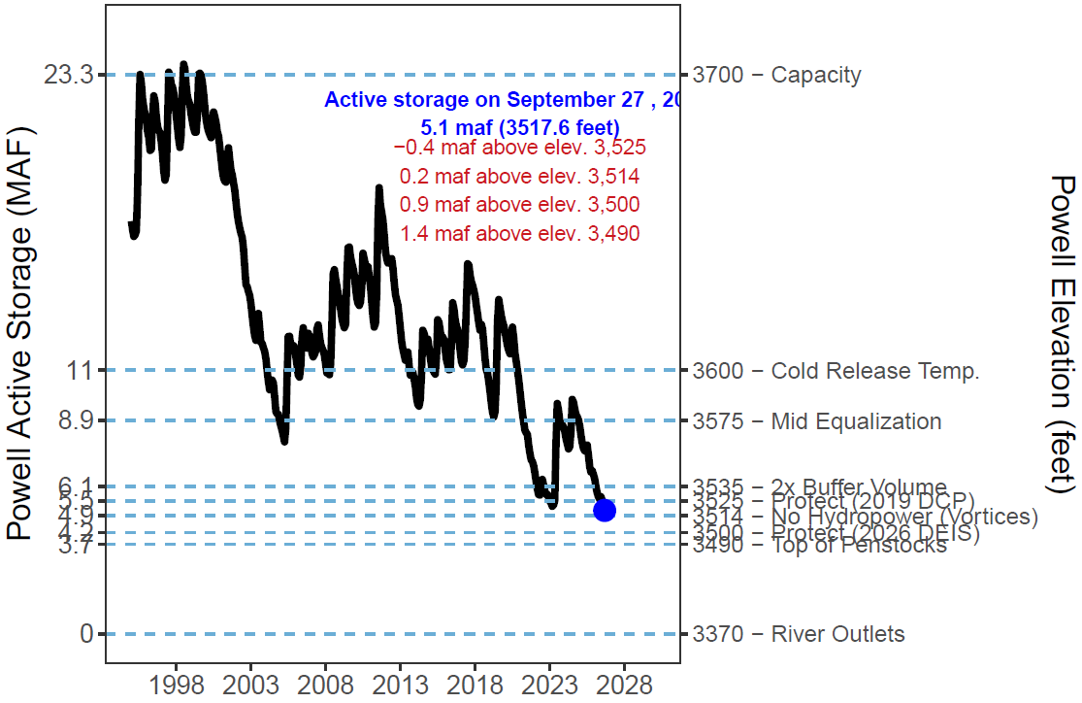
Figure 1. Lake Powell storage over time in relation to critical elevations

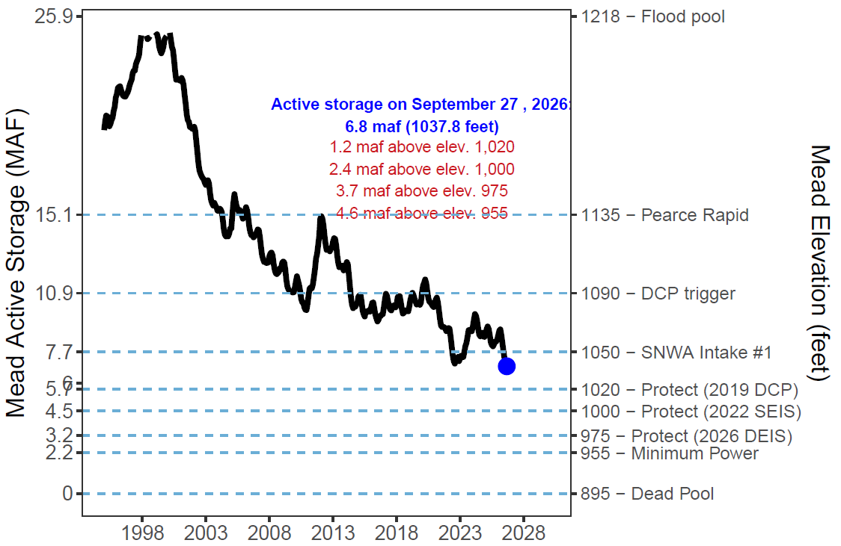
Figure 2. Lake Mead storage over time in relation to critical elevations.
The consequences of reservoir drawdown are potentially catastrophic. Below a Lake Powell elevation of 3,390 feet, it is no longer possible to move water through the Glen Canyon Dam. This stoppage will soon drawdown Lake Mead to levels where it can no longer pass water through Hoover Dam, threatening deliveries to California, Arizona, and Tribal Nations of the Lower Basin as well as U.S. treaty obligations to the Republic of Mexico. The international effects of failing to meet treaty obligations are unknow. Below elevation 3,490 feet, the only way to pass water through Glen Canyon Dam is via the river outlets, which will require operations outside their design specifications (LaFond, 2024). Below 3,490 feet, we also lose the ability to generate and deliver energy to 7 U.S. states from Nebraska to Nevada. Powell also loses redundancy to pass water through the dam. At elevation 3,514 feet, there is risk of cavitation to the penstocks (Prairie, 2026). And starting near 3,525 feet, warm-water invasive fish, such as Small Mouth Bass, start passing through the dam (Friesen et al., 2026). Increasing release temperatures associated with lower lake levels also pose risk that the invasives will spawn, grow, and spread, threatening the expatriation or extinction of endangered native fish in Grand Canyon such as Humpback Chub and Colorado River Pikeminnow (Bruckerhoff et al., 2025; Eppehimer et al., 2025; Pavičević et al., 2025). Other researchers suggested that effects are uncertain because large sediment inputs through Grand Canyon raise turbidity and limit Smallmouth Bass foraging, efficiency, growth, and overwinter survival (Pine et al., 2025).

Rising temperatures, higher precipitation variability, less snowfall, more precipitation falling as rain, earlier melt, and higher evapotranspiration are making it increasingly difficult to forecast future Colorado River supply at seasonal or longer time horizons (Baker et al., 2022; Bass et al., 2023; Gall, 2025; Towler et al., 2022). Operationally, this means it is no longer appropriate to communicate future risk by drawing on flow probabilities, variability, or persistence derived from the historical record. Additionally, Lake Powell and Lake Mead levels can change rapidly with a slight change in streamflow (Wang et al., 2025).

In this paper, we share 6 strategies to communicate and reduce risk of catastrophic system failure that address some of the above identified gaps. The strategies are:

- Communicate risk as agreement across all scenario-generation methods on the magnitude of year-to-year decrease in flow.
- Identify catastrophic elevations where we lose the ability to operate the reservoirs for one or more legislated purposes.
- Communicate Minimum Drawdown Elevations as storage buffers to mitigate catastrophic risks.
- Release less than reservoir inflow and evaporation, such as 95% of inflow, and continue those releases to intentionally build storage above minimum drawdown elevations.
- Increase the frequency of release decisions, such as to monthly, weekly or daily, to respond sooner to volatile flow.
- Move to shorter operating plans to allow experimentation, monitoring, and updating in these new conditions of low reservoir storage and inflow.
The next section further describes each strategy, including supporting data and examples. Section 3 identifies benefits for all users when we identify catastrophic elevations and communicate minimum drawdown elevations. Section 4 discusses our work in the context of prior work. We also contributed our work as public input to the post-2026 process (Fager et al., 2026a; Fager et al., 2026b). Strategies #2 to #6 appear as key principles and operations in the Final Environmental Impact Statement and 2027-2028 operating plan for Powell and Mead (USBR, 2026a; USBR, 2026c). Section 5 concludes.

Strategies to Reduce Risk
In support of planning for post 2026, Reclamation developed 22 different methods to generate scenarios of future river flow. These flows are annual natural flow to Lake Powell. [[[[ ]]]]
There is consensus across all the 22 hydrologic ensembles that Reclamation is using to assess new operations for Lake Powell and Lake Mead that volatile Colorado River flow will continue (Salehabadi et al., 2024; Smith et al., 2022; USBR, 2026b). Volatile flows include annual drops of 6 million acre-feet (maf) of natural flow above Lake Powell (Figure 1). Reclamation’s ensembles include paleo‑drought resampled, climate‑informed, drying with variability, and 19 other methods to generate future flows. In Figure 1, we only include declines where the first year flow starts at or below the recent mean flow (≤ 12.5 maf). For example, a year 1 annual natural flow of 11 maf followed by a 6 maf decline would give a year 2 natural flow of 5 maf (11 – 6 = 5 maf). The 12.5 maf break point recognizes that declines from larger flows may not drawdown reservoirs to catastrophic levels and thus do not present imminent risk. Here we share 4 reservoir operational strategies to reduce risks that volatile flow will drawdown Lake Powell and Lake Mead to levels where they cannot deliver water, generate hydropower, protect native fish or infrastructure.
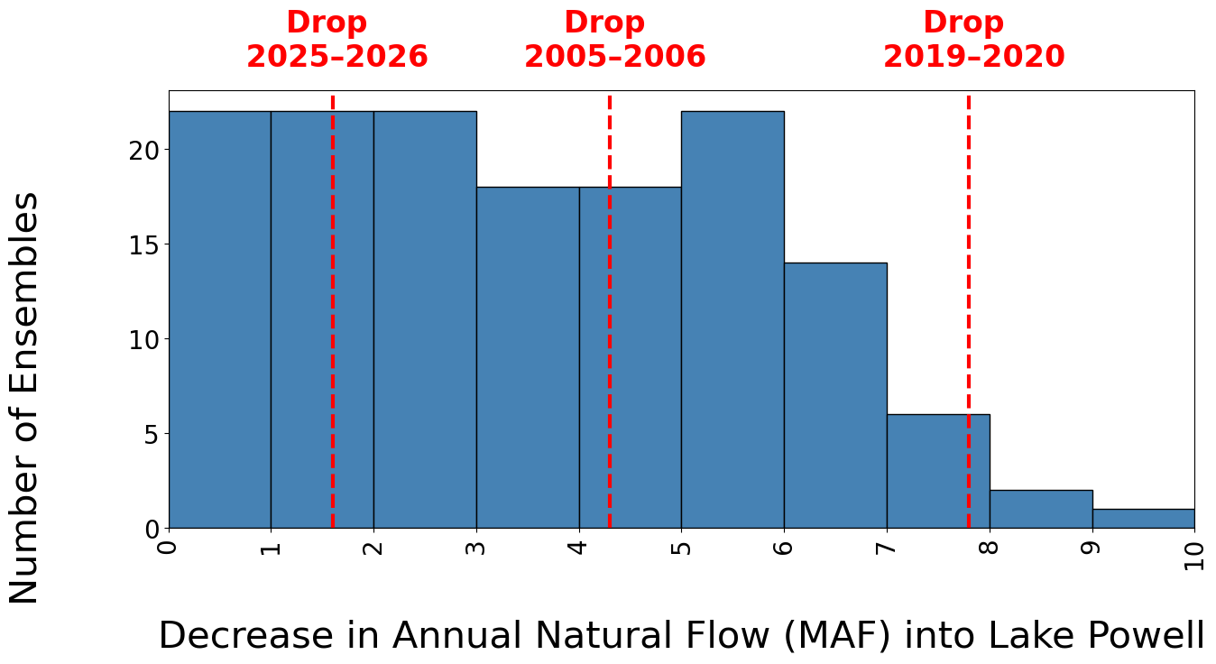
Figure 1. Consensus across Reclamation’s 22 hydrologic ensembles that volatile Colorado River flow will continue, including annual drops of 6 maf. Dashed red lines show 3 drops over the past 25 years.

Strategy 1: Identify Catastrophic Reservoir Elevations
A catastrophe elevation is where the reservoir system loses the ability to perform one or more of its Congressionally mandated purposes: deliver water, generate hydropower, protect native fish, or sustain infrastructure (Figure 2). Below this elevation, operators can still move some water. However, they must wait for larger reservoir inflows to rebuild storage and resume operations for all system purposes. Recently, Reclamation stated a Lake Powell elevation of 3,514 feet (4.9 maf active storage) as the elevation where vortices prevent releases through the penstocks and the river outlets at 3,370 feet (0 maf active storage; dead pool) become the only way to pass water through Glen Canyon Dam (Prairie, 2026). Lake Powell’s catastrophic elevation could be higher, such as at 3,525 feet, where temperatures from mixing penstock and river outlet releases are still warmer than 15.5ºC and allow invasive fish to pass through the dam, spawn, grow, and spread (Eppehimer et al., 2025). For Lake Mead, a possible catastrophic elevation is 955 feet where Hoover Dam can no longer generate hydropower (2.2 maf active storage). Identifying catastrophic elevations makes explicit where reservoir operators lose the ability to meet one or multiple Congressional legislated purpose(s).
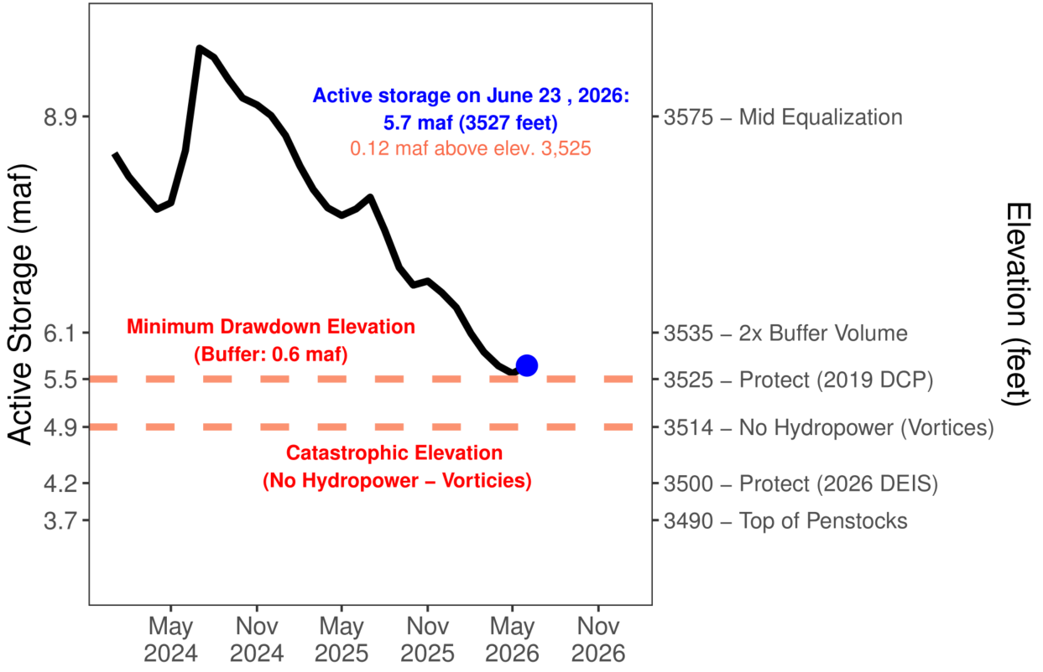
Figure 2. Recent Lake Powell storage (black) with example minimum drawdown and catastrophic elevations (red dashed). There is a buffer volume of 0.6 maf between the two elevations to mitigate risk of volatile flow.

Strategy 2: Communicate Minimum Drawdown Elevations
Table 1. Time to react with a buffer volume of 0.6 maf and annual decrease in flow of 2 maf.
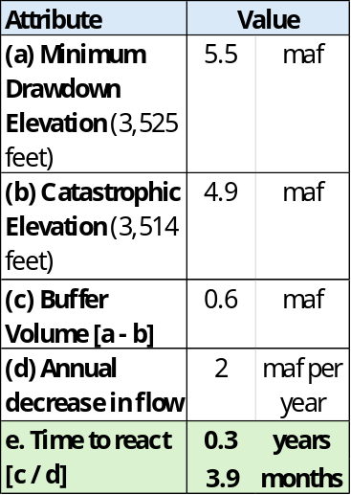
Communicating a minimum reservoir drawdown elevation provides a buffer to reduce risk of drawdown to catastrophic levels (Figure 2). The buffer volume divided by the annual decrease in flow identifies the time reservoir operators have to prevent drawdown to catastrophic elevations. A larger buffer volume and smaller decrease in annual inflow give more time to adapt; a smaller buffer volume and more volatile inflow give less time. For example, communicating a minimum drawdown elevation for Lake Powell of 3,525 feet as defined in the 2019 Drought Contingency Plan (5.5 maf active storage)(USBR, 2019) provides a buffer of 0.6 maf against catastrophic loss of hydropower generation at 3,514 feet (5.5 - 4.9 = 0.6 maf). Dividing the buffer volume of 0.6 maf by a 2 maf annual decrease in reservoir inflow gives operators 0.3 of a year or just under 4 months to react (Table 1). If the annual decrease in reservoir inflow is 4 maf, the time to react decreases by half to 2 months. Communicating a minimum drawdown elevation of 3,535 feet (6.1 maf active storage) doubles the buffer volume to 1.2 maf. There is conflicting information for a minimum drawdown elevation for Lake Mead. Elevations range from 975 to 1,020 feet (USBR, 2019; USBR, 2026b). These elevations imply Lake Mead buffer volumes of 1.0 to 3.5 maf above elevation 955 feet where Hoover Dam can no longer generate hydropower.

Strategy 3. Sustain Minimum Drawdown Elevations
Sustaining Lake Powell or Lake Mead above their minimum drawdown elevations requires setting reservoir releases below reservoir inflow and evaporation (e.g., 95%) and then continuing those releases until storage recovers to an off-ramp elevation higher than the minimum drawdown elevation (Fager et al., 2026a). This operation improves on run-of-river operation in 2 ways: (i) Start at minimum drawdown elevations rather than dead pool, and (ii) build storage above the minimum drawdown elevation. There is still risk—operators must specify reservoir releases before reservoir inflow is known. If a reservoir release turns out to be greater than actual inflow, the reservoir will drawdown into its buffer storage. On June 23, 2026, Lake Powell’s elevation was 3,527.0 feet—120,000 acre-feet above a possible minimum drawdown elevation of 3,525 feet (Figure 2). To sustain elevation 3,525 feet, we need to start releasing less than reservoir inflow and evaporation soon.

Step 4. Increase the Frequency of Release Decisions
Presently, Lake Powell releases are set once each fall when uncertainty in annual inflow is highest. The release is possibly adjusted once in spring when there is more certainty in runoff. With a Lake Powell buffer volume of 0.6 maf and 2 maf annual drop in reservoir inflow, an annual or semi-annual decision frequency offers only one opportunity in Fall to set the release to prevent drawdown to the catastrophic elevation. Switching to monthly decisions offers 4 opportunities to adjust reservoir releases to prevent drawdown to catastrophic elevations. Weekly decisions offer 16 opportunities. Daily decisions offer 117 opportunities. Exploratory modeling of Lake Powell rules to sustain a minimum drawdown elevation of 3,525 feet in the face of volatile paleo-conditioned hydrology shows a semi-annual decision frequency is too slow—Lake Powell falls multiple times below both 3,514 feet where vortices start in the penstocks and the top of the penstock intakes at 3,490 feet (Figure 3). A monthly decision frequency sustains Lake Powell above both elevations for the entire simulation period. More frequent operational decisions also allow earlier, smaller, and smoother adjustments. Ten-year Lake Powell release volumes for the two decision frequencies differ by less than 150,000 acre-feet. The differences suggest more frequent decisions have small impacts on downstream users. Increased decision frequency also narrows forecast error, making it easier to keep releases below inflow.
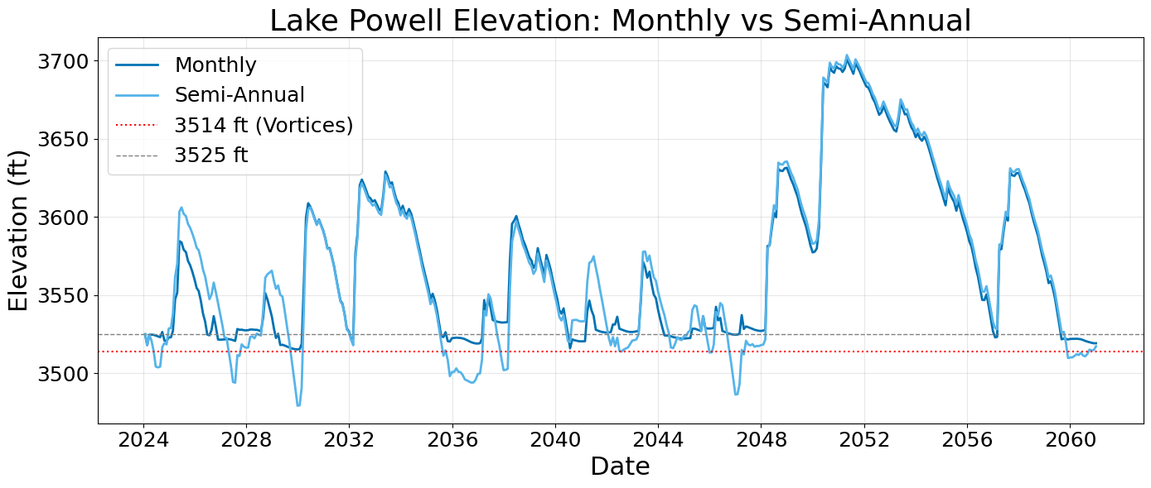
Figure 3. Simulated Lake Powell elevations with a minimum drawdown elevation of 3,525 feet (dashed black) and volatile paleo-conditioned hydrology. A semi-annual decision frequency (light blue) is too slow—Lake Powell falls multiple times below the top of the penstock intakes at 3,490 feet and 3,514 feet where vortices start in the penstocks (dotted red). A monthly decision frequency (dark blue) sustains Lake Powell above both elevations for the entire simulation period. Between 2048 and 2057, high inflows pose little risk for either decision frequency.

Multiple Wins
Water held in Lake Powell and Lake Mead between their minimum drawdown and catastrophic elevations generates continuing benefits for hydropower, native fish, infrastructure, and water delivery capacity, whereas if released, buffer water can only be consumed 1 time by downstream users. More specifically:
- Hydropower: The buffer volume reduces the risk of drawdown to elevations where operators cannot release water through dam penstocks to generate hydropower. Larger buffer volumes increase operating head between the reservoir water surface and tailwater. Higher head generates more energy for the same volume of release.
- Ecosystem: Larger buffer volumes raise reservoir surface elevations. Higher elevations reduce risk of entraining invasive fish in dam outlets. Higher elevations also lower release temperatures. Lower temperatures reduce the risk of invasive fish to spawn, grow, and spread downstream. Higher elevations also reduce the need to mix warmer water from the penstocks with cooler water from lower outlets that do not generate hydropower.
- Downstream water users: Larger buffer volumes reduce risk to lose capacity to deliver water downstream to California, Arizona, Nevada, Mexico, Tribal Nations, and the Colorado River delta. More frequent release decisions give users earlier information, smaller adjustments, and smoother transitions.
- Upstream water users: The buffer volume reduces the need to make emergency releases from upstream reservoirs to prop up Lake Powell and Lake Mead.
- Infrastructure: Minimum drawdown elevations reduce the risk of operating reservoirs beyond their original design capabilities. Minimum drawdown elevations also retain redundancy to deliver water via outlets at different elevations.

Conclusions
Volatile Colorado River flow will continue. Communicating minimum drawdown elevations for Lake Powell and Lake Mead provide storage buffers to mitigate risks that volatile flow will drawdown reservoirs to catastrophic elevations where they cannot fulfill their Congressionally legislated purposes to deliver water, generate hydropower, protect native fish, and sustain infrastructure. If we can communicate and sustain minimum drawdown elevations, everyone can better see how much—or how little—they can draw on reservoir storage and thus better plan how to mitigate their own risk of water shortages. Larger buffer volumes and more frequent decisions further reduce everyone’s risk. Reclamation is authorized to formulate and implement operations so reservoirs continue to serve their Congressionally legislated purposes. We do not propose minimum drawdown elevations or decision frequencies. Rather, we see need to communicate reservoir operations to maintain public trust that the Colorado River system will not collapse.

Data Availability
Data, models, and code to generate Figures 1 and 3 are available at (Fager, 2026). Data and code to generate Figure 2 and Table 1 are available at (Rosenberg, 2026).

Requested Citation
Brittany Fager, David Rosenberg, Erik Porse (2026). Why communicating minimum drawdown elevations for Lake Powell and Lake Mead can mitigate risks of volatile Colorado River flow. Utah State University Digital Commons. https://doi.org/10.15142/h11w-a657.

References
Baker, S. A., Wood, A. W., Rajagopalan, B., Prairie, J., Jerla, C., Zagona, E., Butler, R. A., and Smith, R. (2022). "The Colorado River Basin Operational Prediction Testbed: A Framework for Evaluating Streamflow Forecasts and Reservoir Operations." Journal of the American Water Resources Association, 58(5), 690-708. https://doi.org/10.1111/1752-1688.13038.
Bass, B., Goldenson, N., Rahimi, S., and Hall, A. (2023). "Aridification of Colorado River Basin's Snowpack Regions Has Driven Water Losses Despite Ameliorating Effects of Vegetation." Water Resources Research, 59(7). https://doi.org/10.1029/2022WR033454.
Bonacci, O., Žaknić-Ćatović, A., and Roje-Bonacci, T. (2026). "Analysis of Annual Water Level Variability in the Mead and Powell Reservoirs of the Colorado River." Water, 18(2), 224. https://doi.org/10.3390/w18020224.
Bonham, N., Kasprzyk, J., and Zagona, E. (2022). "Post-MORDM: Mapping policies to synthesize optimization and robustness results for decision-maker compromise." Environmental Modelling & Software, 157, 105491. https://doi.org/10.1016/j.envsoft.2022.105491.
Bonham, N., Kasprzyk, J., Zagona, E., and Smith, R. (2024). "Interactive and Multimetric Robustness Tradeoffs in the Colorado River Basin." Journal of Water Resources Planning and Management, 150(3). https://doi.org/10.1061/JWRMD5.WRENG-6199.
Bruckerhoff, L. A., Yackulick, C. B., Eppehimer, D. E., Bestgen, K. R., Jones, M. T., and Michaud, C. (2025). "Estimating drivers and identifying uncertainties in smallmouth bass population dynamics in an invaded river network." Journal of Fisheries and Aquatic Sciences. https://datadryad.org/dataset/doi:10.5061/dryad.76hdr7t5z.
Cheng, Y., Yan, Z., Yan, D., Liu, M., and Wei, R. (2025). "Determination and Application of a New Drought Resistant Control Water Level for Multi-Reservoir Systems Based on a Water Resource Allocation Model." Water Resources Management, 39(13), 7227-7241. 10.1007/s11269-025-04294-4.
Cid, D. A. C., Filho, F. d. A. d. S., and Porto, V. C. (2023). "Collaborative Modeling to Construct a Hedging Policy for Drought Management in Reservoir Systems." Journal of Water Resources Planning and Management, 149(1), 05022012. https://doi.org/10.1061/(ASCE)WR.1943-5452.0001632.
Draper, A. J., and Lund, J. R. (2004). "Optimal Hedging and Carryover Storage Value." Journal of Water Resources Planning and Management, 130(1), 83-87. https://doi.org/10.1061/(ASCE)0733-9496(2004)130:1(83).
Eppehimer, D. E., Yackulic, C. B., Bruckerhoff, L. A., Wang, J., Young, K. L., Bestgen, K. R., Mihalevich, B. A., and Schmidt, J. C. (2025). "Declining reservoir elevations following a two-decade drought increase water temperatures and non-native fish passage facilitating a downstream invasion." Canadian Journal of Fisheries and Aquatic Sciences, 82, 1-19. https://doi.org/10.1139/cjfas-2024-0187.
Fager, B. (2026). "Lake Powell Inflow Comparisons: Volatility and Decision Frequency." Github, Utah State Unviersity. https://github.com/BrittanyFager/LakePowellInflow/tree/main.
Fager, B., Myers, A., Porse, E., and Rosenberg, D. (2026a). "How a 2 to 5-Year Experimental Lake Powell and Lake Mead Release Program Tied to Reservoir Inflows can be a Win for Adaptive Risk Management." Utah Water Research Lab, Utah State University. https://doi.org/10.26077/749c-2bd9.
Fager, B., Rosenberg, D., and Porse, E. (2026b). "Why communicating minimum drawdown elevations for Lake Powell and Lake Mead can mitigate risks of volatile Colorado River flow." Utah State University Digital Commons. https://doi.org/10.15142/h11w-a657.
Friesen, B., Pennock, C. A., and Budy, P. (2026). "Invasion potential of nonnative fishes through a large western dam into an iconic and vulnerable ecosystem." Hydrobiologia, 853(11), 3249-3268. 10.1007/s10750-026-06137-8.
Gall, M. (2025). "Not Enough Water: Drought Emergencies in the American Southwest." U.S. Emergency Management in the 21st Century: From Disaster to Catastrophe, Second Edition, 143-162. https://doi.org/10.4324/9781003591900-13.
Garcia, M., Ridolfi, E., and Di Baldassarre, G. (2020). "The interplay between reservoir storage and operating rules under evolving conditions." Journal of Hydrology, 590. https://doi.org/10.1016/j.jhydrol.2020.125270.
Hadjimichael, A., Reed, P. M., Quinn, J. D., Vernon, C. R., and Thurber, T. (2024). "Scenario Storyline Discovery for Planning in Multi-Actor Human-Natural Systems Confronting Change." Earth's Future, 12(9). https://doi.org/10.1029/2023EF004252.
Hammond, J. S., Keeney, R. L., and Raiffa, H. (1998). "The hidden traps in decision making." Harvard Business Review, 76(5). https://hbr.org/1998/09/the-hidden-traps-in-decision-making-2.
Harding, B. L. (2024). "Reservoir Memory Complicates Water Management in the Upper Colorado River Basin." ESS Open Archive, 2024(0715). https://doi.org/10.22541/essoar.172108198.83331203/v1.
Horne, A., Szemis, J. M., Kaur, S., Webb, J. A., Stewardson, M. J., Costa, A., and Boland, N. (2016). "Optimization tools for environmental water decisions: A review of strengths, weaknesses, and opportunities to improve adoption." Environmental Modelling & Software, 84, 326-338. https://doi.org/10.1016/j.envsoft.2016.06.028.
Kroepsch, A. C., Andrews, E., Upadhyay, S., and Marshall, A. (2025). "Let's Talk About Dead Pool: How We Discuss the Shallows of Reservoirs." Water Resources Research, 61(10), e2025WR041330. https://doi.org/10.1029/2025WR041330.
LaFond, R. (2024). "Technical Decision Memorandum: Establishment of Interim Operating Guidance for Glen Canyon Dam during Low Reservoir Levels at Lake Powell." Reclamation. https://www.usbr.gov/uc/DocLibrary/Memos/20240326-EstablishmentInterimOperatingGuidanceGlenCanyonDamLowReservoirLevels-TechnicalDecisionMemo-508-TSC.pdf.
Langsdale, S., Beall, A., Bourget, E., Hagen, E., Kudlas, S., Palmer, R., Tate, D., and Werick, W. (2013). "Collaborative Modeling for Decision Support in Water Resources: Principles and Best Practices." Journal of the American Water Resources Association, 49(3), 629-638. https://doi.org/10.1111/jawr.12065.
Li, S., Xia, J., Zhou, Y., Xu, C. Y., and Chang, F. J. (2025). "Multi-objective optimization of seasonal emergency storage in cascade reservoirs for enhanced drought resilience and hydropower synergy." Journal of Water and Climate Change, 16(10), 3046-3066. 10.2166/wcc.2025.816.
Li, S., Zhu, D., Lin, F., Xia, J., Zhou, Y., Chang, F.-J., and Xu, C.-Y. (2024). "Unlocking synergies of drawdown operation: Multi-objective optimization of reservoir emergency storage capacity." Journal of Environmental Management, 368, 122148. https://doi.org/10.1016/j.jenvman.2024.122148.
Lin, F., Zhou, Y., Ning, Z., Xiong, L., and Chen, H. (2023). "Exploring a novel reservoir drawdown operation framework for boosting synergies of hydropower generation and drought defense." Sustainable Energy Technologies and Assessments, 60, 103562. https://doi.org/10.1016/j.seta.2023.103562.
Owusu, A., Mul, M., Zaag, P. v. d., and Slinger, J. (2022). "May the Odds Be in Your Favor: Why Many Attempts to Reoperate Dams for the Environment Stall." Journal of Water Resources Planning and Management, 148(5), 04022009. https://doi.org/10.1061/(ASCE)WR.1943-5452.0001521.
Pavičević, M., Ploussard, Q., Veselka, T., Usis, M., Henriquez, W. A., and Wilhite, J. (2025). "Hydropower and environmental flow management: System-level trade-offs at Glen Canyon Dam." Journal of Hydrology: Regional Studies, 61. https://doi.org/10.1016/j.ejrh.2025.102624.
Pine, W. E., Korman, J., Valdez, R. A., and Walters, C. J. (2025). "Assessing the potential for Smallmouth Bass population establishment in Grand Canyon." Transactions of the American Fisheries Society, 154(5), 469-489. https://doi.org/10.1093/tafafs/vnaf027.
Prairie, J. (2026). "Colorado River Basin: Western Water Forecast Concerns and Research Priorities." CIROH Developers Conference, Salt Lake City, Utah. https://ciroh.ua.edu/wp-content/uploads/2026/06/2026CIROH_052726_prairie.pdf.
Quinn, J. D., Reed, P. M., and Keller, K. (2017). "Direct policy search for robust multi-objective management of deeply uncertain socio-ecological tipping points." Environmental Modelling & Software, 92, 125-141. https://doi.org/10.1016/j.envsoft.2017.02.017.
Rosenberg, D. E. (2024). "Lessons from immersive online collaborative modeling to discuss more adaptive reservoir operations." Journal of Water Resources Planning and Management, 150(7). https://doi.org/10.1061/JWRMD5.WRENG-5893.
Rosenberg, D. E. (2026). "Minimum Drawdown Elevations for Lake Powell." Github, Utah State Unviersity, Logan, Utah. https://github.com/dzeke/ColoradoRiverCollaborate/tree/main/MinimumDrawdownElevations.
Salehabadi, H., Tarboton, D. G., Wheeler, K. G., Smith, R., and Baker, S. (2024). "Quantifying and Classifying Streamflow Ensembles Using a Broad Range of Metrics for an Evidence-Based Analysis: Colorado River Case Study." Water Resources Research, 60(7), e2024WR037225. https://doi.org/10.1029/2024WR037225.
Simis, M. J., Madden, H., Cacciatore, M. A., and Yeo, S. K. (2016). "The lure of rationality: Why does the deficit model persist in science communication?" Public Understanding of Science, 25(4), 400-414. 10.1177/0963662516629749.
Smith, R., Zagona, E., Kasprzyk, J., Bonham, N., Alexander, E., Butler, A., Prairie, J., and Jerla, C. (2022). "Decision Science Can Help Address the Challenges of Long-Term Planning in the Colorado River Basin." JAWRA Journal of the American Water Resources Association, 58(5), 735-745. https://doi.org/10.1111/1752-1688.12985.
Sunkara, S. V., Gold, D., and Reed, P. (2026). "Unraveling the Drivers of Water Shortage Across Spatial Scales and Sectors in Colorado's West Slope River Basins." Earth's Future, 14(7). https://doi.org/10.1029/2026EF008137.
Towler, E., Woodson, D., Baker, S., Ge, M., Prairie, J., Rajagopalan, B., Shanahan, S., and Smith, R. (2022). "Incorporating Mid-Term Temperature Predictions into Streamflow Forecasts and Operational Reservoir Projections in the Colorado River Basin." Journal of Water Resources Planning and Management, 148(4), 04022007. 10.1061/(ASCE)WR.1943-5452.0001534.
Udall, B., and Overpeck, J. (2017). "The twenty‐first century Colorado River hot drought and implications for the future." Water Resources Research, 53(3), 2404-2418. https://doi.org/10.1002/2016WR019638.
USBR. (2019). "Agreement Concerning Colorado River Drought Contingency Management and Operations." U.S. Bureau of Reclamation, Washington, DC. https://www.usbr.gov/ColoradoRiverBasin/dcp/index.html.
USBR. (2026a). "Operating Guidelines Colorado River Guidelines for Coordinated Operations of Lake Powell and Lake Mead Operating Years 2027 and 2028." U.S. Bureau of Reclamation. https://www.usbr.gov/ColoradoRiverBasin/post2026/decision-doc/2027-2028OperatingGuidelines_Final.pdf.
USBR. (2026b). "Post-2026 Operational Guidelines and Strategies for Lake Powell and Lake Mead – Draft Environmental Impact Statement." U.S. Bureau of Reclamation. https://www.usbr.gov/ColoradoRiverBasin/post2026/draft-eis/.
USBR. (2026c). "Post-2026 Operational Guidelines and Strategies for Lake Powell and Lake Mead – Final Environmental Impact Statement." U.S. Bureau of Reclamation. https://www.usbr.gov/ColoradoRiverBasin/post2026/final-eis/index.html.
Voinov, A., Kolagani, N., McCall, M. K., Glynn, P. D., Kragt, M. E., Ostermann, F. O., Pierce, S. A., and Ramu, P. (2016). "Modelling with stakeholders – Next generation." Environmental Modelling & Software, 77, 196-220. http://dx.doi.org/10.1016/j.envsoft.2015.11.016.
Wan, W., Wang, Z., Cheng, L., Bai, Y., Wang, W., and Wang, K. (2025). "Integrating Drought Warning Water Level With Analytical Hedging for Reservoir Water Supply Operation." Water Resources Research, 61(8). https://doi.org/10.1029/2024WR038680.
Wang, B., Bass, B., Hall, A., Rahimi, S., and Huang, L. (2025). "Disentangling climate and policy uncertainties for the Colorado River post-2026 operations." Nature Communications, 16(1), 8625. https://doi.org/10.1038/s41467-025-63635-4.
Wheeler, K. G., Udall, B., Wang, J., Kuhn, E., Salehabadi, H., and Schmidt, J. C. (2022). "What will it take to stabilize the Colorado River?" Science, 377(6604). http://doi.org/10.1126/science.abo4452.

