**AI in Daily Life**

**Name:** Sivani Immidi  
**Date:** 07/12/2024

**1. Application 1**

**Name:** ChatGPT

**Description:** ChatGPT is a conversational AI that assists with answering questions, providing information, and generating text based on user prompts.

**AI Type:** Natural Language Processing (NLP)

**AI Functionality:** It processes and understands human language to provide coherent and contextually relevant responses.

**Visuals (Optional):**

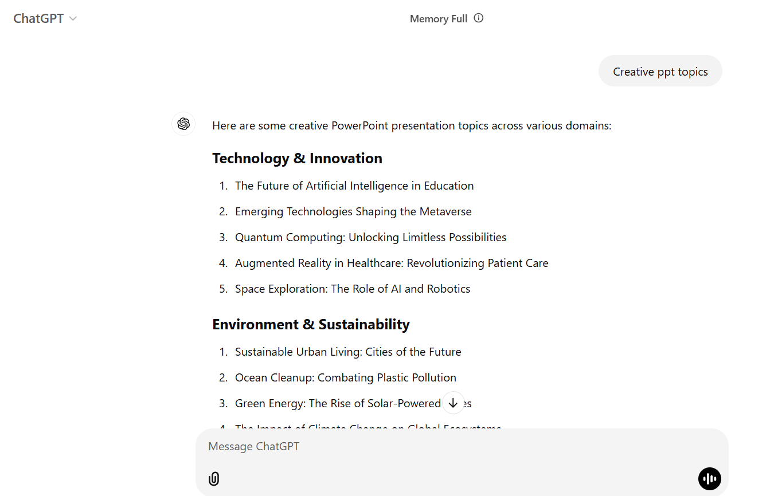

**2. Application 2**

**Name:** Smart Watch

**Description:** A smart watch equipped with AI for health monitoring, notifications, and personal assistance.

**AI Type:** Machine Learning and Sensor Integration

**AI Functionality:** It tracks health metrics like heart rate and sleep patterns, predicts activity trends, and provides personalized recommendations.

**Visuals (Optional):** [Insert a photo of a smart watch]

**3. Application 3**

**Name:** Netflix

**Description:** Netflix uses AI to recommend movies and TV shows based on individual viewing preferences.

**AI Type:** Machine Learning for Recommendation Systems

**AI Functionality:** It analyzes user behavior, ratings, and preferences to suggest tailored content.

**Visuals(Optional):**

