**PROJECT DOCUMENTATION**

**HOW THE PROJECT WAS BORN**

The idea of ​​the development of the project "DrHouseImmobiliare" was born during the course of internship carried out in the 4th grade. During this year in fact, the 4th IB students followed the “Erasmus + - E.C.T. (European City Tour) ", which set itself the goal of designing the European city of the future by the new European generations. Several European schools joined this project, each with a specific field of action:

* Germany (Berlin) 🡪 The migration problem in Europe
* France (Pons - Bordeaux) 🡪 Modeling of the European city
* Hungary (Budapest)🡪 The European architectural problem
* Denmark (Copenhagen) 🡪 Environmental sustainability
* Italy (Bergamo) 🡪 The problem of an aging European population

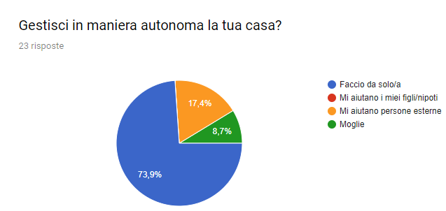The students Ranica and Salvi, authors of the project, took part in the experience in its various aspects, in fact they participated in the cultural exchange in Berlin and took care of the preparation of the Bergamo meeting. To prepare for the meeting in Italy, in fact, a careful statistical survey on the orobic elderly was necessary: ​​on their habits and on their difficulties. In particular, analyzing the data collected shows that the elderly interviewed reside mainly in the city (56.5%) to follow hinterland and province (both at 21.7%), and have an average age of about 70 years. Most of the interviewees live with their spouse (60.9%), followed by those who live alone (21.7%) and finally by those who live with children and grandchildren (17.4%).For the majority of the interviewees, the home where they live is right for their needs (82.6%) even though 17.4% of the elderly who consider their home unsuitable should not be overlooked. Another interesting figure relates to the autonomy of the people who live alone, in fact 73.9% of the respondents autonomously manage their homes, against 26.1 that is helped by external (of these, 66.67% help from third parties while only 33.33% help from their children).

Autonomy is therefore the key word for the elderly. Autonomy in the most common sense, that is, understood as the ability to not depend on others for transport, health care and household chores. DrHouseImmobiliare is born from the growth of this desire, in particular from wanting to give an answer to the needs of the elderly resident population, especially in the choice of the property that will have to be a real home for them.

**USER MANUAL**

Once you have specified how much related to the birth of the project, here is a brief guide that explains what to do in the various situations in which a user can be found.

1. *ACCESS AND REGISTRATION*

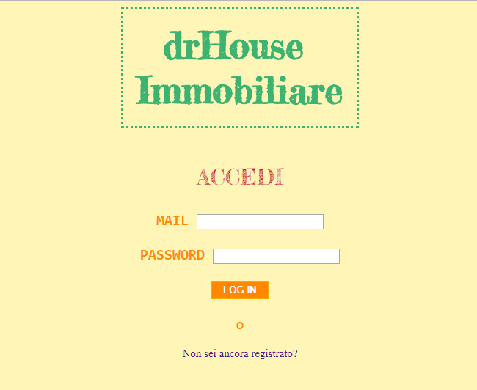The first interface we encounter when visiting the site is as shown on the side. In this case, if we are already registered as a user, all we have to do is enter our credentials, otherwise we have to register following what is required of us on the registration form.

1. *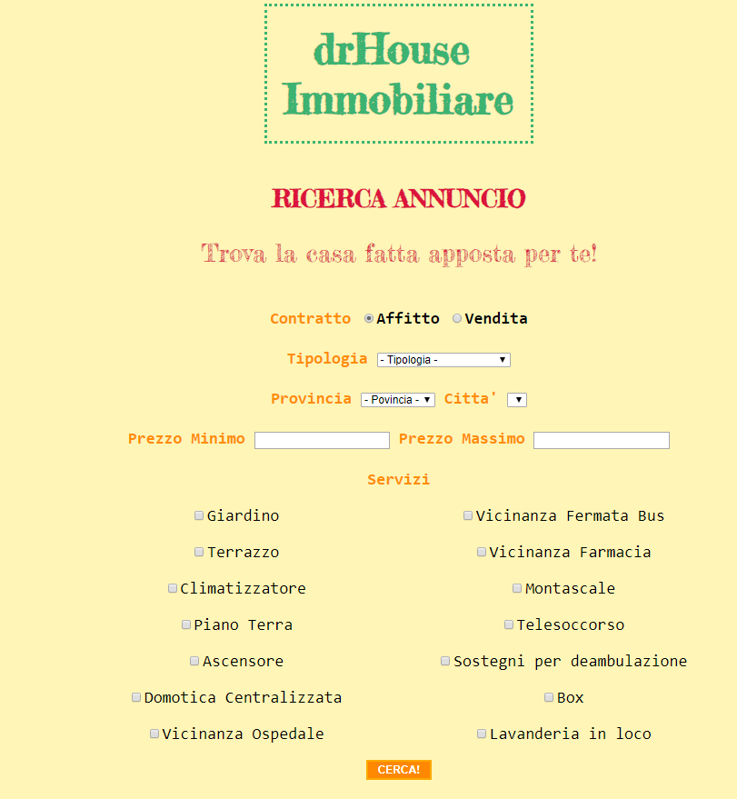SEARCH FOR HOUSE*

Once logged in, the user will find himself in front of a menu with different items. If the user wants to search for a property then he will have to select the first item on the menu that reads "Do you want to search for a house?". After this selection the user finds a menu where he is asked what type of contract he is looking for and the parameters through which to filter the house. Some of these filters are mandatory, such as the type, province and municipality where the house is to be searched. The remaining filters are optional and can be evaluated based on the needs of the 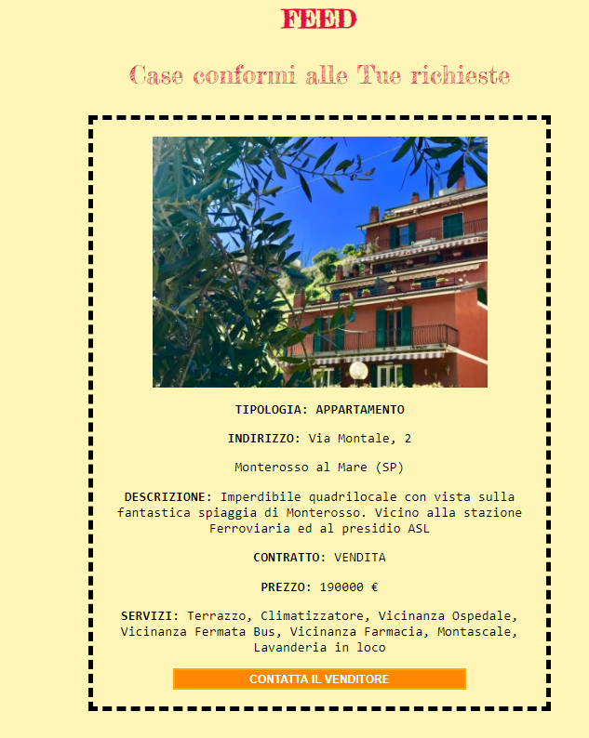applicant. If the search does not produce any result then the absence of real estate is displayed based on the required parameters but, if on the contrary, an apartment is detected that is compatible with the searches carried out, then this is displayed with all the relative characteristics. If the property emerged from the research satisfies the user, then he can contact the owner of the property through the specific form. The owner can be contacted to discuss any inspection or price. It should be emphasized once again that DrHouse Immobiliare DOES NOT take care of the payment of the property.

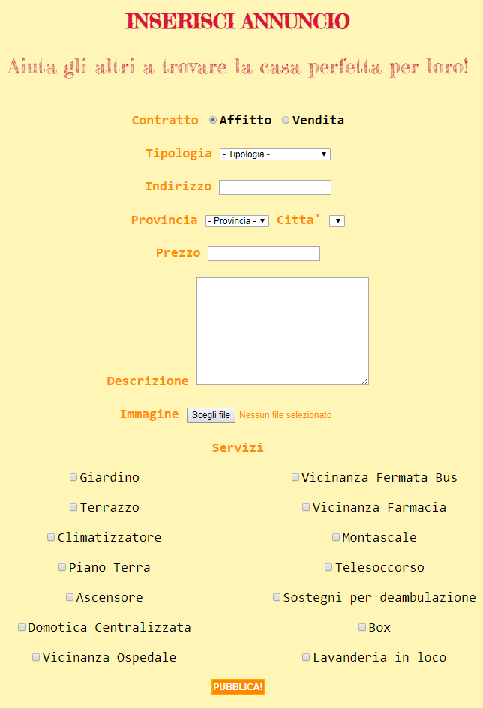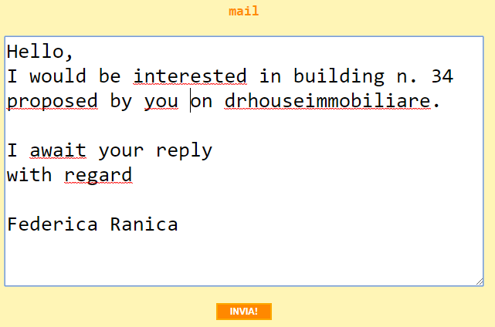

1. *INSERTION OF THE PROPERTY*

If, on the other hand, a user wants to insert his own ad for a property, he must click on the menu item "Do you want to insert an advertisement?". Once this is done, a menu like the one on the side will appear. At this point the user must specify ALL the required fields except for photos and the price (being aware that this will arouse suspicion among potential buyers).

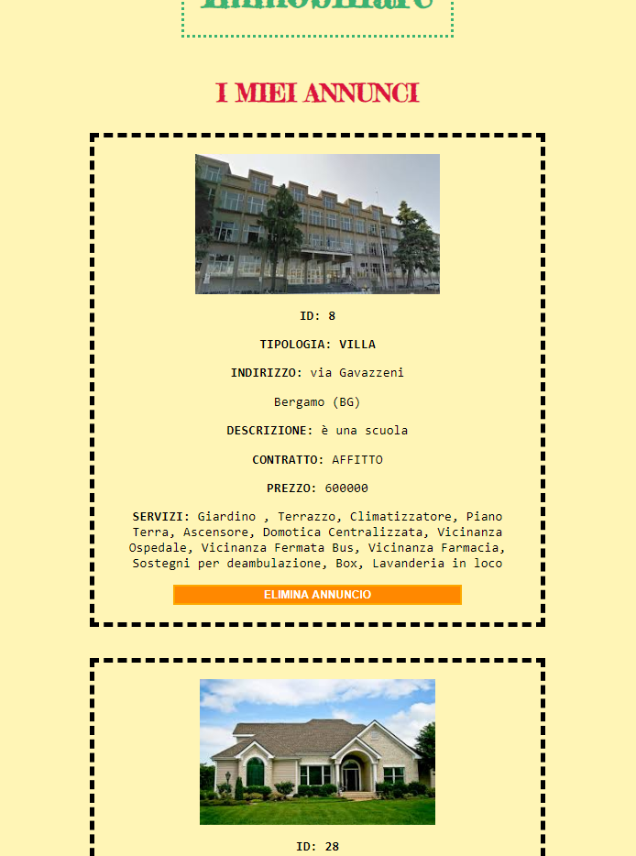From the main menu it is also possible to consult the list of properties published by that customer.

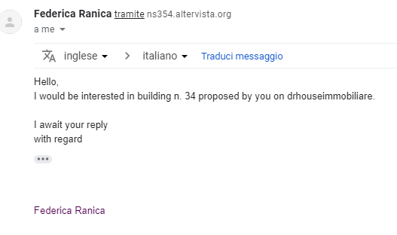When a buyer decides to contact the seller for clarification regarding a property, immediately you receive an email to which you can respond with all the clarifications of the case.

*4. MODIFICATION OF REGISTRATION DATA*

It is possible for a customer to change the data entered at the time of registration. To do this, simply click on the edit data item in the main menu and then change the only data you want to update

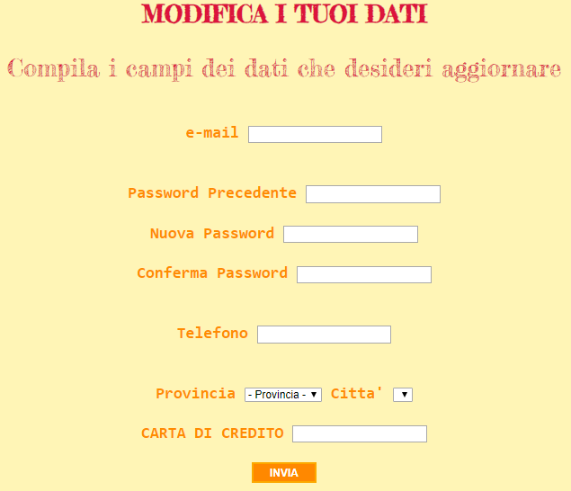

**FINALLY YOU REMEMBER ALL THE CUSTOMERS THE IMPORTANCE OF DISCONNECTION ONCE IT HAS BEEN COMPLETED BY USING THE LOG OUT BUTTON.**