import matplotlib.pyplot as plt

* Plot a function
  + Some x and y value
  + Function maps x and y value
* Give x values to a y value functions
  + Take both of these arrays and pass it to matplot lib to plot graph

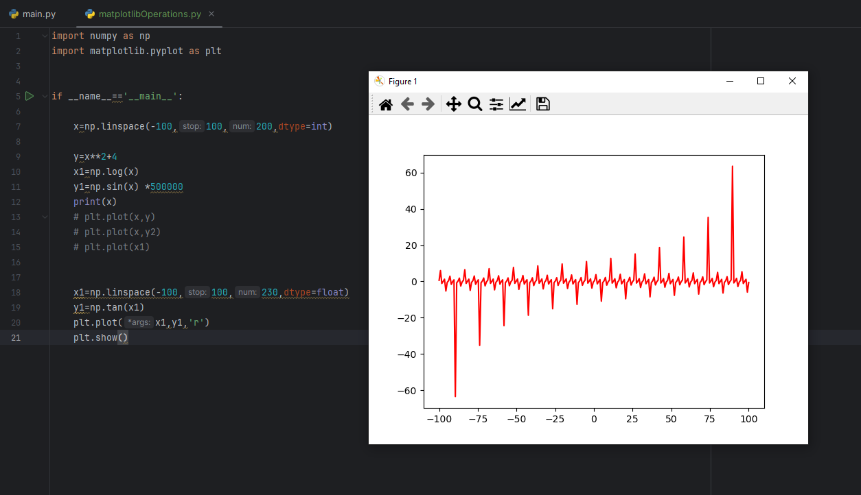

* Subplot
  + Multiple graphs in one window

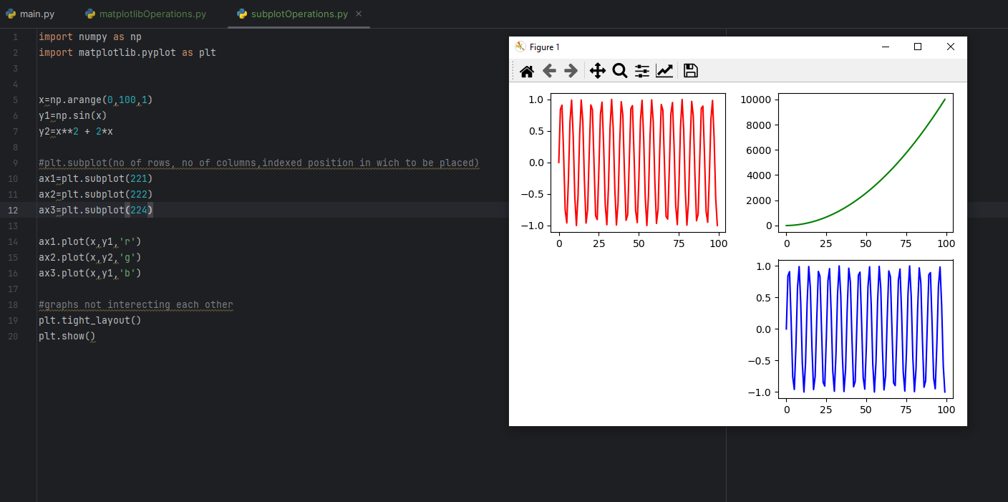

* Multiple figures and different graphs

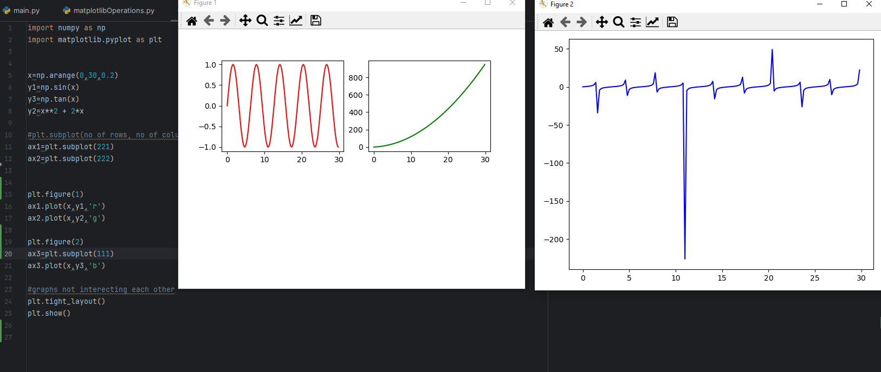

* Design - we can use different designs for graphs
  + style.use('dark_background')
  + <https://matplotlib.org/stable/gallery/style_sheets/style_sheets_reference.html> - doc
  + Plt.grid(True) - to add grid is some styles don’t have it
  + Plt.title()
  + Plt.xlabel()
  + Plt.ylabel()
  + Plt.plot(x1,y1,label='sin',color='r')
  + Plt.legend(loc='upper left')
    - Used to label the lines/plot

