Documentation

Jianyang Zhang 1477617

Map construction is a web application built on ASP.NET Core MVC, Entity Framework Core, ASP.NET Core Identity, React and Sql Server Database.

As an alternative way to run the application from Visual Studio 2015, you can choose to open the public URL for this website directly from browser: http://dochyper.unitec.ac.nz/zhangj188/asp_application1

# Screen Designs

* General Layout

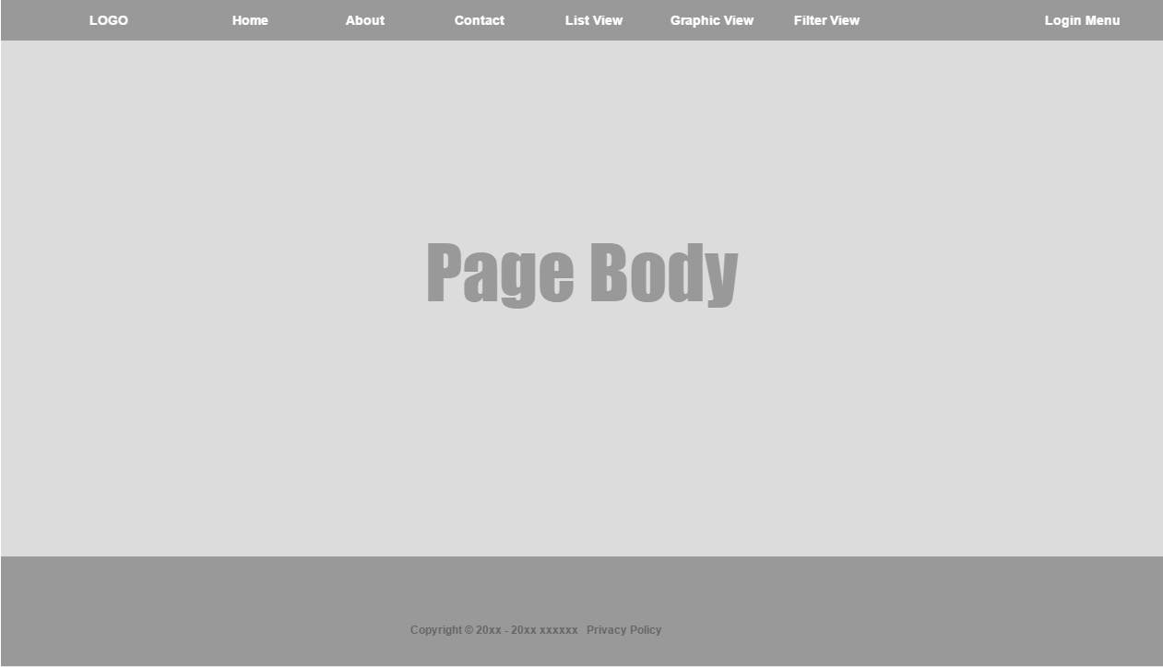

* Home Page
  + Carousel
  + Start Buttons

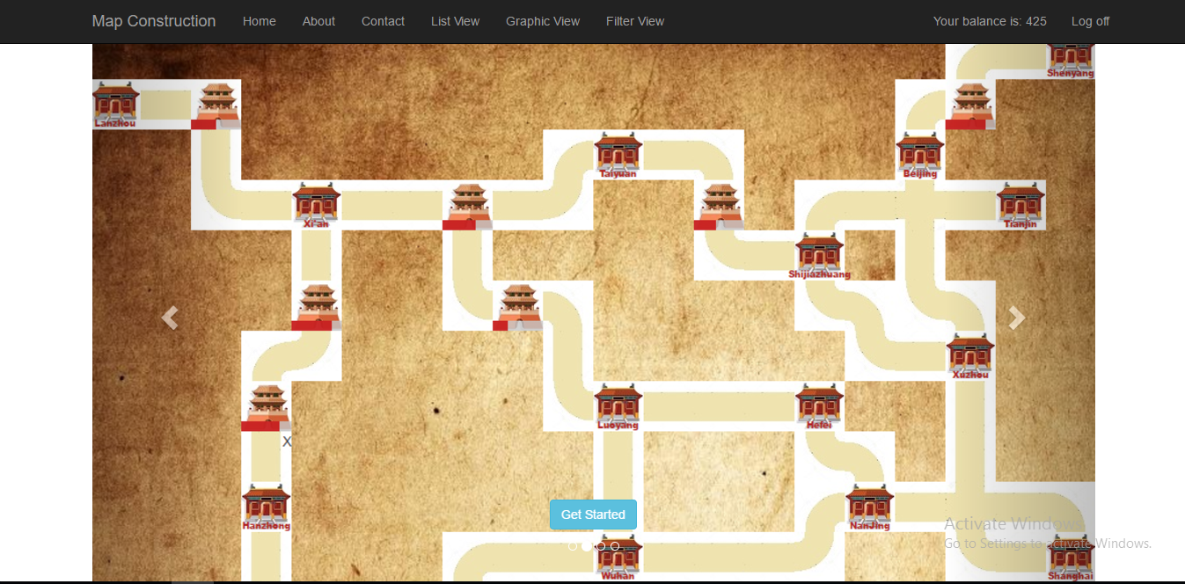

* About Page
  + Game Rules

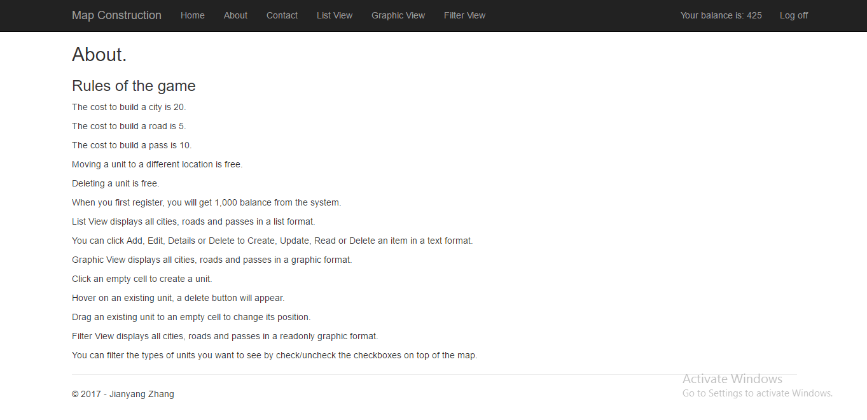

* Contact Page
  + Contact Info

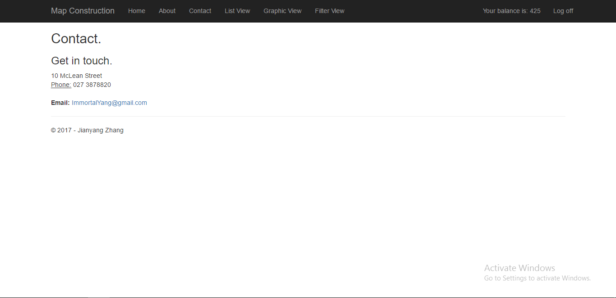

* List View
* Graphic View
* Filter View (Readonly)

# Use Case Diagram

i

# Activity Diagrams

i

# Class Diagram

