Test Cases for Map Construction
Requirement to test | Test Data Input | Expected Outcomes | Actual Outcomes
Home page is displayed properly | Run program or open url in browser | header, footer, carousel, start buttons displayed properly. User balance is shown if user has logged in. | 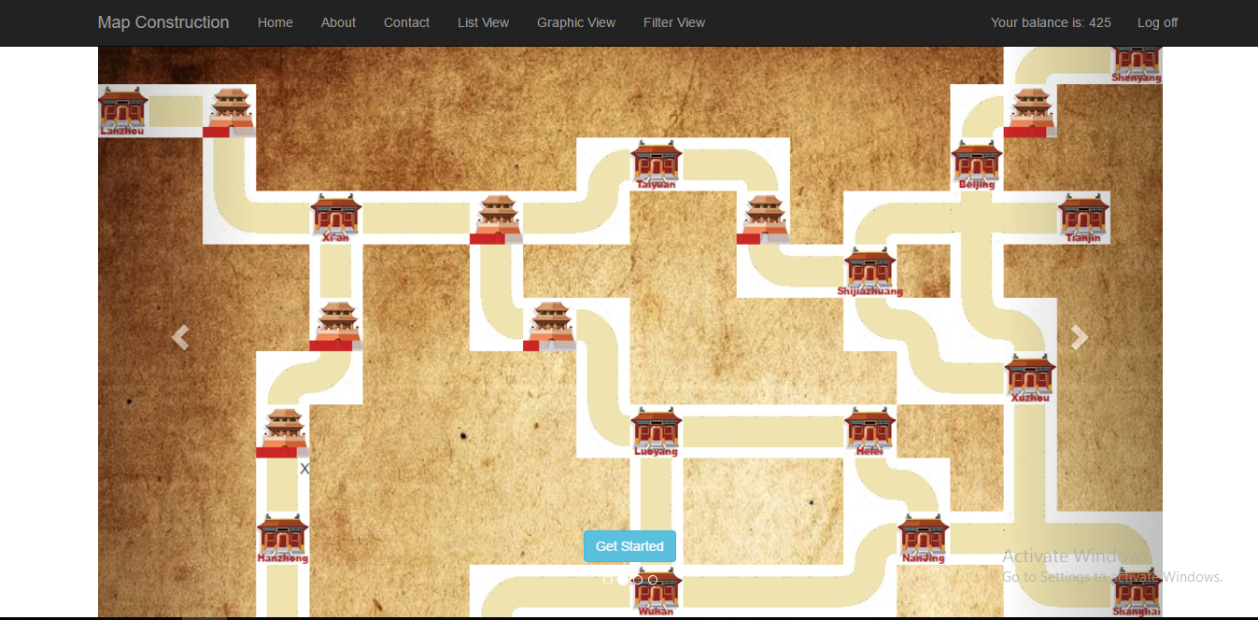
About page is displayed properly | User click About menu in header | User can see game rules explained. | 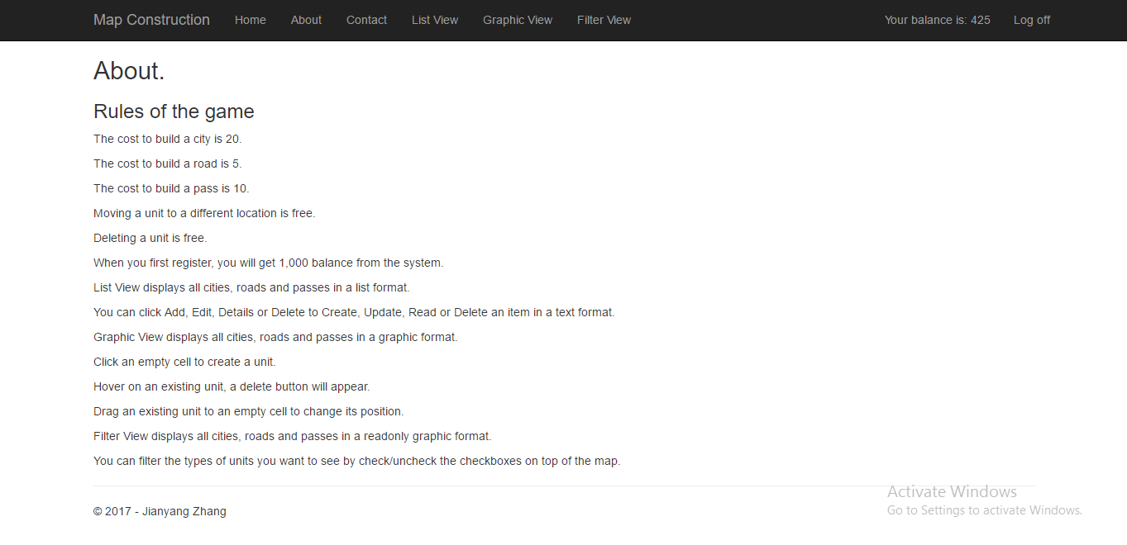
Contact page is displayed properly | User click Contact menu in header | User can see contact information. | 