Test Cases for Create and save Reservation (including initialization)
Requirement to test | Test Data Input | Expected Outcomes | Actual Outcomes
Interface is displayed correctly when the program runs | User open the program | System shows the calendar, resources, dates and existing reservations correctly. The edit panel is disabled. (The reservations and resources are initialized by the controller) | 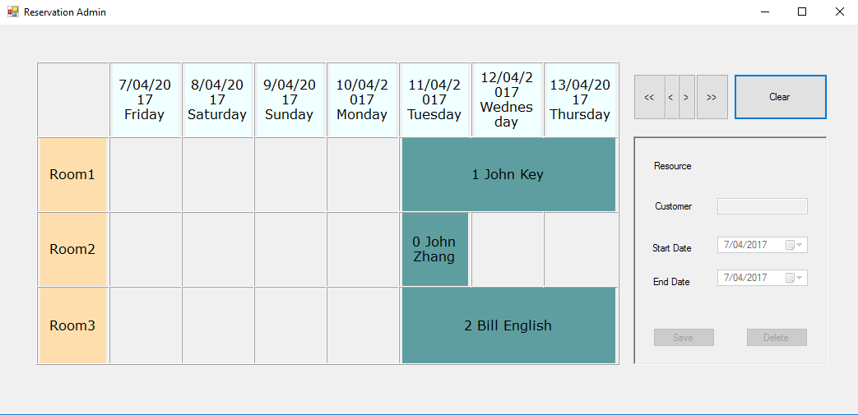
Click on empty cell to create new reservation | User click on an empty cell on the calendar | The system shows the new reservation in the edit panel which is enabled, with correct date associated with the cell that the user clicked. | 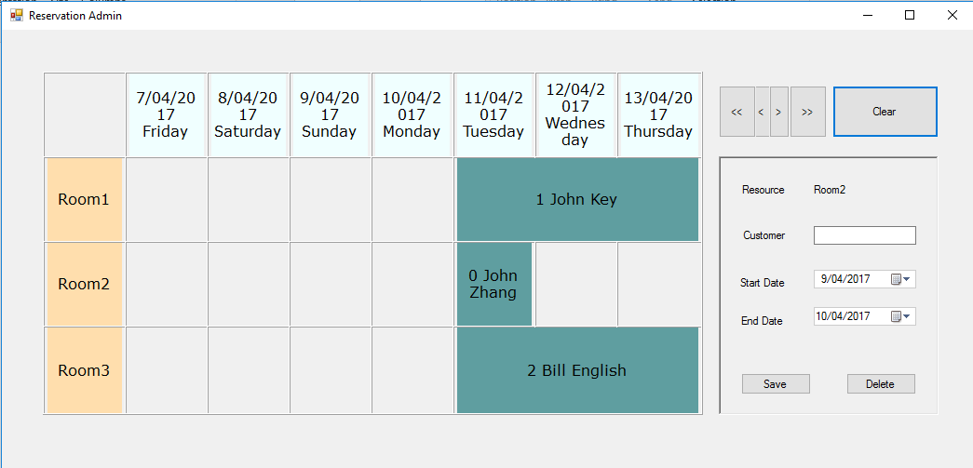
Save new reservation to the system | User click Save button after input data | Save operation success with a prompt | 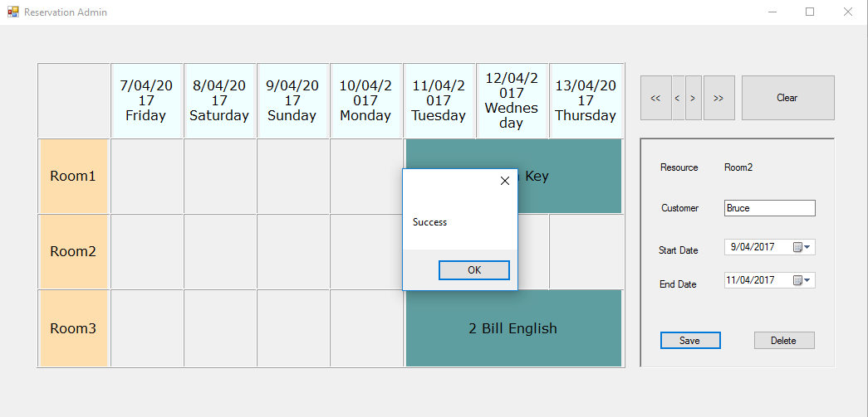
Newly created reservation is shown on calendar | User click ok on the message box | New reservation is correctly shown on calendar | 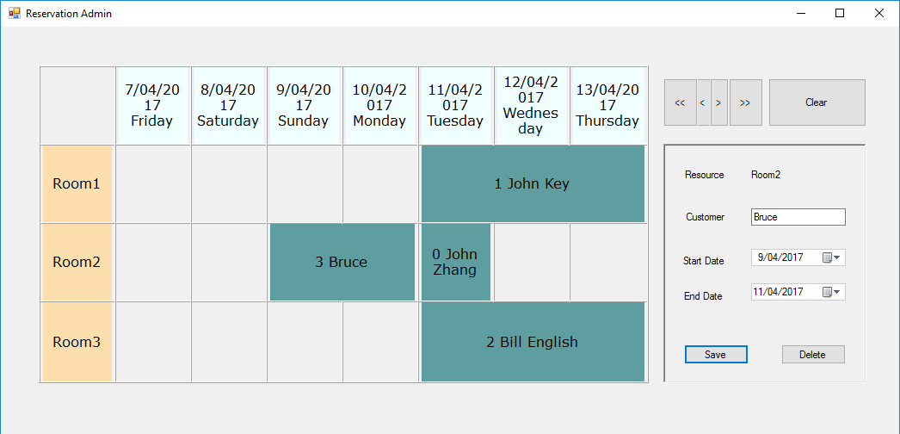
Newly created reservation is indeed saved into the system | User scroll the calendar to check the new reservation is still there | New reservation is correctly shown on calendar | 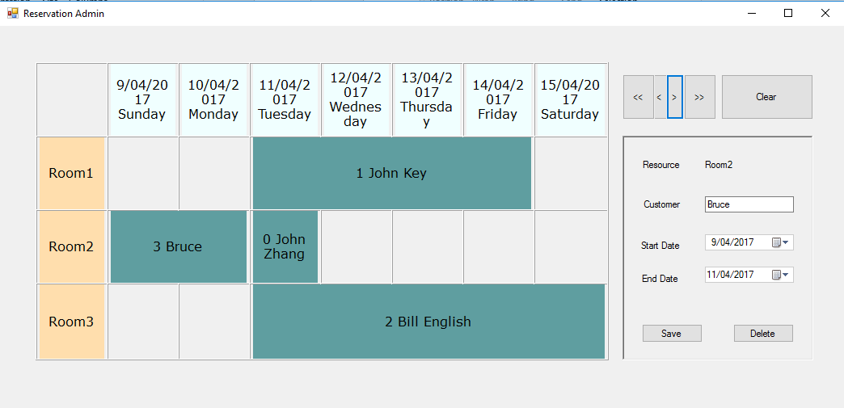

Test Cases for Modify and save Reservation

Requirement to test | Test Data Input | Expected Outcomes | Actual Outcomes
Select existing reservation on the calendar | User click on an existing reservation label (id: 4, GuestName: Sam) | Existing reservation is shown correctly on edit panel, and the edit panel is enabled for editing | 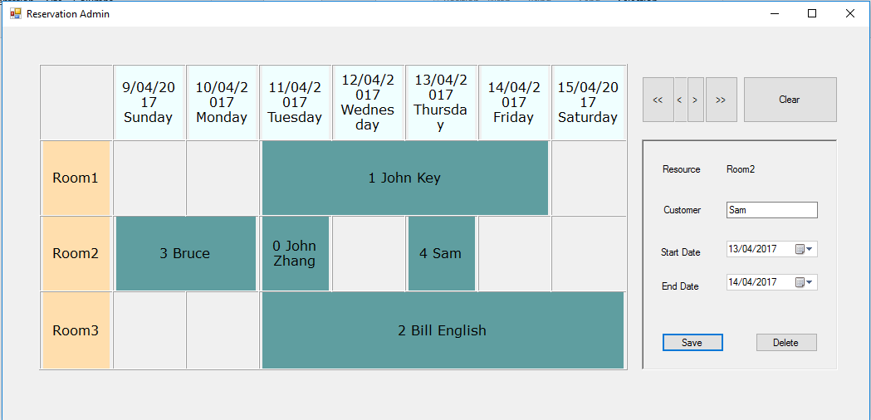
Save new reservation to the system | User click Save button after modifying data (name, start date, end date) | Save operation success with a prompt | 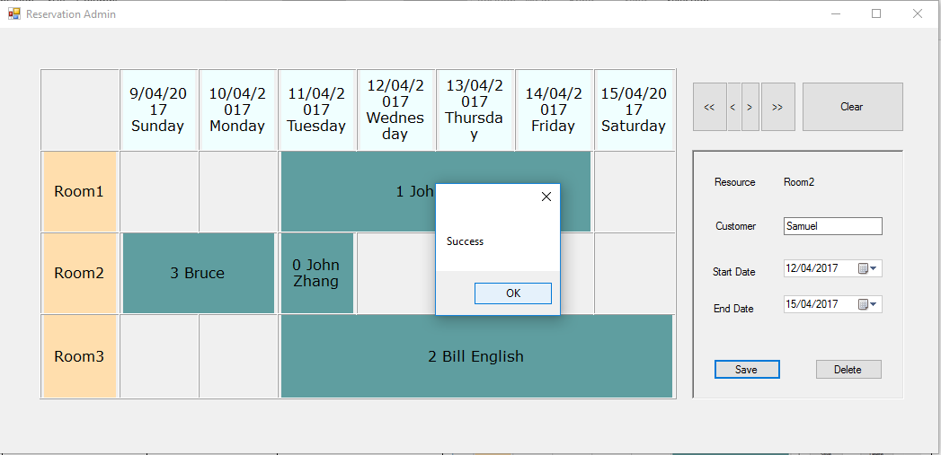
Modified reservation is shown on calendar | User click ok on the message box | Modified reservation is correctly shown on calendar | 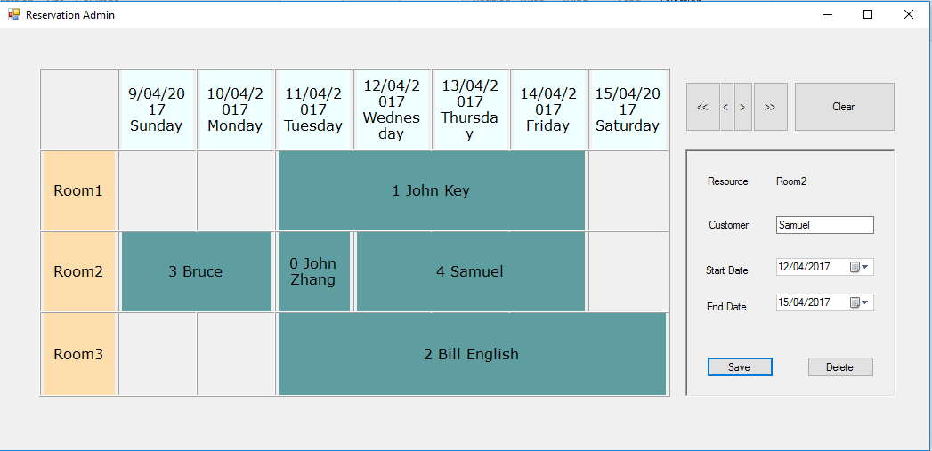
Modified reservation is indeed saved into the system | User scroll the calendar to check the modified reservation is still there | Modified reservation is correctly shown on calendar | 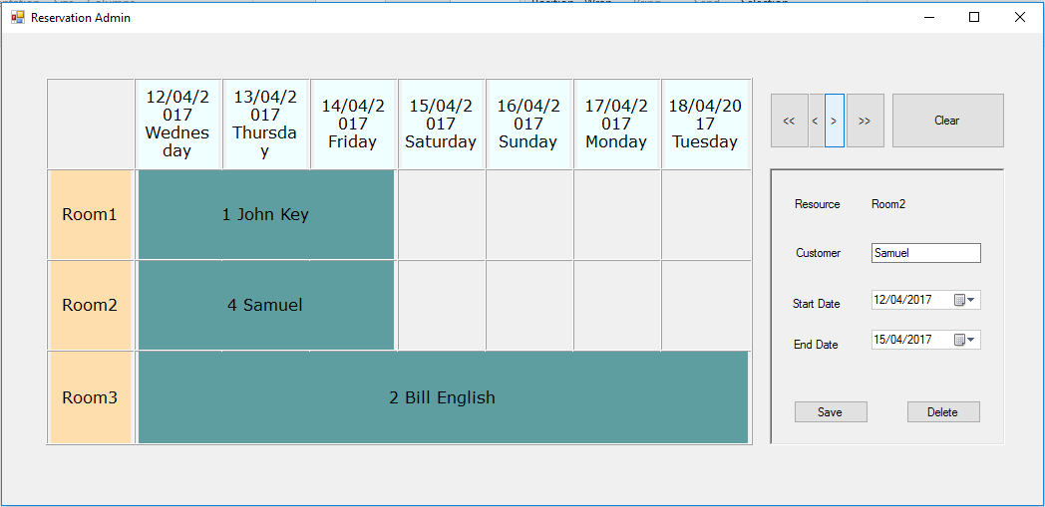

Test Cases for Delete Reservation

Requirement to test | Test Data Input | Expected Outcomes | Actual Outcomes
System pop up delete confirmation | User click on the delete button on the edit panel | Warning: Are you sure you want to delete this reservation? | 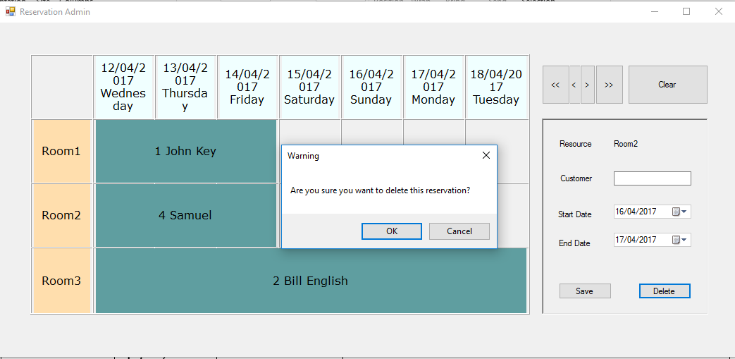
Trying to delete a reservation that is not in the system | User click OK on the warning dialogue, the reservation is not saved though | Pop up message “Please save the reservation first”, delete operation fail | 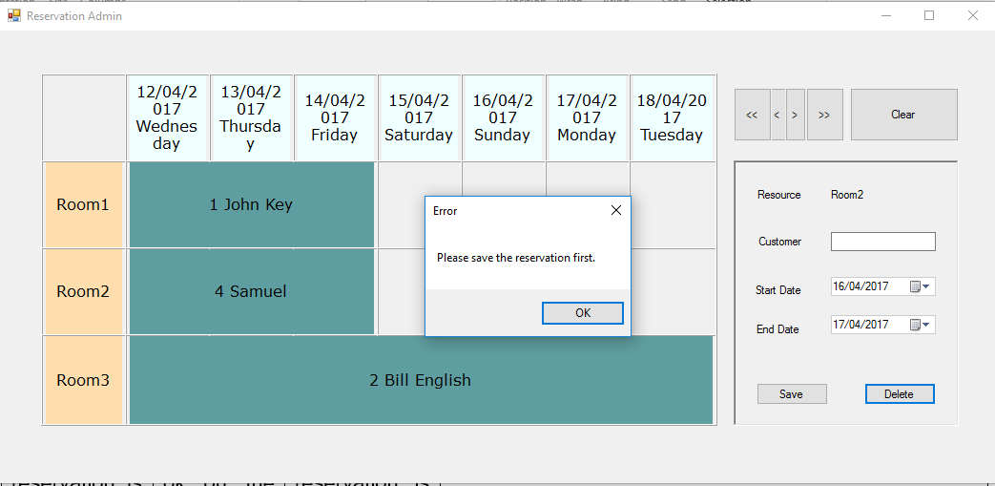
Trying to delete an existing reservation | User click OK on the warning dialogue, the reservation id is 1, guest is John Key | Selected reservation is deleted and is not shown on calendar anymore | 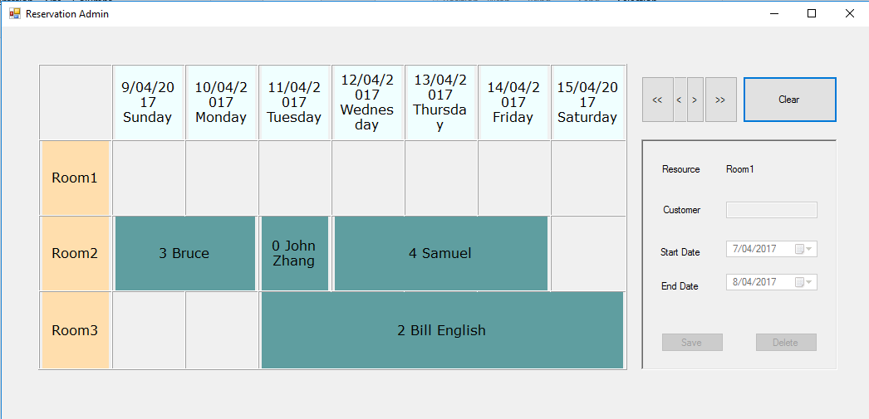
Check the reservation is indeed deleted in the system | User scroll the calendar to check the deleted reservation is not shown anymore | Deleted reservation is not shown | 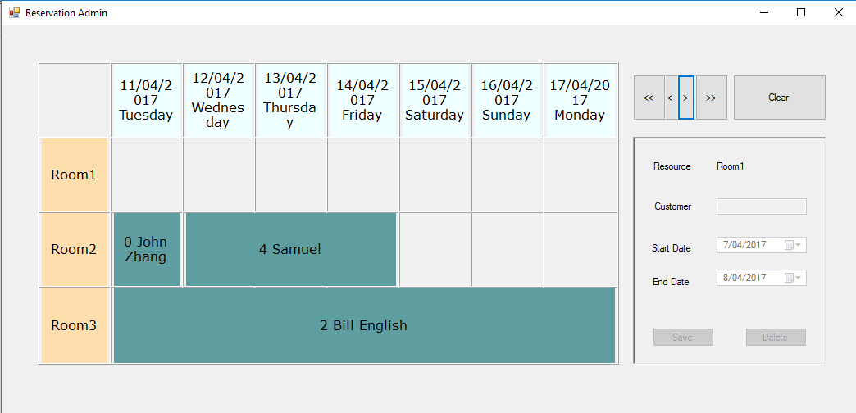

Test Cases for Validate Reservation

Requirement to test | Test Data Input | Expected Outcomes | Actual Outcomes
Validation on guest name | User input an empty guest name and click save button | Pop up info: please enter guest name. | 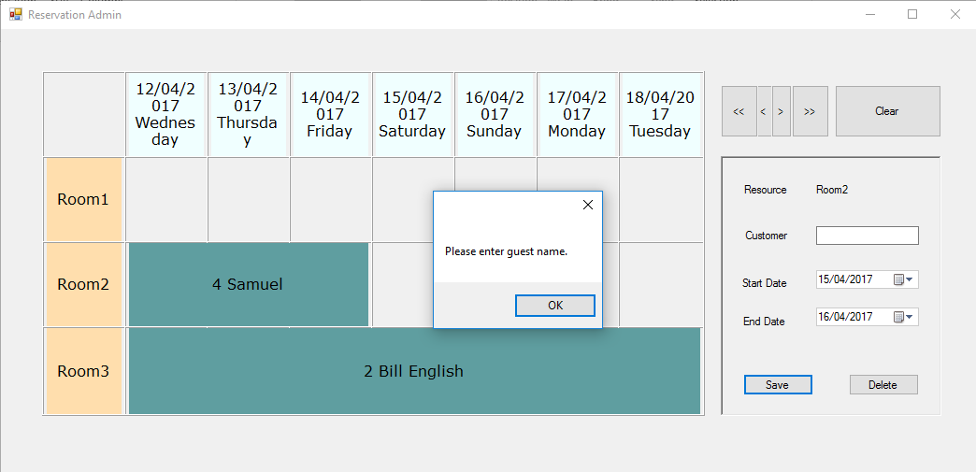
Validation on dates | User input a start date which is not precede to end date | Pop up info: Start date must precede to end date. | 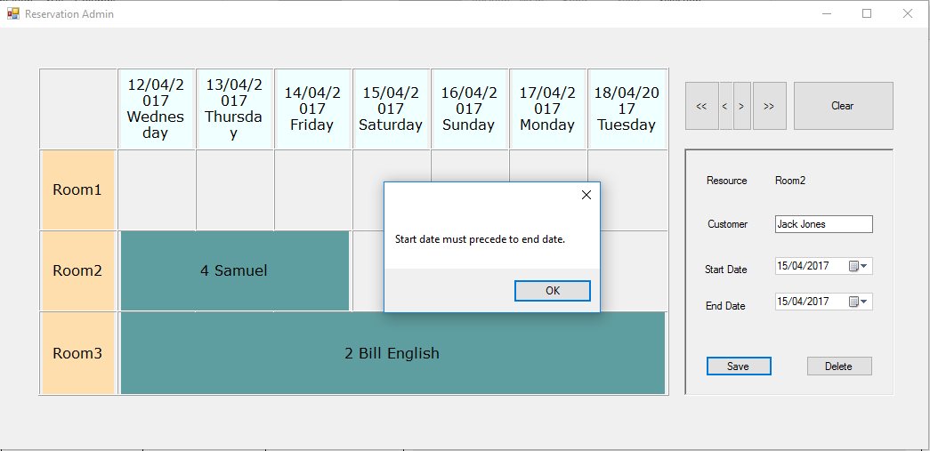
Validation on reservation conflicts | User input date is conflict with other reservation | Pop up info: Date conflict with other reservation | 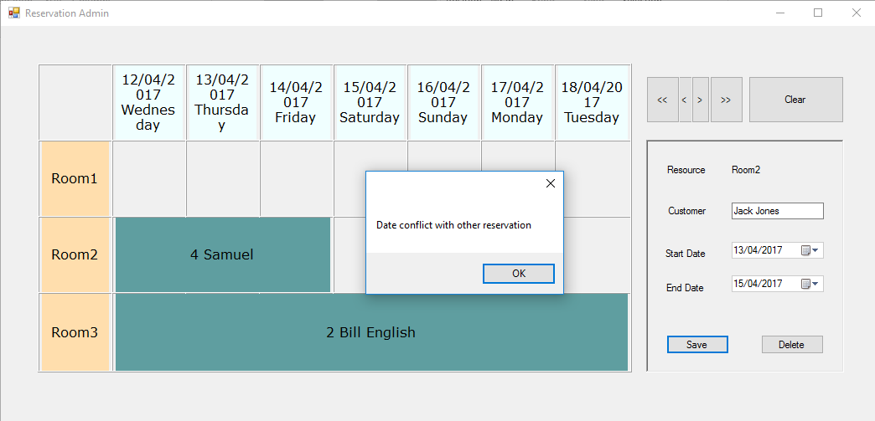
Validation success | User input all fields with correct data formats and values | Successfully saved | 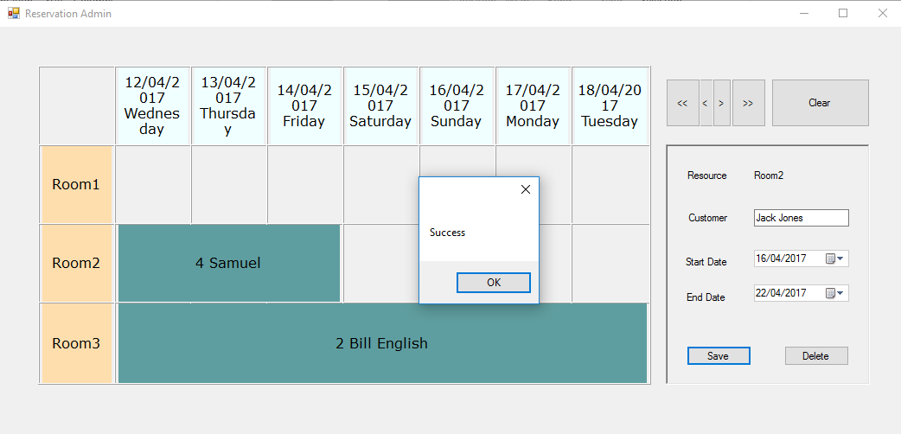

Test Cases for Scroll Calendar

Requirement to test | Test Data Input | Expected Outcomes | Actual Outcomes
Calendar scroll one day backward | User click on < button | Calendar scroll back one day and all reservations are still shown correctly | 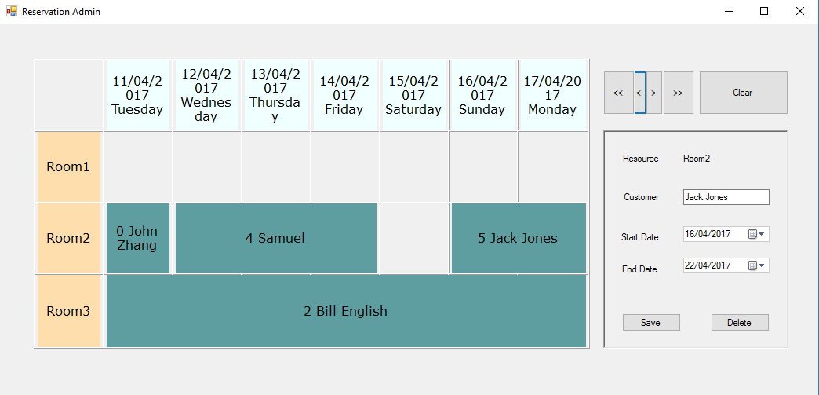
Calendar scroll one day forward | User click on > button | Calendar scroll forward one day and all reservations are still shown correctly | 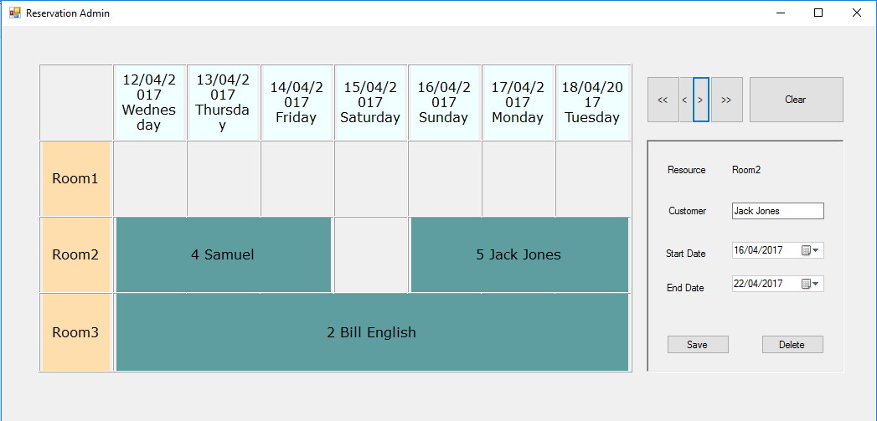
Calendar scroll one week backward | User click on << button | Calendar scroll back one week and all reservations are still shown correctly | 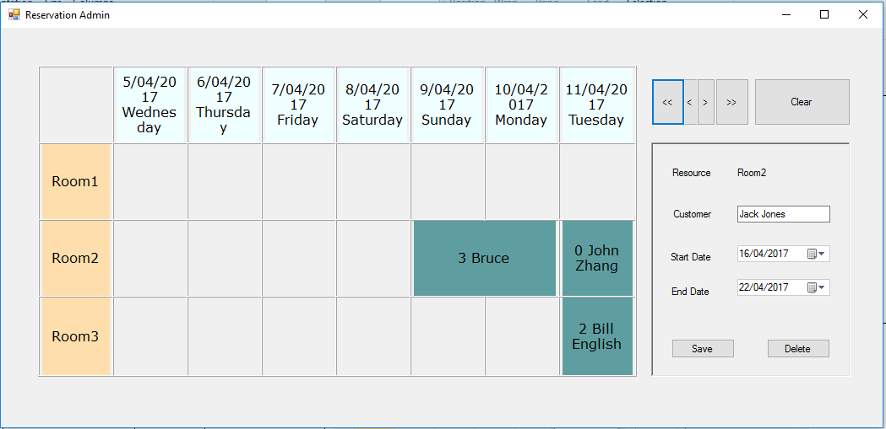
Calendar scroll one week forward | User click on >> button | Calendar scroll forward one week and all reservations are still shown correctly | 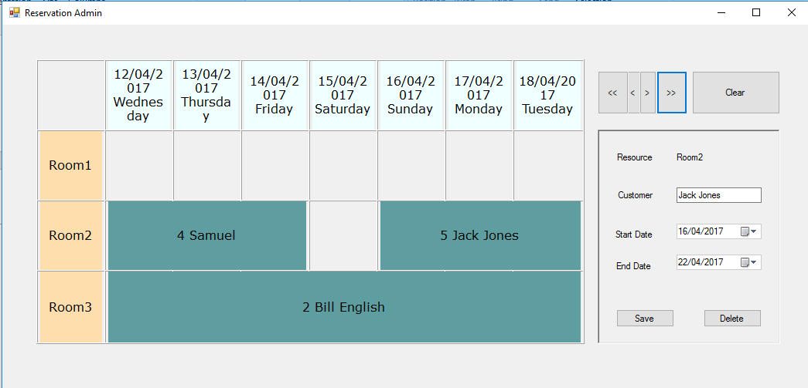

Test Cases for Clear Reservations

Requirement to test | Test Data Input | Expected Outcomes | Actual Outcomes
Warn user before clear all reservations | User click on Clear button | Warning: All reservations will be cleared. This operation is not reversible. Are you sure? | 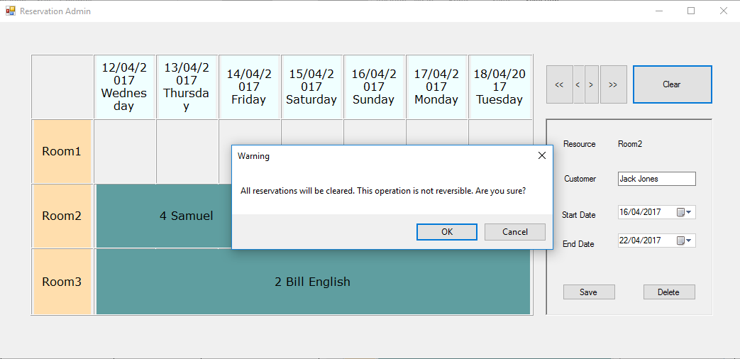
Allow user to cancel clear operation | User click Cancel on the warning dialogue | System don’t clear anything | 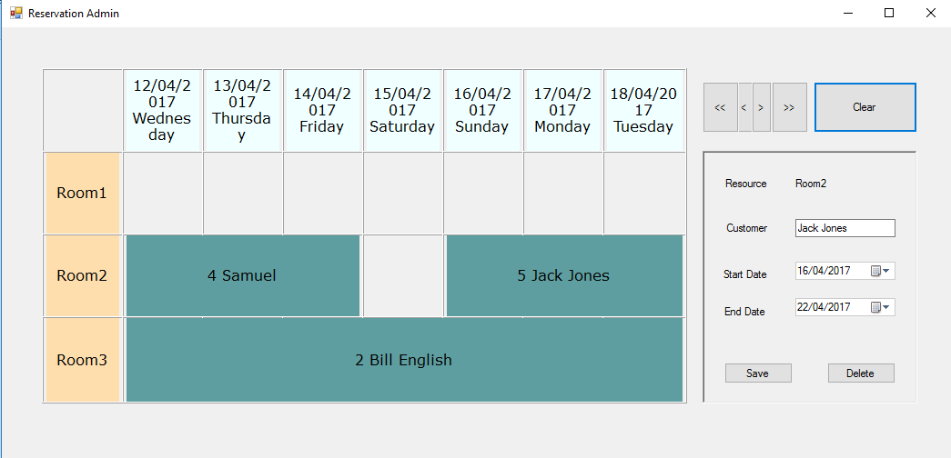
Allow user to clear all reservations | User click on OK button on the warning dialogue | All reservations are cleared and edit panel is disabled | 