Peptide to Spectrum Matching

Shotgun proteomics relies on the assignment of a large number of spectra to theoretical peptides derived from a sequence database. Various search engines have been developed for this task, each with its own advantages and shortcomings. We are going to search the mgf file obtained in Chapter 2 against the database obtained in Chapter 1 using OMSSA**1** and X!Tandem[2](#_ENREF_2" \o "Craig, 2004 #46), two freely available search engines. The necessary spectrum and database files can be found in the resources folder.

Peptide 1

Peptide 2

Peptide 3

Peptide 4

Peptide 1

Peptide 2

Peptide 3

Peptide 4

Peptide 1

Peptide 2

Peptide 3

Peptide 4

Spectrum Collection

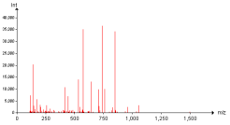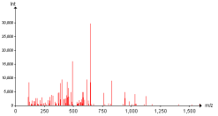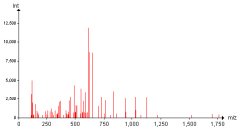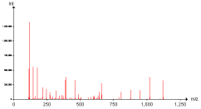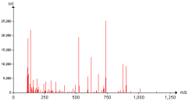

Protein Database

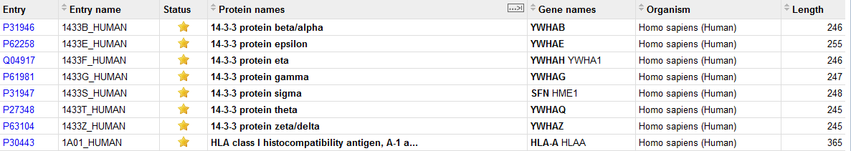

Results



Search Engine

Every search engine has its own specificity and it is recommended to study them on their respective web pages: [http://pubchem.ncbi.nlm.nih.gov/omssa](http://pubchem.ncbi.nlm.nih.gov/omssa/) and [http://www.thegpm.org/tandem](http://www.thegpm.org/tandem/). However, it is possible to use them together *via* a simple interface called SearchGUI3. SearchGUI for Windows platforms is provided in the software folder together with OMSSA and X!Tandem. For Mac and Linux versions, please see the SearchGUI web page: [http://searchgui.googlecode.com](http://searchgui.googlecode.com/). Start SearchGUI by double clicking the file SearchGUI-X.Y.Z.jar (replace X.Y.Z with the current SearchGUI version number).

You will then see the following dialog:

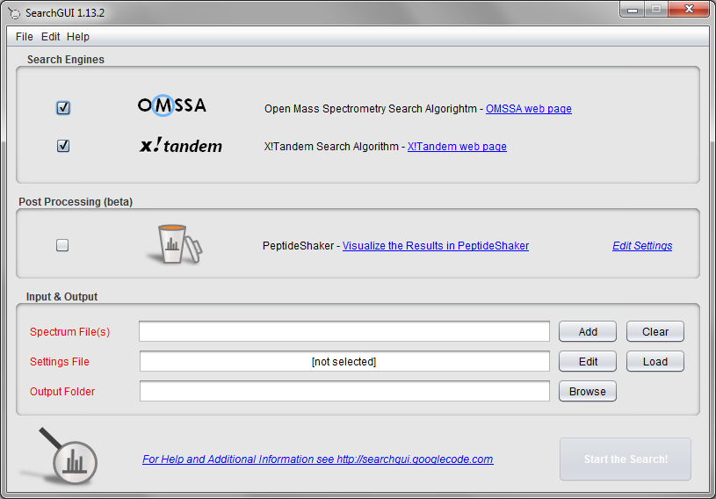

You will notice that OMSSA and X!Tandem is already selected. In fact, keen observers may already have noticed the search engines in the SearchGUI home folder. This means that when you have downloaded the SearchGUI zip file and unzipped it (which comprises the entire installation procedure), you have also already installed OMSSA and X!Tandem along with it!

*Is this legal? Can the SearchGUI authors do this? They did not make OMSSA or X!Tandem?*

In order to perform the search, we need to provide the spectra, the database and experiment dependent search settings. Load the previously created mgf file Velos005137.mgf (available in the resources folder). *Note that you can load multiple mgf files and even entire folders.*

We are now going to set the search settings in the Search Settings dialog. Click the 'Edit' button after the 'Settings File' text field.

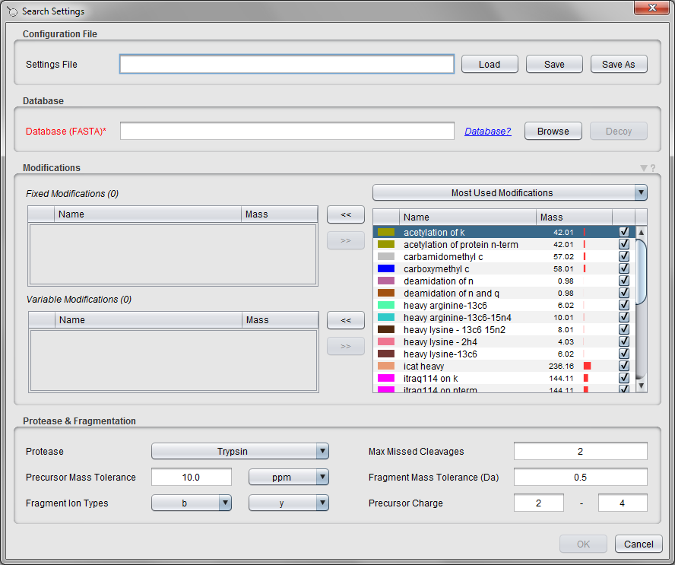

Note that at the top of this tab, you can load or save the settings you will enter - this makes it easy to keep track of your search settings, and to reuse them *verbatim* later on. These can also be loaded directly in the main SearchGUI display. For now, we will define the settings manually.

First we need to specify the database to search against. We will use the database generated in Chapter 1. *How does the database used affect the results? Will we always find the same proteins? How does the size of the database affect the significance/score of the proteins we find?*

Most proteomics databases searches are performed as so-called target/decoy searches, and to perform such a search you first have to add the decoy protein sequences to your database file. More details on target/decoy searches will follow in Chapter 5. For now simply select the human database created in Chapter 1 (also available in the resources folder), and select 'Yes' when SearchGUI offers the option to add decoy sequences. Note that the selected database has changed to use the target/decoy version. (Decoys can also be added manually by clicking the 'Decoy' button.)

The next step is to specify the modifications to consider. As fixed modifications choose carbamidomethyl c, and as variable modifications choose phosphorylation of s, phosphorylation of t, phosphorylation of y and oxidation of m. *Tip: CTRL + Click allows you to select multiple entries.* *Are these all the modifications you would expect for a standard shotgun experiment? How do you define which modifications are variable and which are fixed?*

Then we’ll need to choose the enzyme - leave it set at Trypsin, and keep the number of allowed missed cleavages at 2*. What is a missed cleavage? Why 2 and not 0 or 1?*

Keep the precursor ion mass tolerance at 10 ppm and the fragment ion mass tolerance at 0.5 Da. *How do we choose these values? What is the difference between using a mass tolerance in ppm or Dalton?*

The fragment ion types and the charge bounds are fine as they are. *Why?*

Note that only the most commonly used modifications are listed in this dialog. There are more modifications available in SearchGUI, and you can also set up your own modifications. Click the small triangle above the modification table and select the 'Edit Modifications' option. (The modification details are also available in the main SearchGUI frame, Edit menu > Modifications.)

In the 'Find' field type ‘phosphorylation’. You will see that many modifications are available:

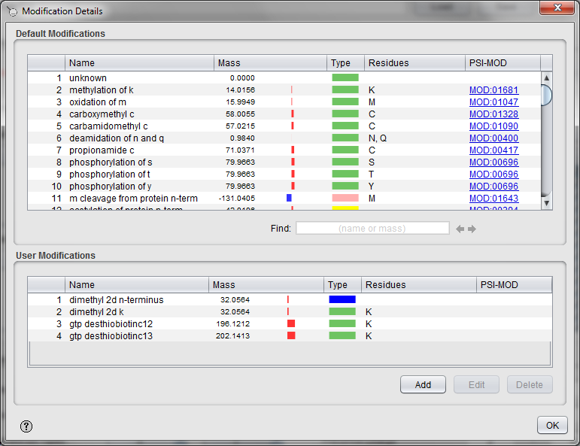

*What is the difference between the different phosphorylation possibilities? How does the selection affect your search results?*

Double clicking on a modification brings up the modification details:

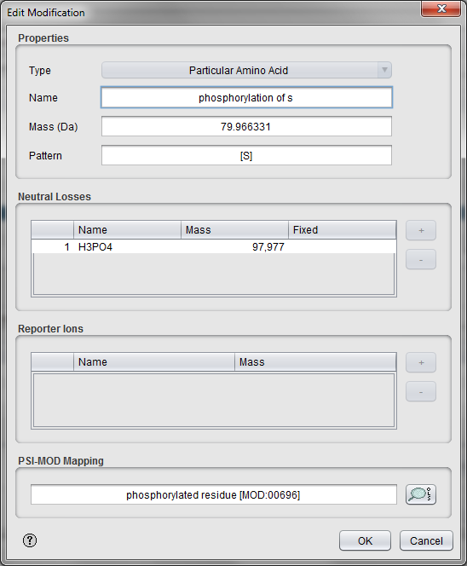

*What is a neutral loss? What is a reporter loss?*

Close the modification details dialogs and go back to the Search Settings dialog. All the search settings are now filled in. Go to the top of the dialog, click the 'Save As' button and save the settings for future reuse. *Tip: The next time you want to use the exact same search settings you can simply select this file in the main SearchGUI frame.* Click 'OK' to close the Search Settings dialog and go back to the main frame.

Note that both search engines are selected at the top. This means that one can run a search using both OMSSA and X!Tandem, and get result files for both of them at the same time. However, to save some time we will just use OMSSA now. To disable the X!Tandem search, simply uncheck the checkbox for X!Tandem.

The X!Tandem search has already been performed for you though, and we will employ the results of both searches in the later analysis. Also leave the PeptideShaker post-processing option unchecked for now.

Finally select an output folder and start the search by pressing the ‘Start the Search!’ button. A progress bar and scrolling text will keep you informed on the progress of the searches. *How does the size of the spectrum file affect the search time? What about the database size? The search parameters? Can all searches be performed on a standard desktop computer?*

***Note: It is strongly recommended to always select an empty folder for the SearchGUI output. This makes it simpler to load the results in PeptideShaker later, and reduced the chance of errors occurring.***

A screenshot of the dialog after completion is shown below:

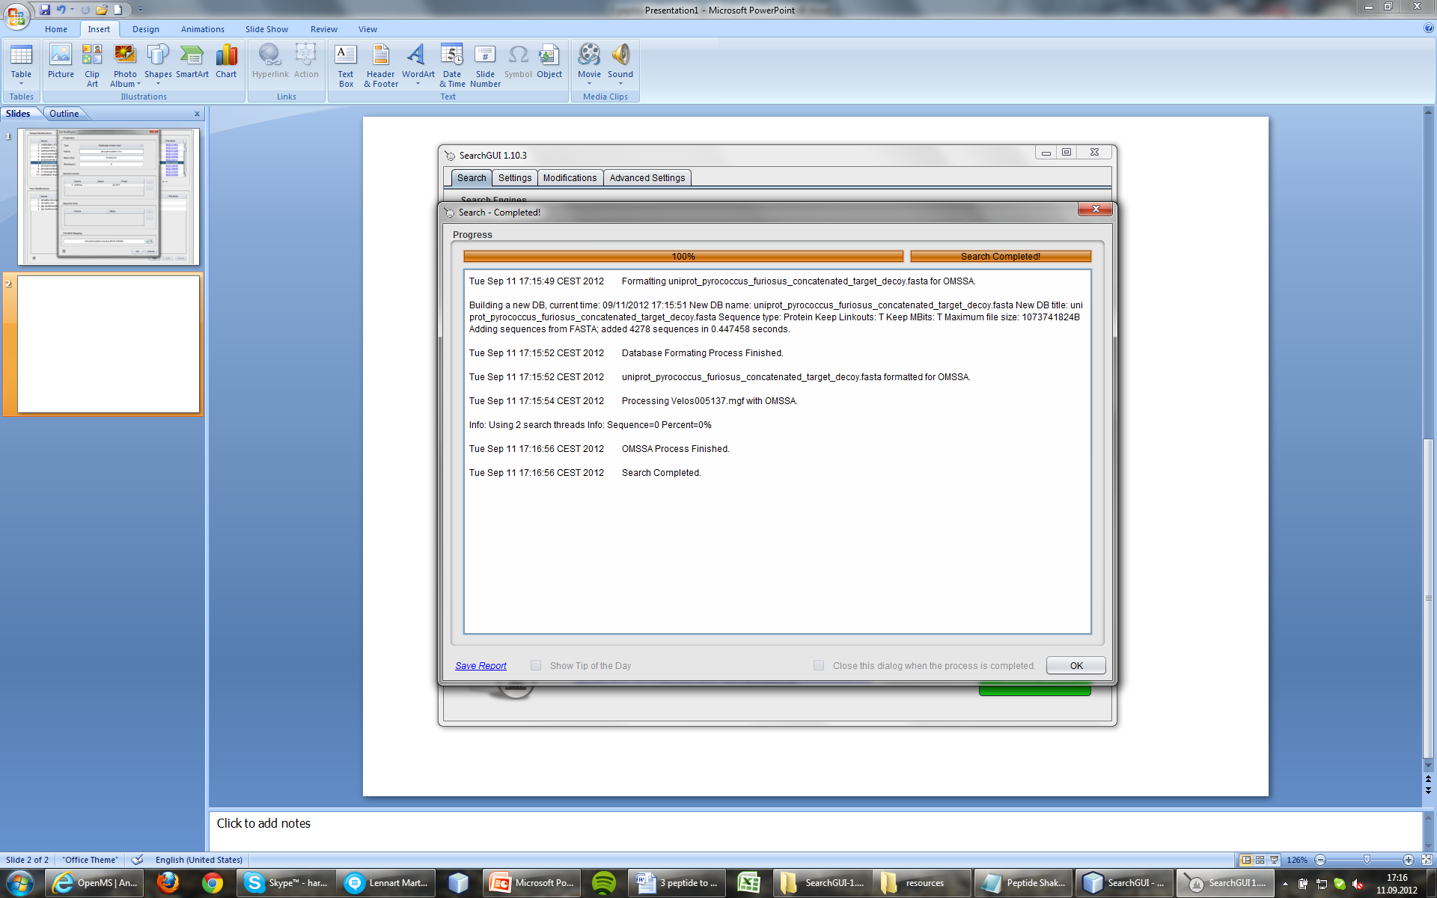

After completion, the output folder will contain several files, where the two most important are the output files for the search engines. The OMSSA output file will be called Velos005137.omx, while the X!Tandem output file will be called Velos005137_[date]_[time].t.xml. These files contain so-called Peptide to Spectrum Matches (PSMs) inferred by the search engines. We will see how to interpret these matches in the next chapter.

If you happen to encounter any issues with SearchGUI, please consult the troubleshooting section at: <http://searchgui.googlecode.com>.

References

1. Geer, L.Y. et al., *J Proteome Res* **3**, 958-964 (2004).

2. Craig, R. & Beavis, R.C., *Bioinformatics* **20**, 1466-1467 (2004).

3. Vaudel, M., Barsnes, H., Berven, F.S., Sickmann, A. & Martens, L., *Proteomics* **11**, 996-999 (2011).