**Imogen Gough**

**MODELS FOR NEURONS AND NEURONAL NETWORKS**

**DEMO - 15th March 2016**

**SINGLE NEURON MODELS**

**Simple Tau Model**

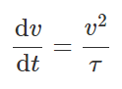

$ OneNeuronTau(vreset, vthresh, time, timestep, tau)

**Regular spiking**:

$ OneNeuronTau(-65, 30, 100, 1, 60)

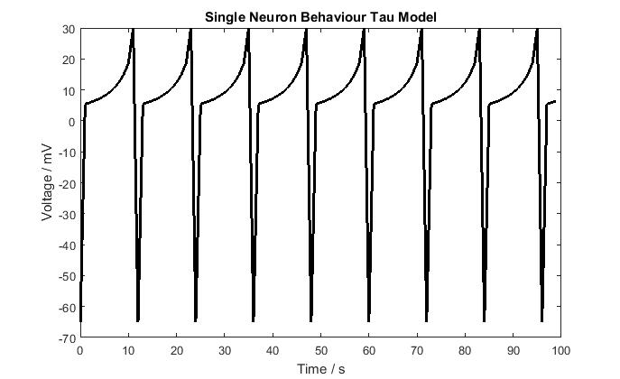

If we increase Tau, then neuron takes longer to spike:

$ OneNeuronTau(-65, 30, 100, 1, 64)

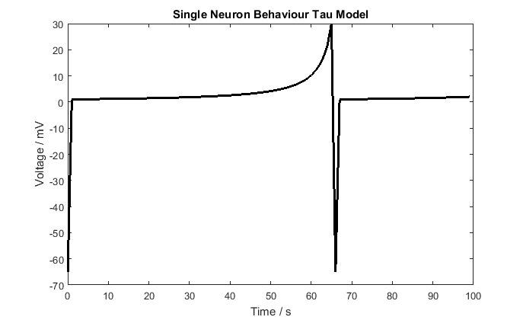

**Izhikevich Integrate and Fire Model**

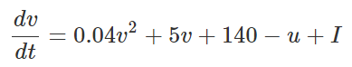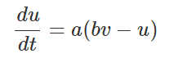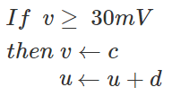

$ OneNeuronIzhInF(time, timestep, a, b, vthresh, vreset, ureset, current)

a = timescale of recovery variable, u

b = sensitivity of recovery variable, u , to potential v

**Excitatory Neurons**

**Regular Spiking:**

$ OneNeuronIzhInF(100, 0.01, 0.02, 0.2, 30, -65, 8, 14)

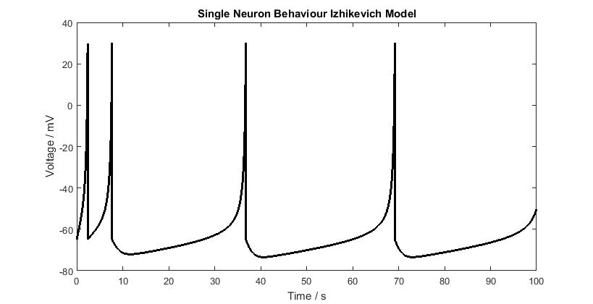

**Intrinsically bursting:**

$ OneNeuronIzhInF(100, 0.01, 0.02, 0.2, 30, -55, 4, 14)

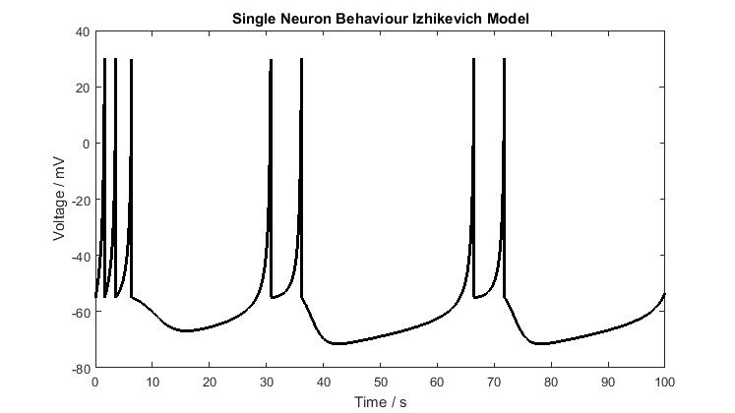

**Chattering:**

$ OneNeuronIzhInF(100, 0.01, 0.02, 0.2, 30, -50, 2, 14)

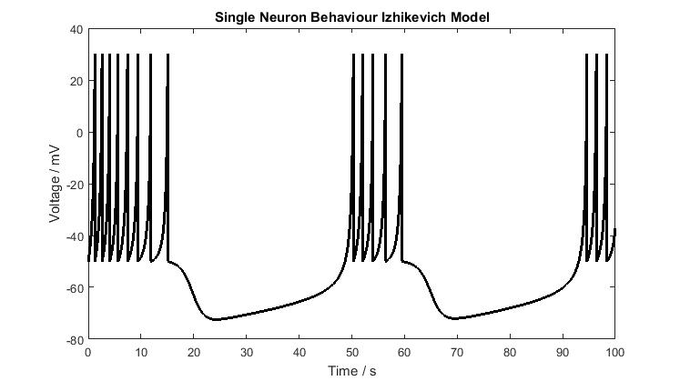

**Inhibitory Neurons**

**Fast spiking:**

$ OneNeuronIzhInF(100, 0.01, 0.1, 0.2, 30, -65, 2, 14)

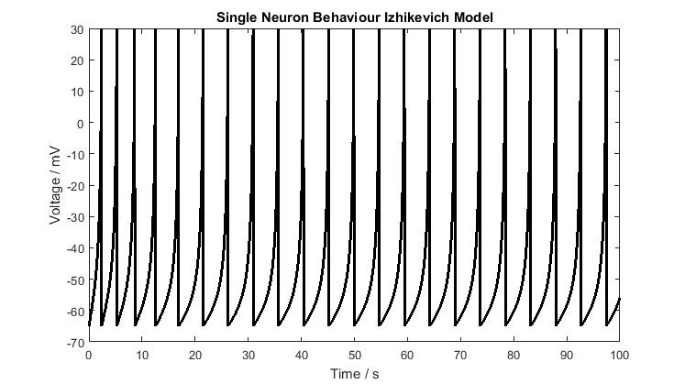

**Low threshold spiking:**

$ OneNeuronIzhInF(100, 0.01, 0.02, 0.25, 30, -65, 2, 14)

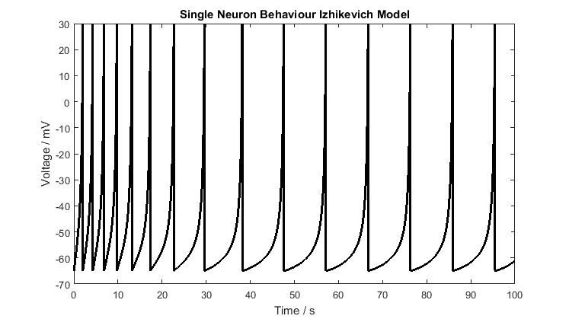

**Exponential Integrate and Fire Model**

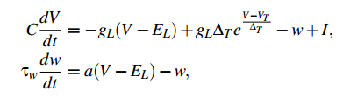

$ OneNeuronExpInf(time, step, current, C, gL, EL, VT, DeltaT, tauw, b, a, Vr)

C = membrane capacitance

gL = leak conductance

EL = leak reversal potential

VT = spike threshold

DeltaT = slope factor

Tauw = adaptation time constant

b = spike triggered adaptation parameter

a = subthreshold adaptation parameter

Vr = voltage reset

**No Spike – weak input current**

$ OneNeuronExpInf(500, 0.01, 500, 281, 30, -70.6, -50.4, 1, 144, 80.5, 4, -50.4)

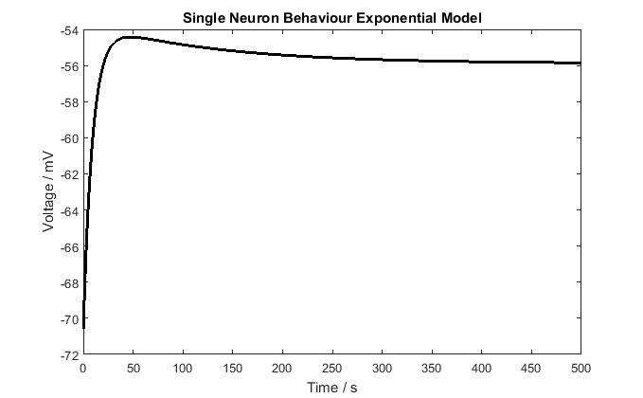

**Regular Spiking**

$ OneNeuronExpInf(100, 0.1, 1000, 281, 30, -70.6, -50.4, 1, 144, 80.5, 4, -50.4)

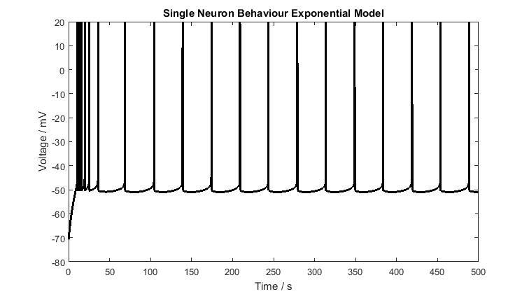

**Bursting – higher voltage reset**

$ OneNeuronExpInf(800, 0.01, 1500, 281, 30, -60, -50.4, 1, 720, 80.5, 80, -47.4)

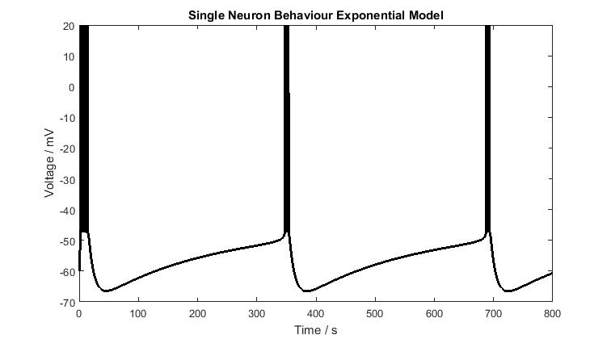

**Hyper Polarised Neuron**

Leak reversal is higher

Subthreshold adaptation is much larger = 80 not 4

Adaptation time constant is much larger = 720 not 144

$ OneNeuronExpInf(500, 0.01, 500, 281, 30, -60, -50.4, 1, 720, 80.5, 80, -50.4)

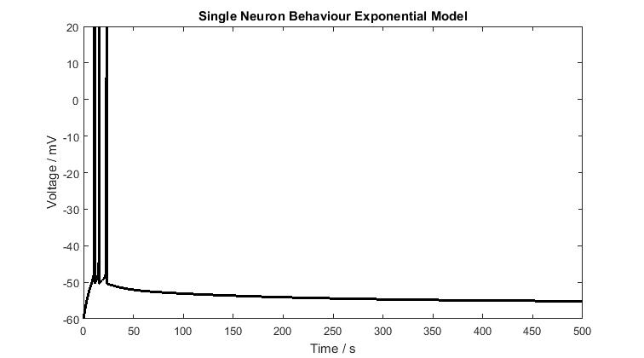

**NEURON NETWORK MODEL**

**Network Topologies:**

**Type 1 – Neurons connected in a long line**

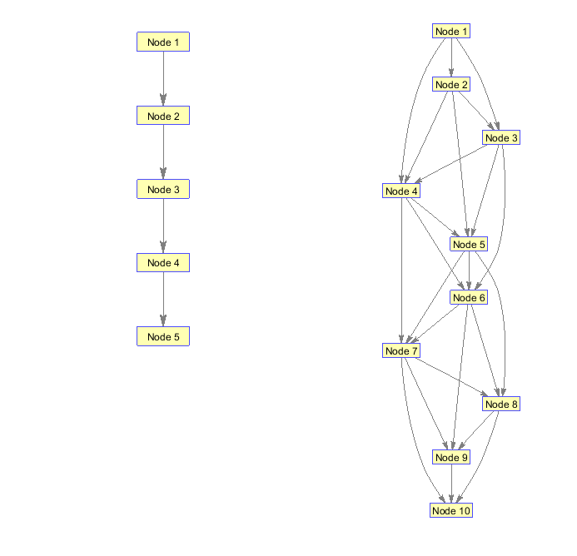

**Type 2 – Neuron connected to next three neighbours**

**Type 3 – Randomly generated network**

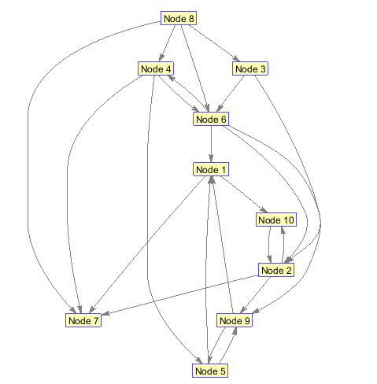

**Type 4 – Tree like structure**

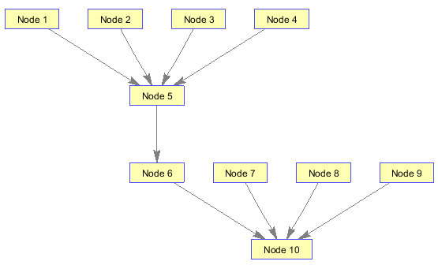

**Neurons connected in the network with a coupling function (neuron i = xi)**

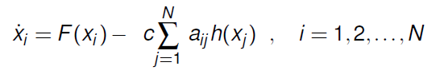

c > 0 = the coupling strength

h(x­­i) = the inner coupling function

A = the coupling matrix

When nodes are associated symmetrically then A = L, with L = (l­­­ij) the laplacian matrix associated with the graph describing the unweighted network topology

**Synchronisation in the network analysed according to the rule of complete synchronisation**

A dynamical network is said to be completely synchronised if:

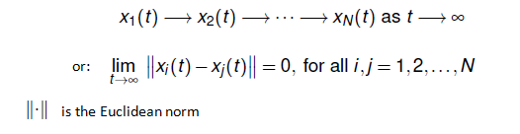

**Synaptic Conductance Dynamics**

Each neuron is stimulated by pre-synaptic spikes arriving at its synapse.

Each pre-synaptic spike makes some contribution, described by a function, alpha(t), to the post-synaptic current. The contributions of different pre-synaptic spikes are linearly summed to obtain the total post-synaptic current.

So the total post-synaptic current to the i-th neuron is expressed as

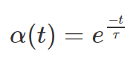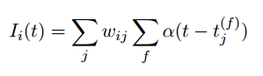

tj(f) = the time of the f-th spike of the j-th pre-synaptic neuron

wij = the strength of synaptic efficacy between neuron i and neuron j (randomly drawn from a Gaussian distribution)